ENGINEERING REFERENCE
Primer: Loop Engineering for Agentic Systems
Designing bounded observe–plan–act–verify cycles that stop safely
Primer takeaway A loop is a controlled state machine, not permission to keep trying. Every iteration must have admitted evidence, a legal action, verification, a budget, a continuation guard, and an explicit stop condition.

How to use this handout
Read it once end to end, then keep the checklists and templates beside the agent specification while authoring or reviewing.

What loop engineering is
Loop engineering designs repeated agent behavior as an observable control system. It defines the state carried between iterations, the evidence admitted at each step, the tools and actions permitted, the verification required, the conditions for another iteration, and the conditions that end or escalate the run.
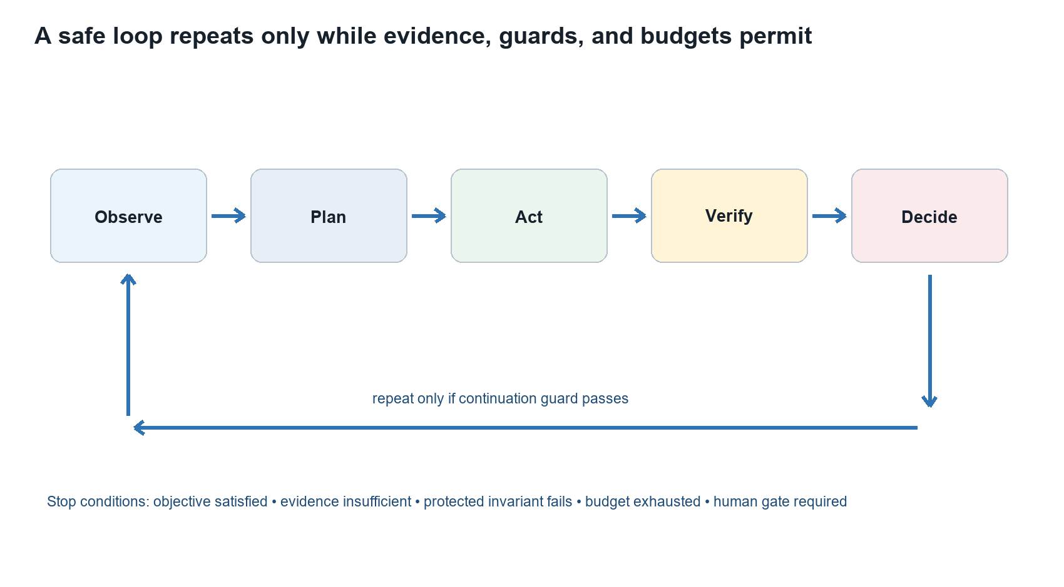

The five-step cycle
Step | Engineering question
Observe | What changed? Which evidence is new, trustworthy, and relevant?
Plan | What bounded action is allowed by policy, state, scope, and budget?
Act | Which tool call or transformation is executed, with what immutable inputs?
Verify | Did the action satisfy the expected invariant without protected regression?
Decide | Stop, repeat, retry, fail, emit incomplete_input, or request human action?
Repository basis: orchestration/workflow-model.md; governance/reviewer-calibration-and-evolution.md

The loop control model
Control | Must define | Evidence retained
Objective | A measurable completion condition | Objective ID and acceptance rule
State | Durable lifecycle state and iteration state | State before and after
Observation | Admissible evidence and freshness rules | Evidence IDs, hashes, coverage
Policy | Allowed actions, tools, permissions, and boundaries | Policy and contract versions
Action | One bounded mutation or analysis step | Tool input, output, execution ID
Verification | Expected invariant and regression checks | Test results and score deltas
Budget | Iteration, time, token, tool, cost, and mutation limits | Consumption and remaining budget
Termination | Success, failure, insufficient evidence, budget, or human gate | Stop reason and final state
Continuation guard Repeat only when the objective is unmet, the next action is legal and materially different, verification supports continuation, protected invariants hold, and sufficient budget remains.

Design the loop before writing the prompt
- Define the objective and terminal success evidence.
- Name the lifecycle states and legal transitions.
- Define the observation contract: sources, freshness, provenance, coverage, and conflict handling.
- Define the action space: permitted tools, mutations, credentials, side effects, and reversibility.
- Define verification: expected invariants, tests, validators, and consumer compatibility.
- Set budgets: maximum iterations, elapsed time, tokens, calls, cost, mutations, and tolerated regressions.
- Define retry policy separately from iteration policy, including backoff and retryable error classes.
- Define stop and escalation conditions, including the exact human gate.
- Specify audit events and the state snapshot retained after every iteration.

Iteration is not retry
Mechanism | Purpose | Example
Iteration | Uses verified learning to choose a materially informed next action. | Revise a candidate prompt after benchmark evidence.
Retry | Repeats the same logical action after a transient failure. | Repeat a timed-out read-only tool call with backoff.
Replan | Changes the action sequence because state or evidence changed. | Select another admitted evidence path after a source becomes unavailable.

Controls that keep loops safe
Control | Implementation guidance
Idempotency | Use stable operation IDs; repeated execution must not duplicate irreversible effects.
Checkpointing | Persist state, evidence lineage, budget, pending actions, and stop reason after each iteration.
Least privilege | Grant only the tools and credentials required for the current state and action.
Fail closed | Stop on identity, integrity, contract, policy, or source-revision ambiguity.
Bounded retry | Retry only declared transient failures; use attempt caps, backoff, and timeout.
Progress test | Require measurable new evidence, reduced uncertainty, or improved benchmark result.
Regression guard | Block continuation when a protected invariant or material compatibility condition fails.
Human gate | Pause before approval, risk acceptance, promotion, irreversible mutation, or policy exception.
Deterministic audit | Record state transitions, inputs, actions, outputs, versions, checks, and budget use.
Repository basis: contracts/orchestration-agent-contract.md; contracts/universal-agent-contract.md

Common loop failure modes
Failure mode | What it looks like | Required hardening
Infinite loop | No terminal condition or progress test | Iteration cap, elapsed-time cap, progress invariant
Thrashing | The loop alternates between states without learning | Cycle detection, state hash, repeated-plan guard
Goal drift | A later iteration broadens or changes the objective | Immutable objective ID and scope check each cycle
Evidence laundering | Prior model output becomes unquestioned evidence | Evidence admission and provenance validation
Retry storm | Transient failures trigger unbounded repeated calls | Retry classes, exponential backoff, circuit breaker
Duplicate side effects | The same action executes more than once | Idempotency key, deduplication, transactional boundary
Budget blindness | The loop spends tokens, time, or money without visibility | Budget ledger and pre-action budget guard
Premature success | The model declares completion without verification | Independent validator and explicit success evidence
Silent partial result | A stopped loop presents incomplete work as complete | Explicit incomplete_input or failed terminal state
Authority leak | The loop promotes or approves its own candidate | Separate human review and promotion decision

Loop contract template
Field | Declaration
loop_id / version | Stable identity and semantic version
objective | Owned outcome and terminal success evidence
initial_state | Required starting lifecycle state and prerequisites
observation_contract | Evidence types, provenance, freshness, coverage, conflicts
action_policy | Permitted tools, mutations, permissions, side-effect class
verification_contract | Validators, invariants, regression and compatibility checks
continuation_guard | Conditions that authorize another iteration
retry_policy | Retryable classes, attempts, backoff, timeout, circuit breaker
budgets | Iterations, time, tokens, calls, cost, mutations, regression tolerance
terminal_states | Succeeded, incomplete_input, failed, superseded, human_review
audit_events | State, evidence, action, verification, budget, and stop records
human_gates | Named decisions and irreversible actions requiring authority

Reference pseudocode
state = validate_initial_state(work_packet)
for iteration in range(max_iterations):
evidence = observe(state)
if not evidence_integrity_ok(evidence): stop("failed")
plan = choose_bounded_action(state, evidence, remaining_budget)
if not continuation_guard(state, evidence, plan): stop(reason)
result = execute_idempotently(plan)
verification = verify(result, protected_invariants)
record_audit_event(state, evidence, plan, result, verification)
if verification.success: stop("succeeded")
if verification.requires_human: stop("human_review")
state = transition(state, verification)
stop("budget_exhausted")

Worked example: controlled prompt evolution
The repository’s reviewer-evolution loop is a useful model because it separates iterative candidate improvement from production authority.
Stage | Evidence-controlled behavior
Observe | A benchmark exposes weak incomplete-input handling.
Analyze | Trace the failure to a missing state clause, not to the gold label.
Propose | Create a versioned candidate prompt with the smallest corrective change.
Benchmark | Run the approved subset, then the required full suite.
Regress | Compare protected invariants, compatibility, and material score losses.
Human review | Inspect the diff, evidence, gains, regressions, and remaining uncertainty.
Promote or reject | An authorized human records disposition; production never self-modifies.

Loop review checklist
- Is the objective immutable and independently verifiable?
- Can every transition be explained by an event and a guard?
- Does each iteration produce measurable progress or stop?
- Are iteration, retry, and replan behaviors distinct?
- Are side effects idempotent, reversible, or human-gated?
- Are budgets checked before action and recorded after action?
- Can partial, failed, superseded, and human-review states be distinguished?
- Does the audit record reproduce every action and decision request?
Final question If the loop stops unexpectedly, can another engineer explain exactly what happened, why it stopped, what changed, and what authority is required next?

Repository basis: governance/reviewer-calibration-and-evolution.md; orchestration/workflow-model.md

