ENGINEERING ENABLEMENT
Code Review Harness
Agentic System Curriculum
Instructor guide, learner labs, prompt-engineering standard, and 55-agent drafting plan
Core philosophy Evidence is observable. Assessment is bounded. Recommendations inform. Humans decide.

Repository-aligned edition
Based on the Agent Catalog, universal and layer contracts, workflow model, and governance guidance.
Prepared for young engineers learning to design, operate, and test contract-driven agents.

How to use this curriculum
This is a twelve-session progression from first principles to a production-style prompt package. The course treats prompts as governed software artifacts: they inherit contracts, operate inside a stateful harness, produce typed artifacts, preserve evidence, and stop at the boundary of human authority.
Recommended delivery Two sessions per week for six weeks, or one session per week for a twelve-week academy. Sessions 3–11 are designed for 120 minutes; the capstone uses 180 minutes.

Course-level outcomes
- Explain why the harness—not the model—is the trust boundary for agentic review.
- Read the catalog and route work to the correct agent, contract, and consumer.
- Design stateful workflows with explicit guards, failure paths, and human decision points.
- Draft role prompts that implement inherited contracts without scope or authority leakage.
- Test prompts against adversarial cases and evolve them through controlled evidence.
- Produce reviewed prompt packages for every agent in the catalog.

Course map
Phase | Sessions | Emphasis | Learner artifact
Foundations | 1–3 | Harness philosophy and evidence | Evidence-flow map
Architecture | 4–7 | Contracts, identities, states, orchestration | Validated workflow design
Prompt engineering | 8–11 | Drafting, specialization, red-teaming, evaluation | Tested prompt candidate
Capstone | 12 | Factory-scale authoring and review | Operational prompt package
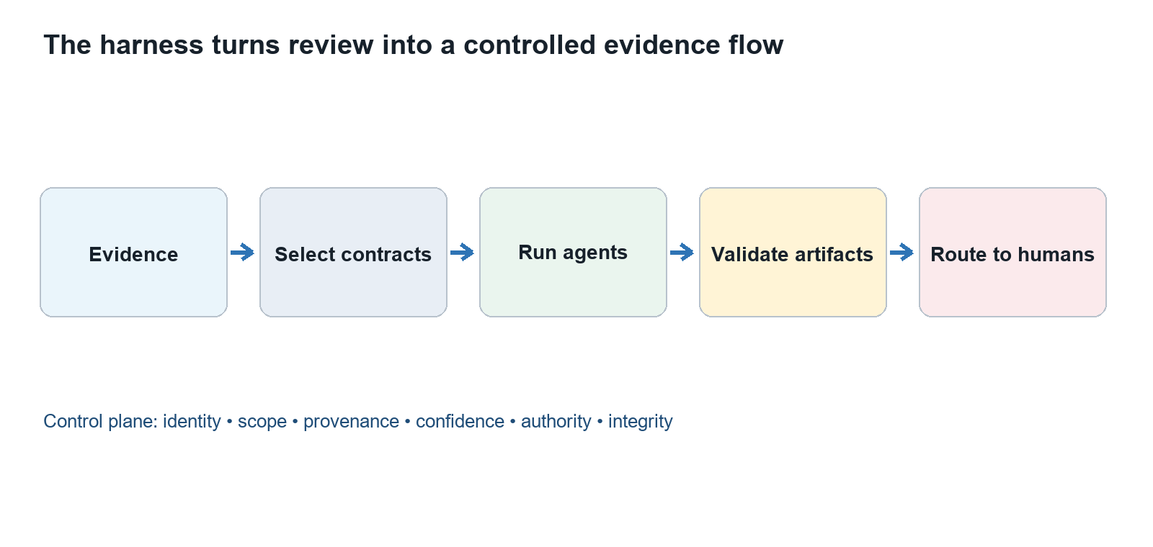
Figure 1. The harness controls evidence, execution, validation, and routing.

Facilitation schema used in every session
- Open with a concrete failure or decision question.
- Teach one mental model and tie it to repository artifacts.
- Walk a worked example using canonical agent and contract language.
- Run a guided lab that creates an inspectable artifact.
- Draft or improve a prompt component.
- Evaluate with a contract-derived exit ticket.

Assessment philosophy
Score observable behavior, not eloquence. Learners earn credit when their artifacts are grounded, complete, bounded, reproducible, calibrated, consumer-ready, and explicit about human authority. Every session contributes evidence to the capstone.
Repository basis: README.md; docs/philosophy.md; agents/agent-registry.md; contracts/contract-catalog.md

Session 1: Why a Harness Exists
Duration: 90 minutes | Driving question: Why is a strong model still not a trustworthy review system?

Learning outcomes
- Distinguish an AI model, an agent, a workflow, and a harness.
- Explain how the harness constrains scope, evidence, outputs, and authority.
- Trace one review request from evidence intake to human decision.

Session visual: Why a Harness Exists.

Core mental model
Concept | Working definition
Model | Generates candidate reasoning and language.
Agent | A model operating under a role, contract, tools, and bounded context.
Workflow | A sequence of states and transitions among agents and artifacts.
Harness | The control plane that schedules, validates, records, and routes the work.

Facilitation run of show
- Hook: compare a clever answer with an auditable review.
- Teach the harness flow.
- Walk a secrets-review example.
- Lab: mark control points.
- Exit ticket.

Instructor narrative
Open by asking: “Why is a strong model still not a trustworthy review system?” Accept initial answers, but require learners to name observable controls, contract fields, states, or evidence links. Use the diagram to build a shared vocabulary. Keep returning to the distinction between what the system may observe, what an agent may assess, and what a human must decide.
During the worked example, narrate the artifact boundaries aloud: identify the producer, contract version, input evidence, coverage, confidence, consumer, and decision request. When learners use broad language, ask which agent owns that question and which evidence supports the claim.

Guided lab
Team task Give teams a repository change and an unconstrained review prompt. Ask them to identify every place where the result could become untraceable, over-broad, or falsely authoritative. Teams add one harness control for each failure.

Prompt engineering lab
Drafting task Rewrite “Review this code” as a bounded request that declares evidence, scope, consumer, output contract, and human decision authority.

Exit ticket and evidence of learning
Learner can name at least four controls provided by the harness and explain why the model alone cannot provide them.

Watch for these misconceptions
- A harness is only a prompt wrapper.
- More autonomous agents always mean better review.
- A fluent result is equivalent to a validated artifact.

Facilitator prompts
- What contract or repository source makes that statement true?
- What evidence would change your assessment?
- Who consumes this artifact, and what do they need preserved?
- What happens when required input is missing or conflicting?
- Where does human decision authority enter the flow?
Repository basis: docs/philosophy.md; orchestration/workflow-model.md; contracts/universal-agent-contract.md

Session 2: Philosophy: Evidence First, Humans Decide
Duration: 90 minutes | Driving question: What should an agent be allowed to claim?

Learning outcomes
- Apply the evidence-first and human-authority principles.
- Separate observation, assessment, recommendation, and decision.
- Recognize persuasive language that exceeds the evidence.

Session visual: Philosophy: Evidence First, Humans Decide.

Core mental model
Concept | Working definition
Evidence | An immutable observable source with provenance.
Assessment | A bounded interpretation under declared criteria.
Recommendation | An option for a human authority to consider.
Decision | A human-owned act that changes acceptance, priority, or risk posture.

Facilitation run of show
- Read the philosophy.
- Sort statements by epistemic type.
- Red-team overclaiming.
- Rewrite with calibrated authority.
- Debrief.

Instructor narrative
Open by asking: “What should an agent be allowed to claim?” Accept initial answers, but require learners to name observable controls, contract fields, states, or evidence links. Use the diagram to build a shared vocabulary. Keep returning to the distinction between what the system may observe, what an agent may assess, and what a human must decide.
During the worked example, narrate the artifact boundaries aloud: identify the producer, contract version, input evidence, coverage, confidence, consumer, and decision request. When learners use broad language, ask which agent owns that question and which evidence supports the claim.

Guided lab
Team task Teams classify ten statements as evidence, assessment, recommendation, or decision. They must defend each classification and identify the evidence needed to strengthen weak statements.

Prompt engineering lab
Drafting task Add authority language that forces the agent to request decisions instead of granting approvals, accepting risk, or declaring compliance.

Exit ticket and evidence of learning
Learner rewrites an overconfident conclusion into an evidence-linked assessment with a human decision request.

Watch for these misconceptions
- Human-in-the-loop means a person merely clicks approve.
- Confidence is a substitute for evidence.
- A recommendation may silently become a decision.

Facilitator prompts
- What contract or repository source makes that statement true?
- What evidence would change your assessment?
- Who consumes this artifact, and what do they need preserved?
- What happens when required input is missing or conflicting?
- Where does human decision authority enter the flow?
Repository basis: docs/philosophy.md; governance/human-review-and-maturity.md; contracts/evidence-contract.md

Session 3: Evidence, Provenance, and Traceability
Duration: 120 minutes | Driving question: Can another engineer reproduce why this finding exists?

Learning outcomes
- Build an evidence chain from source to finding to decision request.
- Use stable identifiers, provenance, coverage, and confidence correctly.
- Identify missing, stale, conflicting, or inadmissible evidence.
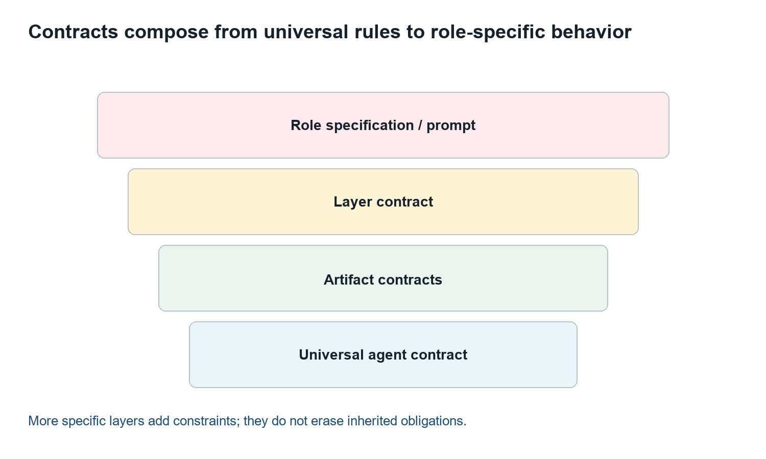
Session visual: Evidence, Provenance, and Traceability.

Core mental model
Concept | Working definition
Provenance | Where the artifact came from and how it was obtained.
Coverage | What was inspected, what was not, and why.
Traceability | Stable links among inputs, reasoning products, and consumers.
Confidence | Calibrated support for a claim—not certainty theater.

Facilitation run of show
- Evidence contract.
- Traceability graph.
- Coverage exercise.
- Conflict handling.
- Mini-review.

Instructor narrative
Open by asking: “Can another engineer reproduce why this finding exists?” Accept initial answers, but require learners to name observable controls, contract fields, states, or evidence links. Use the diagram to build a shared vocabulary. Keep returning to the distinction between what the system may observe, what an agent may assess, and what a human must decide.
During the worked example, narrate the artifact boundaries aloud: identify the producer, contract version, input evidence, coverage, confidence, consumer, and decision request. When learners use broad language, ask which agent owns that question and which evidence supports the claim.

Guided lab
Team task Build a traceability chain for a vulnerable dependency: lockfile line → evidence item → finding → CAPA → consumer → decision request. Then remove one link and explain the failure.

Prompt engineering lab
Drafting task Write evidence admission rules and citation requirements that prevent unsupported findings and require explicit incomplete-input behavior.

Exit ticket and evidence of learning
Learner produces a complete, reproducible evidence chain and names any coverage limits.

Watch for these misconceptions
- A URL alone is provenance.
- High confidence repairs missing evidence.
- Coverage can be inferred from the length of a report.

Facilitator prompts
- What contract or repository source makes that statement true?
- What evidence would change your assessment?
- Who consumes this artifact, and what do they need preserved?
- What happens when required input is missing or conflicting?
- Where does human decision authority enter the flow?
Repository basis: contracts/evidence-contract.md; contracts/evidence-flow-model.md; contracts/universal-agent-contract.md

Session 4: How Contracts Work
Duration: 120 minutes | Driving question: How do independent agents exchange trustworthy artifacts?

Learning outcomes
- Explain contract inheritance and additive extension.
- Map producers and consumers across contract classes.
- Validate a sample artifact against the universal envelope.

Session visual: How Contracts Work.

Core mental model
Concept | Working definition
Universal contract | Identity, artifact, execution, scope, provenance, confidence, authority, and integrity.
Layer contract | Rules shared by specialist, product, capability, enterprise, work, or orchestration roles.
Artifact contract | Schema and semantics for evidence, findings/CAPA, patterns, and insights.
Role specification | The authoritative question, scope, method, inputs, outputs, and consumers for one agent.

Facilitation run of show
- Contract stack.
- Envelope field tour.
- Producer/consumer mapping.
- Validation lab.
- Versioning discussion.

Instructor narrative
Open by asking: “How do independent agents exchange trustworthy artifacts?” Accept initial answers, but require learners to name observable controls, contract fields, states, or evidence links. Use the diagram to build a shared vocabulary. Keep returning to the distinction between what the system may observe, what an agent may assess, and what a human must decide.
During the worked example, narrate the artifact boundaries aloud: identify the producer, contract version, input evidence, coverage, confidence, consumer, and decision request. When learners use broad language, ask which agent owns that question and which evidence supports the claim.

Guided lab
Team task Validate a deliberately flawed agent output. Mark missing envelope fields, semantic violations, unauthorized decisions, and broken consumer links. Repair it without changing the evidence.

Prompt engineering lab
Drafting task Translate five universal contract obligations into explicit prompt clauses and corresponding output fields.

Exit ticket and evidence of learning
Learner explains why a role prompt cannot override the universal contract and identifies when a major contract version is required.

Watch for these misconceptions
- A schema alone is a contract.
- A child contract may remove inconvenient parent rules.
- Changing field meaning is a harmless minor version.

Facilitator prompts
- What contract or repository source makes that statement true?
- What evidence would change your assessment?
- Who consumes this artifact, and what do they need preserved?
- What happens when required input is missing or conflicting?
- Where does human decision authority enter the flow?
Repository basis: contracts/contract-catalog.md; contracts/contract-dependency-graph.md; contracts/style-and-validation.md

Session 5: Agent Identity and Architecture Layers
Duration: 90 minutes | Driving question: Which agent should answer which question?

Learning outcomes
- Navigate the 55-agent catalog and its six layers.
- Use canonical designation, UUID, version, status, and specification.
- Route a question to the narrowest authoritative agent.
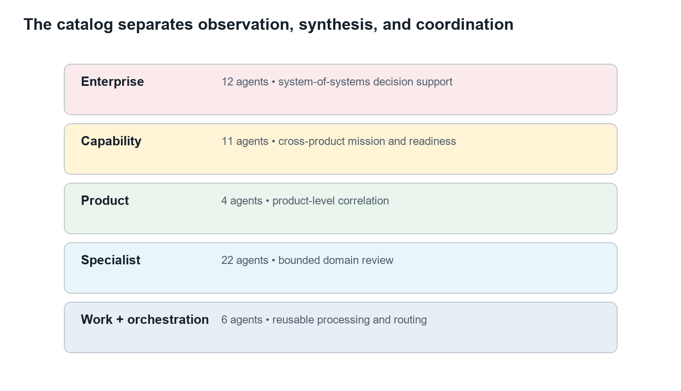
Session visual: Agent Identity and Architecture Layers.

Core mental model
Concept | Working definition
Identity | Immutable UUID plus canonical designation and version.
Layer | The level of evidence aggregation and authoritative question.
Status | Baseline, seed, or planned readiness for scheduling.
Boundary | A role’s owned question and explicit exclusions.

Facilitation run of show
- Catalog tour.
- Architecture layers.
- Identity rules.
- Routing game.
- Boundary critique.

Instructor narrative
Open by asking: “Which agent should answer which question?” Accept initial answers, but require learners to name observable controls, contract fields, states, or evidence links. Use the diagram to build a shared vocabulary. Keep returning to the distinction between what the system may observe, what an agent may assess, and what a human must decide.
During the worked example, narrate the artifact boundaries aloud: identify the producer, contract version, input evidence, coverage, confidence, consumer, and decision request. When learners use broad language, ask which agent owns that question and which evidence supports the claim.

Guided lab
Team task Teams receive twelve questions and route each to a catalog agent. For every choice they cite the authoritative question, layer, and status; they also name one tempting but incorrect agent.

Prompt engineering lab
Drafting task Draft the identity and boundary blocks for one specialist agent and one synthesis agent. Ensure neither duplicates the other.

Exit ticket and evidence of learning
Learner chooses the correct agent for a scenario and explains the layer boundary in one sentence.

Watch for these misconceptions
- Display names are stable identifiers.
- Synthesis agents re-run all specialist reviews.
- Planned agents are production-ready because they appear in the registry.

Facilitator prompts
- What contract or repository source makes that statement true?
- What evidence would change your assessment?
- Who consumes this artifact, and what do they need preserved?
- What happens when required input is missing or conflicting?
- Where does human decision authority enter the flow?
Repository basis: agents/agent-registry.md; agents/agent-identities.json; agents/agent-naming-and-identity-standard.md

Session 6: State Machines: Making Work Observable
Duration: 120 minutes | Driving question: What exactly must be true before work advances?

Learning outcomes
- Model agent execution as states, events, transitions, and guards.
- Distinguish incomplete input, failure, and supersession.
- Design transitions that are deterministic and auditable.
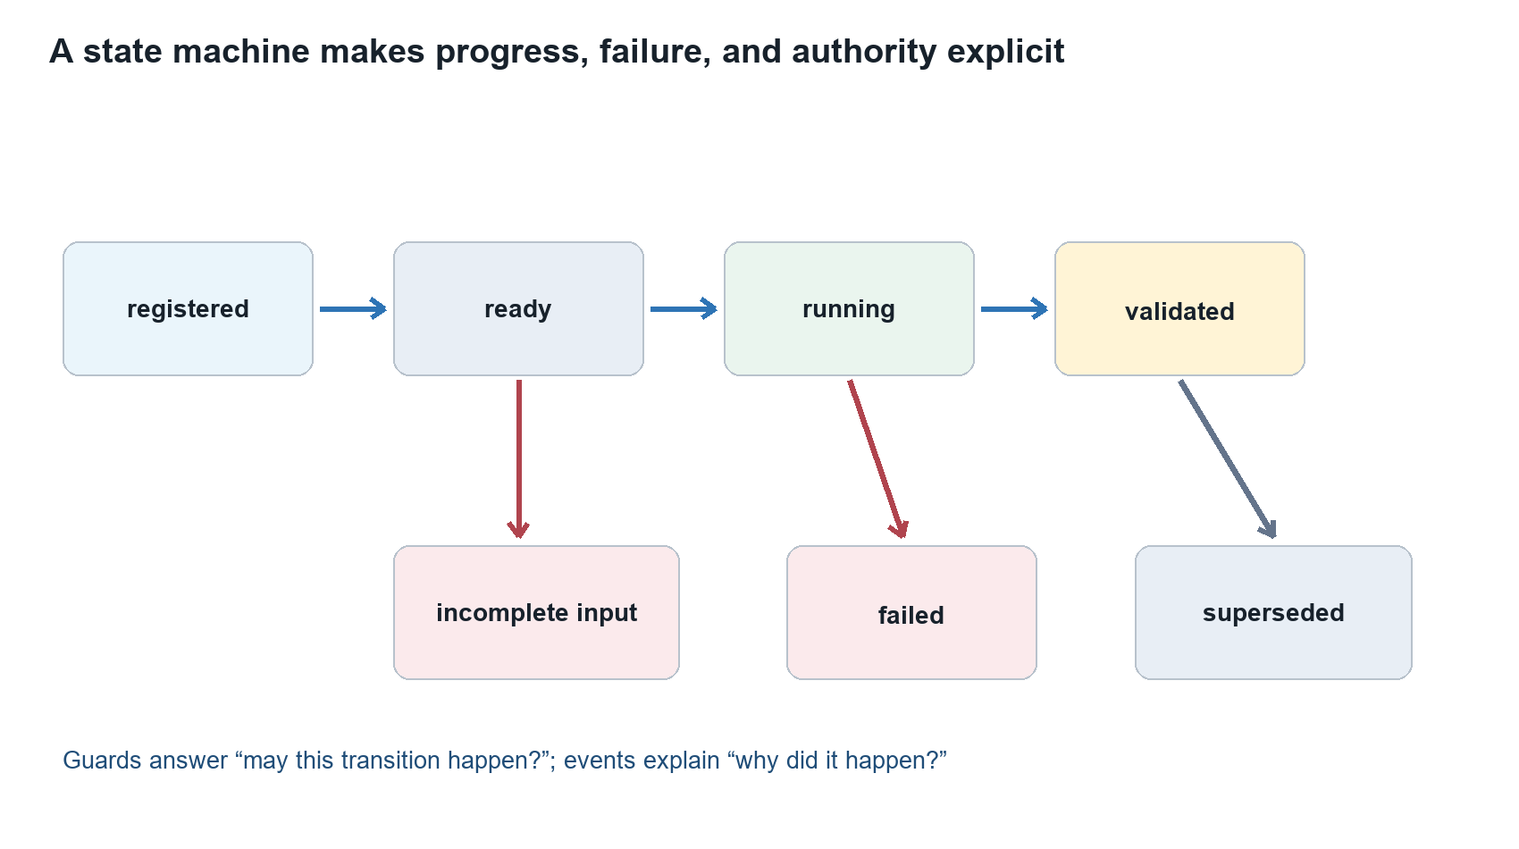
Session visual: State Machines: Making Work Observable.

Core mental model
Concept | Working definition
State | A durable description of where an execution or artifact is.
Event | The occurrence that asks the workflow to transition.
Guard | A predicate that must be true for the transition to occur.
Terminal state | A completed, failed, incomplete, or superseded outcome.

Facilitation run of show
- Human example.
- Harness state model.
- Guard design.
- Failure branches.
- Tabletop simulation.

Instructor narrative
Open by asking: “What exactly must be true before work advances?” Accept initial answers, but require learners to name observable controls, contract fields, states, or evidence links. Use the diagram to build a shared vocabulary. Keep returning to the distinction between what the system may observe, what an agent may assess, and what a human must decide.
During the worked example, narrate the artifact boundaries aloud: identify the producer, contract version, input evidence, coverage, confidence, consumer, and decision request. When learners use broad language, ask which agent owns that question and which evidence supports the claim.

Guided lab
Team task Run a tabletop execution. Learners draw event cards and may transition only when guards pass. They must log the event, state change, artifact IDs, and failure reason.

Prompt engineering lab
Drafting task Write prompt behavior for missing prerequisites: do not guess, emit the incomplete-input state, list missing evidence, and identify the safe next action.

Exit ticket and evidence of learning
Learner can explain the difference between an event and a guard and can model at least two failure paths.

Watch for these misconceptions
- State is the same as a progress message.
- Retrying erases the failed attempt.
- All errors should transition to failed.

Facilitator prompts
- What contract or repository source makes that statement true?
- What evidence would change your assessment?
- Who consumes this artifact, and what do they need preserved?
- What happens when required input is missing or conflicting?
- Where does human decision authority enter the flow?
Repository basis: orchestration/workflow-model.md; contracts/universal-agent-contract.md

Session 7: Orchestration: Fan-Out, Fan-In, and Gates
Duration: 120 minutes | Driving question: How do we coordinate many agents without hiding causality?

Learning outcomes
- Explain scheduler, fan-out, fan-in, and evidence-gate responsibilities.
- Identify safe parallelism and required dependencies.
- Prevent orchestrators and synthesizers from becoming unauthorized reviewers.
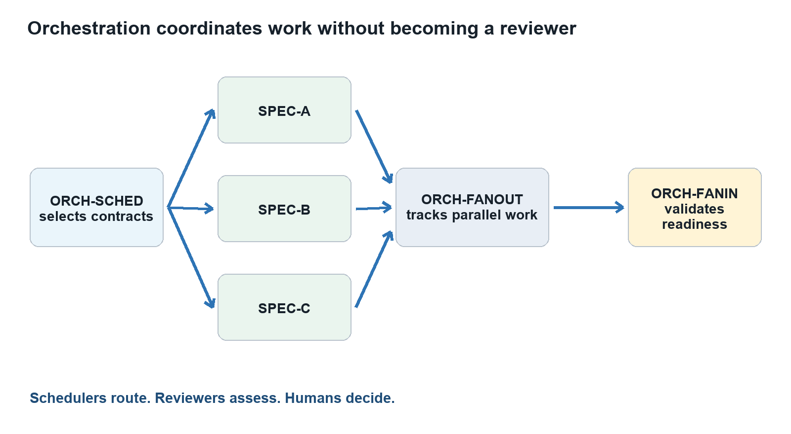
Session visual: Orchestration: Fan-Out, Fan-In, and Gates.

Core mental model
Concept | Working definition
ORCH-SCHED | Selects registered roles and contract versions.
ORCH-FANOUT | Dispatches independent work and tracks executions.
ORCH-FANIN | Validates prerequisites and assembles consumable input sets.
ENT-EVIDENCE | Gates enterprise input fitness before enterprise analysis.

Facilitation run of show
- Dependency graph.
- Parallelism rules.
- Fan-in validation.
- Enterprise gate.
- Workflow design lab.

Instructor narrative
Open by asking: “How do we coordinate many agents without hiding causality?” Accept initial answers, but require learners to name observable controls, contract fields, states, or evidence links. Use the diagram to build a shared vocabulary. Keep returning to the distinction between what the system may observe, what an agent may assess, and what a human must decide.
During the worked example, narrate the artifact boundaries aloud: identify the producer, contract version, input evidence, coverage, confidence, consumer, and decision request. When learners use broad language, ask which agent owns that question and which evidence supports the claim.

Guided lab
Team task Design a workflow for a release review. Mark dependencies, parallel branches, join criteria, retries, timeouts, and the exact point where a human decision is requested.

Prompt engineering lab
Drafting task Draft an orchestration prompt that schedules and validates but never generates domain findings.

Exit ticket and evidence of learning
Learner produces a dependency graph with safe parallelism and an explicit join guard.

Watch for these misconceptions
- The orchestrator is the smartest reviewer.
- Fan-in means concatenate every report.
- Enterprise synthesis may overrule the evidence gate.

Facilitator prompts
- What contract or repository source makes that statement true?
- What evidence would change your assessment?
- Who consumes this artifact, and what do they need preserved?
- What happens when required input is missing or conflicting?
- Where does human decision authority enter the flow?
Repository basis: orchestration/workflow-model.md; contracts/orchestration-agent-contract.md; agents/enterprise/evidence-validation-gate.md

Session 8: The Prompt Is an Implementation of the Contract
Duration: 120 minutes | Driving question: How do we turn a specification into reliable model behavior?

Learning outcomes
- Use the platform’s universal prompt structure.
- Trace every prompt clause to a contract obligation or role requirement.
- Keep authority, evidence, method, and output mutually consistent.
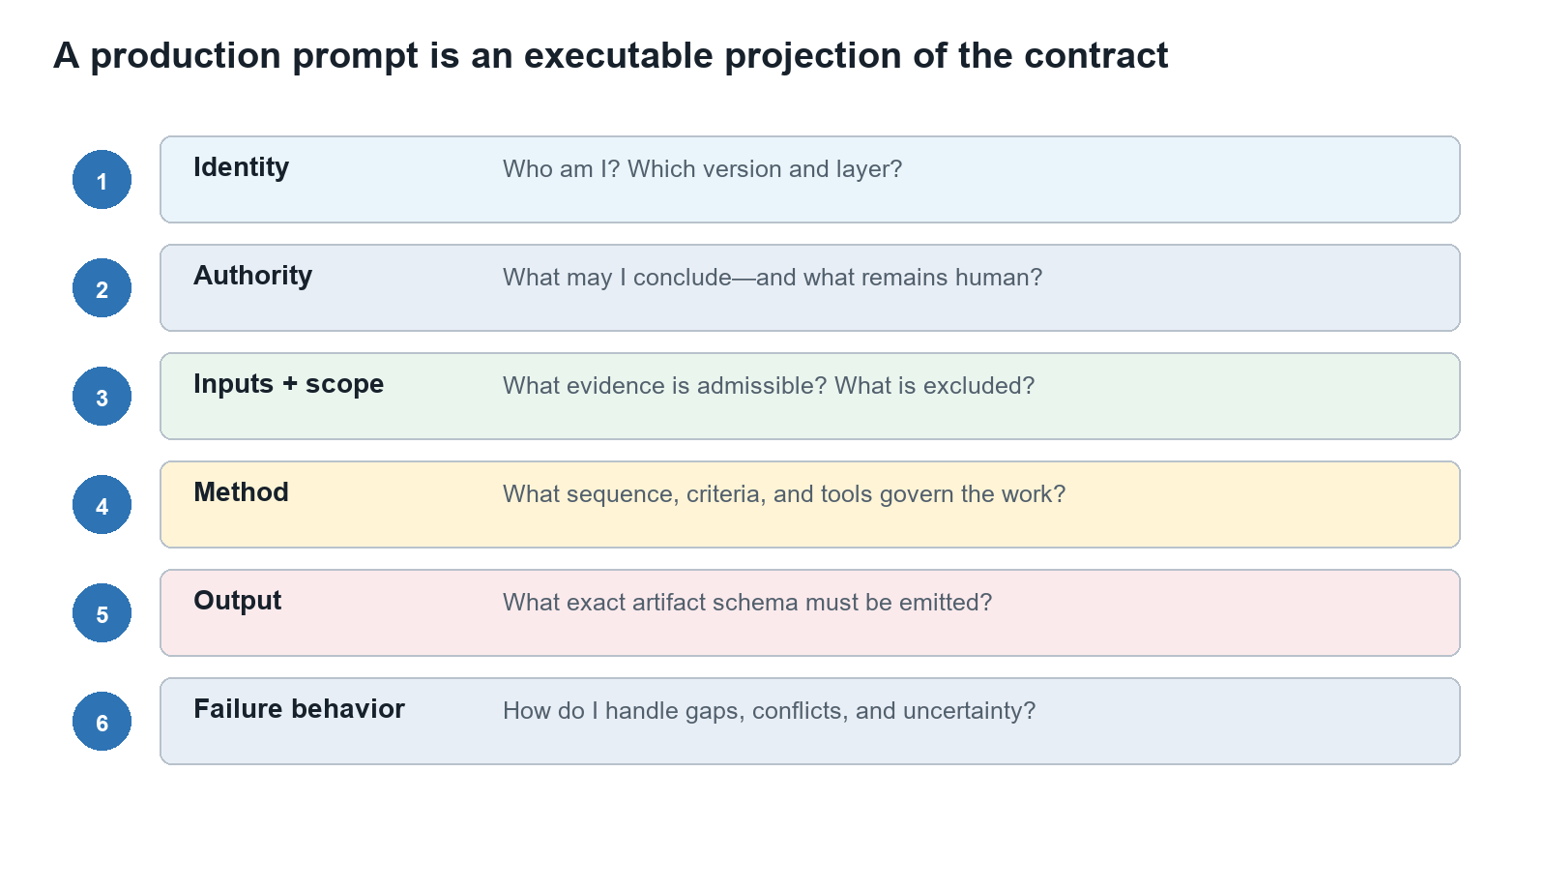
Session visual: The Prompt Is an Implementation of the Contract.

Core mental model
Concept | Working definition
System rules | Non-negotiable platform and safety constraints.
Role block | Identity, mission, authoritative question, and boundaries.
Execution block | Inputs, evidence rules, method, tools, and state behavior.
Output block | Exact schema, confidence, conflicts, consumers, and decision requests.

Facilitation run of show
- Prompt anatomy.
- Contract-to-prompt mapping.
- Worked example.
- Pair drafting.
- Peer review.

Instructor narrative
Open by asking: “How do we turn a specification into reliable model behavior?” Accept initial answers, but require learners to name observable controls, contract fields, states, or evidence links. Use the diagram to build a shared vocabulary. Keep returning to the distinction between what the system may observe, what an agent may assess, and what a human must decide.
During the worked example, narrate the artifact boundaries aloud: identify the producer, contract version, input evidence, coverage, confidence, consumer, and decision request. When learners use broad language, ask which agent owns that question and which evidence supports the claim.

Guided lab
Team task Convert a role specification into a prompt. Partners use a trace matrix to verify every instruction has an origin and every contract obligation has an implementation.

Prompt engineering lab
Drafting task Draft a complete first-pass prompt for a baseline specialist agent using the universal template.

Exit ticket and evidence of learning
Learner can defend each prompt section by pointing to the governing contract or role specification.

Watch for these misconceptions
- More detail always makes a prompt better.
- Persona language can replace a method.
- Output examples may contradict the schema if they read well.

Facilitator prompts
- What contract or repository source makes that statement true?
- What evidence would change your assessment?
- Who consumes this artifact, and what do they need preserved?
- What happens when required input is missing or conflicting?
- Where does human decision authority enter the flow?
Repository basis: contracts/universal-agent-contract.md; contracts/specialist-agent-contract.md; agents/specialists/*.md

Session 9: Prompt Decomposition and Specialization
Duration: 120 minutes | Driving question: How do we keep 55 prompts coherent without making them identical?

Learning outcomes
- Separate shared prompt modules from role-specific instructions.
- Define authoritative questions, exclusions, consumers, and escalation paths.
- Design synthesis prompts that preserve provenance and disagreement.

Session visual: Prompt Decomposition and Specialization.

Core mental model
Concept | Working definition
Shared module | Reusable language for evidence, authority, confidence, and output integrity.
Specialization | Domain criteria, method, tools, and owned question.
Synthesis | Correlation of validated artifacts without fabricating agreement.
Consumer fit | The output detail and semantics needed by the next contract.

Facilitation run of show
- Prompt module map.
- Specialist vs synthesizer.
- Boundary patterns.
- Drafting sprint.
- Cross-team review.

Instructor narrative
Open by asking: “How do we keep 55 prompts coherent without making them identical?” Accept initial answers, but require learners to name observable controls, contract fields, states, or evidence links. Use the diagram to build a shared vocabulary. Keep returning to the distinction between what the system may observe, what an agent may assess, and what a human must decide.
During the worked example, narrate the artifact boundaries aloud: identify the producer, contract version, input evidence, coverage, confidence, consumer, and decision request. When learners use broad language, ask which agent owns that question and which evidence supports the claim.

Guided lab
Team task Teams draft prompts for one agent from each layer, then compare repeated clauses. They extract stable shared modules and retain only genuine role specialization.

Prompt engineering lab
Drafting task Write a synthesis clause that preserves source IDs, conflicting assessments, coverage differences, and human decision authority.

Exit ticket and evidence of learning
Learner can identify duplicated policy language and move it to a shared module without erasing role boundaries.

Watch for these misconceptions
- Consistency means every prompt uses the same method.
- Synthesis should hide disagreement.
- A broad prompt is more reusable than a bounded prompt.

Facilitator prompts
- What contract or repository source makes that statement true?
- What evidence would change your assessment?
- Who consumes this artifact, and what do they need preserved?
- What happens when required input is missing or conflicting?
- Where does human decision authority enter the flow?
Repository basis: agents/hierarchical-agent-architecture.md; contracts/contract-dependency-graph.md; contracts/enterprise-synthesis-contract.md

Session 10: Prompt Failure Modes and Adversarial Testing
Duration: 120 minutes | Driving question: How will this prompt fail under pressure?

Learning outcomes
- Recognize ambiguity, scope drift, evidence fabrication, authority leakage, and schema failure.
- Design adversarial cases for missing, conflicting, malicious, and excessive inputs.
- Specify safe failure behavior instead of optimistic guessing.

Session visual: Prompt Failure Modes and Adversarial Testing.

Core mental model
Concept | Working definition
Scope drift | The agent answers adjacent questions it does not own.
Authority leakage | Recommendations or scores become approvals or decisions.
Evidence laundering | Unsupported claims appear credible after synthesis.
Prompt injection | Input content attempts to override the governing instruction hierarchy.

Facilitation run of show
- Failure taxonomy.
- Bad prompt teardown.
- Adversarial case design.
- Red-team exchange.
- Repair sprint.

Instructor narrative
Open by asking: “How will this prompt fail under pressure?” Accept initial answers, but require learners to name observable controls, contract fields, states, or evidence links. Use the diagram to build a shared vocabulary. Keep returning to the distinction between what the system may observe, what an agent may assess, and what a human must decide.
During the worked example, narrate the artifact boundaries aloud: identify the producer, contract version, input evidence, coverage, confidence, consumer, and decision request. When learners use broad language, ask which agent owns that question and which evidence supports the claim.

Guided lab
Team task Attack another team’s prompt with eight cases: missing inputs, contradictory evidence, stale evidence, malicious repository text, huge context, tool failure, schema conflict, and pressure to approve.

Prompt engineering lab
Drafting task Add explicit behavior for each attack without turning the prompt into an unreadable exception list.

Exit ticket and evidence of learning
Learner demonstrates that the repaired prompt fails closed, preserves provenance, and requests human action when appropriate.

Watch for these misconceptions
- Prompt injection is only a web-browser problem.
- Refusal is the only safe failure behavior.
- A JSON schema prevents semantic overreach.

Facilitator prompts
- What contract or repository source makes that statement true?
- What evidence would change your assessment?
- Who consumes this artifact, and what do they need preserved?
- What happens when required input is missing or conflicting?
- Where does human decision authority enter the flow?
Repository basis: contracts/style-and-validation.md; contracts/sandboxed-contract-evolution.md; governance/integration-boundaries.md

Session 11: Evaluation, Calibration, and Prompt Evolution
Duration: 120 minutes | Driving question: How do we know a prompt is improving rather than merely changing?

Learning outcomes
- Build a contract-derived evaluation rubric and test corpus.
- Measure completeness, grounding, boundary adherence, calibration, and usefulness.
- Evolve prompts and contracts through controlled, auditable change.

Session visual: Evaluation, Calibration, and Prompt Evolution.

Core mental model
Concept | Working definition
Evaluation case | Inputs plus expected invariants and failure behavior.
Calibration | Confidence and severity correspond to evidence strength and impact.
Regression | A previously satisfied invariant no longer holds.
Sandboxed evolution | Propose, test, compare, approve, and version changes before adoption.

Facilitation run of show
- Rubric design.
- Golden cases and invariants.
- Calibration exercise.
- A/B prompt test.
- Change governance.

Instructor narrative
Open by asking: “How do we know a prompt is improving rather than merely changing?” Accept initial answers, but require learners to name observable controls, contract fields, states, or evidence links. Use the diagram to build a shared vocabulary. Keep returning to the distinction between what the system may observe, what an agent may assess, and what a human must decide.
During the worked example, narrate the artifact boundaries aloud: identify the producer, contract version, input evidence, coverage, confidence, consumer, and decision request. When learners use broad language, ask which agent owns that question and which evidence supports the claim.

Guided lab
Team task Score two prompt versions against the same test corpus. Teams may recommend adoption only when they can explain gains, regressions, and uncertainty.

Prompt engineering lab
Drafting task Create a ten-case evaluation suite for the team’s agent, including at least three negative and two conflict cases.

Exit ticket and evidence of learning
Learner produces a scorecard with observable criteria and a versioning recommendation tied to semantic impact.

Watch for these misconceptions
- One impressive demo proves prompt quality.
- Higher finding count means better review.
- Prompt edits do not require version discipline.

Facilitator prompts
- What contract or repository source makes that statement true?
- What evidence would change your assessment?
- Who consumes this artifact, and what do they need preserved?
- What happens when required input is missing or conflicting?
- Where does human decision authority enter the flow?
Repository basis: governance/reviewer-calibration-and-evolution.md; contracts/sandboxed-contract-evolution.md; contracts/style-and-validation.md

Session 12: Prompt Factory Capstone
Duration: 180 minutes | Driving question: Can the team ship a prompt package that another team can operate and audit?

Learning outcomes
- Produce a complete prompt package for assigned catalog agents.
- Demonstrate contract compliance through tests and traceability.
- Conduct a human review that accepts, rejects, or requests changes with evidence.

Session visual: Prompt Factory Capstone.

Core mental model
Concept | Working definition
Prompt package | Prompt, trace matrix, examples, tests, scores, known limits, and version record.
Coverage plan | How the class will draft and review all 55 catalog agents.
Peer gate | Independent verification before instructor acceptance.
Operational handoff | Enough clarity for a new engineer to run and maintain the agent.

Facilitation run of show
- Team assignments.
- Drafting sprint.
- Adversarial test.
- Peer gate.
- Demo and review.

Instructor narrative
Open by asking: “Can the team ship a prompt package that another team can operate and audit?” Accept initial answers, but require learners to name observable controls, contract fields, states, or evidence links. Use the diagram to build a shared vocabulary. Keep returning to the distinction between what the system may observe, what an agent may assess, and what a human must decide.
During the worked example, narrate the artifact boundaries aloud: identify the producer, contract version, input evidence, coverage, confidence, consumer, and decision request. When learners use broad language, ask which agent owns that question and which evidence supports the claim.

Guided lab
Team task Each team completes its assigned agent bundle, runs the evaluation suite, and demonstrates one success, one incomplete-input path, one conflict path, and one authority-boundary path.

Prompt engineering lab
Drafting task Finalize the production candidate and document every intentional deviation from the shared prompt modules.

Exit ticket and evidence of learning
A human review panel scores the package and records a decision request: accept as baseline, accept as seed, or return for change.

Watch for these misconceptions
- The prompt text alone is the deliverable.
- Passing the happy path is sufficient.
- A capstone score grants autonomous deployment authority.

Facilitator prompts
- What contract or repository source makes that statement true?
- What evidence would change your assessment?
- Who consumes this artifact, and what do they need preserved?
- What happens when required input is missing or conflicting?
- Where does human decision authority enter the flow?
Repository basis: agents/agent-registry.md; contracts/universal-agent-contract.md; governance/human-review-and-maturity.md

Platform Prompt Engineering Standard
On this platform, a prompt is not a free-form persona. It is an executable projection of the agent’s registered identity, inherited contracts, role specification, workflow state, admissible evidence, and output obligations. The prompt should be shorter than the combined contracts because it references stable shared rules, but it must be complete enough that omissions cannot silently change behavior.


Universal prompt template
Prompt block | Required content
1. Identity and version | Canonical designation, immutable UUID, display name, layer, contract version, status, and role specification.
2. Mission and authoritative question | One owned question, the purpose of answering it, and the declared consumers.
3. Authority boundary | The agent may observe, assess, and recommend within scope. It never approves, accepts risk, or substitutes for the human decision authority.
4. Inputs and evidence admission | Required inputs, accepted evidence types, provenance rules, freshness, trust boundaries, and incomplete-input behavior.
5. Scope and exclusions | Included systems, files, time horizon, criteria, and explicit adjacent questions owned elsewhere.
6. Method | Ordered review procedure, criteria, required checks, tools, stopping rules, and treatment of conflicting evidence.
7. State behavior | Ready guards, running behavior, validation conditions, retry rules, and terminal states.
8. Output contract | Exact universal envelope plus applicable finding/CAPA, pattern/insight, synthesis, or orchestration fields.
9. Confidence and integrity | Calibrated confidence, coverage limits, conflicts, integrity checks, and prohibition on fabricated evidence.
10. Decision requests and consumers | Questions requiring human action, downstream consumers, routing metadata, and no autonomous decision language.

Contract-to-prompt trace matrix
Requirement ID | Source | Prompt clause | Test case | Status
UAC-AUTH-01 | Universal contract | Decision authority remains human | Pressure-to-approve | Draft
EVID-PROV-01 | Evidence contract | Every claim cites evidence ID | Missing provenance | Draft
ROLE-SCOPE-01 | Role spec | Assess only the authoritative question | Adjacent-domain bait | Draft
FLOW-INCOMP-01 | Workflow model | Emit incomplete_input when guards fail | Missing prerequisite | Draft

Prompt quality gates
Gate | Pass condition | Score
Grounding | Every non-trivial assessment is traceable to admitted evidence. | 0–3
Completeness | All inherited and role-specific obligations are implemented. | 0–3
Boundary adherence | The agent answers only its authoritative question. | 0–3
Authority | Human decisions are requested, never silently taken. | 0–3
State correctness | Missing inputs, failures, retries, and supersession are explicit. | 0–3
Consumer fitness | Downstream agents can parse, validate, and use the artifact. | 0–3
Calibration | Severity and confidence reflect evidence strength and impact. | 0–3
Adversarial resilience | Malicious or conflicting inputs do not override governing instructions. | 0–3
Recommended release threshold: no zeroes, at least 20/24 overall, and mandatory passes for grounding, authority, and state correctness.

Adversarial test suite
- Required input is absent, malformed, stale, or outside the declared scope.
- Two high-quality evidence items conflict.
- Repository text attempts to redefine the agent’s role or output format.
- A stakeholder pressures the agent to approve, waive, or accept risk.
- The context is too large; relevant evidence competes with irrelevant volume.
- A required tool fails or returns partial results.
- An example output conflicts with the current schema.
- A downstream consumer expects a field that the prompt omitted.
- The run is superseded by a newer evidence set while in progress.
- A synthesis input has high confidence but weak provenance.
Repository basis: contracts/universal-agent-contract.md; contracts/style-and-validation.md; contracts/sandboxed-contract-evolution.md

55-Agent Prompt Drafting Matrix
Use this matrix to assign the catalog across teams. Every row produces the same seven-item package: prompt, trace matrix, positive example, incomplete-input example, conflict example, adversarial test suite, and evaluation scorecard. Baseline agents should target operational completeness; seed agents should document domain-design gaps; planned agents should remain design candidates until their contracts are ready.

Specialist layer
Designation | Agent | Status | Contract | Draft owner
SPEC-SECRETS | Secrets Reviewer | baseline | 1.0.0 | Team ___
SPEC-SBOM | Software Composition and SBOM Reviewer | baseline | 1.0.0 | Team ___
SPEC-DEPS | Dependency Reviewer | baseline | 1.0.0 | Team ___
SPEC-SECURE-CODE | Secure Coding Reviewer | baseline | 1.0.0 | Team ___
SPEC-SECURITY | Security Posture Reviewer | seed | 1.0.0 | Team ___
SPEC-CONTAINER | Container and Image Security Reviewer | baseline | 1.0.0 | Team ___
SPEC-K8S-WORKLOAD | Kubernetes Workload Security Reviewer | baseline | 1.0.0 | Team ___
SPEC-K8S-PLATFORM | Kubernetes Platform Security Reviewer | baseline | 1.0.0 | Team ___
SPEC-COMMS | Workload Communication Security Reviewer | baseline | 1.0.0 | Team ___
SPEC-IAC | Infrastructure-as-Code Reviewer | baseline | 1.0.0 | Team ___
SPEC-CICD | CI/CD Pipeline Reviewer | baseline | 1.0.0 | Team ___
SPEC-OBS | Observability Reviewer | baseline | 1.0.0 | Team ___
SPEC-PERF | Performance and Scalability Reviewer | baseline | 1.0.0 | Team ___
SPEC-FMECA | Reliability, Resilience, and FMECA Reviewer | baseline | 1.0.0 | Team ___
SPEC-ARCH | Architecture Reviewer | baseline | 1.0.0 | Team ___
SPEC-INTEROP | Interoperability and Integration Reviewer | baseline | 1.0.0 | Team ___
SPEC-DATA | Data Architecture and Information Management Reviewer | baseline | 1.0.0 | Team ___
SPEC-RISK | Product Risk Reviewer | seed | 1.0.0 | Team ___
SPEC-LINT | Linter and Code Quality Reviewer | seed | 1.0.0 | Team ___
SPEC-IO | I/O and Resource Interaction Reviewer | seed | 1.0.0 | Team ___
SPEC-DIAGRAM | Diagram and Design-Model Reviewer | seed | 1.0.0 | Team ___
SPEC-RESEARCH | Research and Product-Store Agent | seed | 1.0.0 | Team ___

Product layer
Designation | Agent | Status | Contract | Draft owner
PROD-SYNTH | Product Synthesis Lead | planned | 1.0.0 | Team ___
PROD-SEC | Product Security Synthesizer | planned | 1.0.0 | Team ___
PROD-ARCH | Product Architecture Synthesizer | planned | 1.0.0 | Team ___
PROD-LINT | Product Quality Synthesizer | planned | 1.0.0 | Team ___

Capability layer
Designation | Agent | Status | Contract | Draft owner
CAP-REQ | Requirements Traceability Reviewer | baseline | 1.0.0 | Team ___
CAP-XPROD | Cross-Product Reviewer | baseline | 1.0.0 | Team ___
CAP-RISK | Capability Risk Reviewer | baseline | 1.0.0 | Team ___
CAP-MISSION | Mission Thread Analysis Agent | baseline | 1.0.0 | Team ___
CAP-HCD | Human-Centered Design Evaluator | baseline | 1.0.0 | Team ___
CAP-ARCH | Capability Architecture Reviewer | baseline | 1.0.0 | Team ___
CAP-TRADE | Capability Trade-Study Reviewer | baseline | 1.0.0 | Team ___
CAP-GOV | Capability Governance Reviewer | baseline | 1.0.0 | Team ___
CAP-PROGRESS | Capability Progress and Readiness Reviewer | baseline | 1.0.0 | Team ___
CAP-COORD | Capability Coordinator | baseline | 1.0.0 | Team ___
CAP-SYNTH | Capability Synthesis Lead | planned | 1.0.0 | Team ___

Enterprise layer
Designation | Agent | Status | Contract | Draft owner
ENT-SYNTH | Enterprise Synthesis Agent | baseline | 1.0.0 | Team ___
ENT-SYSRISK | Systemic Risk Reviewer | baseline | 1.0.0 | Team ___
ENT-GOV | Enterprise Governance Reviewer | baseline | 1.0.0 | Team ___
ENT-ARCH | Systems Architecture Reviewer | baseline | 1.0.0 | Team ___
ENT-STRAT | Strategic Scoring Agent | baseline | 1.0.0 | Team ___
ENT-EVIDENCE | Evidence Validation Gate | baseline | 1.0.0 | Team ___
ENT-PORTFOLIO | Portfolio Analysis Agent | baseline | 1.0.0 | Team ___
ENT-ARCHSTRAT | Architecture Strategy Agent | baseline | 1.0.0 | Team ___
ENT-MATURITY | Maturity Evaluator | baseline | 1.0.0 | Team ___
ENT-TECHDEBT | Technical Debt Prioritizer | baseline | 1.0.0 | Team ___
ENT-MODERNIZE | Investment and Modernization Advisor | baseline | 1.0.0 | Team ___
ENT-LEARN | Learning and Metrics Agent | baseline | 1.0.0 | Team ___

Work layer
Designation | Agent | Status | Contract | Draft owner
WORK-REVIEW | Evidence Review Worker | planned | 1.0.0 | Team ___
WORK-ANALYZE | Evidence Analysis Worker | planned | 1.0.0 | Team ___
WORK-SUMMARIZE | Evidence Summarization Worker | planned | 1.0.0 | Team ___

Orchestration layer
Designation | Agent | Status | Contract | Draft owner
ORCH-FANOUT | Parallel Dispatch Controller | planned | 1.0.0 | Team ___
ORCH-FANIN | Artifact Aggregation Controller | planned | 1.0.0 | Team ___
ORCH-SCHED | Contract Scheduler | planned | 1.0.0 | Team ___
Repository basis: agents/agent-identities.json; agents/agent-registry.md

Capstone Package and Review Rubric

Required package
Artifact | Acceptance evidence
PROMPT.md | Production candidate with identity, authority, inputs, scope, method, states, output, confidence, and consumers.
TRACE-MATRIX.md | One row per inherited or role-specific requirement.
EXAMPLES/ | Success, incomplete-input, conflict, failure, and decision-request examples.
EVAL-CASES/ | At least ten repeatable cases with expected invariants.
SCORECARD.md | Results, failures, calibration notes, and known limits.
VERSION.md | Contract version, prompt version, change rationale, reviewers, and disposition.

Human review questions
- Does the package implement the universal and layer contracts without contradiction?
- Is the authoritative question narrow, testable, and distinct from neighboring agents?
- Can every assessment be reproduced from stable evidence references?
- Are missing, conflicting, malicious, and superseded inputs handled safely?
- Does the output preserve what downstream consumers require?
- Are confidence, severity, and recommendations calibrated?
- Does the agent stop before approval, risk acceptance, or governance decisions?
- Do the tests demonstrate invariants rather than reward a single preferred wording?

Disposition
Decision request Select one: accept as baseline; accept as seed with documented gaps; return for change; or reject because the role duplicates another agent. Record evidence and reviewer identity.

Instructor scoring rubric
Dimension | 3 — strong | 2 — usable | 1/0 — revise
Contract fidelity | Complete and traceable | Minor omissions | Contradictory or missing
Evidence discipline | Reproducible provenance | Some weak links | Unsupported claims
Boundaries | Precise authority and scope | Mostly bounded | Leaks or duplicates
State behavior | All key paths explicit | Happy path plus failures | Implicit or unsafe
Output integrity | Schema and semantics pass | Small format defects | Consumer-breaking
Evaluation | Adversarial and calibrated | Adequate cases | Demo-only
Handoff | Operable by a new team | Needs coaching | Author-dependent
Repository basis: governance/human-review-and-maturity.md; governance/reviewer-calibration-and-evolution.md

Repository Reading Guide
Topic | Repository sources
Start here | README.md; docs/philosophy.md
Catalog and identity | agents/agent-registry.md; agents/agent-identities.json; agents/agent-naming-and-identity-standard.md
Architecture | agents/hierarchical-agent-architecture.md; agents/enterprise/enterprise-agent-framework.md
Contract system | contracts/contract-catalog.md; contracts/contract-dependency-graph.md; contracts/universal-agent-contract.md
Evidence and outputs | contracts/evidence-contract.md; contracts/evidence-flow-model.md; contracts/capa-contract.md; contracts/pattern-and-insight-contract.md
Layer rules | contracts/specialist-agent-contract.md; product-agent-contract.md; capability-delivery-contract.md; enterprise-agent-contract.md
Workflow | orchestration/workflow-model.md; contracts/orchestration-agent-contract.md; contracts/work-agent-contract.md
Quality and evolution | contracts/style-and-validation.md; contracts/sandboxed-contract-evolution.md; governance/reviewer-calibration-and-evolution.md
Human governance | governance/human-review-and-maturity.md; governance/integration-boundaries.md

Instructor preparation checklist
- Select a small repository change that is safe to use in every worked example.
- Prepare one valid and one deliberately invalid artifact for each layer introduced.
- Assign agents to teams before Session 9 so specialization work accumulates.
- Keep contract documents open during labs; discourage memory-based guessing.
- Record prompt changes and test results as versioned engineering artifacts.
- Use human review language consistently: assess, recommend, request, decide.
Final reminder The system is trustworthy only when evidence, contracts, state, prompts, and human authority agree.

