Draft report

Logbook
Feb 15: Revise Python
Feb 16: Revise C++
Feb 18: Install GNU Radio on Windows [failed]
Feb 19: Install Ubuntu + GNU Radio
Feb 20: Tutorial part 2: GRC
Feb 22: Tutorial part 3: Python blocks
Feb 24: Tutorial part 4: C++ blocks
Feb 27: Exploring GNU Radio blocks + examples
Mar 4 : Exploring GNU Radio blocks + examples
- Packet encoder/decoder block modulates?
- FEC blocks
Mar 2 : Exploring packetized transmission possibilities
Reading about Packet Header Generator, Packet Header Parser, Packet/Header Demux
Mar 8 : Defining requirements of packet encoder/decoder block
Checking OFDM blocks as example

Evaluation of current packet encoder/decoders
Goal: easily encode packets with a preamble and payload. The preamble will be modulated with BPSK, while the payload will be modulated with higher-order modulations, such as QPSK.

Packetizing using multiplexing
Problem: correlation in receiver is not as good. Reason? Correlate and sync block not adapted, does not support extra header fields (only preamble)

Packet encoder/decoder block
Problem: deprecated, basic functionality.
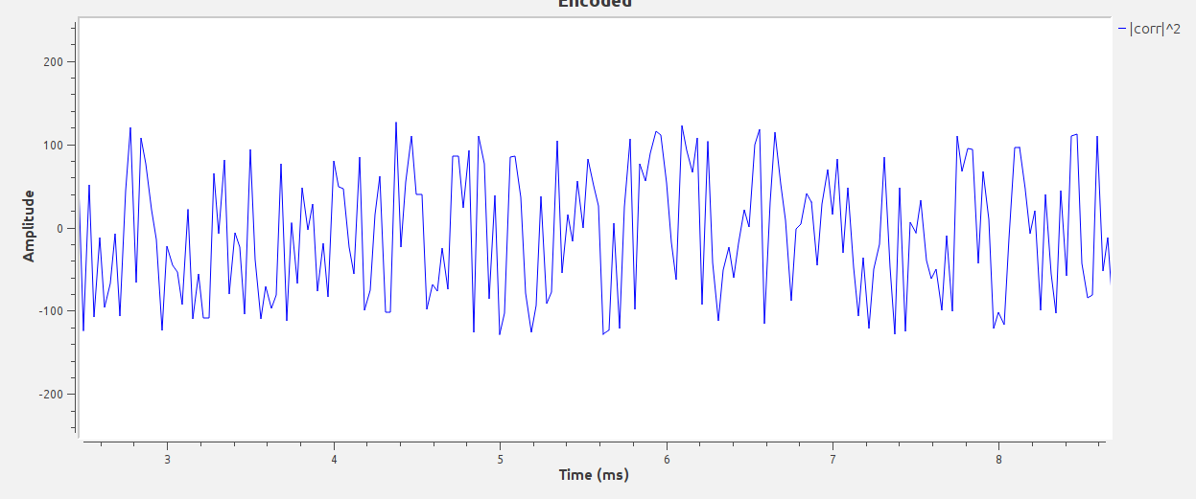

Using header/payload demux block
http://gnuradio.org/doc/doxygen/page_packet_data.html

New block requirements
- support soft constellation decoding → output floats
- get input stream (bytes) and packetize it with a predefined preamble
- support for header length field, header (with fields) and payload
→ how can header fields be generated? Tagged stream or messages
→ payload length field?
- preamble BPSK, payload QPSK or higher
→ use Grs constellation methods for defining the payload constellation points
- modulate?

- integrate with polyphase clock sync, costas loop and correlate and sync?

Block interface
ENCODER
IN:
- header data (byte) (tagged) [generated by Packet Header Generator]
- payload data (byte) (tagged)
OUT:
- modulated data (complex) (no tags)

SETTINGS:
- preamble/header constellation as constellation field
- payload constellation as “”
- preamble format
- length tag key
- sps
-

DECODER
IN:
-modulated data
OUT:
- payload data
SETTINGS:

Header formatter?

Header modulation?

