**6. Program to Sort strings.**

**Source Code:**

import java.util.Scanner;

import java.util.Arrays;

public class StringSort {

int n;

String temp;

String a[]=new String[10];

Scanner sc=new Scanner(System.in);

StringSort(int size){

n=size;

}

public void read(){

System.out.println("Enter the strings:");

for(int i=0;i<n;i++){

a[i]=sc.nextLine();

}

}

public void sort(){

for(int i=0;i<n;i++){

for(int j=i+1;j<n;j++){

if(a[i].compareTo(a[j])>0){

temp = a[i];

a[i] = a[j];

a[j] = temp;

}

}

}

System.out.println("Sorted Strings:");

for(int i=0;i<n;i++){

System.out.println(a[i]);

}

}

public static void main(String[] args) {

int n;

Scanner sc=new Scanner(System.in);

System.out.print("Name : Thomas V.G\nRollno : 58\nDate : 26/03/2024\nProgram : String sort\n");

System.out.println("Enter the no of strings :");

n=sc.nextInt();

StringSort s1=new StringSort(n);

s1.read();

s1.sort();

}

}

**Output**

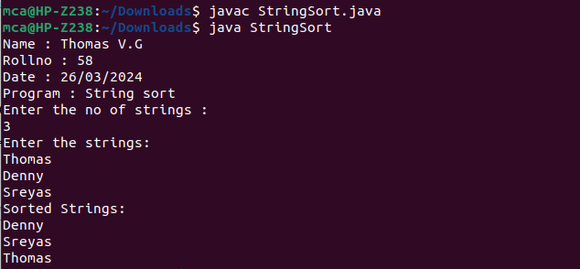

**7. Search an element in an array.**

**Source Code:**

import java.util.*;

class Array

{

public static void main(String args[])

{

Scanner sc = new Scanner(System.in);

int i,n,search,flag=0;

System.out.print("Name : Thomas V.G\nRollno : 58\nDate : 26/03/2024\nProgram : Search an element in an array\n");

System.out.println("Enter the number of elements:") ;

n = sc.nextInt();

int[] a = new int[n];

System.out.println("Enter the elements") ;

for(i=0;i<n;i++)

{

a[i] = sc.nextInt();

}

System.out.println("Enter the element to be seached");

search = sc.nextInt();

for(i=0;i<n;i++)

{

if(a[i]==search)

{

System.out.println("Element "+search+" found at "+(i+1)+" position");

flag=1;

break;

}

}

if(flag==0)

{

System.out.println("Element"+search+" not found");

} } }

**Output:**

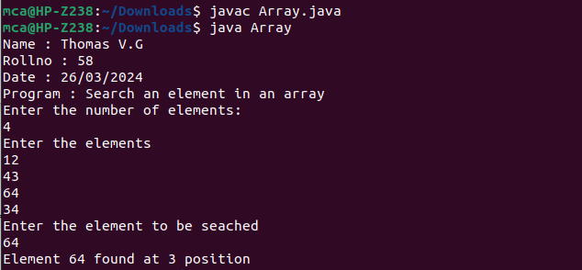

**8. Perform string manipulations**

**Source Code:**

public class StringManipulation {

public static void main(String[] args) {

System.out.print("Name : Thomas V.G\nRollno : 58\nDate : 26/03/2024\nProgram : String manipulation\n");

StringBuilder sb = new StringBuilder();

sb.append("Hello");

sb.append(" ");

sb.append("world");

System.out.println("Concatenated string : " + sb.toString());

String str1 = "Hello";

String str2 = "hello";

if(str1.equalsIgnoreCase(str2)){

System.out.println("Strings are equal");

}else {

System.out.println("String are not equal!");

}

String strWhiteSpace = " Good ";

System.out.println("Trimmed String : " + strWhiteSpace.trim());

String splitString = "hello,world";

String parts[] = splitString.split(",");

System.out.println("Split Strings:");

for (String st : parts){

System.out.println(st);

}

String stringConvert = "Hello";

System.out.println("Uppercase : " + stringConvert.toUpperCase());

System.out.println("Lowercase : " + stringConvert.toLowerCase());

String substring = "Hello World";

if (substring.contains("World")){

System.out.println("Substring exist in the string");

}else {

System.out.println("Substring not exist in the string");

}

}

}

**Output:**

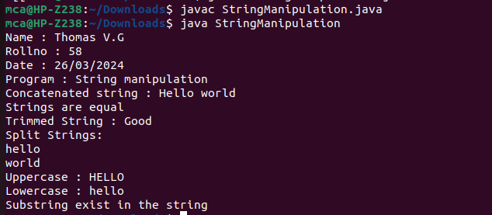

**9. Program to create a class for Employee having attributes eNo, eName eSalary. Read n**

**employ information and Search for an employee given eNo, using the concept of Array of**

**Objects.**

**Source Code:**

import java.util.Scanner;

public class Emp

{

int eno;

String ename;

double esalary ;

public void Emp(int no,String s ,double sal)

{

eno = no;

ename = s;

esalary = sal;

}

void getdata()

{

Scanner sc=new Scanner(System.in);

System.out.println("enter employee id :");

eno =sc.nextInt();

System.out.println("enter employee name : ");

ename = sc.next();

System.out.println("enter employee salary:");

esalary = sc.nextDouble();

}

void display()

{

System.out.println("employee id is : "+eno);

System.out.println("employee name is : "+ename);

System.out.println("employee salary is : "+esalary);

}

public static void main(String[] args)

{

int a,i,fl;

System.out.print("Name : Thomas V.G\nRollno : 58\nDate : 26/03/2024\nProgram : Employee Details\n");

System.out.println("enter the number of employees:");

Scanner sc1=new Scanner(System.in);

int n=sc1.nextInt();

Emp e1[]=new Emp[n];

for(i=0;i<n;i++)

{

System.out.println("Enter details of employee "+(i+1));

e1[i]=new Emp();

e1[i].getdata();

}

System.out.println("Employee details are:");

for ( i = 0; i <n; i++)

{

System.out.println("details of employee "+i+ "are:");

e1[i].display();

}

System.out.println("Enter employe id to be searched for:");

a=sc1.nextInt();

for(i=0;i<n;i++)

{

if(a==e1[i].eno)

{

fl=1;

break;

}

}

System.out.println("details of corresponding employee are:");

e1[i].display();

}

}

**Output:**

