1. Write a Shell Program to check the given number is even or odd.

#Author : Thomas V.G

echo "Enter a number:"
read num

if [ $((num % 2)) -eq 0 ]; then
echo "$num is even."
else
echo "$num is odd."
fi

Output

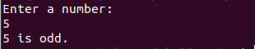

2. Write a Shell program to check a leap year.

#Author : Thomas V.G

echo "Enter a year:"
read year

if [ $((year % 4)) -eq 0 ] && [ $((year % 100)) -ne 0 ] || [ $((year % 400)) -eq 0 ]; then
echo "$year is a leap year."
else
echo "$year is not a leap year."
fi

Output
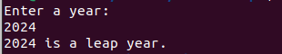

3. Write a Shell program to find the area and circumference of a circle.

#Author : Thomas V.G

echo "Enter the radius of the circle:"
read radius

area=$(echo "3.14 * $radius * $radius" | bc)
circumference=$(echo "2 * 3.14 * $radius" | bc)

echo "Area of the circle with radius $radius is: $area"
echo "Circumference of the circle with radius $radius is: $circumference"

Output

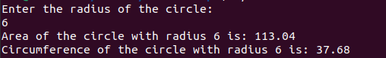

4. Write a Shell program to check the given number and its reverse are same.

#Author : Thomas V.G

echo "Enter a number:"
read number

reverse=0
temp=$number

while [ $temp -gt 0 ]
do
remainder=$((temp % 10))
reverse=$((reverse * 10 + remainder))
temp=$((temp / 10))
done

if [ $number -eq $reverse ]; then
echo "$number is same to its reverse."
else
echo "$number is not same to its reverse."
fi

Output
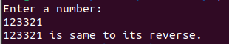

5. Write a Shell program to check the given string is palindrome or not.

#Author : Thomas V.G
echo "Enter a string:"
read string

clean_string=$(echo "$string" | tr -d '[:space:]' | tr '[:upper:]' '[:lower:]')

reverse_string=$(echo "$clean_string" | rev)

if [ "$clean_string" = "$reverse_string" ]; then
echo "$string is a palindrome."
else
echo "$string is not a palindrome."
fi

Output

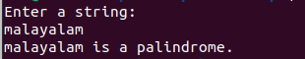

6. Write a Shell program to find the sum of odd and even numbers from a set of numbers.

#Author : Thomas V.G
echo "Enter the set of numbers separated by spaces:"
read -a numbers

sum_even=0
sum_odd=0

for num in "${numbers[@]}"
do
if [ $((num % 2)) -eq 0 ]; then
sum_even=$((sum_even + num))
else
sum_odd=$((sum_odd + num))
fi
done

echo "Sum of even numbers: $sum_even"
echo "Sum of odd numbers: $sum_odd"

Output

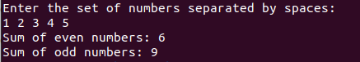

7. Write a Shell program to find the roots of a quadratic equation.

#Author : Thomas V.G
echo "Enter the coefficients of the quadratic equation (ax^2 + bx + c):"
echo "Enter coefficient a:"
read a
echo "Enter coefficient b:"
read b
echo "Enter coefficient c:"
read c

# Calculate discriminant
discriminant=$((b * b - 4 * a * c))

# Check if the discriminant is positive, negative, or zero
if [ $discriminant -gt 0 ]; then
root1=$(echo "scale=2; (-$b + sqrt($discriminant)) / (2 * $a)" | bc)
root2=$(echo "scale=2; (-$b - sqrt($discriminant)) / (2 * $a)" | bc)
echo "Roots are real and distinct."
echo "Root 1 = $root1"
echo "Root 2 = $root2"
elif [ $discriminant -eq 0 ]; then
root=$(echo "scale=2; -($b) / (2 * $a)" | bc)
echo "Roots are real and equal."
echo "Root = $root"
else
real_part=$(echo "scale=2; -($b) / (2 * $a)" | bc)
imaginary_part=$(echo "scale=2; sqrt(-$discriminant) / (2 * $a)" | bc)
echo "Roots are complex."
echo "Root 1 = $real_part + $imaginary_part i"
echo "Root 2 = $real_part - $imaginary_part i"
fi

Output

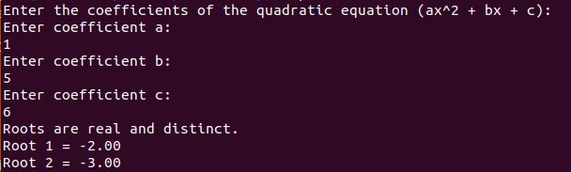

8. Write a Shell program to check the given integer is Armstrong number or not.

#Author : Thomas V.G
check_armstrong() {
num=$1
num_digits=${#num}
sum=0
temp=$num

while [ $temp -gt 0 ]
do
digit=$(( $temp % 10 ))
sum=$(( $sum + $digit ** $num_digits ))
temp=$(( $temp / 10 ))
done

if [ $sum -eq $num ]; then
echo "$num is an Armstrong number."
else
echo "$num is not an Armstrong number."
fi
}

# Main program
read -p "Enter an integer: " number

check_armstrong $number

Output

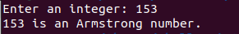

9. Write a Shell program to check the given integer is prime or not.

#Author : Thomas V.G
check_prime() {
num=$1
is_prime=1

if [ $num -eq 1 ]; then
is_prime=0
fi

for (( i=2; i*i<=$num; i++ ))
do
if [ $((num%i)) -eq 0 ]; then
is_prime=0
break
fi
done

if [ $is_prime -eq 1 ]; then
echo "$num is a prime number."
else
echo "$num is not a prime number."
fi
}

# Main program
read -p "Enter an integer: " number

check_prime $number

Output

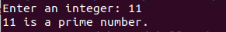

10. Write a Shell program to generate prime numbers between 1 and 50.

#Author : Thomas V.G
generate_primes() {
for (( num=2; num<=50; num++ ))
do
is_prime=1

if [ $num -eq 1 ]; then
is_prime=0
fi

for (( i=2; i*i<=$num; i++ ))
do
if [ $((num%i)) -eq 0 ]; then
is_prime=0
break
fi
done

if [ $is_prime -eq 1 ]; then
echo $num
fi
done
}

# Main program
echo "Prime numbers between 1 and 50 are:"
generate_primes

Output

