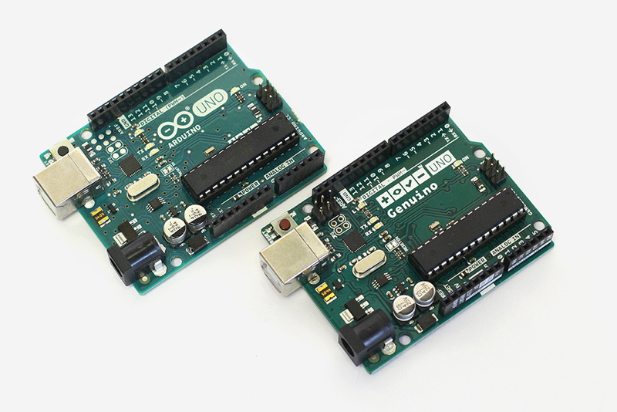

14 digital input/output

6 can be used as PWM outputs

8 erm not.

6 analog inputs

14 digital input/output

6 can be used as PWM outputs

2 needed for 2 motors, 1 for each motor

2 for the sonar?

8 erm not.

6 analog inputs