**Overview for Task 4 of the Magic Carpet Ride Task Sequence** **(Back to Top)**

Main Goal: To develop conjectures about linear dependence/independence. Secondary goals are to develop generalizations about span and about connections between span and linear (in)dependence.

By the end of the lesson students should be able to:

* Develop a travel interpretation of a non-zero scalar times the zero vector (e.g., $4\left[\begin{matrix}0 \\ 0\end{matrix}\right]$ means riding a stationary bike for 4 hours)
* Develop generalized notions of linear independence and dependence in **R*n***
  + Essential generalizations:
    - If a set contains two vectors that are scalar multiples of each other, then the set is linearly dependent.
    - If at least one vector in a set is a linear combination of the other vectors in the set, then the set is linearly dependent.
    - Any set of vectors from **R*n*** containing more than *n* vectors is linearly dependent.
    - Any set containing the zero vector is linearly dependent.

***NOTE:*** The latter three generalizations are consistent with Theorems 7-9 of Chapter 1 of Lay (2007).

* + Possible generalizations:
    - Any set of vectors from **R*n*** with fewer than *n* vectors cannot span **R*n***
    - A set of *n* vectors in **R*n*** spans **R*n*** if and only if the set is linearly independent.

***NOTE:*** These could support early notions of basis and help form a foundation for the Invertible Matrix Theorem.

* Develop an intellectual need for efficient computational strategies and sophisticated solution techniques when working with vector equations and systems of equations

The instructor should:

* Assist students in writing out their conjectures in more formal ways
* It is essential to discuss with the students why these are true, but the level of rigor with which you discuss the proofs of the conjectures depends on the level of your course.

**Task 4 of the Magic Carpet Ride Task Sequence** **(Back to Top)**

**Handout 4: Linear Independence and Dependence: Creating Examples**

An image of Handout 4 is given below. See page 45 for a printable student version of the handout.

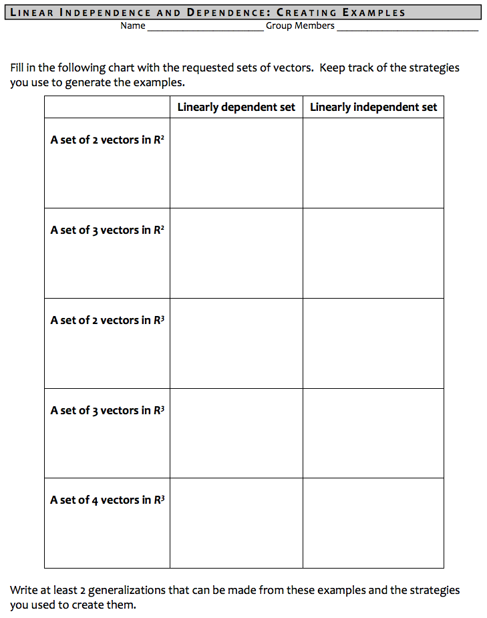

**Task 4 of the Magic Carpet Ride Task Sequence** **(Back to Top)**

**Handout 4: Linear Independence and Dependence: Creating Examples**

**Learning Goals & Rationale**

**Goals**

The main goal of Handout 4 – Linear Independence and Dependence: Creating Examples – is to guide students to develop generalizations and supporting justifications regarding linear independence and dependence for any given set of vectors, shifting away from a reliance on the Magic Carpet Ride scenario.

Although worded in terms of 2 and 3, the students’ reasoning behind the strategies should inform the development of generalizations that extend to any n as they work on and discuss Handout 4.

A secondary goal is to develop an intellectual need for efficient computational strategies and sophisticated solution techniques.

**Rationale**

Handout 4 asks students to generate sets of vectors that satisfy three varying constraints: number of vectors (2, 3, or 4), vector space (2 or 3), and linear dependence or linear independence. These were chosen to provide a wide enough variety of situations that students would have a good opportunity to develop the essential generalizations. The prompts purposefully ask for examples from 2 and 3 because students have already developed some intuition for vectors in 2 and 3 dimensions because of their work on Tasks 1-3 (and perhaps from other courses like physics).

***Classifying Types of Linearly Dependent Sets***:

To communicate more easily in this document, we developed abbreviated names for the types of generalizations we expect students to make about linearly dependent sets of vectors. We do not intend for the instructor to use these names in class discussion. It is merely for coherence and conciseness within this document that we use the following names. These classifications align with the essential generalizations described in the Overview for Task 4.

*Scalar multiple dependence*: when a set contains two or more vectors that are scalar multiples of each other (e.g., $\left\{\left[\begin{matrix}1 \\ 2\end{matrix}\right],\left[\begin{matrix}2 \\ 4\end{matrix}\right]\right\}$).

*Zero vector dependence*: when the set includes the zero vector (e.g., $\left\{\left[\begin{matrix}1 \\ 2\end{matrix}\right],\left[\begin{matrix}0 \\ 0\end{matrix}\right],\left[\begin{matrix}-5 \\ 0.4\end{matrix}\right]\right\}$).

*Linear combination dependence*: when a vector can be written as a linear combination of the other vectors in the set (e.g., $\left\{\left[\begin{matrix}1 \\ 1 \\ 1\end{matrix}\right],\left[\begin{matrix}6 \\ 3 \\ 8\end{matrix}\right],\left[\begin{matrix}4 \\ 1 \\ 6\end{matrix}\right]\right\}$).

*“Too many vectors” dependence*: When the cardinality of the set of vectors exceeds the dimension of the vector space (i.e., a set of 3 vectors in 2).

***Note:*** These classifications are not mutually exclusive.

**Task 4 of the Magic Carpet Ride Task Sequence** **(Back to Top)**

**Handout 4: Linear Independence and Dependence: Creating Examples**

**Student Thinking**

This section highlights examples of responses to Handout 4 and points out the types of linear dependence that the examples satisfy. It also points out instances in which groups used sets of vectors from previous tasks in the MCR Unit.

**Group 1**:

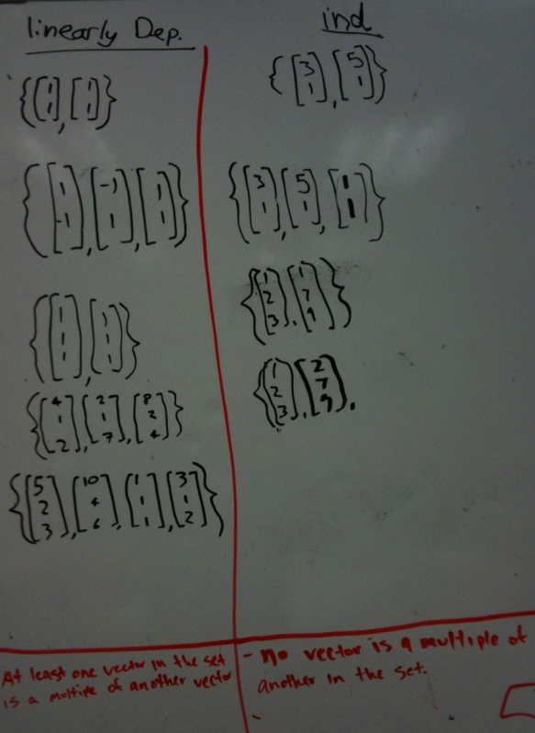*Linear Dependence*: Every row seems to satisfy scalar multiple dependence. In rows 1 and 3, however, the scalar multiple of the first vector is 1 so, set theoretically, each set only has one element and does not satisfy the constraints required by Handout 4. In row 2, the scalar is -1 and in rows 4 and 5, the scalar is 2, making these examples correct.

*Linear Independence*: Row 1contains a correct example. Row 2 contains each vector from the first row as well as the vector <1, 1>. This set satisfies “too many vectors” dependence and, so, is incorrect. Row 4 seems incomplete, since there are only two vectors written. Row 5 has been left blank. This may be because Group 1 was unable to complete the handout in time or because no such example is possible.

*Generalizations:*

Group 1 wrote, “At least one vector in the set is a multiple of another vector” under the first column and “No vector is a multiple of another in the set” under the LI column. This first statement is sufficient but not necessary for linear dependence, whereas the second statement is necessary but not sufficient for linear independence.

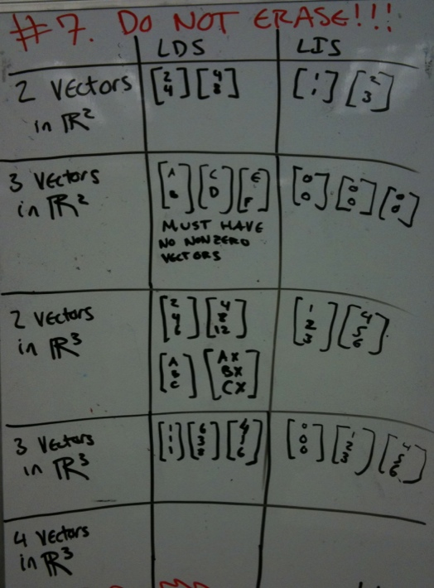

**Group 2**:

*Linear Dependence*: The sets in rows 1 and 3 satisfy scalar multiple dependence. The group wrote an algebraic formula in row 3 that generally represents scalar multiple dependence. Row 4 contains the vectors from Task 3. Row 5 is left blank. It is seems that Group 2 did not have enough time to finish because row 5 is also blank in the linear independence column.

*Linear Independence*: Rows 1 and 3 contain correct examples of linearly independent sets. Row 2 contains three copies of the zero vector. The fourth row contains the vectors from the third row and also the zero vector. The examples in rows 2 and 4 are incorrect because they satisfy zero vector dependence.

*Generalizations*: Group 2’s work in row 3 of the linearly dependent column indicates that they have developed a general formula for such a set of vectors: $\left\{\left[\begin{matrix}A \\ B \\ C\end{matrix}\right], \left[\begin{matrix}Ax \\ Bx \\ Cx\end{matrix}\right]\right\}$.

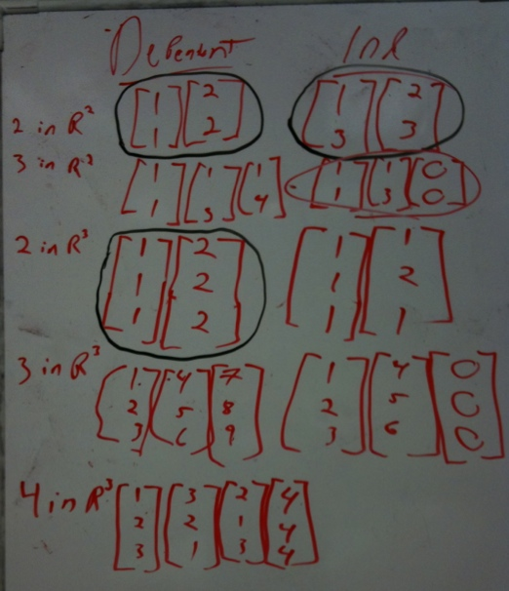**Group 3***:*

*Linear Dependence*: Rows 1 and 3 satisfy scalar multiple dependence. Row 4 contains three vectors that satisfy linear combination dependence - with components arranged as though the students counted from 1 to 9. Row 5 contains four vectors that satisfy “too many vectors” dependence. All of the sets are indeed linearly dependent.

*Linear Independence*: Rows 1 and 3 contain two vectors that are linearly independent. It is not immediately clear how the students know that these sets are in fact linearly independent. Rows 2 and 4 have the first two vectors from the corresponding sets in the LD columns, but the students have replaced each of the third vectors with the zero vector. These two sets are not linearly independent because they each contain the zero vector and, so, are incorrect responses.

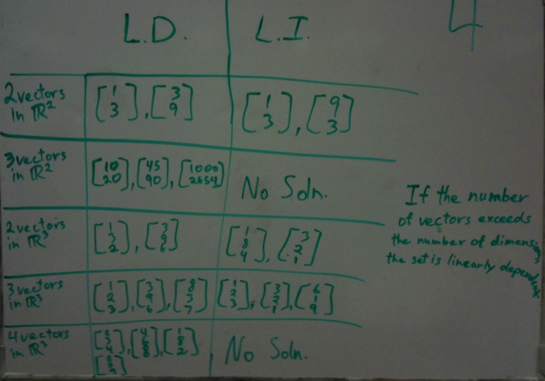

**Group 4**:

*Linear Dependence*: Every row satisfies scalar multiple linear dependence.

*Linear Independence*: Rows 1, 3, and 4 have sets of vectors with integer components, some of which correspond to the components of the vectors in the LD column. Notice that Group 4 used their general rule (below) on rows 2 and 5 as is indicated by their response, “No Soln.”

*Generalization*: Group 4 wrote, “If the number of vectors exceeds the number of dimensions, then the set is linearly dependent.”

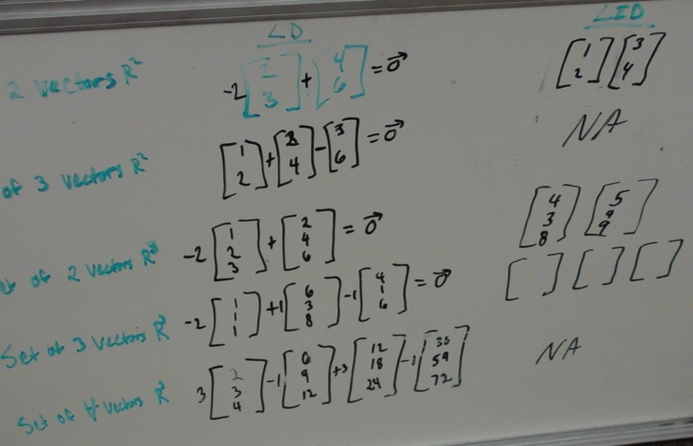**Group 5**:

*Linear Dependence*: This group presented their responses as equations with the zero vector on the right hand side (except in row 5, which is a linear combination of vectors that is equivalent to the zero vector). The sets in rows 1-3 and row 5 satisfy scalar multiple dependence. Row 4 contains the vectors from Task 3. While correct examples would have the vectors written as elements in a set, this group’s work is useful because the vector equations show how they determined the sets were linearly dependent and can be leveraged to relate students’ examples to the definitions of linear dependence and linear independence.

*Linear Independence*: In rows 1 and 3, these students wrote sets of two vectors that were not scalar multiples of each other. Row 4 contains three empty brackets, which likely indicate that the students did not have time to complete the handout. Rows 2 and 5 read NA. It is not clear whether Group 5 developed a generalization for the “too many vectors” dependence.

**Task 4 of the Magic Carpet Ride Task Sequence** **(Back to Top)**

**Handout 4: Linear Independence and Dependence: Creating Examples**

**Implementation**

**Getting Started with the Task**

Before the students begin work on Handout 4, the instructor may choose to put the formal definitions of linear independence and linear dependence on the class whiteboard or projector screen.

To get the students started on Handout 4, the instructor could remind them to make use of the formal definitions, geometric interpretations, and/or travel interpretations to assist them in creating their examples.

The instructor should ask students to try to identify several strategies for determining the linear (in)dependence of a set of vectors as they generate their examples. The reasoning behind the strategies could inform the development of generalizations as they work on and discuss Handout 4.

**Working in small groups**

As students work on Handout 4 in small groups, the instructor should look for examples from the groups that would be good to include during whole class discussion:

One thing to look for is students’ examples that illustrate various types of linear dependence:

* *Scalar multiple dependence*: when a set contains two or more vectors that are scalar multiples of each other (e.g., $\left\{\left[\begin{matrix}1 \\ 2\end{matrix}\right],\left[\begin{matrix}2 \\ 4\end{matrix}\right]\right\}$ or $\left\{\left[\begin{matrix}1 \\ 1 \\ 1\end{matrix}\right],\left[\begin{matrix}5 \\ 5 \\ 5\end{matrix}\right],\left[\begin{matrix}-4 \\ -4 \\ -4\end{matrix}\right]\right\}$).
* *Zero vector dependence*: when the set includes the zero vector (e.g., $\left\{\left[\begin{matrix}1 \\ 2\end{matrix}\right],\left[\begin{matrix}0 \\ 0\end{matrix}\right],\left[\begin{matrix}-5 \\ 0.4\end{matrix}\right]\right\}$).
* *Linear combination dependence*: when a vector can be written as a linear combination of the other vectors in the set (e.g., $\left\{\left[\begin{matrix}1 \\ 1 \\ 1\end{matrix}\right],\left[\begin{matrix}6 \\ 3 \\ 8\end{matrix}\right],\left[\begin{matrix}4 \\ 1 \\ 6\end{matrix}\right]\right\}$).
* Another thing to look for is examples from student work that contradict another group’s work. For instance, one group says that having a set of 3 vectors in 2 that is linearly independent is impossible and another group gives an example of such a set (this is the most common example of a contradictory case). This will allow the instructor to select specific students to debate their reasoning, in turn, producing a richer and more productive whole-class discussion.
* Finally, the instructor should look for student thinking that is unexpected and new to him/her.

***NOTE:*** Handout 4 tends to be more successful if students do not have the chance to consult their linear algebra textbook as they complete the handout. Without the book, the students must both (a) generate their own examples, and (b) generate their own conjectures about linear (in)dependent sets.

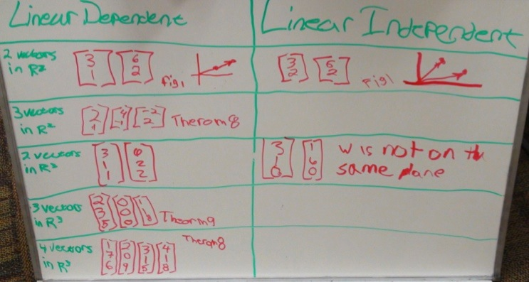

*Example:* This group consulted their textbook (Lay, 2009), as indicated by their references to Theorems 8 and 9. While the group’s work is correct, consulting the book only allowed them to practice *using* the theorems, rather than to practice *generating* theorems that are sensible to them based on their own mathematical experiences and understanding.

The instructor should keep in mind that some groups may be unsuccessful at generating some of the examples requested in Handout 4. While only two examples are impossible to generate (3 linearly independent vectors in 2 and 4 linearly independent vectors in 3), students may have difficulty generating examples in other cells where it is possible. The instructor might find it beneficial to talk with students when they have empty blanks – did they run out of time? Did they think those examples were too hard to find, or did they think there was no solution?

Finally, the instructor should encourage students to keep track of the strategies used to generate their examples. As students use these to write generalizations (that are conjectural), the instructor could encourage them to think about how they might determine if their conjectures are true (i.e., develop some sort of proof of each conjecture).

**Sharing examples during whole class discussion**

Facilitating the sharing of examples can seem daunting to an instructor because every group will (most likely) have different examples, and there are 10 cells to complete – plus generalizations – on the handout. Instructors should *not* feel as though they must have every example from every cell shared and explained in whole class discussion. Rather, the instructor has the freedom to make choices about which examples to discuss as a class and how to do so.

The following two example discussion questions can be used multiple times as the instructor leads the class in discussing Handout 4.

**Example Discussion Question:**

Look around to your classmates’ examples. Do you see any that seem like a different type of

example than what your group did for any given cell?

A question such as this encourages students to be invested in each other’s mathematics. It also helps the instructor gauge students’ understanding of the content and streamline which aspects of Handout 4 to dwell on and which lead less discussion.

**Example Discussion Question:**

Look around to your classmates’ examples. Do you see any that seem like that group used a

different strategy to generate its example than what your group did for any given cell?

Additionally, as students listen to each other explain why an example is valid, they should also begin to be able to identify instances in which they used a different approach than their peers.

Below is a summary of key points of Handout 4, organized by row:

Row

**Row 1** (2 vectors in 2):

Because they have seen examples of each, students normally generate examples in this row relatively easily.

* The most common example for LD is 2 nonzero vectors that are scalar multiples of each other (scalar multiple dependence), and the most common for LI is 2 vectors that are not scalar multiples of each other.
* The instructor should ask students to provide justifications for why these examples are valid. He/she may also encourage students to share more than one type of justification, such as:
  + *Definition:* The set $\left\{\left[\begin{matrix}5 \\ 3\end{matrix}\right],\left[\begin{matrix}10 \\ 6\end{matrix}\right]\right\}$ is linearly dependent because there exists nonzero solutions, such as *a* = 2 & *b* = -1, to the equation $a\left[\begin{matrix}5 \\ 3\end{matrix}\right]+b\left[\begin{matrix}10 \\ 6\end{matrix}\right]=\left[\begin{matrix}0 \\ 0\end{matrix}\right]$
  + *Travel:* The set $\left\{\left[\begin{matrix}5 \\ 3\end{matrix}\right],\left[\begin{matrix}10 \\ 6\end{matrix}\right]\right\}$ is linearly dependent because I can ride a mode of transportation defined by $\left[\begin{matrix}5 \\ 3\end{matrix}\right]$ in the forward direction for 2 hours and a mode of transportation defined by $\left[\begin{matrix}10 \\ 6\end{matrix}\right]$ in reverse for an hour, and return back home.
  + *Geometric:* The set $\left\{\left[\begin{matrix}5 \\ 3\end{matrix}\right],\left[\begin{matrix}10 \\ 6\end{matrix}\right]\right\}$ is linearly dependent because the vectors in the set lie on the same line.

This could set the bar for what counts as valid justifications in whole class discussion as students explain the remainder of the handout examples. It also allows students to share diverse strategies, which can lay the foundation for generalizations.

**Row 2** (3 vectors in 2):

In the linear dependence column, row 2 provides the opportunity for more variety in examples than in row 1:

* Students commonly generate examples of scalar multiple dependence or of linear combination dependence.
* It is less common for students to generate examples that contain the zero vector. If it does occur here, it can lay a nice foundation for the generalization, “Any set containing the zero vector is linearly dependent.”

In the linear independence column, row 2 confronts students with trying to create an example that is not possible.

* It is often the case, however, that students still feel as though they have successfully generated an example. The instructor should be aware of which groups have and have not generated an example so that they may have students debate their reasoning (e.g., students were asked to debate Groups 3 and 4’s examples because they could not both be correct).
* By the end of this discussion, there should at least be a conjecture out that any set in 2 of more than 2 vectors has to be linearly dependent, hopefully generated by the students’ reasoning. This lays a foundation for the broader generalization, “any set of vectors from ***n*** containing more than *n* vectors is linearly dependent.”

**Row 3** (2 vectors in 3):

This row is similar to Row 1, except that the vectors are in 3 rather than 2. Instructors may want to address that shift in dimension directly, if needed. That is, this row could be useful for allowing students to practice visualizing and reasoning with vectors in 3, especially when they generate linearly independent sets. Otherwise, this row can be skimmed over and treated more lightly than the other rows.

**Row 4** (3 vectors in 3):

Here, students may have a harder time being sure that the examples they create (or that the other groups create) are indeed linearly independent or linearly dependent. As such, many rely on using systems of equations to try to confirm that a generated set is either linearly independent or linearly dependent. The instructor could hint at how cumbersome and annoying it is to go through this process. This starts to lay the foundation for an intellectual need for solution strategies such as Gaussian elimination.

**Row 5** (4 vectors in 3):

Depending on time, this row can receive a lighter treatment.

For the linearly dependent column:

* Examples using scalar multiple or linear combination dependence are most common
* Students may suggest examples using zero vector dependence or “too many vectors” dependence, based on discussions about Row 3

For the linearly independent column:

* In light of Row 3, students should also be able to use “too many vectors” dependence to explain why no such set of vectors is linearly independent.

**Making generalizations**

The instructor should elicit student-created generalizations that are inspired by the discussion of the their examples from Rows 1-5.

* All of these generalizations should be written on the board in one place so that students may organize their results.

* There is flexibility in how to write these up on the board - organically as the class progresses through the example cells, at the end once the examples are discussed, etc. The instructor should choose what feels natural during class that day.

The degree to which students create generalizations - and their confidence in the generalizations’ validity - varies between students as well as across the specific generalizations.

The four generalizations listed below represent typical responses. They are considered to be essential generalizations (i.e., if students do not generate them, the instructor should suggest them for consideration):

1. If a set contains two vectors that are scalar multiples of each other, then the set is linearly dependent.
2. If at least one vector in a set is a linear combination of the other vectors in the set, then the set is linearly dependent.
3. Any set of vectors from **R*n*** containing more than *n* vectors is linearly dependent.
4. Any set containing the zero vector is linearly dependent.

***NOTE:*** The latter three generalizations are consistent with Theorems 7-9 of Chapter 1 of Lay (2007). As such, this task, coupled with Task 3, can replace a textbook section on linear (in)dependence.

Sometimes students’ wording of the conjectures is not of this form. For example, #1 might be written as “A set of vectors is linearly dependent if there are 2 vectors that lie on the same line,” or #3 might be written as “If the number of vectors is greater than the number of dimensions then the set is LD.” Students might also generate a specific rather than general case of a generalization. For instance, “no two vectors add to be another” can be discussed during whole class discussion to expand to #2.

It is up to the instructor to determine what will count as justifications for the various generalizations that the class offers conjecturally. What counts as a “convincing argument,” i.e., a proof, varies depending on the level of rigor expected in a given class. See p. 44 for examples of justifications given by students in whole class discussion for generalizations #3-4 mentioned above.

Finally, the instructor could also have students discuss any generalizations that they made that they now think are invalid:

**Example Discussion Question:**

After discussing each other’s examples, do you think any of the generalizations that your group

or other groups conjectured are invalid? If so, which one and why?

For instance, Group 3 in the “Student Thinking” section wrote, “No vector is a multiple of another in the set” as a generalization for linear independence. This is a necessary but not sufficient condition to guarantee linear independence.

**Developing an intellectual need for sophisticated solution techniques**

A final learning goal of Task 4 is the development of an intellectual need for an efficient computational strategies and sophisticated solution techniques. It is common for students to assume that if by inspection they cannot immediately “see” the dependence relation among a set of vectors in R*n* for $n≥3$, then the set must be linearly independent. The instructor is in the position to draw attention to this, stating that sometimes it is difficult to be certain from inspection alone whether or not a set of vectors is linearly dependent. Thus, they needed a more rigorous solution strategy.

**Example Transition Statement, given by the instructor:**

“One aspect of this Handout is that when we got to the certain part of the table, it's just hard to

check if the examples are correct. Some of you were strategic about the way you picked your

vectors, and some picked randomly. But it wasn't always easy to check whether they're linearly

independent or dependent. That will be even truer as we work with larger sets and with vectors

in R4 and higher. So our next goal is to develop an efficient computational method to check if

sets are linear independent or dependent, and if certain vectors are in the span of a given set.”

Based on this need to check rigorously and efficiently for properties of sets of vectors, the instructor can transition out of the Magic Carpet Ride instructional sequence into a section on the method of row-reduction and Gaussian elimination. Rather than simply being the next chapter or the next unit for study, Gaussian elimination can germinate from a genuine need within this classroom: a need to be certain that a set of vectors is or is not linear independent, and a need for an efficient computational strategy for solving large systems of equations.

**(Optional) Extension of Task 4: Span**

If time permits in a given classroom, an instructor may wish to have students determine the span of the given set for the examples generated in Handout 4. This provides further practice with span. It also may lay a foundation for students to make conjectures regarding span, or regarding the relationship between span and linear (in)dependence for certain types of sets of vectors.

Alternatively, this exercise could be given as part of a homework assignment.

**Task 4 of the Magic Carpet Ride Task Sequence** **(Back to Top)**

**Handout 4: Linear Independence and Dependence: Creating Examples**

**Examples of Student Justification for Various Generalizations**

**A whole class discussion about “any set containing the zero vector is linearly dependent.”**

*Instructor:* I heard the table in the back say they were confident [that $\left\{\left[\begin{matrix}1 \\ 1\end{matrix}\right],\left[\begin{matrix}1 \\ 3\end{matrix}\right],\left[\begin{matrix}0 \\ 0\end{matrix}\right]\right\}$ is linearly independent]. Can I have a volunteer from your table to come up and tell us why you're confident?

*Gabe*: Basically, this breaks out a problem of number theory. If you believe zero is a number, you go with us. That's my campaign.

*Justin*: [Raises hand] Can I rebuttal?

*Instructor*: I don't understand the original one yet. Can somebody tell me what you said there?

*Gabe*: Zero vector, if <0, 0> can be a vector, ours is correct.

*Nate*: Yeah, but at the same time, if you say <0, 0> is a vector, by the linearly dependent definition, we say that you can use it if one of them, if one constant is not equal to zero, so we set *c*1 and *c*2 as zeroes and the *c*3 is set to anything, and it's still a linearly dependent set.

*Gabe:* So the definition says that they all have to be zero.

*Justin*: And the last one can be any number you want.

*Robert*: Look, if you have a zero vector, then every, every set of vectors will be dependent.

*Justin:* Exactly!

*Robert:* If you put any coefficient in front of that <0, 0>, and it would be not all equal to zero.

*Abraham*: Including 2,564 or whatever that is up there.

...

*Robert*: If you put, if you want to say that all of them can be zero to get linear independence, then if you put any coefficient in front of that <0, 0> and say it's okay to have any coefficient in front of that, then it's not ever going to be linearly independent. Because you won't have a zero *c* in front of that zero vector.

*Justin:* Can I say that again?

*Instructor:* You can go ahead, you can say it again.

*Justin:* So what he's saying is, for it to be linearly independent, all the *c*'s must be zero, they have to be zero. So if we chose zero for the first two, that's great, fine. But for the zero vector, we can chose any number, 8,462 if we want, and it's still going to be a solution that's zero.

**Justin’s justification for “Any set of vectors from R*n* containing more than *n* vectors is linearly dependent”:**

**“**So if you start in any **R**n, and you just start with 1 vector and keep adding more. So let's do **R**3, just for an example. So we start with 1 vector. So either, we have 2 choices: The next vector we add can either be on the same line, which means it's already linearly dependent, so we don't want that, so we're going to put it off somewhere else. Now the span of that is a plane in 3 dimensions. So now we're going to add another vector in. Our 3rd vector, now it can either be in that span or out of that span. And we want it to be linearly independent, so we're going to put it out of that span. But now that we have that going off of that plane, we just extended our span to all of **R**3. So our 4th vector, when we put it in, no matter where we put it, it's going to get us back home. Because just like in this case, we have to have the last one to get back home, we can get anywhere with those 1st 3 that we put in, but we have to have to have that 4th one to come back. And so it works like that in any dimension, because the more you, if you keep adding, eventually you're going to get the span of your dimensions, and then you're going to have that extra one bringing you back. Unless you have 2 vectors that are lying on the same line, then you won't have the span of all of your dimension, but it's negligible because those 2 will give you a linearly dependent set. Does that make sense?”