**Introduction to the Italicizing N Task Sequence** **(Back to Top)**

The first learning goal of the instructional sequence is interpreting matrices as mathematical objects that transform input vectors to output vectors. Thus, a goal of this introductory whole-class discussion is to help students conceive of input-output pairs of vectors that are related through a matrix transformation.

It is appropriate to introduce students to this through a mini-lecture with a few examples. This will provide the pre-requisite information students need to engage in the Italicizing N task sequence.

Time Required: Approximately 20 minutes.

**Assumed prior knowledge**

* Linear combinations, span, and linear (in)dependence
* Methods for determining solutions to a linear system such as Gaussian elimination; existence and uniqueness of solutions
* The interpretation of *A***x** = **b** as a vector equation both algebraically and geometrically
* The interpretation of *A***x** = **b** as a system of equations both algebraically and geometrically

**Mini-lecture on transformations**

The instructor could begin by reminding the class that they have already worked with two interpretations of the equation Ax = b (vector equation & system of linear equations).

**Example Discussion Topic:**

Let’s review the interpretations of $Ax=b$ we’ve seen by considering the example $\left[\begin{matrix}5 & 2 \\ 1 & 3\end{matrix}\right]\left[\begin{matrix}1 \\ 4\end{matrix}\right]=\left[\begin{matrix}13 \\ 13\end{matrix}\right].$

 As a vector equation:

* + The solution (1, 4) is the number of the first column vector and the number of the second column vector needs to become the linear combination $\left[\begin{matrix}13 \\ 13\end{matrix}\right].$

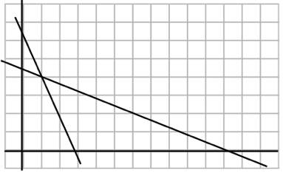As a systems of equations:

$5\left(1\right)+2\left(4\right)=13$

$$1\left(1\right)+3\left(4\right)=13$$

* The solution (1, 4) is the location in the Cartesian plane in which the equations $5x+2y=13$ and $x+3y=13$ intersect.

As a linear transformation:

* 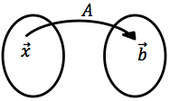One can also consider $Ax=b$ **is** as *A* transforming the vector **x** into the vector **b**. That is, we can think of *A* as “acting on **x**” to turn it into a vector **b**.
* Considering the same example $\left[\begin{matrix}5 & 2 \\ 1 & 3\end{matrix}\right]\left[\begin{matrix}1 \\ 4\end{matrix}\right]=\left[\begin{matrix}13 \\ 13\end{matrix}\right]$, the transformation defined by $A=\left[\begin{matrix}5 & 2 \\ 1 & 3\end{matrix}\right]transforms the vector \left[\begin{matrix}1 \\ 4\end{matrix}\right] into the vector \left[\begin{matrix}13 \\ 13\end{matrix}\right].$
* 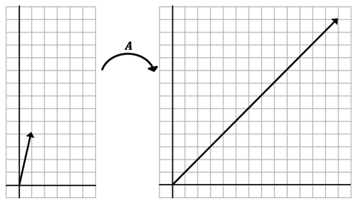Graphically:

**Definitions:**

The instructor might give the following definitions and briefly relate them to how students are familiar with them from high school and calculus (functions from R to R).

**NOTE:**

Depending on the students’ backgrounds and/or the rigor of the linear algebra course, the instructor

could choose to wait until after students have worked on Task 1 to introduce these terms,

connecting them to the work students will have done in Task 1.

* 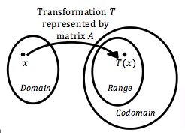A **transformation** (function) $T:R^{n}→R^{m}$ is a rule that assigns to each ${x∈R}^{n}$ a vector $T({x)∈R}^{m}$.
* The **domain** is the set of all possible input vectors $x$. Here, the domain is $R^{n}$
* The output $T\left(x\right)$ is the **image** of $x$ under the transformation *T*
* The **range** is the set of all images under the transformation *T*
* **Codomain**: The (vector) space that contains the range of the transformation *T*

**Examples (Use these if the above definitions have been given):**

**Familiar examples:**

1. $T:R→R$ given by $T\left(x\right)=x^{2}$

* $The$ domain and codomain are both $R,$ whereas the range is only $\left[0,∞\right).$

1. $T:R→R$ given by $T\left(x\right)=x+5$

* $The$ domain and codomain are both $R,$ and the range is also $R.$

**New Examples:**

1. 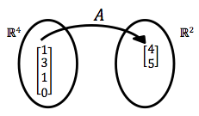Let $T:R^{4}→R^{2}$ be a transformation defined by $A=\left[\begin{matrix}1 & \begin{matrix}0 & 3 & 2\end{matrix} \\ 2 & \begin{matrix}1 & 0 & 5\end{matrix}\end{matrix}\right]$. That is, $T(x_{1},x_{2}$, $x_{3},x_{4})$ = ${(x}_{1}+3x_{3}+2x_{4}, 2x_{1}+x_{2}+5x_{4}).$ Note that *A* is transforming vectors from $R^{4}$ into vectors in $R^{2}.$ For examples, let $x=\left[\begin{matrix}1 \\ \begin{matrix}3 \\ 1 \\ 0\end{matrix}\end{matrix}\right]$. Then $Ax=\left[\begin{matrix}1 & \begin{matrix}0 & 3 & 2\end{matrix} \\ 2 & \begin{matrix}1 & 0 & 5\end{matrix}\end{matrix}\right]\left[\begin{matrix}1 \\ \begin{matrix}3 \\ 1 \\ 0\end{matrix}\end{matrix}\right]=\left[\begin{matrix}4 \\ 5\end{matrix}\right]$. A graphical interpretation is hard to do for this, but we can think of it set theoretically:
2. Let *T* be a transformation defined by *A*. Let $A=\left[\begin{matrix}1 & -2 \\ 5 & -9 \\ -3 & 6\end{matrix}\right]$, let $u=\left[\begin{matrix}2 \\ 1\end{matrix}\right]$. Find the image of $u$ under the transformation *T.*
3. If the domain for a transformation *T* is $R^{5}$ and the codomain for *T* is $R^{3}$, and *T* is defined by a matrix *A*, what would the dimensions of *A* have to be? (i.e., how many rows and how many columns does *A* have and why?)

**Examples (use the versions below if the above definitions have NOT been given at this time)**

1. Let $A=\left[\begin{matrix}1 & \begin{matrix}0 & 3 & 2\end{matrix} \\ 2 & \begin{matrix}1 & 0 & 5\end{matrix}\end{matrix}\right]$. Note that *A* transforms vectors from $R^{4}$ to vectors in $R^{2}.$ For example, let $x=\left[\begin{matrix}1 \\ \begin{matrix}3 \\ 1 \\ 0\end{matrix}\end{matrix}\right]$. Then $Ax=\left[\begin{matrix}1 & \begin{matrix}0 & 3 & 2\end{matrix} \\ 2 & \begin{matrix}1 & 0 & 5\end{matrix}\end{matrix}\right]\left[\begin{matrix}1 \\ \begin{matrix}3 \\ 1 \\ 0\end{matrix}\end{matrix}\right]=\left[\begin{matrix}4 \\ 5\end{matrix}\right]$. A graphical interpretation is hard to do for this, but we can think of it set theoretically:



1. Let $A=\left[\begin{matrix}1 & -2 \\ 5 & -9 \\ -3 & 6\end{matrix}\right]$, let $u=\left[\begin{matrix}2 \\ 1\end{matrix}\right]$. Find the image of $u$ under multiplication by *A.*
2. What is the size of a matrix that sends vectors in $R^{5}$ to vectors in $R^{3}$?