**Overview for Task 2 of the Italicizing N Task Sequence** **(Back to Top)**

Main Goal: To understand how linear transformations affect the entire space

By the end of the lesson students should be able to:

* Explain how the Italicizing N transformation affects the entire plane, not just one “N”
* Interpret matrices as objects that transform sets of input vectors to sets of output vectors in a coordinated and predictable way
* Determine the matrix for a linear transformation (from 2 to 2) for common geometric transformations such as reflection, rotation, stretching, and shearing
* Identify the geometric affect of a transformation based on the associated matrix values

The instructor should:

* Prompt students to consider how the entire domain is affected by a transformation
* Provide follow-up example transformations (from 2 to 2 or from 3 to 3)

**Overview for Task 2 of the Italicizing N Task Sequence** **(Back to Top)**

**Handout 2: Beyond the N**

An image of Handout 2 is given below. See page 49 for a printable student version of the handout.

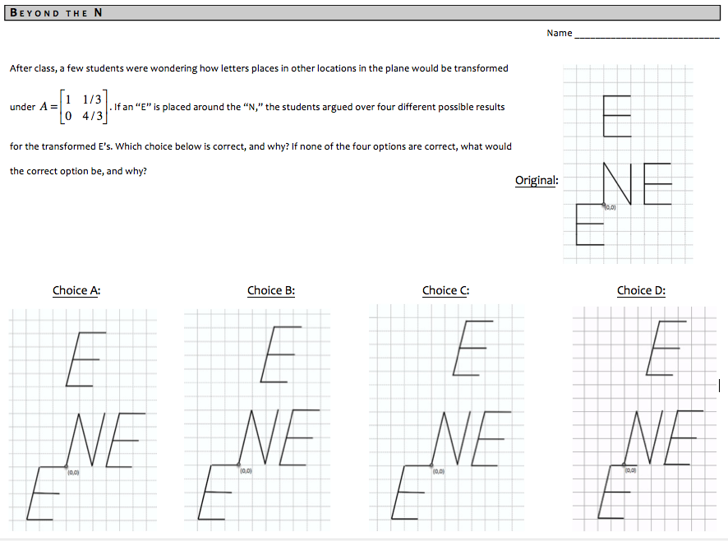

**Overview for Task 2 of the Italicizing N Task Sequence** **(Back to Top)**

**Handout 2: Beyond the N**

**Learning Goals and Rationale**

In this task and its follow-ups, emphasis here is to shift away from only considering particular input-output pairs to how transformationsaffect the entire space without needing to go through the motions of plotting particular pairs.

The “Beyond the N” task asks students to consider how the letter “E,” placed in various locations on the plane, is affected by the transformation defined by . Rather than have students graph the image of the original E’s, the students are asked to determine which image (from a choice of 4) is correct, if any.

**Rationale**

The task on Handout 2 asks students to evaluate choices because it prompts them to consider not only what the correct transformation is (choice C), but also why the other choices are incorrect. The choices lay a foundation for the class to discuss how the entire domain changes under the transformation, not just the points within the original N.

We placed an “E” above the N because the change in the vertical distance between the N and the E highlights how the entire space is transformed, even the seemingly “empty” space. This can be leveraged for conversation in class.

The follow-ups to Handout 2 include investigating geometric interpretations of the standard 2x2 matrices for rotations, reflections, stretches, and skews. This is compatible with the learning goal of coming to view matrices as objects that geometrically transform a space. Furthermore, we see these as useful to investigate because:

* Conceptualizing the geometric interpretation of elementary matrices helps students in coordinating the “undoing” of a linear transformation with the process of determining *A*-1 by row-reducing [ *A* | *I* ] to [ *I* | *A*-1 ]
* It lays the foundation for exploring other “geometric” transformations, such as stretching along lines other than the standard axis (i.e., along eigenvectors) as a way to connect to eigentheory

**Overview for Task 2 of the Italicizing N Task Sequence** **(Back to Top)**

**Handout 2: Beyond the N**

**Student Thinking**

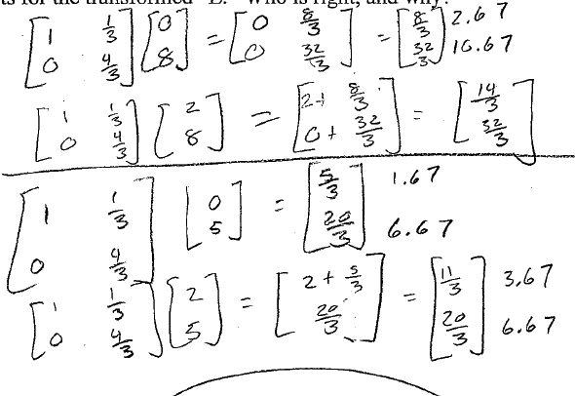**Student 1:**

Student 1 calculated the transformation of the matrix on specific vectors. Similar to students’ typical work on Task 1, this student chose vectors that corresponded to corners of the letters in the figure. After calculating the images of these vectors, the student chose answer C, which showed the image corresponding to the calculated output values.

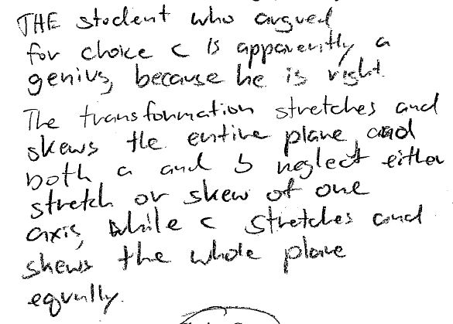

**Student 2:**

This student focused on how the matrix geometrically stretched and skewed the plane. Notice, though, that the student does not explicitly state what aspects of the matrix indicated that the plane would be stretched and skewed as Student 2 describes. After noticing that neither of the first two answer choices altered the plane according to his expectations, Student 2 selected answer C.

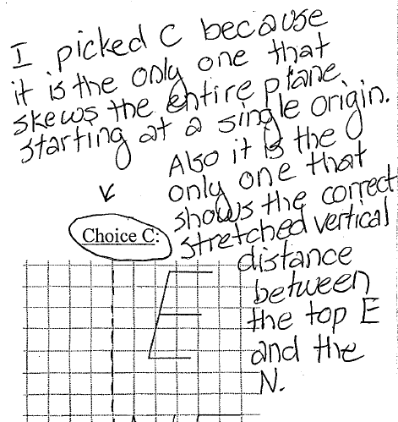

**Student 3:**

This student also focused on how the matrix skewed the plane, but elaborated by pointing out an important distinction between Answer B and Answer C. Answer C also stretches the “empty” space between the original N from Task 1 and the E above it. This is an important aspect of the geometric distortions involved in the transformation of the plane under matrix multiplication.

**Students 4, 5, and 6:**

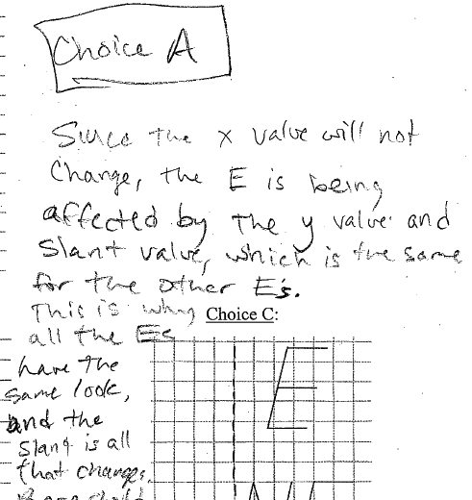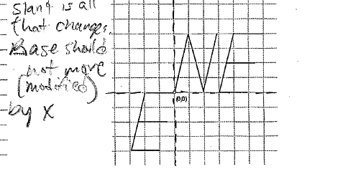

This response indicates that these students might not have attended to the horizontal change caused by the upper, right entry (1/3) of the matrix. Instead, the students generalized aspects of the matrix transformation that held true in Task 1. For instance, Student 4 (right) argued that the “base” of the letters would not move. Because of this, the student chose the answer in which the upper-most E was fixed on the y-axis. Student 5 (below, left) argued that the “letters don’t get displaced horizontally.” This indicates that the student is not thinking about the distortion that the matrix has on the “empty space” between the bottom of the upper-most E and the x-axis. Student 6 responded similarly (below, right), arguing that the letters are “anchored.”

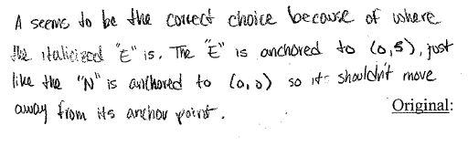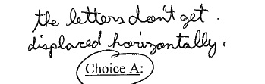

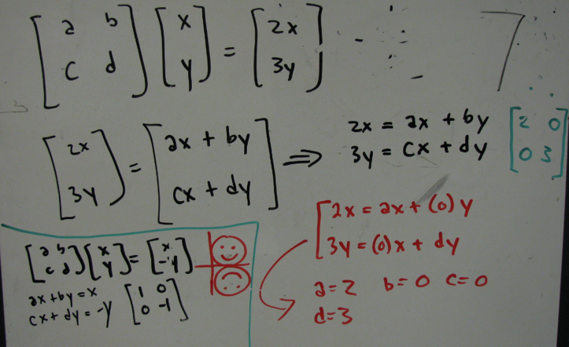**Group response to the “Smiley” Task**

This response is typical of most groups’ work. The students multiplied a matrix of unknowns times the vector <x, y> and set this product equal to the vector <2x, 3y>. From this, the students solved the system of linear equation by noticing that two of the unknowns (b and c) could be set equal to zero.

**Overview for Task 2 of the Italicizing N Task Sequence** **(Back to Top)**

**Handout 2: Beyond the N**

**Implementation**

**Getting Started with the Task**

This task is meant to be a natural follow up to the Italicizing N task in Handout 1. As such, students should be able to “jump in” with respect to understanding what Handout 2 is asking them to investigate. This does not mean that the correct answer is obvious to students, but rather that the question connects to their previous experience.

**Example “Getting Started” Prompt**:

So we just determined the matrix *A* that would perform that one *N*, which we treated as if it was

in the first quadrant.

In another class, I have some students that wonder what would happen to the letter “E” placed

in various locations under that transformation matrix.

The students can’t decide. On this handout I have 4 of different answers that students believe

represent how the “E’s” would be transformed. We need to help them decide who is right.

**Working in Small Groups**

The instructor should allow students to work on this problem in their small groups. This task should not take students too long, so 5-8 minutes in small group should be sufficient.

Choice C is the correct answer to the task on Handout 2. The difference between choice B and C is that choice B does not account for the vertical stretch of the “empty space” between the N and the E above it, whereas choice C does. Choice A incorrectly keeps the bottom of the E above the N “anchored,” and choice D incorrectly has the E in the third quadrant skew incorrectly.

**Sharing Responses in Whole Class Discussion**

This task presents a nice opportunity for students to share their ways of thinking with the whole class. As in the work by Student 4, 5, and 6 in the student thinking section, not all students realize Choice C is the correct answer.

**Choice A**

Students who choose this tend state that the transformation doesn’t have a horizontal affect. This reasoning possibly arises from a conflation with the preservation of length in the horizontal direction; that is, that if the horizontal lengths of the letters were 2 units long in the original image they are still 2 units long in the transformed image. An instructor may choose to have a student who chose Choice A justify it in class (which would most likely lead to a debate). An instructor may alternatively ask a student who did not choose A explain how he/she knew that choice A was incorrect.

**Choice D**

Choice D is not commonly chosen. It was created as a distractor because it seems to “lean” in the same manner as the N. One response that students give for why it is not correct is that (0,0) was mapped to (1,0), which they know is not possible in a linear transformation.

**Choice B**

Choice B is the most common incorrect response. Students who choose this tend to not consider how the vertical stretch in the transformation affects the “empty space” between the N and the E above it. They are, however, at least implicitly, realizing that the transformation affects the whole plane, not just the N.

**Choice C**

This is the correct choice. Students who choose this tend to reason that the whole space is affects by the transformation and notice the small difference in the placement of the upper E between choices B and C. Many students, such as Student 1 in the Student Thinking section, actually compute *A***x** for a set of **x** vectors from that E, such as (0,5) and (2,5). This helps them to see that vertical stretching of the plane increased the vertical “empty space” between the N and the E.

We recommend that the instructor have students share their reasoning and lead the class in coming to a consensus that Choice C is correct. We also recommend a mini-lecture in which the instructor “tells” the students that, consistent with what this task was demonstrating, linear transformations affect the entire domain in a consistent and predictable manner.

**Exploring additional linear transformations**

We recommend that instructors allow the students to explore additional linear transformations beyond the one highlighted in the Italicizing N tasks. We recommend some coverage of the standard linear transformations from R2 to R2: rotations, horizontal and vertical stretches and dilations, and skews. Some may be addressed in class, whereas others may be relegated to homework.

One task that can assist in transitioning to considering other transformations is the “Smiley Face” task. An editable version of this is found at the end of the student pages section.

**The “Smiley Face” Transformation**:

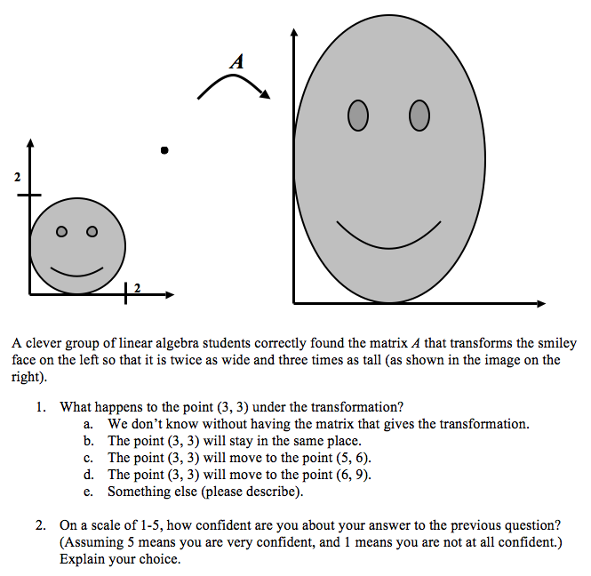

The Smiley Face problem provides students with an image in which the input / output vectors may be harder to determine (for instance, (2,0) is not on the smiley face). The question itself asks students to determine what happens to the point (3,3), which is not on the smiley face. Most students can answer correctly (choice *D*) without problem.

A nice follow-up is to ask students to determine the matrix that represents this transformation of stretching by 2 horizontally and by 3 vertically:

**Example follow-up question to the “Smiley Face” Transformation**:

The problem states that a group of students found the matrix *A* that transforms the smiley

face into one twice as wide and three times as tall. We’ve discussed how this matrix would

have that same effect on the entire plane. **What is that matrix *A*?**

This question is beneficial because it gives students additional practice in determining a matrix based on how input-output pairs are coordinated.

* Some students pick specific input-output pairs to determine , such as and , correctly yielding .
* Other students use a generic vector and reason that because the transformation stretches things twice as wide and three times as tall, every vector is transformed to . The only matrix that makes the equation for every *x* and *y* value is (see the student thinking page).

**Exploring Transformation Matrices for Common Geometric Transformations**

The Smiley Face problem can serve as a transition into considering transformation matrices for common geometric transformations, namely (a) Horizontal Stretch / Dilation, (b) Vertical Stretch / Dilation (c) Skew, (d) Rotation, and (e) Reflection. The instructor could lead a discussion in which the class explores why a matrix of the form corresponds to a horizontal stretch transformation for *k* > 1, and corresponds to a vertical stretch transformation for k > 1.

We see three main ways for instructors to pursue exploring these with their students. Instructors should make their decision based on their own learning goals, technological resources, and amount of time to dedicate during class. As such, much of these could be relegated to homework if so desired. Some examples of past homework problems are given in the next section.

* Instructors could verbally describe transformations and ask students to determine the matrix that represents that transformation.
* Instructors could provide a matrix and ask students to describe in words how the space would be transformed graphically.
* Instructors could point students towards applets that aid them in exploring how the various entries in the matrix affect the transformation graphically.

We conclude with examples of each of these three avenues for exploration.

**Example questions for: Find the matrix for the given transformation**

1. Find a matrix for the transformation that reflects all vectors in R2 over *y*-axis
2. Find a matrix for the transformation that rotates all vectors in R2 by degrees counterclockwise.

**Example questions for: Describe the transformation for the given matrix**

1. Describe the geometric affect of the transformation defined by .
2. Describe the geometric affect of the transformation defined by .

**Example applets for: Graphical Explorations with Technology**

We recommend instructors make use of the *free* *Wolfram Demonstrations Project* to aid in

exploring transformations graphically*.*

This website contains thousands of free demonstrations:[**http://demonstrations.wolfram.com/**](http://demonstrations.wolfram.com/).

Users can explore the demonstrations in a limited way on the website but will have more

freedom from the downloaded version (that needs an installed player, which can be

downloaded for free at: [**http://www.wolfram.com/products/player/**](http://www.wolfram.com/products/player/)

The demonstrations we have chosen as useful are below. Of course, there may be others that instructors find useful or interesting instead.

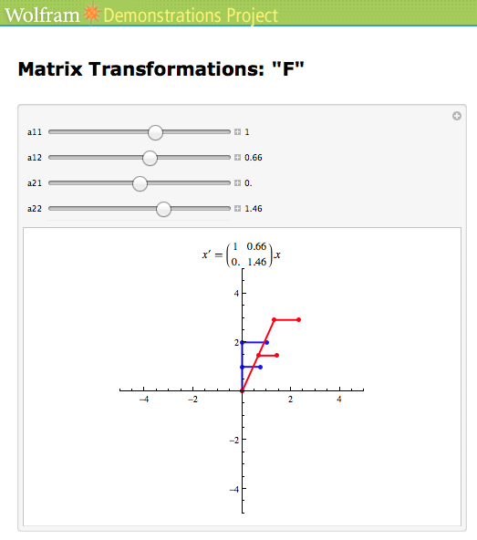

<http://demonstrations.wolfram.com/MatrixTransformationsF/>

This demonstration keeps an original letter “F” in blue fixed and allows the user to change the values in the transformation matrix via 4 sliders. The resulting transformed “F” is graphed in red.

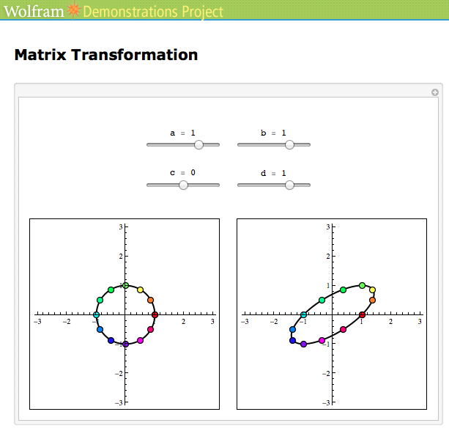

<http://demonstrations.wolfram.com/MatrixTransformation/>

This demonstration is similar to the one above except that the original “circle” is in all four quadrants, rather than only quadrant one. Manipulating and exploring this figure and its graphical image may provide further insight that the “F” demonstration does not facilitate.

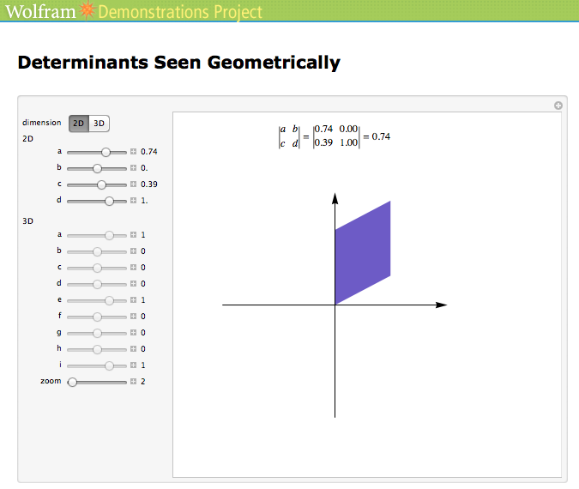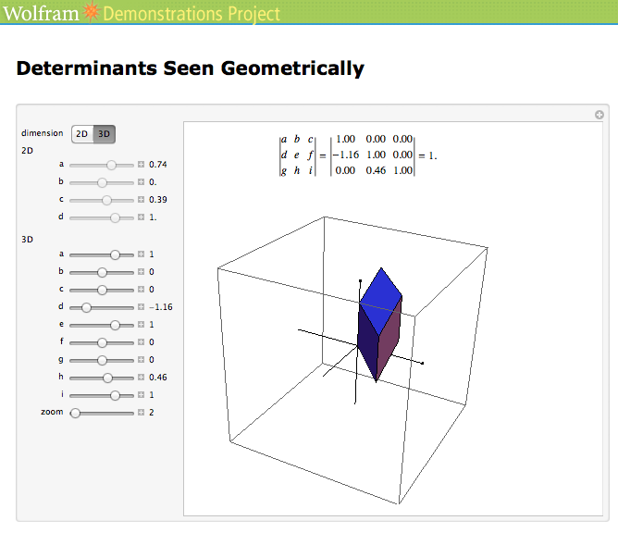

<http://demonstrations.wolfram.com/DeterminantsSeenGeometrically/>

This demonstration is labeled as being about determinants. It also, however, allows a user to see how the unit square and the unit cube are transformed when the entries of the transformation matrix (according to the standard basis) are changed. We particularly like that this allows for exploration in 3 dimensions.

**Overview for Task 2 of the Italicizing N Task Sequence** **(Back to Top)**

**Handout 2: Beyond the N**

**Suggestions for homework**

Below are problems we have used in the past for homework. Instructors should feel free to use any subset of these that they feel would be beneficial to their students.

***NOTE:*** #1-7 could be given after Task 1 or after Task 2.

1. Let and define by *T*(**x**) = *A***x**. Find the images under *T* of , and the vector (**u** + **v**). Also sketch the three vectors before and after the transformation. Write 1-2 sentences that explain how you found your answers/knew they were right and why the sketch makes sense.
2. Let and define by *T*(**x**) = *A***x**.
   1. Find the image under *T* of
   2. Find a vector **x** whose image under *T* is . Explain why your work makes sense.
3. [If not done in class] Suppose that a transformation is defined by the matrix . In order to do this, you must show that the definition of linear transformation is satisfied with this matrix *A*. To help you get started, let and , and *c* be a real number. You need to algebraically show both that and .
4. Show that the transformation *T* defined by is not a linear transformation.
5. TRUE OR FALSE: (Assume that the product *AB* is defined). If the columns of *B* are linearly dependent, then so are the columns of *AB*. If TRUE, provide a justification. If FALSE, provide a counterexample.
6. 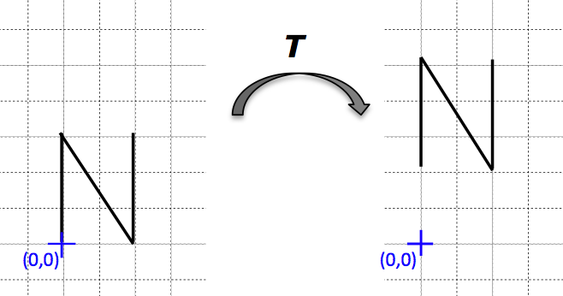After class, two linear algebra students start talking about linear transformations and the letter “N.” One of the students suggested translation (shifting up) as another linear transformation that could be done to the letter “N,” like the following:

The other student disagreed, stating that shifting the “N” up like this is NOT an example of a linear transformation. Which student is right? Why?

1. 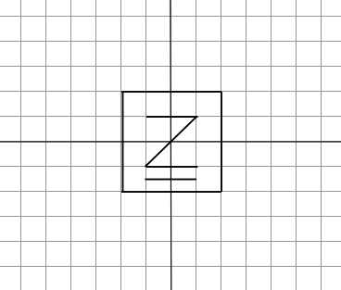Consider the image given below and the transformation matrix

***C***

1. Sketch what will happen to the image under the transformation.
2. Describe in words what will happen to the image under the transformation.
3. Describe how you determined that happened. (What, if any, calculations did you do? Did you make a prediction? How did you know you were right? etc.)

1. Assume that *T* is a linear transformation and that and . For each part, find the standard matrix *A* for *T*, and draw the image of the “half-shaded unit square” (shown below) under the given transformation.
   1. rotates points (about the origin) through –π/4 radians (clockwise)
   2. is a vertical shear that maps **e1** into **e1** – **e**2 but leaves the vector **e**2 unchanged
   3. 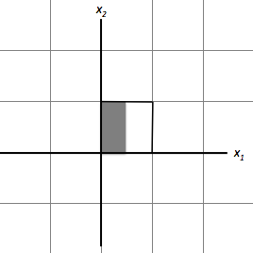 first reflects points across the vertical axis and then rotates points π/2 radians (counterclockwise)

*A*

?