COURSE PROJECT

Product Analytics and Iteration

Instructions
For this project, you will analyze data about your product to measure progress and inform your product roadmap. After you launch a product you want to answer the questions “How are people using it?” and “What should we change, given what we have learned?” In this project, you will have a chance to practice the key skills of analyzing what is happening within your product and developing a compelling plan for what to do next.
In Part One, you create a dashboard that lists the metrics you plan to measure.
In Part Two, you analyze results and generate hypotheses about why they occurred.
In Part Three, you articulate what you have learned to your team and stakeholders and recommend a path forward.
Except as indicated, use this document to record all your project work and responses to any questions. At a minimum you will need to turn in a digital copy of this document to your instructor as part of your project completion. You may also have additional supporting documents that you will need to submit. Your instructor will provide feedback to help you work through your findings.
Note: Though your work will only be seen by those grading the course and will not be used or shared outside the course, you should take care to obscure any information you feel might be of a sensitive or confidential nature.
Complete each project part as you progress through the course. Wait to submit the project until all parts are complete. Begin your course project by completing Part One below. A submit button can be found on both Course Project assignment pages. Information about the grading rubric is available on any of the course project assignment pages online. Do not hesitate to contact your instructor if you have any questions about the project.

Part One
Measure Progress
In this part of the course project, you will design a dashboard for defining and tracking metrics for your product. After writing objectives and key results and getting feedback on your prototype, you should have a strong sense for how to measure success. Now it is time to define your key metrics with further precision and present a succinct dashboard for monitoring results.

Instructions:
- Use the project scenario you have been using from earlier modules.
  - Virtual assistant
  - OR your own product idea

- List the key metrics you want to measure. You don’t need to list every single Key Result; focus on the most important ones you want to constantly track (aim for 5-10 metrics).
- For each metric, in the notes section, write comments about the following, where applicable.
- Calculation
  - Are clarifications required about how the metric is calculated?
  - Examples:
    - For Monthly Active Users, is it last calendar month, last 31 days, last 30 days? Do you include users who visit but don’t log in?
    - For % of users who upgrade, what if 10% of users upgrade to your premium (paid) offering but half of them cancel before their credit card is charged? Is % of users who upgrade 10% or 5%? It is not important which way you go, but it is important that you define your metrics precisely so you can have productive conversations with your team.
- Strengths
  - What is good about this metric?
- Weaknesses
  - How could this metric lead you astray if you are not careful?

Dashboard:
Metric | Notes
Example: Monthly Active Users | Calculation: Total unique, logged in users who accessed the app at least once in the past 30 days.  Strengths: Easy to measure. Simple to understand. Relatively strong proxy for user growth.  Weaknesses: Doesn’t capture whether or not users are happy. Will need to accompany it with engagement metrics.
Answer… | Answer…
Answer… | Answer…

Part Two
Validate Hypotheses
In the second part of the course project, you will practice validating product hypotheses based on data and results. By validating a hypothesis, we do not mean trying to prove that your idea was right. We mean objectively assessing whether or not the initial hypothesis was true, with the intention of adjusting your hypotheses until they prove true. Trying to make your ideas look good, vs. seeking the truth, will lead to slower progress, weaker products, and a significantly higher chance of failure. So we will practice ruthless intellectual honesty, which maximizes your chances of winning in the market.
For this exercise, we are focusing on the virtual assistant example only and have described a specific scenario. Read through the scenario carefully, then answer the questions that follow.

Scenario:
You built a Minimum Viable Product for a virtual assistant, which helps working professionals better manage their calendar by providing recommendations about work, social, and family activities. You launched it and your user base is growing. After seeing initial results, you developed a few hypotheses and prioritized features on the roadmap accordingly.

Below is a summary of your 3 key hypotheses, the actions you took based on your hypotheses, and the results.

- Context: 1% of users who visit your website were signing up for an account.
- Hypothesis: While this is in line with many benchmarks, you felt that the value prop was not clear enough and by making adjustments to the website you could increase the number of website visitors who register for an account.
- Action: You made a series of changes to the website.
- Results: Website visitors who register for an account changed from 1% to 2%.

- Context: 40% of account registrations were for paid accounts, 60% were for free accounts.
- Hypothesis: You believed you could increase the % of registrations for paid accounts by accepting Apple Pay so that Apple users wouldn’t have to enter credit card information.
- Action: You implemented Apple Pay as an option.
- Results: Paid registrations dropped from 40% of registrations to 20%.

- Context: For people who registered for a free account, 10% of them upgraded to a paid account within the first 30 days.
- Hypothesis: You believed that highlighting a few premium features in the free version would entice upgrades.
- Action: You changed the free version to highlight features from the premium (paid) version.
- Results: Users who upgrade from free accounts to paid accounts within the first 30 days stayed flat at 10%.

You made all three of these changes simultaneously. These results can also be visualized below. Let’s assume all other metrics remained unchanged.

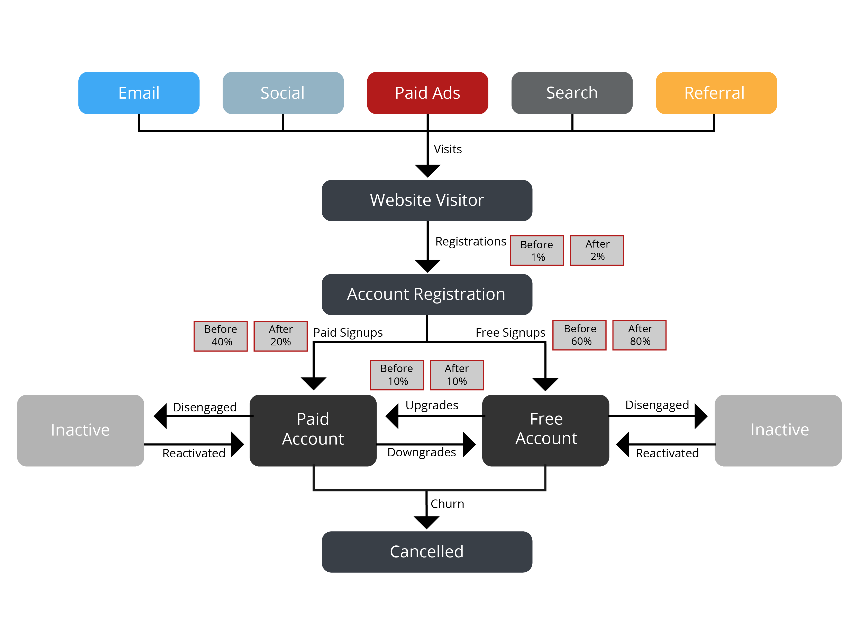

Please answer the following questions:
- For each of the 3 hypotheses, assess if the hypothesis was accurate or not. If you believe that more information is needed to assess the hypothesis, please explain.
Enter response:
Hypothesis 1
Hypothesis 2
Hypothesis 3

- For each of the 3 hypotheses, describe potential reasons for why they were accurate or not.
Enter response:
Hypothesis 1
Hypothesis 2
Hypothesis 3

Part Three
Present a Path Forward
Analyses are only useful if you use them to change your behavior and improve results. So it’s time to practice another critical product management skill and recommend changes to the roadmap based on what you learned.
Continue with the virtual assistant product scenario laid out in part two of this project. Your ultimate goal is to increase the % of website visitors who become paid users within 30 days.
Given your goal and the results of your previous product changes (from part two), determine how you would change your product tactics by responding to the following questions.

- You improved the website.
- What should you do now?
  - Continue making changes to the website
  - Revert the changes back
  - Keep the changes and move on
- Why?

- You added Apple Pay. However, you don’t have enough data to know if the feature was impactful. You doubled the website visitors who register for an account (from 1% to 2%) but you do not know (yet) which users have Apple devices. That means you can’t measure if users with Apple devices (the only ones impacted by Apple Pay) are more likely, less likely, or just as likely to upgrade as they were before.
- What should you do now?
  - Continue adding other payment features
  - Remove Apple Pay
  - Keep the features and move on
  - Gather more data (if so, what data and what would you like to do with it?)
- Why?

- You gave free users a preview of premium features.
- What should you do now?
  - Continue improving the feature previews
  - Revert the changes
  - Keep the changes and move on
  - Something else (please explain
- Why?

- What other recommendations do you have for product investments that could increase the number of paid users?

Enter response:
Response

To submit this assignment, please refer to the instructions in the course.

