Thomas Graham  UX Researcher · Research Ops · Product Thinker  UX Researcher with 20+ years spanning research, product design, and delivery across web, SaaS, and large-scale digital platforms. I plan and execute end-to-end mixed-methods research, from early discovery through usability testing, and translate evidence into decision-ready recommendations for product, design, and leadership. | thomas_graham@me.com  (407) 325-9466  thomas-graham.me | 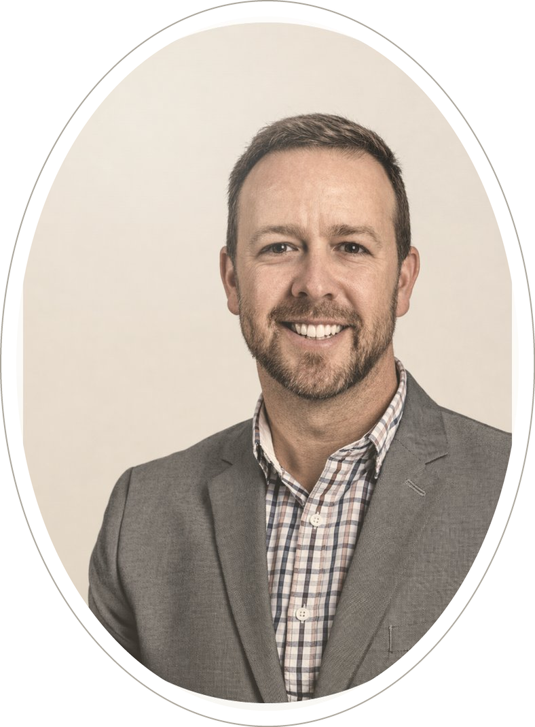
EXPERIENCE
UX Researcher & Research Operations Lead · AdventHealth Feb 2020 – Present
- Own end-to-end research across multiple product teams—from problem framing and method selection through insight delivery and roadmap recommendations
- Built and scaled a Research Ops foundation: standardized intake workflows, participant recruiting coordination, study templates, synthesis processes, and insight-sharing practices that increased team output and consistency
- Developed AI-assisted analysis workflows that compressed synthesis cycle time from roughly two weeks to days, enabling faster decisions and parallel studies
- Partnered with Product, Engineering, and Analytics to triangulate qualitative research with behavioral signals and A/B test learnings, building a holistic picture of customer behavior
- Tracked and reported research output and impact metrics; mentored designers and peers on research planning, facilitation, and synthesis
Product Designer — Discovery & Research · Hitachi Vantara Jan 2018 – Feb 2020
- Led generative discovery using interviews, journey mapping, workshops, and rapid prototyping for a data integration platform; aligned cross-functional teams on the problem space
- Produced decision-driving artifacts—insight readouts, workshop outputs, wireframes—connecting research to engineering requirements and roadmap decisions
Director, UX Design · Ascentus Mar 2016 – Dec 2017
- Built UX design and research practice from the ground up: established planning rituals, documentation standards, and delivery workflows for a cross-functional Product/Design/Engineering team
- Ran A/B tests and qualitative user research; partnered with analytics to drive iterative improvements — delivered +23% call volume growth and +18% ad revenue increase
Product Designer · Team Cymru Jun 2014 – Mar 2016
- Drove UX research and methodology across multiple software programs; planned and facilitated usability testing; maintained a governed design asset library across U.S. and U.K. offices
Project Lead · Carley Corporation / U.S. Navy DoD Aug 2004 – Jun 2014
- Led cross-functional team of 10 delivering PC-based simulation training systems for U.S. Navy programs; owned scope, delivery planning, and deployment from analysis through rollout
Earlier: Web/Brand Designer — Capital Cargo International Airlines · Media Producer/Art Director — Century III / Universal Studios
METHODS & TOOLS
Research Continuous discovery · Generative interviews · Moderated & unmoderated usability testing · Concept evaluation · Journey mapping · Workshop facilitation · Survey & feedback signals · A/B testing · Synthesis & executive storytelling
Operations Intake & triage systems · Participant recruitment · Study scheduling · Insight management · Documentation standards · Team rituals & rhythms · Onboarding programs · OKR/metric tracking
Tools Figma · Maze · Miro · Jira · Optimizely · Amplitude · Medallia · dscout · Axure · Adobe XD · Claude · Codex · HTML/CSS
EDUCATION & CERTIFICATIONS
Product Manager Certification — Cornell University (2025)
User Experience Certification — BCS (2021)
AS Digital Media — Full Sail University (1998)

