Contents
Toy Vending Machine 2
Introduction 2
Use Cases 2
Database Tables 3
Class Diagrams 4
Overview 4
Person, Customer, and Owner 5
Database 6
Source Codes 7
App.java 7
Person.java 9
Owner.java 10
Customer.java 12
VendingMachine.java 14
CapsuleVendingMachine.java 15
CapsuleFactory.java 16
MiniFigurineCapsuleFactory.java 17
StickerCapsuleFactory.java 18
DAO.java 19
HibernateDAO.java 20
MiniFigurineCapsuleDAO.java 22
StickerCapsuleDAO.java 23
Capsule.java 24
ColoredToyCapsule.java 25
MiniFigurineCapsule.java 26
StickerCapsule.java 27
Content.java 28
Describable.java 29
MiniFigurine.java 30
Sticker.java 31
Resources 32
beans.xml 32
MiniFigurine.hbm 35
MiniFigurineCapsule.hbm 36
Sticker.hbm 37
StickerCapsule.hbm 38

Toy Vending Machine

Introduction

The project is about a capsule vending machine. You put a quarter into the slot, and a capsule rolls out. A database will be used to store the capsules, and each time a user turns the knob, the vending machine will remove a capsule from
the database and return the capsule to the user.

User can now choose between mini figurines or stickers. Unlike figurines, each capsule contains two stickers.

Use Cases

- Anyone can interact with the toy vending machine. They can turn the knob, and the machine will crank out a toy.

- Anyone can interact with the toy itself. They can open the capsule, and inside is a mini figurine or stickers

- Anyone can choose between mini figurines or stickers

- Only the owner can refill the machine.

Database Tables

create table MiniFigurine (
FigurineId int primary key,
name varchar(255)
);

create table MiniFigurineCapsule (
CapsuleId int primary key,
Color varchar(10),
FigurineId int
);

create table Sticker (
StickerId int primary key,
name varchar(255),
CapsuleId int
);

create table StickerCapsule (
CapsuleId int primary key,
Color varchar(10)
);

Class Diagrams

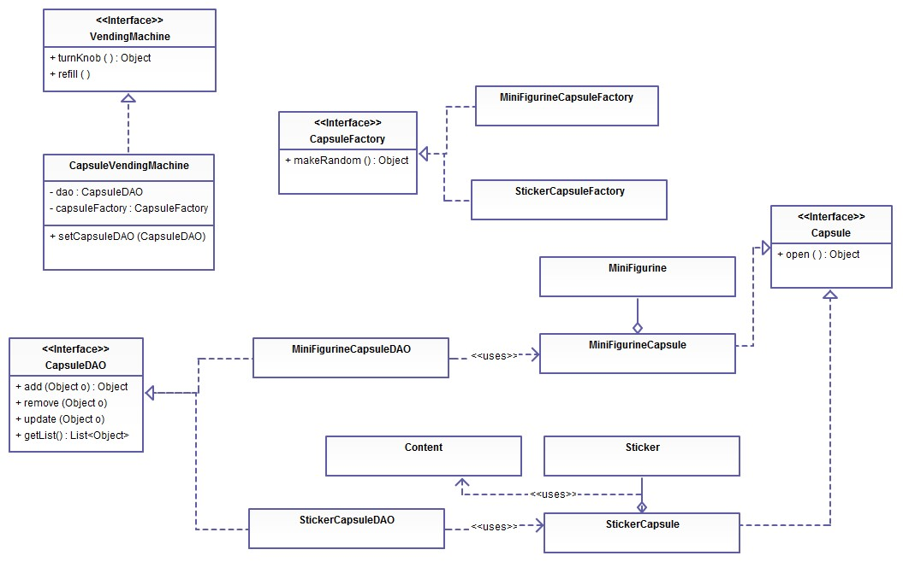
Overview

Person, Customer, and Owner

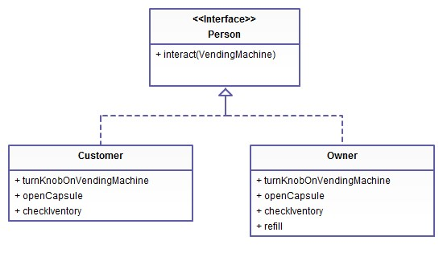

Database

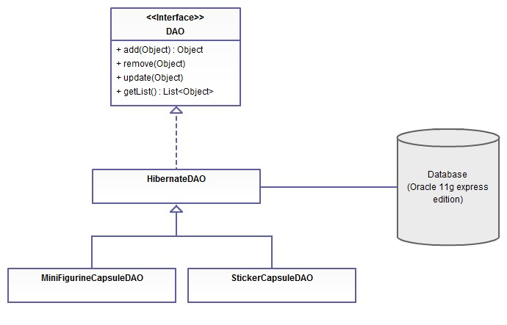

Source Codes

App.java

package com.tom.VendingMachine;

import java.io.BufferedReader;
import java.io.InputStreamReader;

import org.springframework.context.ApplicationContext;
import org.springframework.context.support.ClassPathXmlApplicationContext;

/**
* Hello world!
*
*/
public class App
{
public static void main( String[] args )
{
ApplicationContext context = new ClassPathXmlApplicationContext("beans.xml");

// display greeting
System.out.println( "Hello! Welcome to the store!" );
try {
// prompt user: ask for 'customer or owner' status
System.out.println("Are you a customer or the owner?[customer, owner]");

// read user input
BufferedReader br = new BufferedReader(new InputStreamReader(System.in));
String prompt1 = br.readLine();

// prompt user
System.out.println("Which capsule vending machine to use?[mini figurine, sticker]");

// read user input
BufferedReader br2 = new BufferedReader(new InputStreamReader(System.in));
String prompt2 = br.readLine();

VendingMachine vendingMachine = null;

// The user interacts with the machine.
if (new String("sticker").contains(prompt2.toLowerCase())) {
vendingMachine = (VendingMachine) context.getBean("sticker vending machine");
} else if (new String("mini figurine").contains(prompt2.toLowerCase())) {
vendingMachine = (VendingMachine) context.getBean("figurine vending machine");
} else {
throw new Exception("unsupported vending machine");
}

// The user interacts with the machine.
if (new String("owner").contains(prompt1.toLowerCase())) {
Person person = new Owner();
person.interact(vendingMachine);
} else if (new String("customer").contains(prompt1.toLowerCase())) {
Person person = new Customer();
person.interact(vendingMachine);
} else {
throw new Exception("unknown person category");
}
} catch (Exception e) {
e.printStackTrace();
}
}
}

Person.java

package com.tom.VendingMachine;

public interface Person {
void interact(VendingMachine vm) throws Exception;
}

Owner.java

package com.tom.VendingMachine;

import java.io.BufferedReader;
import java.io.InputStreamReader;
import java.util.ArrayList;
import java.util.List;

public class Owner implements Person {
private Customer customer = new Customer();

public Object turnKnobOnVendingMachine(List<Describable> inventory, VendingMachine vendingMachine) {
return customer.turnKnobOnVendingMachine(inventory, vendingMachine);
}

public void openCapsule(List<Describable> inventory, List<Capsule> unopenedCapsules) {
customer.openCapsule(inventory, unopenedCapsules);
}

public void checkInventory(List<Describable> inventory) {
customer.checkInventory(inventory);
}

public void refill(VendingMachine vendingMachine) {
vendingMachine.refill();
System.out.println("\nYou refill the vending machine.");
}

public void interact(VendingMachine vm) throws Exception {
List<Describable> inventory = new ArrayList<Describable>();
List<Capsule> unopenedCapsules = new ArrayList<Capsule>();

System.out.println("You are the owner.");

while (true) {
System.out.println();
System.out.println("What would you like to do?");
System.out.println("1. Turn knob on vending machine");
System.out.println("2. Open a capsule");
System.out.println("3. Check inventory");
System.out.println("4. Refill vending machine");
System.out.println("5. Exit");

System.out.print("Choose an option: ");

// read user input
BufferedReader br = new BufferedReader(new InputStreamReader(System.in));
String prompt = br.readLine();

if (prompt.contains("1")) {
Object o = turnKnobOnVendingMachine(inventory, vm);
if (o != null) {
unopenedCapsules.add((Capsule) o);
}
} else if (prompt.contains("2")) {
openCapsule(inventory, unopenedCapsules);
} else if (prompt.contains("3")) {
checkInventory(inventory);
} else if (prompt.contains("4")) {
refill(vm);
} else if (prompt.contains("5")) {
System.out.println("Good bye!");
break;
}
}
}
}

Customer.java

package com.tom.VendingMachine;

import java.io.BufferedReader;
import java.io.InputStreamReader;
import java.util.ArrayList;
import java.util.List;

public class Customer implements Person {

public Customer() { }

public Object turnKnobOnVendingMachine(List<Describable> inventory, VendingMachine vendingMachine) {
Object o = vendingMachine.turnKnob();
if (o != null) {
Describable d = (Describable) o;
System.out.println("\nYou turn the knob. The machine cranks out a "
+ d.getDescription());
inventory.add(d);
} else {
System.out.println("\nYou turn the knob. The vending machine is empty!");
System.out.println("The owner needs to refill it.");
}
return o;
}

public void openCapsule(List<Describable> inventory, List<Capsule> unopenedCapsules) {

if (unopenedCapsules.isEmpty()) {
System.out.println("\nThere are no unopened capsules");
} else {
Capsule capsule = unopenedCapsules.remove(0);
Describable capsuleDesc = (Describable) capsule;
Describable content = capsule.open();
System.out.println("\nYou open a "+capsuleDesc.getDescription()
+". Inside is a "+ content.getDescription());
inventory.remove(capsuleDesc);
if (content instanceof Content) {
for (Describable d : (Content) content) {
inventory.add(d);
}
} else {
inventory.add(content);
}
}
}

public void checkInventory(List<Describable> inventory) {
System.out.println("\nYour inventory:");
for (Describable d : inventory) {
System.out.println(" "+d.getDescription());
}
}

public void interact(VendingMachine vm) throws Exception {
List<Describable> inventory = new ArrayList<Describable>();
List<Capsule> unopenedCapsules = new ArrayList<Capsule>();

System.out.println("You are a customer.");

while (true) {
System.out.println();
System.out.println("What would you like to do?");
System.out.println("1. Turn knob on vending machine");
System.out.println("2. Open a capsule");
System.out.println("3. Check inventory");
System.out.println("4. Exit");

System.out.print("Choose an option: ");

// read user input
BufferedReader br = new BufferedReader(new InputStreamReader(System.in));
String prompt = br.readLine();

if (prompt.contains("1")) {
Object o = turnKnobOnVendingMachine(inventory, vm);
if (o != null) {
unopenedCapsules.add((Capsule) o);
}
} else if (prompt.contains("2")) {
openCapsule(inventory, unopenedCapsules);
} else if (prompt.contains("3")) {
checkInventory(inventory);
} else if (prompt.contains("4")) {
System.out.println("Good bye!");
break;
}
}
}
}

VendingMachine.java

package com.tom.VendingMachine;

public interface VendingMachine {
Object turnKnob();
void refill();
}

CapsuleVendingMachine.java

package com.tom.VendingMachine;

import java.util.List;

public class CapsuleVendingMachine implements VendingMachine {

private DAO dao;
private CapsuleFactory capsuleFactory;

public void setDao(DAO dao) {
this.dao = dao;
}

public void setCapsuleFactory(CapsuleFactory capsuleFactory) {
this.capsuleFactory = capsuleFactory;
}

public Object turnKnob() {
List<Object> lo = dao.getlist();
if (lo.isEmpty())
return null;

Object o = lo.remove(0);
dao.remove(o);
return o;
}

public void refill() {
List<Object> lo = dao.getlist();

for (int i=lo.size(); i<10; i++) {
Object o = capsuleFactory.makeRandom();
dao.add(o);
}
}
}

CapsuleFactory.java

package com.tom.VendingMachine;

public interface CapsuleFactory {
Object makeRandom();
}

MiniFigurineCapsuleFactory.java

package com.tom.VendingMachine;

import java.util.HashMap;
import java.util.Map;

import org.springframework.beans.BeansException;
import org.springframework.context.ApplicationContext;
import org.springframework.context.ApplicationContextAware;

public class MiniFigurineCapsuleFactory implements CapsuleFactory, ApplicationContextAware {

private ApplicationContext context;

public Object makeRandom() {
Map<Integer, String> map = new HashMap<Integer, String>();
map.put(1, "red capsule");
map.put(2, "green capsule");
map.put(3, "blue capsule");

int i = (int) (Math.random() * 3 + 1);
return context.getBean(map.get(i));
}

public void setApplicationContext(ApplicationContext arg0)
throws BeansException {
context=arg0;
}

}

StickerCapsuleFactory.java

package com.tom.VendingMachine;

import java.util.HashMap;
import java.util.Map;

import org.springframework.beans.BeansException;
import org.springframework.context.ApplicationContext;
import org.springframework.context.ApplicationContextAware;

public class StickerCapsuleFactory implements CapsuleFactory, ApplicationContextAware {

private ApplicationContext context;

public Object makeRandom() {
Map<Integer, String> map = new HashMap<Integer, String>();
map.put(1, "purple capsule");
map.put(2, "orange capsule");
map.put(3, "yellow capsule");

int i = (int) (Math.random() * 3 + 1);
return context.getBean(map.get(i));
}

public void setApplicationContext(ApplicationContext arg0)
throws BeansException {
context=arg0;
}

}

DAO.java

package com.tom.VendingMachine;

import java.util.List;

public interface DAO {
Object add(Object t);
void remove(Object t);
void update(Object t);
List<Object> getlist();
}

HibernateDAO.java

package com.tom.VendingMachine;

import java.util.List;

import org.hibernate.HibernateException;
import org.hibernate.Session;
import org.hibernate.SessionFactory;
import org.hibernate.Transaction;

public abstract class HibernateDAO implements DAO {

private SessionFactory sessionFactory;
private Class type;

public HibernateDAO(Class type) {
this.type = type;
}

public void setSessionFactory(SessionFactory sessionFactory) {
this.sessionFactory = sessionFactory;
}

public SessionFactory getSessionFactory() {
return this.sessionFactory;
}

public Object add(Object t) {
Session session = sessionFactory.openSession();
Transaction tx = session.beginTransaction();

try
{
session.save(t);
tx.commit();
} catch (Exception e) {
tx.rollback();
e.printStackTrace();
} finally {
session.close();
}

return t;
}
public void remove(Object t) {
Session session = sessionFactory.openSession();
Transaction tx = session.beginTransaction();

try
{
session.delete(t);
tx.commit();
} catch (HibernateException e) {
tx.rollback();
e.printStackTrace();
} finally {
session.close();
}
}
public void update(Object t) {
Session session = sessionFactory.openSession();
Transaction tx = session.beginTransaction();

try
{
session.update(t);
tx.commit();
} catch (Exception e) {
tx.rollback();
e.printStackTrace();
} finally {
session.close();
}
}

public List<Object> getlist() {
Session session = getSessionFactory().openSession();
Transaction tx = session.beginTransaction();

List<Object> lt = null;

try {
lt = session.createCriteria(type).list();
tx.commit();
} catch (Exception e) {
tx.rollback();
e.printStackTrace();
} finally {
session.close();
}
return lt;
}
}

MiniFigurineCapsuleDAO.java

package com.tom.VendingMachine;

public class MiniFigurineCapsuleDAO extends HibernateDAO {

public MiniFigurineCapsuleDAO() {
super(MiniFigurineCapsule.class);
}
}

StickerCapsuleDAO.java

package com.tom.VendingMachine;

public class StickerCapsuleDAO extends HibernateDAO {

public StickerCapsuleDAO( ) {
super(StickerCapsule.class);
}
}

Capsule.java

package com.tom.VendingMachine;

public interface Capsule {
Describable open();
}

ColoredToyCapsule.java

package com.tom.VendingMachine;

public abstract class ColoredToyCapsule implements Describable, Capsule {

private int capsuleId;
private String color;

public void setCapsuleId (int id) {
capsuleId = id;
}

public int getCapsuleId () {
return capsuleId;
}

public void setColor(String color) {
this.color = color;
}

public String getColor() {
return this.color;
}

public abstract Describable open();

public String getDescription() {
return getColor() + " capsule";
}

}

MiniFigurineCapsule.java

package com.tom.VendingMachine;

public class MiniFigurineCapsule extends ColoredToyCapsule {
private MiniFigurine figurine;

public void setFigurine(MiniFigurine figurine) {
this.figurine = figurine;
}

public MiniFigurine getFigurine() {
return figurine;
}

@Override
public Describable open() {
return figurine;
}
}

StickerCapsule.java

package com.tom.VendingMachine;

import java.util.List;

public class StickerCapsule extends ColoredToyCapsule {

private List<Sticker> stickers;

public void setStickers(List<Sticker> stickers) {
this.stickers = stickers;
}

public List<Sticker> getStickers () {
return this.stickers;
}

public Describable open() {
Content content = new Content();
content.setDescription("few stickers");
content.addAll(stickers);
return content;
}

}

Content.java

package com.tom.VendingMachine;

import java.util.ArrayList;

public class Content extends ArrayList<Describable> implements Describable {

private String description;

public void setDescription(String description) {
this.description = description;
}

public String getDescription() {
return this.description;
}

}

Describable.java

package com.tom.VendingMachine;

public interface Describable {
String getDescription();
}

MiniFigurine.java

package com.tom.VendingMachine;

public class MiniFigurine implements Describable {

private int figurineId;
private String name;

public void setFigurineId (int id) {
figurineId = id;
}

public int getFigurineId () {
return figurineId;
}

public String getName() {
return name;
}

public void setName(String name) {
this.name = name;
}

public String getDescription() {
return getName() + " mini figurine";
}

}

Sticker.java

package com.tom.VendingMachine;

public class Sticker implements Describable {

private int stickerId;
private String name;

public void setName (String name) {
this.name = name;
}

public String getName () {
return this.name;
}

public void setStickerId (int id) {
stickerId = id;
}

public int getStickerId () {
return this.stickerId;
}

public String getDescription() {
return name + " sticker";
}
}

Resources

beans.xml

<?xml version="1.0" encoding="UTF-8"?>
<beans xmlns="http://www.springframework.org/schema/beans"
xmlns:xsi="http://www.w3.org/2001/XMLSchema-instance"
xsi:schemaLocation="http://www.springframework.org/schema/beans http://www.springframework.org/schema/beans/spring-beans.xsd">

<bean id="dataSource"
class="org.springframework.jdbc.datasource.DriverManagerDataSource">
<property name="driverClassName" value="oracle.jdbc.driver.OracleDriver" />
<property name="url" value="jdbc:oracle:thin:@localhost:1521:xe" />
<property name="username" value="tom" />
<property name="password" value="123" />
</bean>

<bean id="sessionFactory" class="org.springframework.orm.hibernate4.LocalSessionFactoryBean">
<property name="dataSource" ref="dataSource"/>
<property name="mappingResources">
<list>
<value>/MiniFigurine.hbm.xml</value>
<value>/MiniFigurineCapsule.hbm.xml</value>
<value>/Sticker.hbm.xml</value>
<value>/StickerCapsule.hbm.xml</value>
</list>
</property>
<property name="hibernateProperties">
<props>
<prop key="hibernate.dialect">org.hibernate.dialect.Oracle10gDialect</prop>
<prop key="hibernate.show_sql">true</prop>
</props>
</property>
</bean>

<bean id="red capsule" scope="prototype" class="com.tom.VendingMachine.MiniFigurineCapsule">
<property name="color" value="red" />
<property name="figurine" ref="batman figurine" />
</bean>

<bean id="batman figurine" scope="prototype" class="com.tom.VendingMachine.MiniFigurine">
<property name="name" value="batman" />
</bean>

<bean id="blue capsule" scope="prototype" class="com.tom.VendingMachine.MiniFigurineCapsule">
<property name="color" value="blue" />
<property name="figurine" ref="superman figurine" />
</bean>

<bean id="superman figurine" scope="prototype" class="com.tom.VendingMachine.MiniFigurine">
<property name="name" value="superman" />
</bean>

<bean id="green capsule" scope="prototype" class="com.tom.VendingMachine.MiniFigurineCapsule">
<property name="color" value="green" />
<property name="figurine" ref="spiderman figurine" />
</bean>

<bean id="spiderman figurine" scope="prototype" class="com.tom.VendingMachine.MiniFigurine">
<property name="name" value="spiderman" />
</bean>

<bean id="figurine vending machine" class="com.tom.VendingMachine.CapsuleVendingMachine">
<property name="dao" ref="figurine capsule dao" />
<property name="capsuleFactory" ref="MiniFigurineCapsuleFactory" />
</bean>

<bean id="figurine capsule dao" class="com.tom.VendingMachine.MiniFigurineCapsuleDAO">
<property name="sessionFactory" ref="sessionFactory" />
</bean>

<bean id="MiniFigurineCapsuleFactory" class="com.tom.VendingMachine.MiniFigurineCapsuleFactory">
</bean>

<bean id="mickey mouse sticker" class="com.tom.VendingMachine.Sticker" scope="prototype">
<property name="name" value="mickey mouse" />
</bean>

<bean id="donald duck sticker" class="com.tom.VendingMachine.Sticker" scope="prototype">
<property name="name" value="donald duck" />
</bean>

<bean id="goofy sticker" class="com.tom.VendingMachine.Sticker" scope="prototype">
<property name="name" value="goofy" />
</bean>

<bean id="purple capsule" scope="prototype" class="com.tom.VendingMachine.StickerCapsule">
<property name="color" value="purple" />
<property name="stickers">
<list value-type="com.tom.VendingMachine.Sticker">
<ref bean="mickey mouse sticker"/>
<ref bean="donald duck sticker" />
</list>
</property>
</bean>

<bean id="yellow capsule" scope="prototype" class="com.tom.VendingMachine.StickerCapsule">
<property name="color" value="yellow" />
<property name="stickers">
<list value-type="com.tom.VendingMachine.Sticker">
<ref bean="mickey mouse sticker"/>
<ref bean="goofy sticker" />
</list>
</property>
</bean>

<bean id="orange capsule" scope="prototype" class="com.tom.VendingMachine.StickerCapsule">
<property name="color" value="orange" />
<property name="stickers">
<list value-type="com.tom.VendingMachine.Sticker">
<ref bean="goofy sticker"/>
<ref bean="donald duck sticker" />
</list>
</property>
</bean>

<bean id="sticker vending machine" class="com.tom.VendingMachine.CapsuleVendingMachine">
<property name="dao" ref="sticker capsule dao" />
<property name="capsuleFactory" ref="StickerCapsuleFactory" />
</bean>

<bean id="sticker capsule dao" class="com.tom.VendingMachine.StickerCapsuleDAO">
<property name="sessionFactory" ref="sessionFactory" />
</bean>

<bean id="StickerCapsuleFactory" class="com.tom.VendingMachine.StickerCapsuleFactory">
</bean>

</beans>

MiniFigurine.hbm

<?xml version="1.0"?>
<!DOCTYPE hibernate-mapping PUBLIC "-//Hibernate/Hibernate Mapping DTD 3.0//EN"
"http://hibernate.sourceforge.net/hibernate-mapping-3.0.dtd">
<!-- Generated Feb 7, 2014 10:47:36 PM by Hibernate Tools 3.4.0.CR1 -->
<hibernate-mapping>
<class name="com.tom.VendingMachine.MiniFigurine" table="MINIFIGURINE">
<id name="figurineId" type="int">
<column name="FIGURINEID" />
<generator class="increment" />
</id>
<property name="name" column="NAME" />
</class>
</hibernate-mapping>

MiniFigurineCapsule.hbm

<?xml version="1.0"?>
<!DOCTYPE hibernate-mapping PUBLIC "-//Hibernate/Hibernate Mapping DTD 3.0//EN"
"http://hibernate.sourceforge.net/hibernate-mapping-3.0.dtd">
<!-- Generated Feb 7, 2014 10:47:36 PM by Hibernate Tools 3.4.0.CR1 -->
<hibernate-mapping>
<class name="com.tom.VendingMachine.MiniFigurineCapsule" table="MINIFIGURINECAPSULE">
<id name="capsuleId" type="int">
<column name="CAPSULEID" />
<generator class="increment" />
</id>
<many-to-one name="figurine" class="com.tom.VendingMachine.MiniFigurine"
fetch="join" cascade="all">
<column name="FIGURINEID" />
</many-to-one>
<property name="color" column="COLOR" />
</class>
</hibernate-mapping>

Sticker.hbm

<?xml version="1.0"?>
<!DOCTYPE hibernate-mapping PUBLIC "-//Hibernate/Hibernate Mapping DTD 3.0//EN"
"http://hibernate.sourceforge.net/hibernate-mapping-3.0.dtd">
<!-- Generated Feb 7, 2014 10:47:36 PM by Hibernate Tools 3.4.0.CR1 -->
<hibernate-mapping>
<class name="com.tom.VendingMachine.Sticker" table="STICKER">
<id name="stickerId" type="int">
<column name="STICKERID" />
<generator class="increment" />
</id>
<property name="name" column="NAME" />
</class>
</hibernate-mapping>

StickerCapsule.hbm

<?xml version="1.0"?>
<!DOCTYPE hibernate-mapping PUBLIC "-//Hibernate/Hibernate Mapping DTD 3.0//EN"
"http://hibernate.sourceforge.net/hibernate-mapping-3.0.dtd">
<!-- Generated Feb 7, 2014 10:47:36 PM by Hibernate Tools 3.4.0.CR1 -->
<hibernate-mapping>
<class name="com.tom.VendingMachine.StickerCapsule" table="STICKERCAPSULE">
<id name="capsuleId" type="int">
<column name="CAPSULEID" />
<generator class="increment" />
</id>
<bag name="stickers" cascade="all">
<key column="CAPSULEID" />
<one-to-many class="com.tom.VendingMachine.Sticker"/>
</bag>
<property name="color" column="COLOR" />
</class>
</hibernate-mapping>

