**Lambda Function Report**

In image 1 we see the lambda function that reads in JSON. The function lambda_handler uses python3.8 Lambda runtime. When the function is invoked, Lambda passes two arguments to the handler method and returns a response. The function returns a message that contains data from the JSON-formatted event object it received as input. The function receives ‘first_name’ and ‘last_name’ as input from the event, runs the handler method, and returns ‘“statusCode”: 200’ along with ‘“output”: name’, which is ‘first_name’ and ‘last_name’ combined. The handler also receives a context object as the second argument which provides information about the invocation, function, and runtime environment.

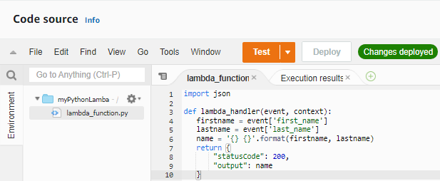

* Image 1

In image 2 we have the test event with ‘first_name’ and ‘last_name’ JSON event data to invoke the function.

In image 3 we have the successful execution result from the test event in image 2. Lambda invoked our function with ‘first_name’ and ‘last_name’ event data and successfully returned “statusCode”: 200 and “output”: Jane Doe.”

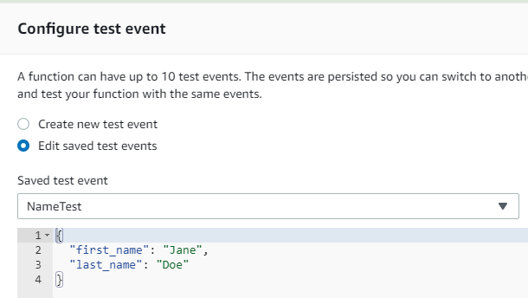

* Image 2

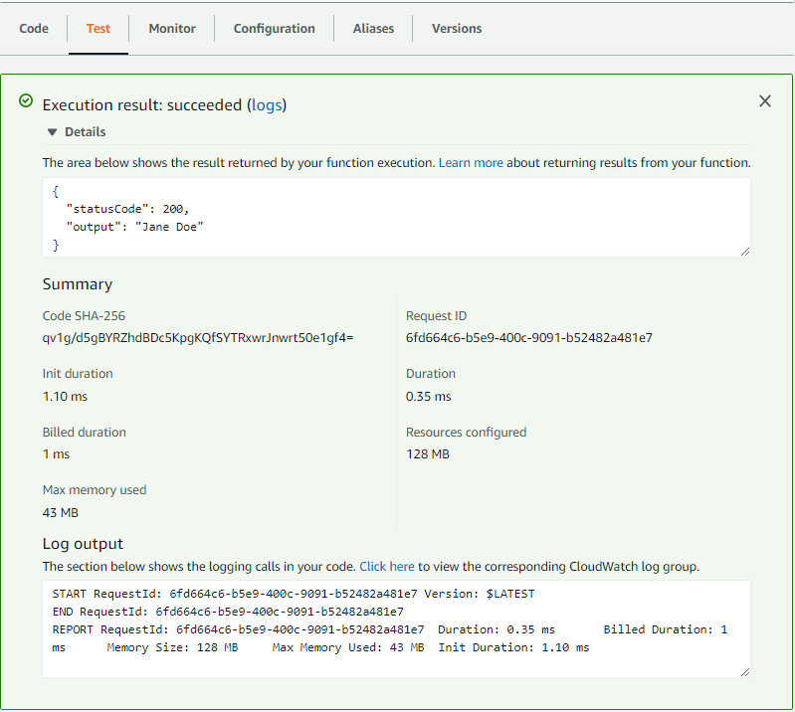

* Image 3