Practical 7
import pandas as pd
from sklearn.linear_model import LogisticRegression
from sklearn.svm import LinearSVC, SVC
from sklearn.tree import DecisionTreeClassifier
from sklearn.model_selection import train_test_split
from sklearn.preprocessing import LabelEncoder
from sklearn.metrics import accuracy_score, confusion_matrix
import pathlib as pl
import os

## DisableWarning: sklearn.exceptions.ConvergenceWarning
import warnings
from sklearn.exceptions import ConvergenceWarning
warnings.simplefilter(action='ignore', category=ConvergenceWarning)

script_dir = pl.Path(__file__).parent.absolute()
os.chdir(script_dir)

df = pd.read_csv('iris.csv')
print(df.head())

encoder = LabelEncoder()
df.Species = encoder.fit_transform(df.Species)

train , test = train_test_split(df, test_size=0.2, random_state=35)

train_x = train.drop(columns=['Species'],axis=1)
train_y = train['Species']

test_x = test.drop(columns=['Species'],axis=1)
test_y = test['Species']

models = {
"Logistic Regression": LogisticRegression(),
"SVM (one-vs-one)": SVC(),
"Linear SVM (one-vs-rest)": LinearSVC(dual=False),
"Decision Tree (Criterion : Entropy)": DecisionTreeClassifier(criterion='entropy')
}

for name, model in models.items():
print(f"Model: {name}")
model.fit(train_x,train_y)
predict = model.predict(test_x)
# actual_vs_predict = [f"{i} | {j}" for i,j in zip(encoder.inverse_transform(test_y),encoder.inverse_transform(predict))]
# print('Actual vs Predicted')
# for i in actual_vs_predict:
# print(i)
print(f"Accuracy: {accuracy_score(test_y,predict)}")
print(f"Confusion Matrix: \n{confusion_matrix(test_y,predict)}")
7

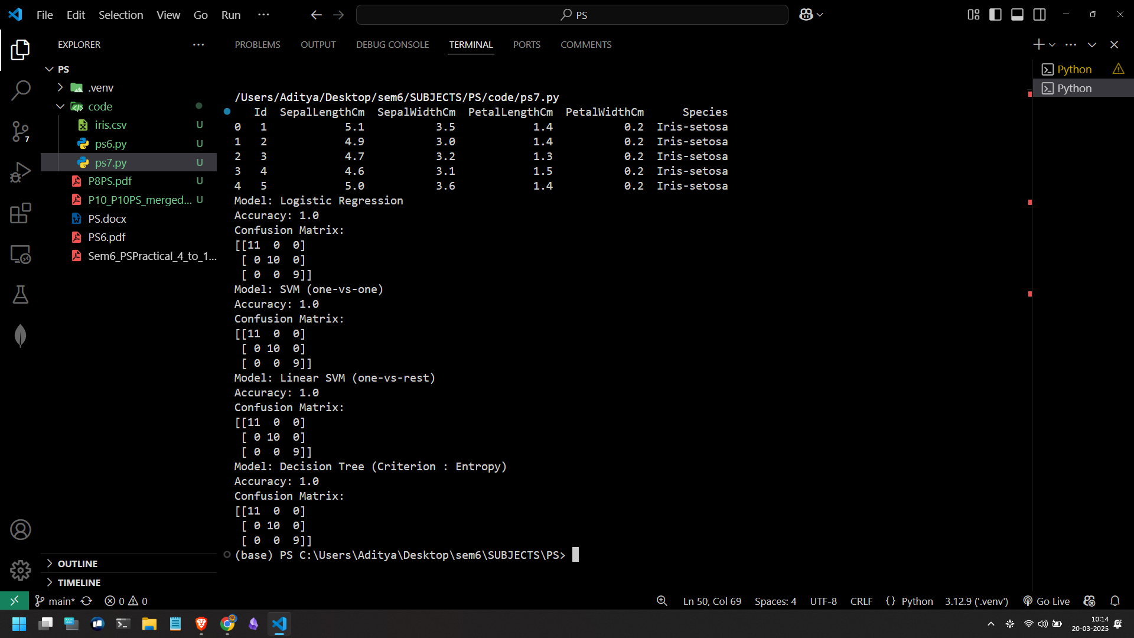

Practical 9
import pathlib as pl
import os
import pandas as pd
import numpy as np
from sklearn.preprocessing import LabelEncoder
from sklearn.model_selection import train_test_split
import matplotlib.pyplot as plt
import seaborn as sns
from sklearn.neighbors import KNeighborsClassifier
from sklearn.metrics import accuracy_score, confusion_matrix
from sklearn.model_selection import cross_val_score

script_dir = pl.Path(__file__).parent.absolute()
os.chdir(script_dir)

df = pd.read_csv('iris.csv')

feature_columns = ['SepalLengthCm', 'SepalWidthCm', 'PetalLengthCm','PetalWidthCm']
X = df[feature_columns].values
y = df['Species'].values

encoder = LabelEncoder()
y = encoder.fit_transform(y)

X_train, X_test, y_train, y_test = train_test_split(X, y, test_size=0.2, random_state=35)

sns.pairplot(df.drop("Id", axis=1), hue='Species', height=2, markers=['o', 's', 'D'])

classifier = KNeighborsClassifier(n_neighbors=3)
classifier.fit(X_train, y_train)

y_pred = classifier.predict(X_test)

cm = confusion_matrix(y_test, y_pred)
print(f"Confusion Matrix: \n{cm}")

accuracy = accuracy_score(y_test, y_pred)
print(f"Accuracy: {accuracy}")

plt.show()

9

