PB230: REPLICATION

-Study Results-

**Study Title:** *Prescribed Optimism: Is it Right to Be Wrong About the Future?* by David A. Armor, Cade Massey & Aaron M. Sackett (2008, *Psychological Science*)

# I. Preliminary Analyses

People tend to make optimistically biased predictions about their personal futures. For example, we anticipate living longer than average, and we overestimate our chances of success in the job market (Weinstein, 1980). This observation conflicts with the assumption that our primary goal is to be accurate in our predictions. The original study explored–amongst other things–what kind of predictions (accurate, optimistic, or pessimistic) one ought to make.

The distributions of scores for each condition are approximately normal (cheating skewness = -0.23, kurtosis = -.83; cheater skewness = .01, kurtosis = -.33). Figure 1 shows the distribution of scores.

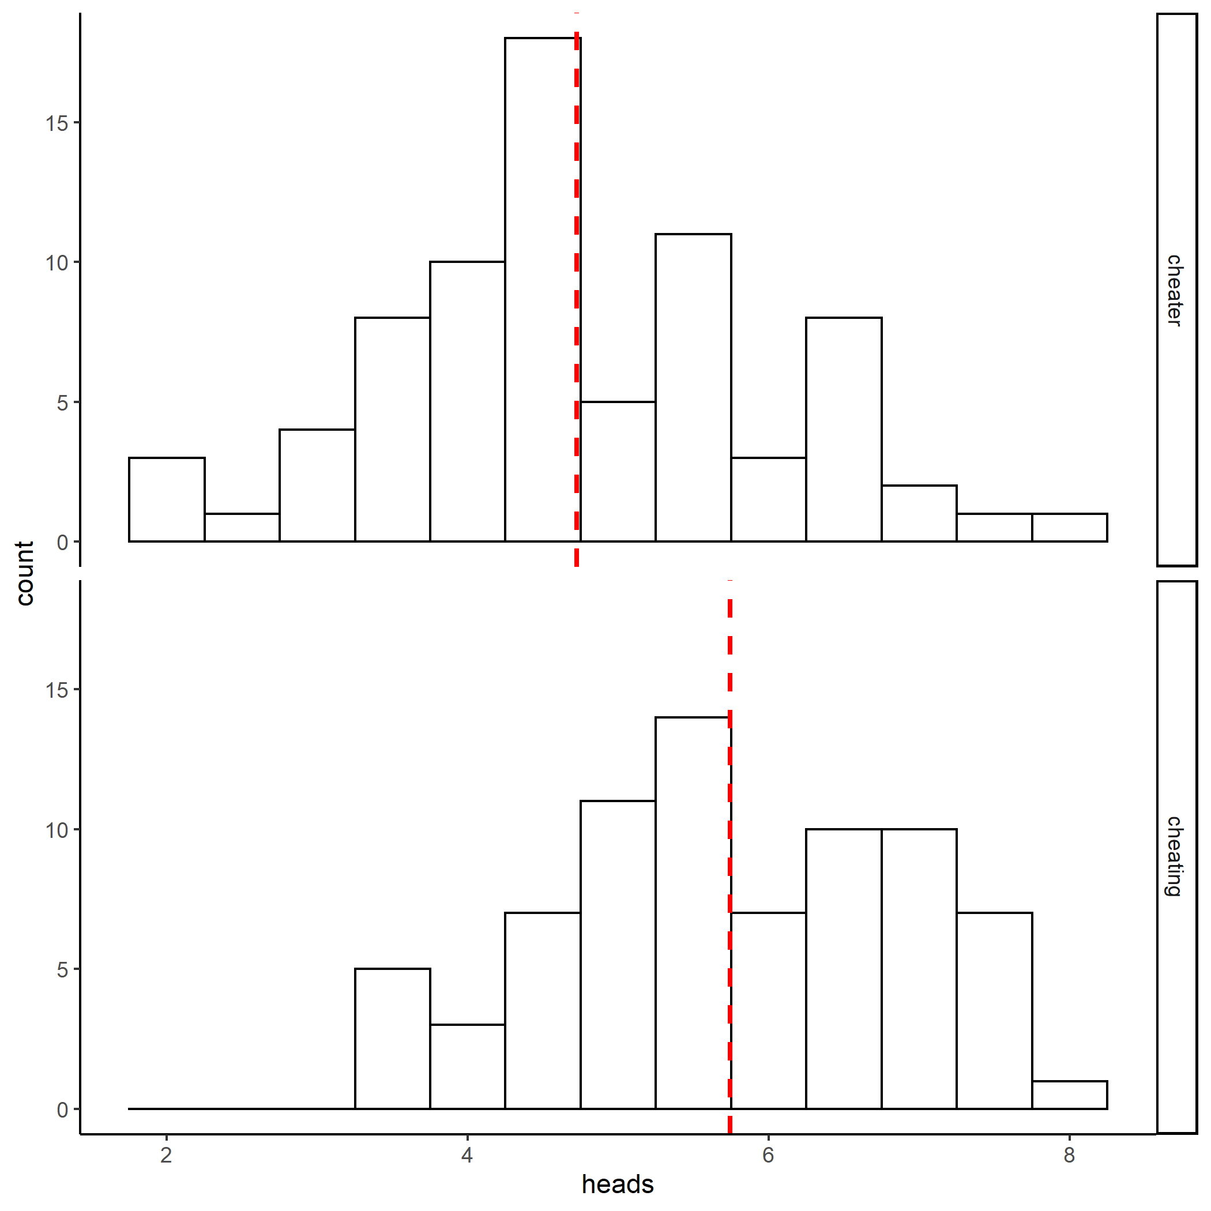**Figure 1.** Distribution of heads reported in cheating and cheater conditons. The mean for each conditon is represnted by the dashed red horizontal line.

Descriptive statistics for the number of heads reported in the cheating and cheater conditions are presented in Table 1. The mean number of heads reported in the cheating condition was 5.74 (SD = 1.14), whereas the mean number of heads reported in the cheater condition was 4.72. The descriptive provide initial support for the alternate confirmatory hypothesis.

**Table 1**

*Descriptive statistics for heads as a function of condition.*

|  |  |  |
| --- | --- | --- |
| Condition | *M* | *SD* |
| Cheater | 4.72 | 1.30 |
| Cheating | 5.74 | 1.14 |

*Note.* *M* and *SD* represent mean and standard deviation.

# II. Confirmatory Analysis

An independent t-test was performed to test the difference in mean number of heads reported between those in the “cheating” condition versus those in the “cheater” condition. Participants in the “cheating” condition claimed to have obtained significantly more heads (M = 5.74, SD = 1.14) than did those in the “cheater” condition (M = 4.72, SD = 1.30), *t*(148) = 5.11, p < .001, d = .83. There was a mean difference in number of heads called between the groups of 1.02 in favor of the cheating condition (see Figure 1). The 95% confidence interval associated with this mean difference was obtained with 5,000 bootstrap resamples and did not include zero (Mdiff = 1.02, 95% CI = .60, 1.45). As such, the difference in mean heads called between those in the “cheating” condition versus those in the “cheater” condition is statistically significant.

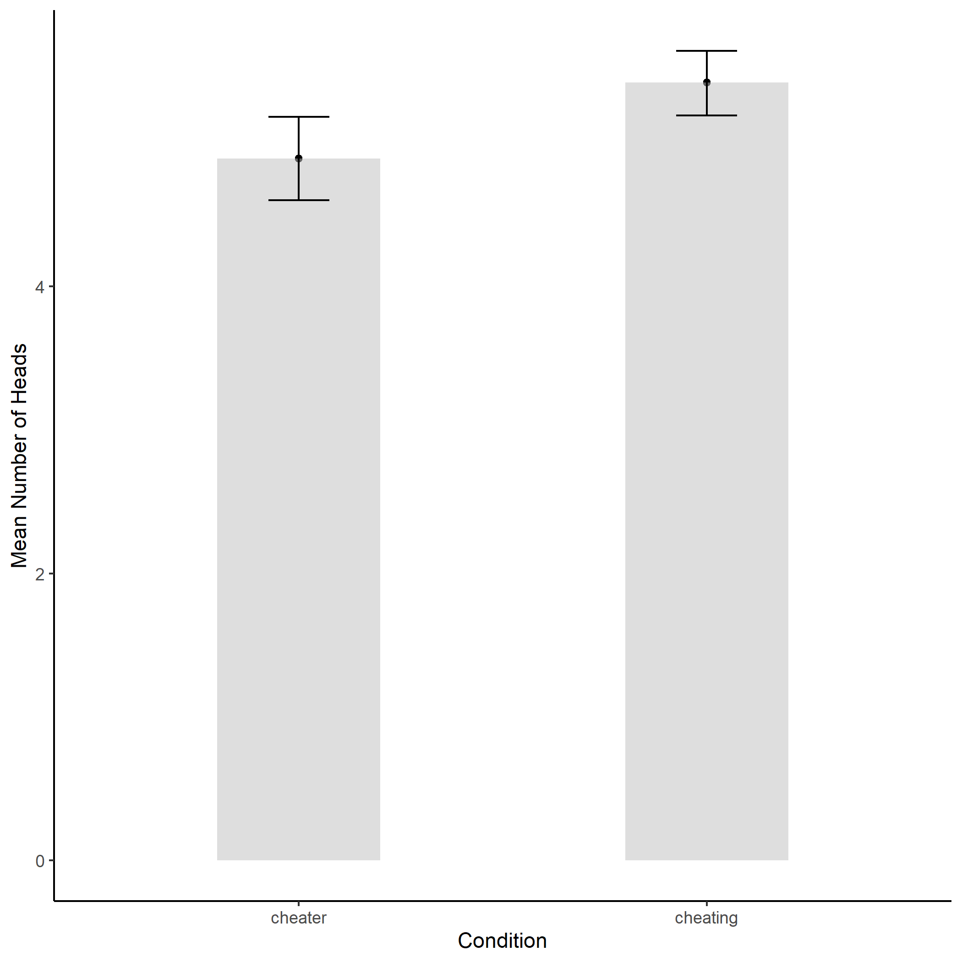**Figure 2.** In the experiment, the mean number of heads claimed in the “cheating” condition was significantly greater than the number claimed in the “cheater” condition