TITLE:

Title:

RISE ONE DEITY

Tagline: Have Faith.

High Concept:

After killing god, inherit its power and travel across the world to stop the resulting demon invasion.

PITCH:

It is common in RPGs that the *final* final boss is some incarnation of a god. But what happens if you killed the only god in the world? What happens after the game ends? That’s what *RISE ONE DEITY* is about. What if the player could use god-like powers to change flip regular battles on their head. What if the player didn’t have to worry about micro-managing individual weapons and pieces of armour -- having to make many mostly pointless choices – since they would have already gathered the best equipment in the world before killing god, right? What if a character’s turn was determined by their action – not just letting the opponent go, while keeping the time the player has to mull over their next move? That’s *RISE ONE DEITY.*

LOOK AND FEEL:

The game is rendered in 3D with a 3rd person view, allowing the player to view the world from multiple viewpoints (without having to create whole new assets). On the Field (the overworld), the player has a top-down view (~60° from ground) allowing them to see the area immediately around them on all sides, but not areas far in front of the player. Overworld character models have exaggerated features so that they can be easily seen from the camera angle, but not so much that they approach being chibi. HUD elements visible in the overworld include the player's overall Faith level, the party's status (comprised of portrait, name and health bar) and a mini-map that shows a slightly larger area around the player while keeping the player in the centre so that the player can fairly see when something (e.g. an enemy) approaches from behind. In battle, the camera is pulled back behind the player('s party), with the enemy party also in view. The HUD shows Faith and party status as before but also shows the same information for the opposing party. Also, on screen is a timeline that shows when each character will next - whether that is choosing the next move or carrying out the previously chosen move. Overall, the art style can be described as realistic but with unpractical (for the real world), exaggerated designs.

The main *feel* is a dark and gritty world with moments of levity that provide relief, but the juxtaposition of both elements serves to make them hit harder.

The visual style is inspired by classic 2D JRPGS such as *Final Fantasy 6* (pictured). It invokes a ”generic medieval Europe” feel. The scenery is comprised of generally darker and muted colours, but character models (for *FFVI*, sprites) have bright colours that let them stand out from the background

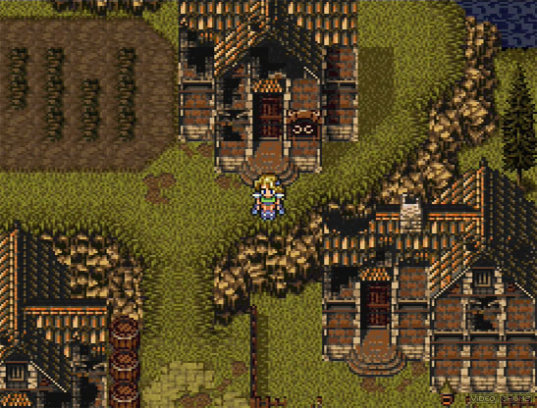

Considering the subject matter, there will be religious imagery. While it shouldn't be directly lifted from a real life (as to not offend a global organised religion) elements are taken from Christian imagery.

Along with this, designs for the holy side will feature light colours, and have seemingly random gold spikes and **crosses**. (Pictured) ’Affinity‘, a type of ’Angel’ from *Bayonetta* is aggressive and not welcoming. While ’Affinity' is an enemy, the same feeling will come from the player’s characters, as a warring force.

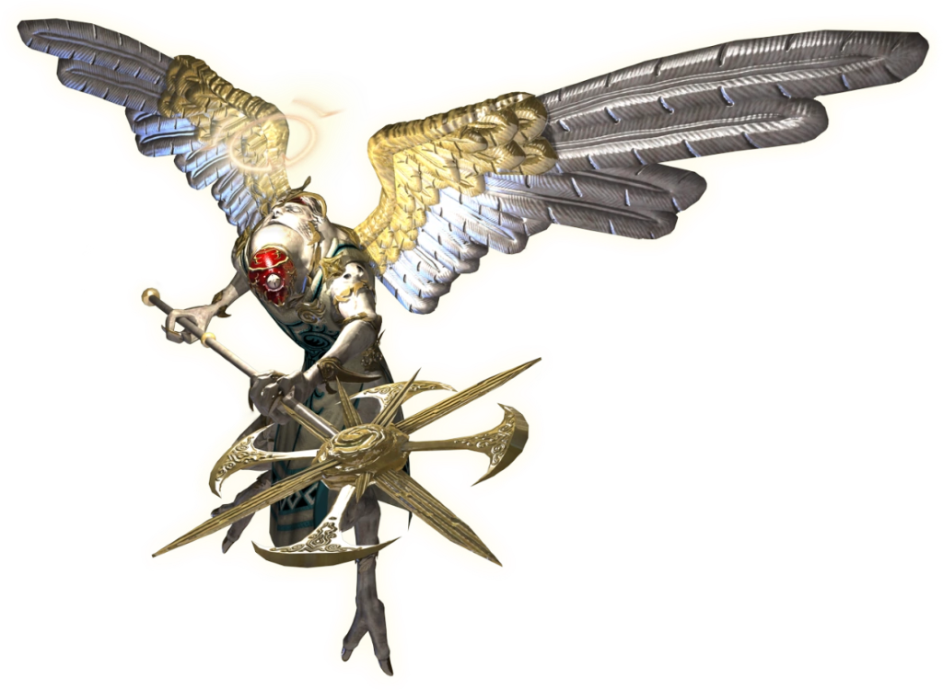

The main battle screen will clearly show the player's options (with sub-menus) and have shortcut buttons, as it is in *Persona 5.* The feeling here is to simplify the selecting from menus, by having actions readily available – giving the player a better sense of what they are doing, rather than scrolling through menus. The menu being stylish helps, too. 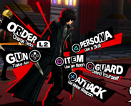

To provide levity, some character designs should be somewhat comical and pushing the boundary of fitting in with the world. Weapons and armour can be comically oversized like ‘Cloud’ from *Final Fantasy VII* or ‘Draug’ from *Fire Emblem* (artwork from the original game)

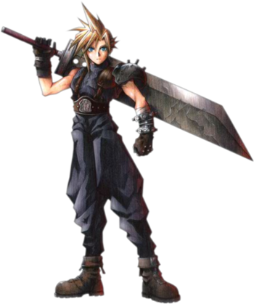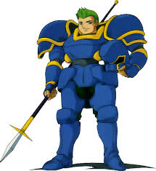

Furthermore, characters are allowed to joke and be silly at the right moments to break up serious moments, providing relief for the player and a better appreciation for the world.

Enemy designs should vary to sometimes be frightening but also sometimes be whimsical, again adding juxtaposition and lighter moments. Consider that these are two enemies from the same game (*Super Mario Odyssey*). While most enemies are designed to fit in with your average ‘Goomba’ (left), there is one boss (right) that is designed with ‘realism’. This feeling should be present, but in reverse.

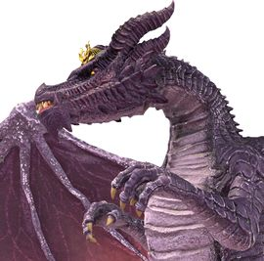

The music should also evoke this theme of light and dark juxtaposition. While player/light will have orchestral instruments (e.g. violins) and choirs (which also relates to the religious theming) while the enemy/dark will have rock/metal style music, with electric guitars and much more significant percussion. Battle themes would be a collision of these two elements.

INTERFACE:

Battle

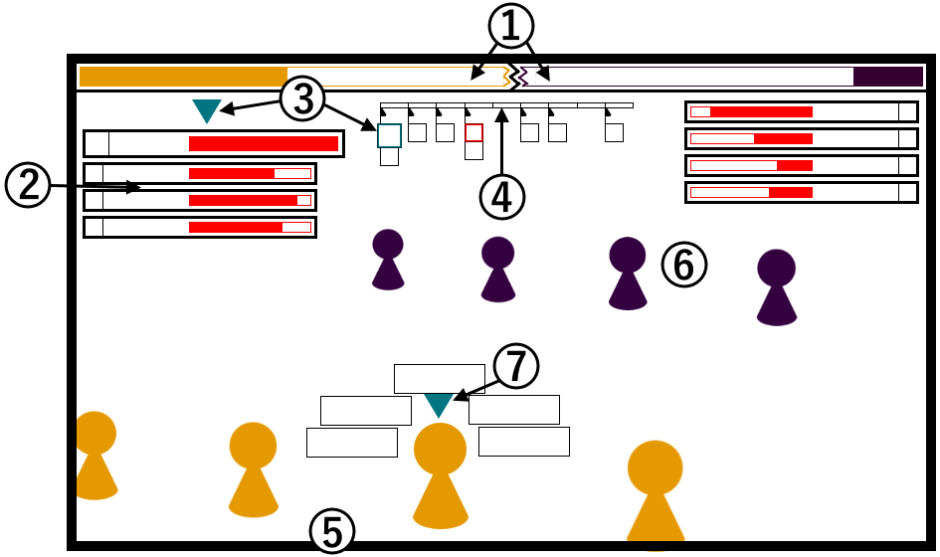

1. The Faith meter for the player/Light (left) and the enemy/Dark (right)
2. The party’s status: Portrait, name and health bar (enemy party also has this on right side of screen)
3. The currently selected character has an indicator appear over their status bar (also over their head), which also expands. Their portrait on the battle timeline also expands to make it easier to see where they appear on it.
4. The battle timeline. It shows when each character (indicated by their portrait), will act. The character currently selected has their portrait expanded. Characters that will release a skill (i.e. are currently charging) portraits are highlighted (here, in red) to indicate at this time – this will happen.
5. The player’s party lined up towards the bottom of the screen.
6. The enemy party lined up towards the top of the top of the screen.
7. Currently selected character has an indicator above their head. If it is one of the player’s party members’ turn, the actions available to them appear around them.

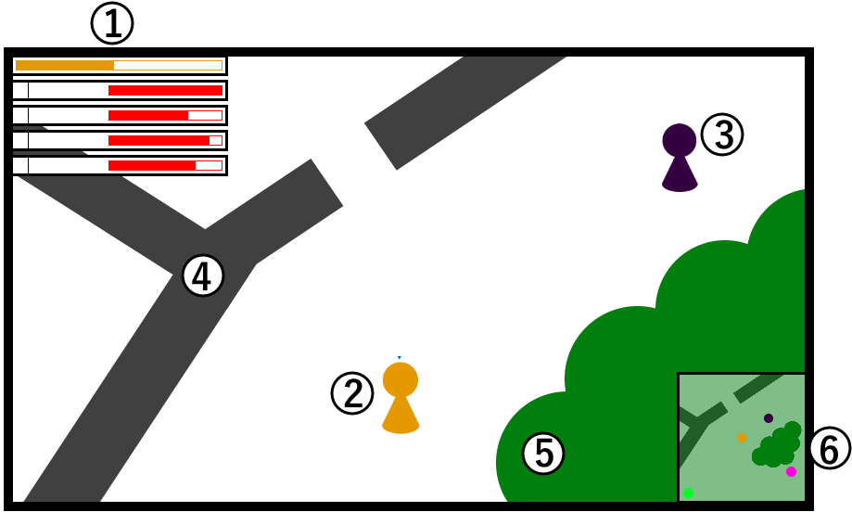

1. The Faith bar and party status condensed to top left of screen.
2. The player is in the centre region of the screen, but the camera isn’t attached to them, so they may be more to one side of the screen than others.
3. An enemy party appears on the map as a single model (party members are hidden to the player)
4. A wall -- characters cannot go through walls. The player can see past walls (unless it is part of a building that has a separate interior, for example a shop in a town, then they can’t), but enemies can’t.
5. Trees. An obstacle as walls.
6. The mini-map – shows a zoomed out view of the surrounding area, with the player perfectly centred. It shows game objects as icons to help direct the player to them. For example, gold is player, purple is enemy, green is (friendly) NPC, pink is an item.

Controller diagrams:

Battle

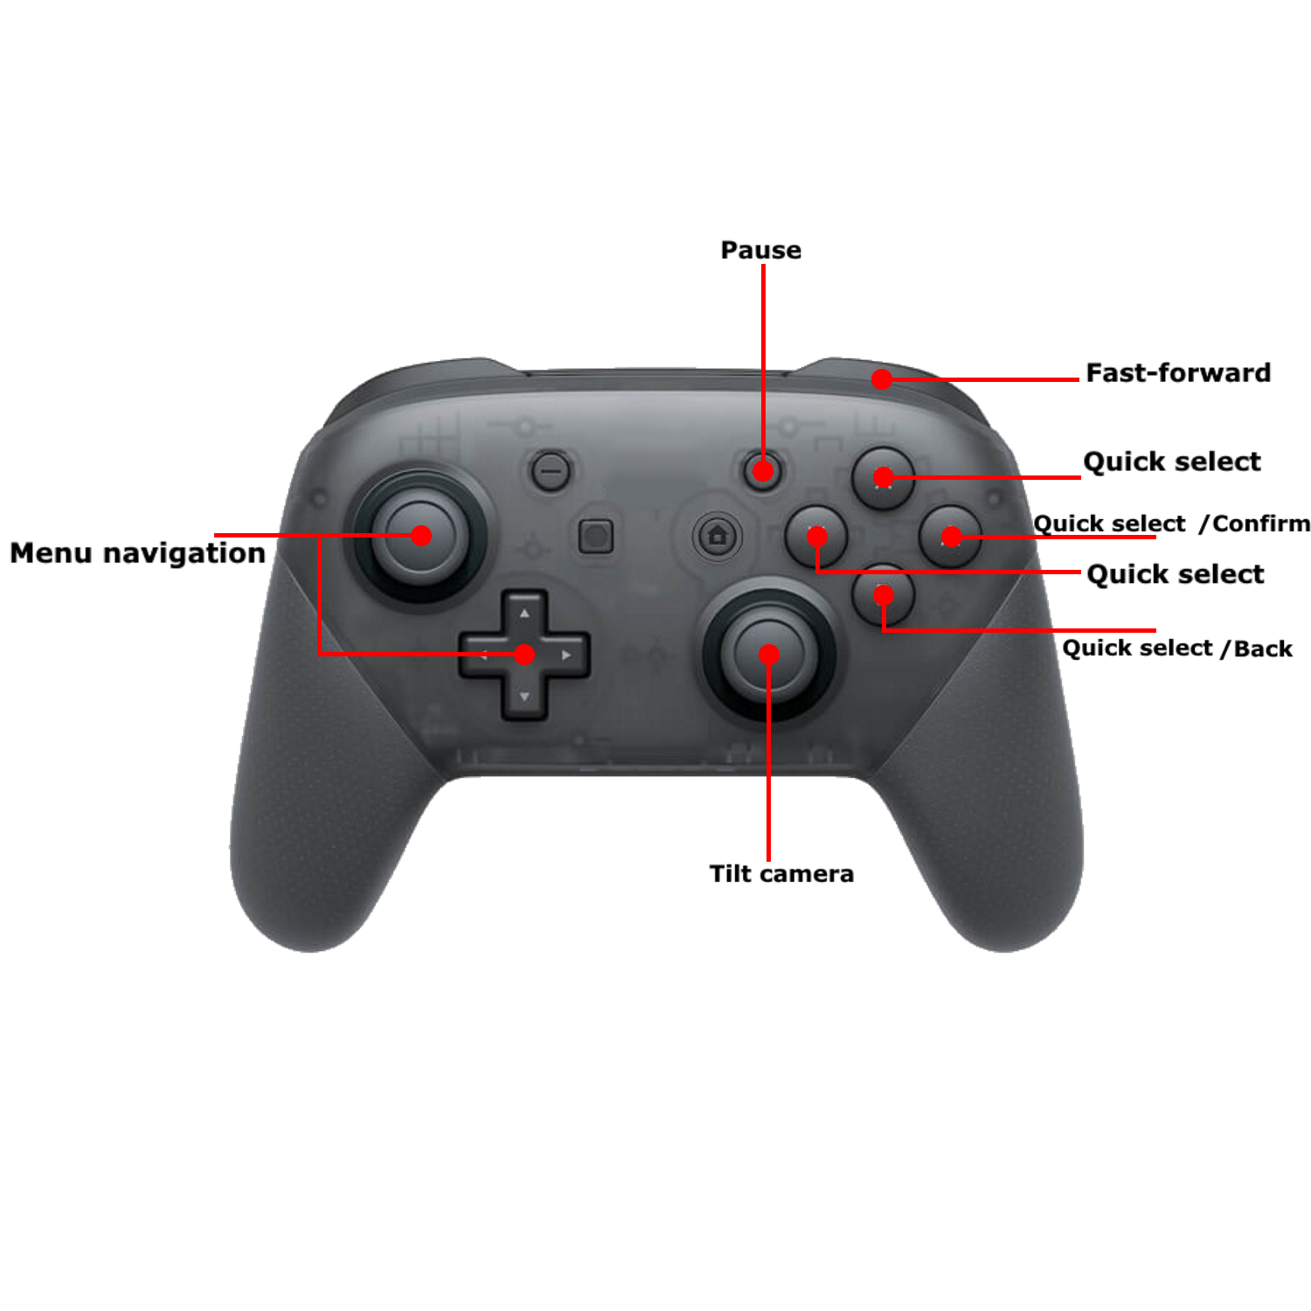Field

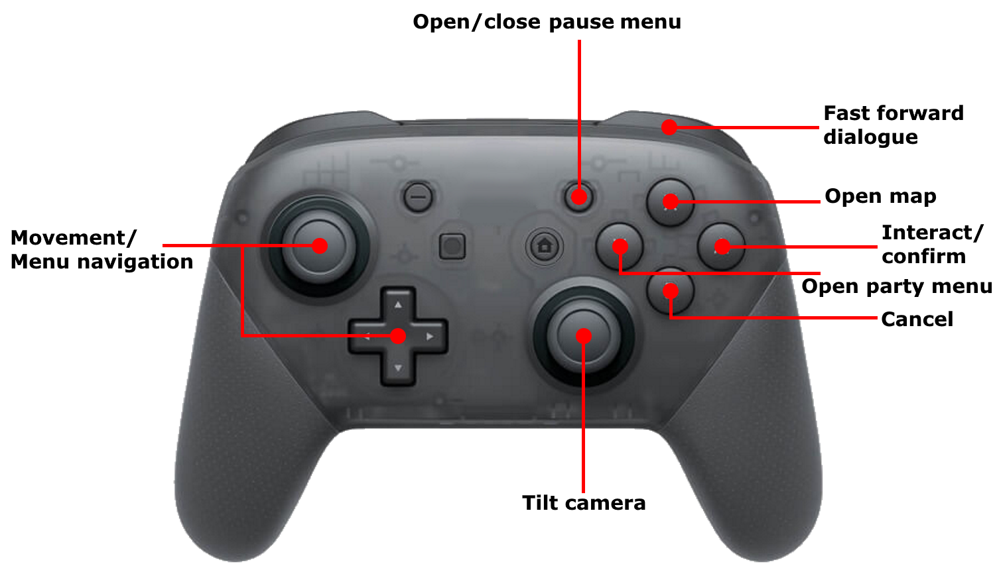

STORY:

World Backstory:

In a peaceful kingdom, the Archwizard Adranel plotted to overthrow the crown. The plot was discovered, but Adranel and a group of dissenters to the Crown fled the kingdom before they could be captured. It emerges that Adranel is using magic to conjure monsters in order to raise an army capable of overthrowing the Crown. So, the Queen tasks a prodigal knight (the player character) to assemble a team of magic users capable of stopping Adranel. A team is assembled and Adranel is stopped but as his final act before capture, he uses all of his power to summon the One Deity - the God of this world. The team uses everything they have and manage to slay One Deity and save the world from its wrath. The world is finally at peace once again, or so they thought…

Player Character Backstory:

The player-character (to be named by the player, in this section called PC for short) grew up comfortably as the child of a Lord that owned land outside of the Capital. They had little to worry about but soon got tired and sought a greater purpose. With the help of their father's connections, they were admitted to the Knight Training School where it became apparent that they would one day become a great knight capable of leading the military. That was until the day when they were approached by the Queen herself to go on a quest to bring back Adranel. They learned on their journey to grow close to other people as they couldn’t at home or at Knight school and to become a leader.

Character Backstory:

Kishi was a knight in training at the same time as PC. He came from a family of average wealth and led an unremarkable life. He wanted to become a knight because of the heroic image he had held of the knights from a young age and he has a strong sense of justice. He did not like or trust PC as he had to go through a much more rigorous process to join knight school (whereas PC was drafted in). He did not have a good relationship with PC so was surprised when he was asked to join the team on the player’s quest. He grew to trust and respect PC as they proved their worth and is over the initial jealousy (that it was).

Adranel had served as the Crown’s Archwizard since the current Queen’s birth until he fled the kingdom. He had though that, using his vast magic powers, he could take down the monarchy and replace it with what he called ‘government’. Though as his magical schemes grew larger, his mind deteriorated to the point where he wanted the kingdom destroyed by any means, which led to him summoning the One Deity to Earth. Since then, now imprisoned, he has mostly returned to what he was originally, but his magic is greatly diminished. He and the Queen reluctantly agreed that PC will need his knowledge of all that is Holy and Dark to be able to save the world.

Narrative:

Months since the defeat of the One Deity, PC and Kishi are working as knights in the capital and the rest of the party went back to their homes. They get a call to what they think is an ordinary job, but it turns out there is an otherworldly creature. They return to PC’s home town, only to find it is being attacked by a horde (in gameplay it’s only a few enemies) of *demons*. PC discovers that they can use powerful magic that they had never learnt from anywhere.

After defeating all of the demons, they go to the Queens palace to consult – then learn from Adranel that PC has gained powers similar to those of the One Deity. So, PC reassembles the party to protect the world from demons and find out how to stop them. Many battles with demons ensue as they try to drive demons out of the kingdom. They find an intelligent demon (I.e. normally they are just monsters) that tells them that as they defeat demons and gain Faith, the demons too get stronger – and that the strength of faith in PC was what led the demons to PC’s hometown. PC despairs and blames themselves for the destruction of their hometown. They must push forward as they have come too far to turn back. More bosses are beaten until PC realises that they aren’t wielding the power of the One Deity, they are a vessel for it – and that its presence is growing inside them.

The party fights their way to confront the intelligent demon but before they can defeat them, the demons merge into a colossus of darkness. Depending on what the player has done, the character decides on how they resolve the situation, which will lead to different endings: Okay/neutral ending (the one a regular player will get) – the PC sacrifices themselves to let the One Deity out increasing the party’s power but effectively killing the PC. The colossus is defeated and the One Deity fades away saving everyone forever(…?). Cool/bad ending (players that want PC to be *bad* would see this first) – the PC very much wants to keep their powers (and life, which isn’t known at this point) and they attempt to merge themselves with the colossus, but it results in an even worse monster. The player then fights their own party and the world is ended in a bad (but pretty cool) ending. True/good ending – if the player has completed (nearly) everything then PC is able to control the One Deity and use it to defeat the Colossus in a (more difficult than in the regular ending) battle. The player is also able to see what happens after the story – and continue playing, rather than the game forcefully reloading before the final boss.

TOKENS:

Battle:

Participants: (Player controlled) Player-character, Ally, (Enemy controlled) Grunt, Boss.

Participants have: Basic Skills (Attacks, Buffs/debuffs etc.), Special Skills (different for each (at least type of) unit), Holy Skills/Dark Skills (PC and Boss enemies can use these. Holy/Dark is just for theming for Player/Enemy), Faith Meter (Player and Enemy side, equivalent to MP), Attack timer

Field:

Player party, Enemy, Squares, Walls, NPCs, Holy/Dark landmarks

RULES:

1. Battle begins when the Player party collides with an Enemy on the Field.
2. Battle ends when Player's health or all Enemies’ health is reduced to 0. (If Player's health is reduced to 0 then it is game over, can also Game Over by running out of Faith)
3. An opponent's health can be reduced by using skills.
4. Skills have a value for how long until the user act again after using the it (character cooldown).
5. Skills have a Faith cost and damage value.
6. Win Faith back by doing damage to enemy causing them to fail. Lose faith by failing or being damaged.
7. A skill can fail by being interrupted/blocked.
8. When a threshold of Faith is reached, a Holy Skill can be used. Holy Skills are able to change certain properties of tokens and some rules (depending on the Skill used) in a battle.

FEATURES:

1. Balancing risk of using a skill and losing Faith against its potential reward of (doing damage and) gaining more Faith to use more skills (potentially leading to greater reward). (R3, R4, R5, R6)
2. Managing time available to use Skills to avoid having them fail or trying to make the opponents skills fail while trying to do damage (progress the battle), or ‘wasting’ a turn so a character can act at a better time. (R4, R7 in combination with F1)
3. Choose to prioritise short-term gain (do immediate damage) or long-term gain (save up Faith points to use a ‘super’ move) depending on the situation (types of enemy, which Skills they have etc.). (R6, R8)

START-UP:

At the end of the tutorial segment, the Player leaves a walled city and are blocked from re-entering. The immediate area is surrounded by dense forest, with two breaks in the trees. One is clearly the main path that will (a player would, correctly, assume) lead to progressing the story. The other is a smaller break with a small area with two enemies and a small shrine. Observant players may notice their Faith bar being very slowly chipped away. The player may choose to go to the small area to apply what they (should have) learned in the tutorial and gain experience (in both the literal and RPG sense) or they may skip this a go straight for the main path. The player is also able to access the menu where they can see a map, view the party’s status and save the game.

OBJECTIVES:

The main objective is to restore peace to the world by ridding it of demons. To do this the player needs to re-capture all territory from them. Take centres (large sections of territory) by beating bosses and expand your own territory by beating normal enemies. To beat enemies, e player needs to reduce their Health to 0 in a battle. Also aim to protect NPCs and landmarks from enemies. The player aims to defeat enemies, protect NPCs and landmarks to increase their own power so they can beat more powerful enemies (experience-type system).

PAY-OFF GRID:

This pay-off grid models the combat as a zero-sum game where the enemy losing health or player gaining health is positive to player and the opposite is true for the enemy. It is also simplified to be a 1 v 1 situation and have fixed turns.

1. Immediate attack short cooldown
2. Immediate attack long cooldown
3. Short charge no cooldown
4. Long charge short cooldown
5. Charging
6. Charging (safe)

|  |  |  |  |  |  |  |
| --- | --- | --- | --- | --- | --- | --- |
| P/E | 1 | 2 | 3 | 4 | 5 | 6 |
| 1 | 0 |  |  |  |  |  |
| 2 | 1 | 0 |  |  |  |  |
| 3 | 2 | 1 | 0 |  |  |  |
| 4 | 3 | 2 | 1 | 0 |  |  |
| 5 | -1.5 | -3 | -4.5 | -6 | 0 |  |
| 6 | -1 | -2 | -3 | -4 | 0 | 0 |

DECISION TREE:

Start

Enemy damaged

Enemy damaged, player in cooldown

Player charging

Player heavily damaged, faith decreased

Player damaged

Player damaged, enemy in cooldown

In this example the player chooses between three kinds of attacks: an attack with no cooldown, an attack with cooldown and an attack that requires charging. On the enemy’s turn the same options are available. The image shows the difference in change of state depending on option. The enemy could choose to charge but then the state would essentially stay the same and they could use different types of attack when the player is charging (this is condensed to a single box for conciseness)

Player charging, ally turn

Player and ally charging

Player charging and protected

Player charging, enemy stunned

One character knocked out of charging, heavily damaged

Player damaged, but still charging

Enemy misses turn

Enemy heavily damaged (player heavily damaged)

Enemy heavily damaged (player lightly damaged)

Enemy heavily damaged (player undamaged)

This example shows possible effects of decisions, in this case where the player has 2 characters having a turn before 1 enemy. The left sub-tree shows both characters charging attacks. The enemy can attack either – this results in one player character heavily damaged from being interrupted and the enemy being damaged from the charged attack – condensed into a single line, but it is two possibilities. The middle sub-tree shows one character charging and another using a skill to prevent an interrupt. Again, it shows that either character could be damaged, but a charged attack will still be used. The right sub-tree shows one character charge while the other stuns the enemy. In this case the enemy has no decision as it can’t act.

GAMEPLAY IN WORDS:

The gameplay is split into two phases: The Field and Battle. The Field is the game's overworld. The Field is comprised of territory, ruled by Holy (the Player) or Dark (Enemies’) forces. The player traverses the Field, travelling all over the game world to capture territory. To capture territory, the player must beat enemies in Battle. In Battle, the player (the player-character and party) uses skills to damage enemies. Skills may also strengthen allies, weaken enemies or stop them from attacking. Enemy parties aim to do the same to the player. Each skill takes time to use and a character cannot do other actions during this time. This time is split between ‘charging’ -- time in which the character can be interrupted -- and 'cooldown’ -- time in which the character cannot do anything. There are also Special Skills which differ between characters; some may special conditions for activation and/or have effects not available by other skills. The player can use their built-up Faith to use a Holy Skill that can change properties of characters and the rules of battle. The player’s maximum Faith is increased by defeating enemies, defending and resting at holy landmarks and by completing quests. The fun comes from finding which skills to use in combination with each other to best win depending on the skills that the player has available and what enemies they are facing. The player gets enjoyment from pulling off a complicated series of attacks. Then the aim is to keep doing this against stronger enemies (until the end of the game).

60 SECONDS OF GAMEPLAY:

I’ve reached this fort that I’m supposed to go to, so I can kill the next boss to advance the story. It looks like there is only one way in and it’s the front entrance which is conveniently open. I’ll interact with this shrine to replenish my Faith and then heal up. I’ll walk up to the gate but not go through just yet -- I’ll probably trigger something -- I should look first. There’s a single enemy waiting just past here. There’s no room to avoid it - it will definitely start chasing me as soon as I go through; I have no choice but to fight (not that I would try and avoid it, I need to level up before I face the boss).

The battle starts; it’s my party of 4 against the enemy party of 3 identical monsters - the type of which is new to me. I don’t know which skills are strong against this type of monster, so I’ll do some quick damage with various types of skills. My character is fastest so goes first - I'll use a quick (quick meaning no charge, short cooldown) fire attack on the middle guy (it doesn't matter which one). It didn't do much; I won't do that again. Next is my Mage: they don't have many offensive moves, so I'll use this Ice attack. Even though it didn't do much raw damage, I now know that Ice moves are a better choice. Next is my Axe wielder: they have a quick Wind element attack - eh, normal damage. All three enemies are going next - my Tank is so slow… Two of the enemies do a small amount of damage but the other is charging an attack - I don't know who it's targeting. Let's hope it's not targeting my Tank because they have a strong Ice attack which has charge time - and that will do plenty of damage. Next round: my character's already off cooldown. I can charge a skill and get it off before the enemies can go again. But first my Mage can act again. They won't be able to do much damage, so let's use this skill to raise my Tank's attack. And my Hero attacks - nice damage. Ouch that one enemy’s charged attack hurt my Mage badly. But now my Tank will attack - nice it's taken out that enemy.