PII Regex Scanner Workflow
Table of contents

PII Regex Scanner Workflow
This document explains the scanner logic in detail for:
PII_regex/pii_regex_scanner.threaded.v2.2.py
The scanner is evidence-led. It does not start by deciding who a person is. It starts by extracting text, finding atomic regex evidence, grouping evidence that co-occurs in a meaningful unit, clustering those units into inferred people, and optionally linking those inferred people to a supplied known-person table.

Package Layout
Version 2.2 uses a standard src package under PII_regex/src/pii_regex_scanner. The versioned script is a compatibility launcher; cli.py provides the package entry point, engine.py preserves the shared runtime composition, and focused modules expose the validation, assembly, extraction, structured-record, rules, scanning, clustering, person-processing, and continuation APIs.
The package can be launched directly with:
PYTHONPATH=PII_regex/src python3 -m pii_regex_scanner
The standard-library unittest suite lives under PII_regex/tests. It includes a generated contract test for every engine function and method, behavioral unit tests across each domain, and a complete command-line integration test.

Legal Disclaimer And Limitations
This tool uses a rule-based analytical approach to identify and re-identify potential personal data from linked evidence. It is designed to support review and triage, not to provide a definitive legal or forensic determination.
The approach does its best to associate evidence with individuals, but there is an inherent margin for error. False positives and false negatives may be introduced by source-data quality, OCR or text-extraction quality, structured-record boundary inference, regex rule coverage, table-header interpretation, clustering assumptions, repeated/common identifiers, incomplete records, and the supplied known-person table.
We are data analysts rather than data forensic experts. Although we have tried to follow relevant domain best practice when designing the workflow, rules, and outputs, users remain responsible for reviewing the results, validating material findings, and deciding how the outputs should be used. We cannot accept legal liability for decisions, reports, or actions based on this tool’s output.
The core model is:
File
-> extracted text
-> evidence
-> linked evidence
-> person cluster
-> known or unknown person reporting
-> individual risk matrices
The important distinction is:
Evidence
= one atomic match
e.g. Institutional Email = jane.smith@example.ac.uk
Linked evidence
= evidence values that co-occur in the same meaningful unit
e.g. one CSV row contains Full Name + Email + DOB + HUSID
Person cluster
= one or more linked-evidence rows merged by configured identity anchors
e.g. Email in file A links to Phone in file B
Known person exposure
= a person cluster, a cluster-excluded linked-evidence row, or a direct raw evidence row matched to a supplied person table
Unknown person in dataset
= an identity-anchored person cluster that did not match the supplied person table

High-Level Flow
The workflow is shown in three smaller stages so that scanning, clustering, and person reporting remain readable on separate pages.

Figure: Scanning And Evidence Generation
This figure summarizes the complete search stage from scanner startup through evidence and summary output.
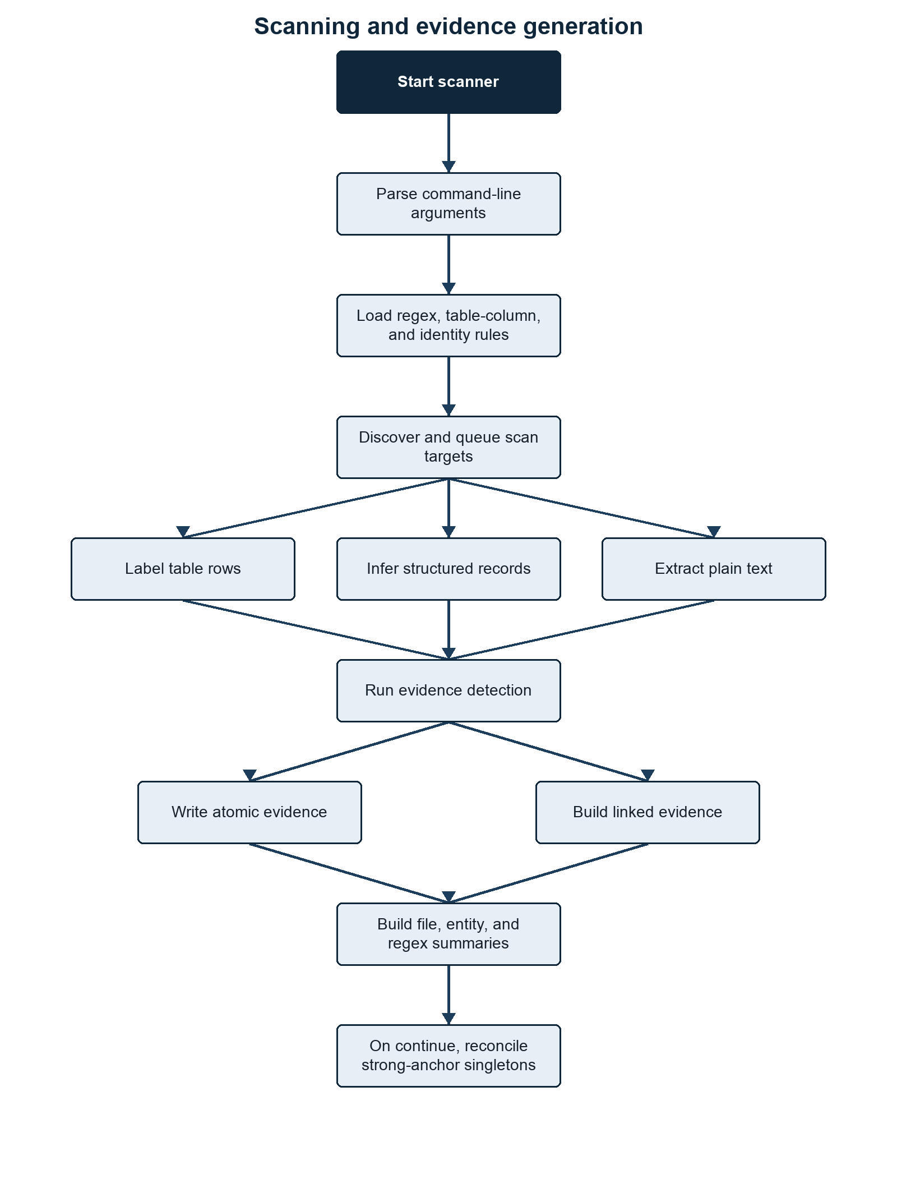
Scanning and evidence generation flow
Figure footer: This diagram shows the scan sequence from argument and rule loading through extraction, evidence detection, linked evidence, and summary generation.

Clustering
The clustering stage merges linked evidence rows into inferred people using configured identity anchors.

Figure: Person Clustering Workflow
This figure isolates the transition from linked evidence to inferred clusters and known-person matching.
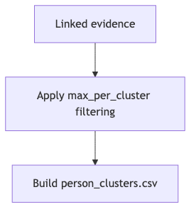
Person clustering workflow
Figure footer: This diagram shows how cluster-eligible linked evidence is merged into person clusters and then used for known-person matching.

Known And Unknown Person Outputs
Known-person processing compares the clustered dataset against the supplied person table and separates matched and unmatched records.

Figure: Known And Unknown Person Outputs
This figure shows how matched and unmatched identity-anchored clusters feed the person-level outputs.
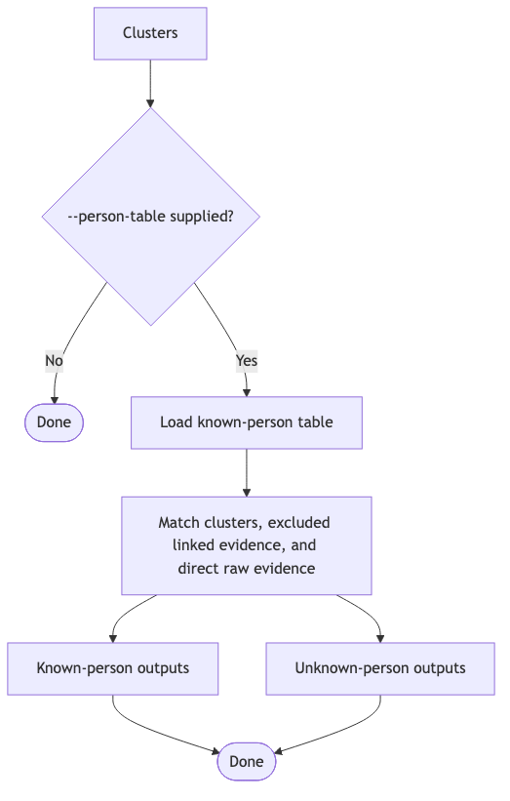
Known and unknown person outputs
Figure footer: This diagram shows how known-person exposure, unknown-person reporting, and per-person evidence outputs are derived.

Main Inputs

--root
The folder to scan. Every visible file under this root is considered unless it is hidden and --include-hidden has not been set, or the file or one of its folders matches --exclude.
The output directory is skipped when it sits inside the scan root, so the scanner does not recursively scan its own CSV outputs.

--output-dir
The folder where output CSVs are written.
The synthetic convention currently used is:
PII_regex/Synthetic/Outputs/<dataset_name>
The current synthetic datasets are:
PII_regex/Synthetic/inputs/breach_dump
PII_regex/Synthetic/inputs/exposed_dump
and their matching output folders are:
PII_regex/Synthetic/Outputs/breach_dump
PII_regex/Synthetic/Outputs/exposed_dump

--rules
Rules root, regex-rules directory, or legacy single JSON file.
Recommended full-rules layout:
PII_regex/rules/
regex_searching/
contact_location/
demographics/
financial/
identity_documents/
student_records/
technical/
table_column_rules/
contact_location/
demographics/
financial/
identity_documents/
name/
student_records/
person_identity_anchors.json
If --rules is omitted, the scanner uses the built-in email-only rule. That is deliberately minimal.
Table-column rules are always discovered from --rules. When --rules points to a rules root, the scanner looks for:
<rules root>/table_column_rules/**/*.json
If no table-column rules are supplied, built-in table-header rules are used.
Person-cluster identity merging is also discovered from --rules. When --rules points to a rules root, the scanner looks for:
<rules root>/person_identity_anchors.json

--person-table
Optional known-person CSV.
The person table can be any CSV shape. The scanner no longer requires fixed columns such as ID, UoN email, First Name, or Last name.
Person-table CSVs are read with encoding fallbacks for common exports. The scanner accepts UTF-8, UTF-8 with BOM, UTF-16-looking files, Windows-1252, and Latin-1. This avoids failures on non-breaking spaces and other common Excel/Windows CSV characters. The Python CSV field-size limit is raised to the largest value supported by the running interpreter so unusually large individual fields do not trigger field larger than field limit.
The scanner:
- preserves the original person-table columns;
- carries those original columns through to known-person outputs;
- treats an exact ID column as the known-person table primary key and as an ID matching anchor;
- resolves each other column name through table-column rules where possible;
- applies the loaded regex rules to each labelled cell;
- extracts email-looking values regardless of column name;
- builds matching anchors from the results;
- combines detected first-name and last-name columns into a full-name Name anchor.

--email-suffix
Optional institutional email suffix.
Example:
--email-suffix example.ac.uk
If set, the loaded Email rule is split at runtime:
Email ending in example.ac.uk -> Institutional Email
All other emails -> Personal Email
The split applies everywhere downstream:
pii_regex_evidence/
file_summary.csv
entity_summary.csv
regex_summary.csv
pii_regex_evidence_linked.csv
person_clusters.csv
known-person matching
risk matrices
The identity-anchor config treats Email as an alias that expands to the active email categories. With --email-suffix, Email expands to:
Institutional Email
Personal Email

--scan-images
Defaults to FALSE.
Use:
--scan-images TRUE
to OCR image files using pytesseract.
When false, image files can still be recorded as file signals, but image OCR text is not extracted.

Other Runtime Controls

Table: Runtime controls and scanner command-line options.
This table identifies the controls that change scan scheduling, resource use, extraction, continuation, and target selection.
Flag | Purpose
--workers | Number of process workers. If the process pool is unavailable, the scanner falls back to threads.
--pending-multiplier | Controls how many futures can be queued ahead of completion.
--max-findings-per-file | Optional cap on evidence rows written per file. 0 means no cap and is the default. Counts still reflect all scanned matches.
--ram-limit-gb | Approximate process-tree RSS budget for scan scheduling. Default is 25. Use 0 to disable.
--finding-buffer-mb | Parent-side finding buffer before flushing grouped evidence CSVs. Default 0 derives ((--ram-limit-gb / --workers) - 1) * 1024 MB, with a 64 MB minimum.
--hash-mode | processed, all, or none for MD5 calculation.
--progress-every | Seconds between progress prints during file scanning, person clustering, and known/unknown person processing.
--write-person-evidence | Writes optional per-person detail folders when set to TRUE. Default is FALSE.
--structured-records | Parses JSON, JSONL, XML, YAML, and YML into inferred record lines before regex scanning. Default is TRUE; set FALSE for plain-text fallback behavior.
--structured-max-depth | Maximum nesting depth inspected while inferring structured records. Default is 12.
--structured-max-records-per-file | Maximum inferred records emitted from one structured file. 0 means no cap and is the default.
--structured-max-record-fields | Maximum flattened scalar fields emitted in one inferred record. Default is 400.
--continue | Skips completed extraction/search outputs, reconciles strong-anchor singleton linkage from saved atomic evidence, and resumes downstream stages when linkage or outputs changed.
--exclude PATH [PATH ...] | Excludes files or folders from traversal. Bare names and relative multi-part path suffixes match at any depth; absolute paths match exactly. Both / and \ separators are accepted. The flag may be repeated.
--priority | Scan submission order: discovery (default), alphabetical, size (largest first), or type (grouped by extension). Non-default modes pre-index all targets.
--include-hidden | Includes dot-prefixed files and folders.
Table footer: These flags control scan parallelism, memory budgeting, structured extraction, continuation, exclusions, and submission order.

Rule Loading
Rule loading happens before files are scanned. It also happens inside worker processes so each worker has the same compiled configuration.

Figure: Runtime Rule-Loading Order
This figure shows the configuration sequence executed before files are scanned.
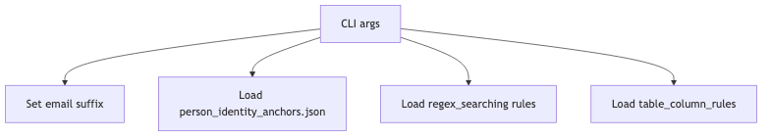
Runtime rule-loading order
Figure footer: This image shows the order in which email suffixes, identity anchors, regex rules, and table-column rules are loaded.

Figure: Loaded Rule-Derived Configuration
This figure summarizes the runtime collections rebuilt from loaded rule metadata.
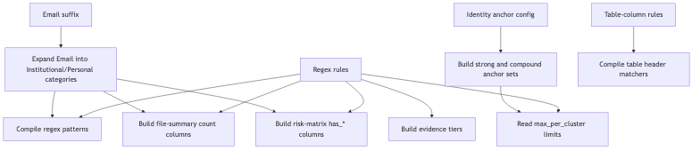
Loaded rule-derived configuration
Figure footer: This image shows the derived runtime sets used for evidence counting, risk roles, anchor priority, and file-signal handling.

The order matters:
- The email suffix is configured first.
- Identity anchors are loaded so the scanner knows which evidence types can be used for person merging.
- Regex rules are loaded.
- max_per_cluster values are read only for evidence types used by identity anchors.
- Table-column rules are loaded for table extraction and person-table matching.

Regex Search Rules
Regex search rules live under:
rules/regex_searching/**/*.json
Each file should contain one rule object.
Example:
{
"evidence_type": "DOB",
"pattern_name": "demographics_dob_context",
"confidence": "high",
"regex": "\\b(?:date\\s*of\\s*birth|birth\\s*date|dob)\\b\\s*[:=#-]?\\s*(?P<value>\\d{4}-\\d{2}-\\d{2}|\\d{1,2}[/-]\\d{1,2}[/-]\\d{2,4})\\b",
"flags": ["IGNORECASE"],
"risk_tier": "tier_2_sensitive_contextual",
"validator": "valid_contextual_date",
"line_triggers": ["date of birth", "birth date", "dob"],
"max_per_cluster": 3
}

Regex Rule Fields

Table: Regex rule fields and how the scanner uses them.
This table defines the supported JSON properties for regex rules and the runtime behavior controlled by each property.
Field | Required | Used for
evidence_type | yes | The category written to outputs, such as DOB, Name, Phone, or Passport.
pattern_name | yes | Stable rule identifier used in output file names and summaries.
regex | yes | Python regex string.
flags | no | Regex flags: IGNORECASE, MULTILINE, DOTALL, ASCII.
confidence | no | Review label written to evidence outputs. Defaults to medium.
risk_tier | no | Tier used to derive file risk, matrix columns, and risk logic. Defaults to tier 3.
validator | no | Name of an allowed internal validator function.
line_triggers | no | Fast lowercase substring checks before running contextual regexes on a line.
max_per_cluster | no | Maximum distinct values of this type allowed in one linked-evidence row before that row is excluded from clustering.
max_per_cluster_by_evidence_type | no | Email-specific override when Email is split into Institutional Email and Personal Email.
normalization | no | Normalization strategy for stored terms: none, lower, or compact_upper.
is_identifiable | no | Whether this evidence type can identify a person when combined with sensitive context.
is_high_risk_standalone | no | Whether this evidence type is high risk without any other evidence type.
Table footer: These fields control rule loading, validation, clustering limits, and the risk metadata derived from each regex rule.

Default/no-op rule metadata should be omitted. Missing normalization behaves as none, and missing booleans behave as false.
Address evidence is not produced by a loose postcode regex rule. It is code-derived only from labelled table or structured-record fields. A syntactically valid UK postcode must appear with at least one searchable address component. The scanner closes the current address group whenever it reaches a postcode, so sequential home/current/term groups on one source row emit separate Address findings rather than one synthetic merged address. Free-text address assembly is intentionally disabled because it produced too many false positives. Standalone postcodes are deliberately not reported as addresses.
Name evidence is also code-derived rather than produced by a free-text regex. Explicit full-name fields are accepted, while recognised first/last, given/family, or forename/surname fields are assembled within their field group. Repeated values separated by semicolons, pipes, or spaced slashes are paired positionally; one shared first or last name may be reused, but ambiguous unequal lists are rejected rather than combined as a cross-product. Prefixes such as applicant and guardian keep separate name groups. Name matching is case-insensitive after whitespace, title, apostrophe, and Surname, Given normalization. Unlabelled names in free text are not reported.
The generic technical Date search is not loaded in the default rules because it is too permissive for PII triage. Date-like values should be reported through contextual rules such as DOB.
CAS evidence is restricted to labelled CAS, CAS number, CAS no, or CAS id fields. The captured value must be exactly 14 uppercase alphanumeric characters and contain at least one letter and one digit. The label match is case-insensitive, but lowercase, hyphenated, short, long, or unlabelled CAS-like values are rejected.
Risk roles are derived from evidence_type in the scanner. Current rule files do not need to carry explicit role lists. The built-in derived roles are:

Table: Evidence types and their derived roles.
This table maps evidence categories to the semantic roles used by risk scoring and linkage logic.
Evidence type | Derived role
Address | address
DOB | dob
Email, Institutional Email, Personal Email | email
ID | id
Name | name
Payment Card | payment_card
Phone | phone
Application Number | application_reference
Table footer: These roles drive the risk logic and are inferred from the evidence type name rather than stored in the JSON rule files.

Active Search Rule Catalogue
The following catalogue describes every active JSON search rule under rules/regex_searching. Contextual rules require their label or trigger text; standalone rules run against every extracted line.

Contact And Location Rules

Email (contact_location_email)
Matches conventional email addresses case-insensitively and normalises them to lowercase. It is a high-confidence tier 1 identifier and runs on every line. With --email-suffix, matches become Institutional Email or Personal Email. A linked row may contain at most three institutional or five personal email values before cluster exclusion.

UK Phone (contact_location_uk_phone)
Matches UK-looking telephone numbers beginning with 0 or +44, including common mobile and geographic layouts. valid_uk_phone_rough requires 10 or 11 non-repeating digits after converting 44 to a leading zero. It is medium-confidence tier 3 supporting evidence and permits up to ten values per cluster candidate.

Demographic Rules

Citizenship/Country (demographics_citizenship_country_context)
Captures a text value following citizenship, nationality, country-of-birth/residence/domicile, domicile, or country labels. It is medium-confidence tier 2 sensitive evidence, uses matching label terms as line triggers, and permits up to five values.

Disability (demographics_disability_context)
Captures optional text following disability, disabled, accessibility, or reasonable-adjustment labels. It is medium-confidence tier 2 sensitive evidence and permits up to ten values. Because the captured value is deliberately broad, this rule requires review for contextual false positives.

DOB (demographics_dob_context)
Captures ISO dates or slash/hyphen day-first dates following date-of-birth, birth-date, or DOB labels. valid_contextual_date requires a real date within the rolling 100-year window ending on the scan date. It is high-confidence tier 2 sensitive evidence and permits up to three values.

Ethnicity (demographics_ethnicity_context)
Captures text following ethnicity, ethnic-group, or race labels. It is medium-confidence tier 2 sensitive evidence, uses those labels as triggers, and permits up to ten values.

Gender/Sex (demographics_gender_context)
Captures a controlled set of values following gender or sex labels: male, female, non-binary variants, other, prefer not to say, M, or F. It is medium-confidence tier 2 sensitive evidence and permits up to two values.

Religion (demographics_religion_context)
Captures text following religion, religious-belief, or faith labels. It is medium-confidence tier 2 sensitive evidence and permits up to ten values.

Financial Rules

UK Sort Code And Account (financial_uk_sort_code_account_context)
Captures a six-digit UK sort code together with an eight-digit account number after a sort-code or bank-sort label. It accepts common separators and optional account-number wording, then applies compact uppercase normalisation. It is high-confidence tier 1, identifiable, high risk as standalone evidence, and permits up to three values.

Payment Card (financial_payment_card_number)
Matches 13 to 19 digits with optional spaces or hyphens on every line. valid_luhn removes separators, rejects repeated single-digit sequences, and requires a valid Luhn checksum. It is high-confidence tier 1 and high risk as standalone evidence, with a three-value cluster limit.

UK UTR (financial_uk_utr_context)
Captures exactly ten digits after UTR or unique taxpayer reference. It is high-confidence tier 1 identifiable evidence, uses those labels as line triggers, and permits up to three values. The rule validates format only; it does not perform an HMRC lookup or checksum.

Identity Document Rules

Chinese National ID (identity_documents_china_national_id)
Matches standalone 18-character Chinese resident identity numbers. valid_china_national_id checks the encoded birth date against the rolling 100-year window and validates the final checksum character. It is high-confidence tier 1, identifiable, and high risk as standalone evidence.

GB Driving Licence (identity_documents_uk_driving_licence_context)
Captures the stable 16-character driver number after driving/driver licence labels and consumes, but does not store, an optional two-digit issue number. valid_uk_driving_licence validates the encoded birth year, gender-adjusted month, and day within the rolling 100-year assumption. It is high-confidence tier 1, identifiable, and high risk as standalone evidence.

UK National Insurance Number (identity_documents_uk_national_insurance_number)
Matches standalone NINO format: two permitted prefix letters, six digits, and suffix A to D, excluding the disallowed prefixes encoded in the regex. It is high-confidence tier 1, identifiable, and high risk as standalone evidence. No external allocation lookup is performed.

NHS Number (identity_documents_nhs_number)
Captures ten digits after an NHS label with optional grouping spaces or hyphens. valid_nhs_number applies the NHS modulus-11 checksum and rejects repeated-digit values. It is high-confidence tier 1, identifiable, and high risk as standalone evidence.

Passport (identity_documents_passport_context)
Captures 6 to 12 alphanumeric characters after a passport label. valid_passport_like rejects status words and requires at least one digit. It is high-confidence tier 1, identifiable, and high risk as standalone evidence, but it is intentionally a contextual multi-country format check rather than authoritative passport validation.

Student Record Rules

CAS Number (student_records_cas_number_context)
Captures exactly 14 uppercase alphanumeric characters after a CAS label and a required :, =, or # separator. valid_cas_number requires at least one letter and one digit. It is high-confidence tier 1 and high risk as standalone evidence.

HUSID (student_records_husid_context)
Captures exactly 13 digits after a HUSID label. valid_husid_entry_year checks that the leading two-digit year can represent a year of entry within the rolling 100-year window. It is high-confidence tier 1 identifiable evidence. The validator does not currently implement the legacy HUSID check-digit algorithm.

SLC ID (student_records_slc_id_context)
Captures 6 to 20 alphanumeric characters after an SLC, SLC ID, SLC number, or SLC no label. It is high-confidence tier 1 identifiable evidence with compact uppercase normalisation. This is a broad contextual institutional rule and does not validate against Student Loans Company systems.

Student SSN (student_records_student_ssn_context)
Captures a nine-digit US-style SSN, with or without 3-2-4 hyphen grouping, after an SSN or student SSN label. It is high-confidence tier 1, identifiable, and high risk as standalone evidence. The digits do not encode a birth date and no SSA lookup is performed.

Technical Rules

IPv4 Address (technical_ipv4)
Matches four decimal octets from 0 to 255 on every line. It is low-confidence tier 3 supporting evidence and permits up to ten values. It validates syntax only and does not distinguish public, private, reserved, broadcast, or loopback ranges.

Code-Derived Evidence

Name (assembled_name)
Name is not loaded from regex JSON. It is assembled from recognised full-name or paired first/last fields in labelled tables and structured records, normalized case-insensitively, and validated as a multi-word name. It is tier 3 identifiable supporting evidence with a ten-value cluster limit.

Address (assembled_address)
Address is not loaded from regex JSON. It is assembled from recognised address/locality fields only when accompanied by a syntactically valid UK postcode and a searchable address component. It is tier 3 supporting evidence with a ten-value cluster limit; standalone postcode and free-text address searching are intentionally disabled.

Validators
Validators are not arbitrary code from JSON.
A rule can contain:
"validator": "valid_uk_postcode"
The scanner looks up that name in its internal validator map. If the name is allowed, it calls the Python function after the regex match. If the validator returns False, the match is discarded.
Allowed validators currently include:
valid_luhn
valid_nhs_number
valid_ucas_personal_id
valid_cas_number
valid_husid_entry_year
valid_uk_driving_licence
valid_bare_8_digit_id
valid_uk_postcode
valid_contextual_date
valid_passport_like
valid_china_national_id
valid_orcid
valid_uk_phone_rough
DOB and date-of-entry validation uses a rolling 100-year window ending on the scan date. Explicit DOB values and the full birth date embedded in a Chinese national ID must be real calendar dates within that window. GB driving-licence numbers validate their encoded year, gender-adjusted month, and day using the same assumption. Legacy 13-digit HUSIDs validate their two-digit year-of-entry component, although a two-digit year cannot independently prove its century across an exactly 100-year window.

Validator Behaviour
- valid_luhn: requires 13 to 19 digits, rejects a repeated single digit, and applies the Luhn checksum. Used by Payment Card.
- valid_nhs_number: requires ten non-repeating digits and applies the NHS modulus-11 checksum. Used by NHS Number.
- valid_ucas_personal_id: accepts exactly ten digits after removing non-digits. Available to rules but not used by the current active JSON set.
- valid_cas_number: requires exactly 14 uppercase alphanumeric characters containing at least one letter and one digit. Used by CAS Number.
- valid_husid_entry_year: requires exactly 13 digits and interprets the leading two digits as a possible entry year in the rolling 100-year window. Used by HUSID.
- valid_uk_driving_licence: requires the 16-character GB driver-number structure and validates its encoded date fields. Used by Driving Licence.
- valid_bare_8_digit_id: requires eight non-repeating digits and rejects obvious sequences and values shaped like common eight-digit dates. Available to rules but not used by the current active JSON set.
- valid_uk_postcode: applies the scanner’s UK postcode syntax, including GIR 0AA. Used internally by address assembly rather than by an active regex JSON rule.
- valid_contextual_date: parses the supported DOB formats and requires a real date in the rolling 100-year window. Used by DOB.
- valid_passport_like: requires 6 to 12 alphanumeric characters, at least one digit, and rejects configured administrative status words. Used by Passport.
- valid_china_national_id: validates 18-character structure, embedded birth date, rolling date window, and checksum. Used by Chinese National ID.
- valid_orcid: applies the ISO 7064 MOD 11-2 checksum to a 16-character ORCID representation. Available to rules but not used by the current active JSON set.
- valid_uk_phone_rough: normalises a leading country code, requires 10 or 11 non-repeating digits, and requires a leading zero. Used by UK Phone.
Unknown validator names cause startup to fail.

line_triggers
line_triggers are not table-column rules.
They are a performance filter for regex scanning. If a regex is broad and contextual, the scanner only runs it on lines containing at least one trigger term.
Example:
"line_triggers": ["student id", "student number", "student no"]
If a line does not contain one of those strings, that rule is skipped for that line.
Rules without line_triggers run on every line.

Evidence Types Are Derived From Rules
The loaded regex rules and the code-derived Name and Address definitions are the source of evidence categories.
From evidence_type, risk_tier, and rule metadata, the scanner builds:
EVIDENCE_COUNT_TYPES
EVIDENCE_COUNT_COLUMNS
EVIDENCE_FLAG_COLUMNS
EVIDENCE_NORMALIZATION
EVIDENCE_RISK_ROLES
TIER_1_EVIDENCE
TIER_2_EVIDENCE
TIER_3_EVIDENCE
IDENTIFIABLE_EVIDENCE
HIGH_RISK_STANDALONE
ID_EVIDENCE_TYPES
ANCHOR_PRIORITY
file_summary.csv count_* columns
known_person_individual_risk_matrix.csv has_* columns
unknown_person_individual_risk_matrix.csv has_* columns
This means removed rules should not appear in new summary outputs unless stale output files are still being viewed, another loaded rule emits that evidence type, or the evidence type is one of the active code-derived definitions.
Risk logic uses these derived sets and evidence-type roles. For example, Email + DOB is evaluated as roles email and dob, not as hard-coded output column names. Payment Card-style logic is triggered by the derived payment_card role and high-risk standalone logic is triggered by is_high_risk_standalone.
The scanner still supports legacy risk_roles in JSON, but the current rules/regex_searching/**/*.json files do not use it. Prefer deriving roles from evidence_type unless the scanner code is deliberately extended with a new semantic role.
File-signal evidence is also gated by the active rule-derived evidence types. For example, the scanner only emits image extension evidence when Pictures is present in the loaded evidence types, and only emits document extension evidence when Document Info is present.

Table-Column Rules
Table-column rules live under:
rules/table_column_rules/**/*.json
They are grouped in folders in the same spirit as regex_searching.
Example:
{
"canonical_header": "student id",
"pattern_name": "student_records_student_id_column",
"header_patterns": [
"\\bstudent\\s*(?:id|number|no)\\b"
]
}
Most current table-column rules use canonical_header, pattern_name, and header_patterns. The loader also still accepts older header_terms rules. In the current rules folder, other_identifiers.json uses that legacy form to provide broad table-detection terms; those terms resolve to the rule name when used as a canonical header.
Another example for split names:
{
"canonical_header": "first name",
"pattern_name": "name_first_name_column",
"name_part": "first",
"header_patterns": [
"\\b(?:first|given|forename)\\s*names?\\b"
]
}

What Table-Column Rules Do
Table-column rules do three things:
- Decide whether headers look like an individual-data table.
- Resolve messy source headers to canonical labels.
- Add metadata, such as name_part, that downstream logic can use.
Most table-column rules do not directly emit PII evidence. They rewrite row text so regex rules can match consistently. Name and address columns are the exceptions: their resolved field roles feed the code-derived name and address assemblers.
Example source table:
HUSID,Given Name,Family Name,Birth Date,Primary Email
2411841234567,Jane,Smith,2001-04-12,jane.smith@example.ac.uk
After table-column resolution, the row becomes labelled text similar to:
TABLE_ROW contacts.csv #1 | husid: 2411841234567 | first name: Jane | last name: Smith | dob: 2001-04-12 | email: jane.smith@example.ac.uk | full name: Jane Smith
The regex scanner then sees that as ordinary text and can emit:
HUSID = 2411841234567
Name = Jane Smith
DOB = 2001-04-12
Institutional Email = jane.smith@example.ac.uk

Header Resolution
For each header, the scanner:
- normalises whitespace;
- checks every compiled header_patterns regex;
- picks the earliest matching pattern in the header;
- uses the configured canonical_header;
- keeps metadata such as name_part.
If no header rule matches, the original header is kept.

Full Name Handling
The scanner supports composite full names across multiple columns.
If table-column rules mark one column with:
"name_part": "first"
and another with:
"name_part": "last"
then the table extractor appends:
full name: <first> <last>
to the labelled row.
This matters because clustering should generally use a full name, not a first name or surname fragment. The clustering code also prefers full-name values for Name compound anchors when they are available.

Person Identity Anchors
Person-cluster merging is controlled by:
rules/person_identity_anchors.json
Example:
{
"strong_anchor_types": ["Email"],
"compound_anchor_sets": [
["Email", "Name", "Address"],
["Email", "Name", "Passport"],
["Email", "Name", "Driving Licence"],
["Email", "Phone"],
["Email", "National Insurance Number"],
["Email", "NHS Number"],
["Phone", "Name", "Address"],
["Name", "NHS Number"],
["Name", "HUSID"],
["Name", "CAS Number"],
["Name", "DOB", "Address"]
],
"anchor_priority": {
"Email": 10,
"Institutional Email": 10,
"Personal Email": 10,
"Phone": 20,
"National Insurance Number": 30,
"NHS Number": 40,
"Passport": 50,
"Driving Licence": 60,
"Name": 70
}
}

strong_anchor_types
One distinct value of a strong-anchor type is sufficient to create an identity candidate. Strong anchors also merge candidate rows globally when they share that normalized value. Lines containing several different values of only that type are not treated as one identity candidate.

anchor_priority
anchor_priority chooses the representative anchor_type for a linked-evidence row when several evidence types co-occur. Lower numbers win. It does not control cluster merging; cluster merging is controlled by strong_anchor_types and compound_anchor_sets.
Example:
strong:Institutional Email:jane.smith@example.ac.uk
If two linked-evidence rows share that key, they are treated as the same inferred person cluster.

compound_anchor_sets
Compound anchors require all configured evidence types to be present together.
Example:
["Email", "Phone"]
creates keys like:
compound:Email+Phone:jane.smith@example.ac.uk:07700900123
This avoids merging on weak identifiers such as name alone.

Full Name Alias
The evidence type emitted by the code-derived name assembler is:
Name
not:
Full Name
For clarity, compound_anchor_sets should normally use:
["Email", "Name", "Address"]
However, the scanner accepts Full Name as an alias and resolves it to Name, so this also works:
["Email", "Full Name", "Address"]
The canonical recommendation is still Name, because the value can be a full-name value such as Jane Smith.

Email Alias Expansion
If --email-suffix is not set, Email means:
Email
If --email-suffix is set, Email expands to:
Institutional Email
Personal Email
This means an identity-anchor config can remain stable:
"strong_anchor_types": ["Email"]
while the runtime evidence types adapt to the email split.

File Enumeration
With the default --priority discovery, the scanner walks --root and queues targets incrementally. This avoids retaining a complete target index in memory.
The other priority modes perform a pre-indexing pass before scanning:
alphabetical sort by full path
size largest files first
type group by file extension, then sort by path
Pre-indexing is required because global ordering cannot be known until traversal is complete. Priority controls submission order; parallel worker completion and output row order can still differ.
It counts:
files
empty folders
In discovery mode the scanner reports that files are being discovered and queued incrementally; the final total becomes known when traversal finishes. Pre-indexed priority modes know the total before worker submission begins.
Hidden files/folders are skipped unless:
--include-hidden
is supplied.
Files and folders can be excluded by name or path, with multiple values supplied together or through repeated flags:
--exclude cache backups "archive/old" --exclude staging.csv
Bare names such as cache or staging.csv match files or folders at any depth. Multi-part relative paths match the same trailing path sequence at any depth, so WP\PostCodes excludes both <root>\WP\PostCodes and <root>\archive\WP\PostCodes, including their complete subtrees. Absolute paths match only that exact file or folder location.
If the output directory is inside the root, the scanner skips it to avoid scanning previous outputs.
Empty folders are emitted as scan targets, but the scanner does not currently emit Empty Folder evidence into the dynamic evidence categories unless a rule or signal path is configured for it.

File Type Detection
The scanner does not rely only on filename suffixes.
For each file it:
- records the original filename extension in extension;
- reads the first bytes;
- detects content signatures;
- records the extraction route in detected_extension;
- uses detected_extension for extraction where possible.
Content sniffing can recognise:
PDF
OLE/legacy Office containers
ZIP-based Office files
RTF
HTML
XML
PNG/JPEG/GIF/TIFF/BMP/WEBP/HEIC
text-like files
CSV/TSV-like text
This helps with scrambled suffixes, for example a real .xlsx file saved with a wrong extension.
For some old or unusual files, extraction can still fail. The error is written to:
pii_regex_evidence/errors.csv
file_summary.csv

Text Extraction
The extraction stage first routes structured, tabular, document, image, and plain-text inputs through the appropriate parser.

Figure: Structured And Plain-Text Extraction Routing
This figure separates structured parsing, plain-text decoding, and table extraction before they converge as scan text.
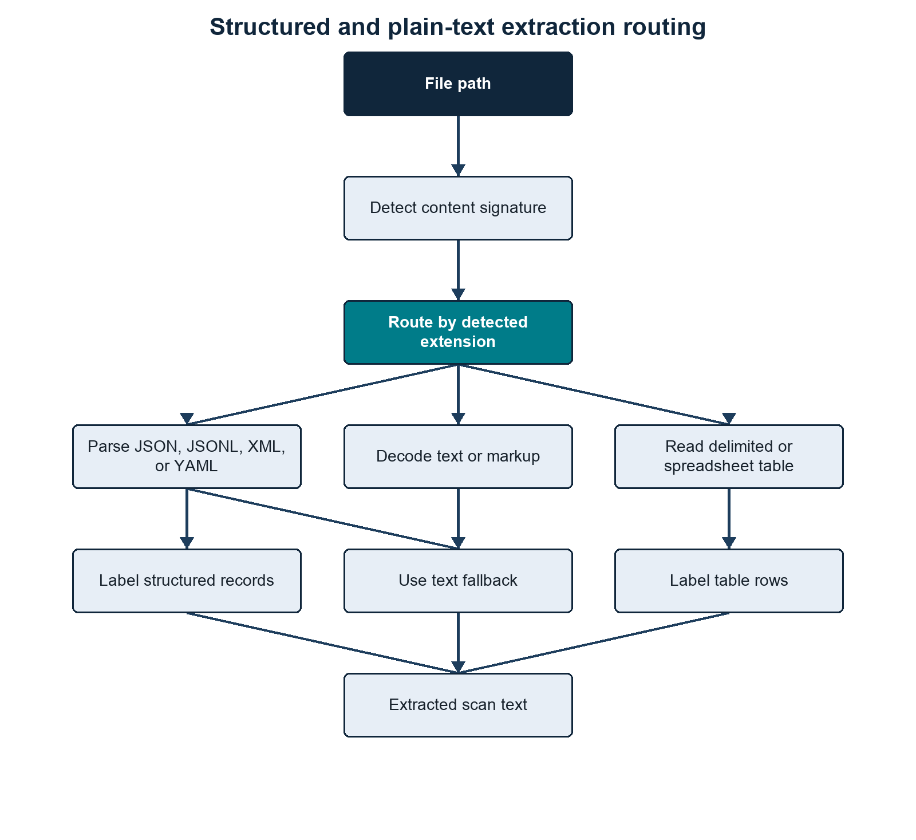
Structured and plain-text extraction routing
Figure footer: This diagram shows how structured data, plain text, delimited tables, and spreadsheets are routed into labelled scan text.

Figure: Document And Image Extraction Routing
This figure shows the parser selected for supported document types and the two image-OCR outcomes.
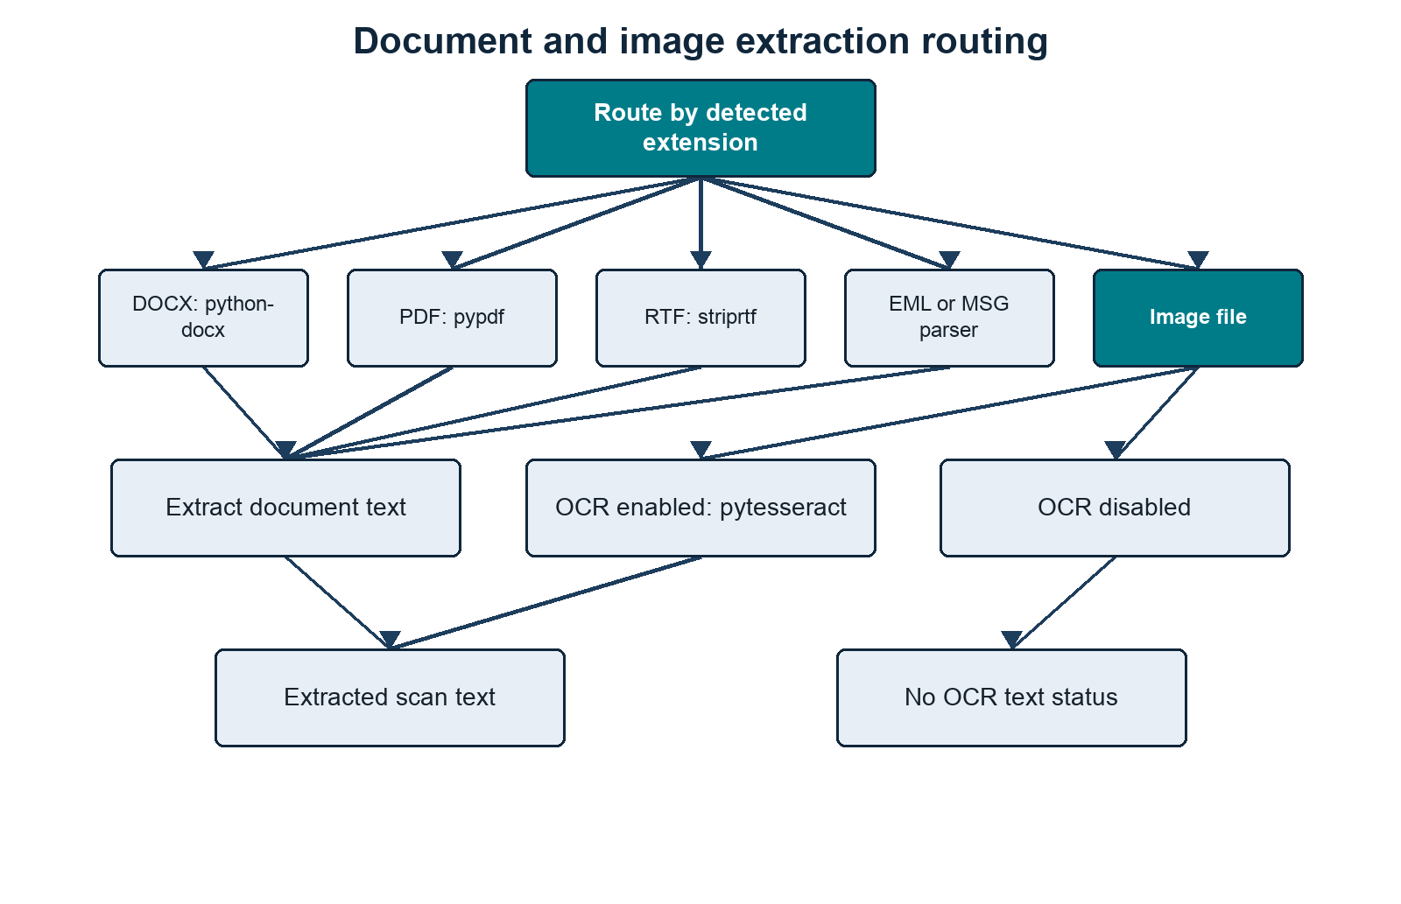
Document and image extraction routing
Figure footer: This diagram shows document and image extraction routes, including the OCR-enabled and OCR-disabled outcomes.

Text-Like Files
Text files are decoded with UTF-aware logic:
UTF-16 BOM
UTF-8 BOM
UTF-16-looking byte patterns
UTF-8 fallback with errors ignored
Binary-looking files are skipped as binary_like_content.

Structured JSON, JSONL, XML, and YAML
Structured-record processing is enabled by default for .json, .jsonl, .xml, .yaml, and .yml. Instead of scanning the serialized document as one undifferentiated text block, the scanner parses the hierarchy and emits bounded labelled lines such as:
JSON_RECORD $.export.student | export.source: SIS | export.student.STUDENT_ID: S1234567 | export.student.FIRST_NAME: Jane | export.student.LAST_NAME: Smith | export.student.BIRTH_DATE: 2001-04-12 | full name: Jane Smith
JSON_RECORD $.export.student.email[0] | export.source: SIS | export.student.email.type: home | export.student.email.value: jane@example.com
Each emitted line is scanned independently. It therefore becomes the meaningful co-occurrence unit used to build linked evidence, in the same way that one labelled CSV row is treated as a unit. This avoids linking every identifier in a large JSON or XML document merely because it appears in the same file.

Parsing by format
- JSON is parsed as one document.
- JSONL is parsed one non-empty source line at a time. Its generated record path retains the original JSONL line number.
- XML is converted into an equivalent nested structure. Attributes use @attribute internally, mixed element text uses #text, and repeated sibling tags become lists.
- YAML and YML use yaml.safe_load; structural YAML processing requires PyYAML.
If structural parsing raises an error, the scanner falls back to its normal text extraction path. JSON, JSONL, YAML, and YML then receive plain-text scanning; XML falls through to markup text extraction. If a valid structured document contains no sufficiently person-like record, its raw text is also scanned. For JSONL, malformed lines are ignored when structured records are successfully emitted from other lines; use --structured-records FALSE when every raw line must be scanned regardless of validity.

Record inference
Record boundaries are inferred from both structure and evidence-bearing field names. Keys are humanised across snake case, hyphens, and camel case before scoring. Strong fields include email and common institutional, person, passport, national, NHS, UCAS, CAS, visa, BRP, username, and identifier fields. Supporting fields include names, DOB/birth date, phone, address, postcode, sex, gender, and nationality. Email values, valid UK postcodes, and contextual dates also contribute to the score. The internal evidence score is 3 * strong fields + supporting fields; a node needs a score of at least 2 before it can be emitted, with additional structural checks deciding where the record boundary sits.
Objects are candidates when they are list items with sufficient evidence, have person-like names such as student, employee, patient, or applicant, contain direct identity evidence, or otherwise contain a defensible combination of strong and supporting fields. Fragment containers such as address, contactDetails, emails, documents, and demographics are normally folded into the nearest person record unless an individual list item is itself a record candidate.
Safe administrative context such as source system, application, case, department, status, timestamps, role, or reference can be inherited by child records. Identity-bearing parent fields are not inherited as generic context, which reduces accidental cross-person linkage.

Parent and repeated child records
Some structures make a person node serve two roles at once:
student
STUDENT_ID
FIRST_NAME
LAST_NAME
BIRTH_DATE
email[]
address[]
programme[]
When a parent has enough direct evidence, the scanner emits a parent self-record while excluding nested child-record subtrees from that parent line. It then emits qualifying repeated email, address, or other child records separately. This preserves parent-level demographics and identifiers without collapsing several sibling records into one unsafe mega-record. Non-record child fields may remain attached to the parent, subject to the field limit.
When exactly one qualifying record exists deeper in a weak container, the scanner lets that lower node become the record and passes down only safe context. When first-name and last-name fields resolve uniquely within a record, it also adds a synthesized full name field for the existing name rules.
The defaults inspect 12 nesting levels, emit an unlimited number of records per file, and cap each record at 400 scalar fields. These can be changed with the --structured-* flags. Depth and field caps can omit evidence beyond their limits; unlimited record output can increase processing time and output volume on very large exports.
Generated row_number, context, and source_row values refer to the emitted labelled record line rather than the original pretty-printed JSON, XML, or YAML line layout. Record inference is heuristic and can still produce false boundaries, missed records, false positives, or false negatives.

CSV and TSV
CSV and TSV files are read as tables when possible.
The first row is treated as headers. If table-column rules recognise the headers, rows are converted into labelled text.
If headers are not recognised, the raw text is scanned.

Excel and Spreadsheet Files
Spreadsheet files are converted into labelled table text where possible.
For .xlsx and .xlsm, the preferred route is openpyxl read-only mode.
For other spreadsheet formats, pandas readers are tried with the relevant engine:
.xlsb -> pyxlsb
.ods -> odf
.xls -> xlrd
There are fallback readers for mislabelled content, including OOXML, HTML tables, delimited text, markup text, and plain text where the bytes are readable.

Word, PDF, RTF, Email, Images

Table: Built-in extractors used for each supported file type.
This table identifies the parser or OCR route used for each supported document and image format.
Type | Extractor
.docx | python-docx paragraphs and tables
.pdf | pypdf embedded text
.rtf | striprtf
.eml | Python email parser
.msg | extract_msg
images | pytesseract, only when --scan-images TRUE
Table footer: The scanner chooses the extractor by detected content type and falls back through the listed routes when the preferred reader fails.

Table Handling
Tables are handled by turning row data into plain labelled text.

Figure: Table Handling Pipeline
This figure follows source headers and cells through canonical labelling and evidence detection.
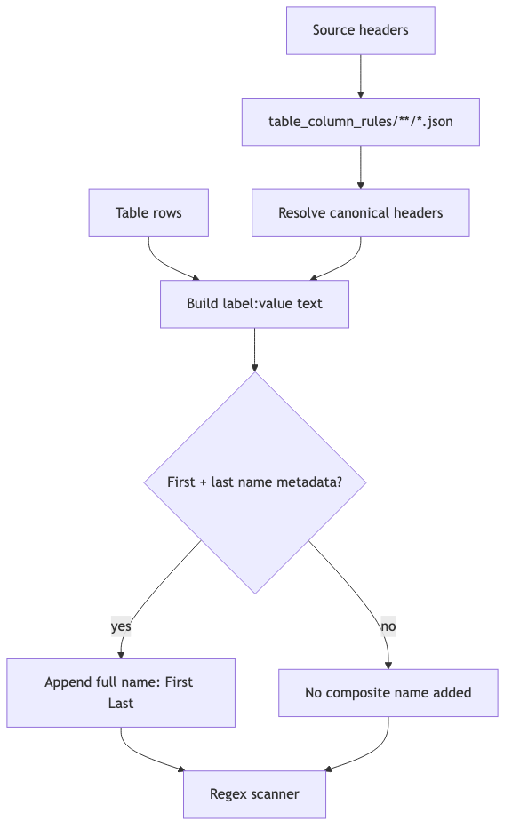
Table handling pipeline
Figure footer: This diagram shows how table headers are resolved, row values are labelled, and the resulting text is passed to evidence detection.

Table-column rules identify field roles as well as providing regex context. Most evidence types are still selected by regex rules, while Name and Address are assembled directly from recognised structured fields.
Example:
source header: Birth Date
canonical header: dob
labelled text: dob: 2001-04-12
regex match: DOB = 2001-04-12
If a table has Given Name and Family Name, and the table-column rules mark them as first/last name parts, the scanner assembles:
full name: Given Family
That directly emits:
Name = Given Family

Evidence Creation
Evidence is created line by line from extracted text. Recognised name and address fields are assembled first; configured regex rules then process the same line.
For each extracted line:
- assemble valid names and addresses from recognised labelled fields;
- start with standalone regex rules;
- add contextual rules whose line_triggers appear in the line;
- run the selected regexes;
- use the named capture group value if present;
- otherwise use the whole regex match;
- run any configured validator;
- split email evidence into institutional/personal if --email-suffix is set;
- normalise the value;
- write the atomic evidence row;
- keep a compact representation for linked-evidence creation.
The atomic evidence fields are:
file_path
file_name
extension
size_bytes
md5
row_number
evidence_type
matched_text
normalized_value
start
end
context
pattern_name
confidence
evidence_tier
Evidence rows are written into:
pii_regex_evidence/
The evidence folder contains one CSV per regex/pattern/evidence output bucket, plus:
pii_regex_evidence/errors.csv

Value Normalisation
Normalisation is evidence-type specific.
Examples:
Email -> lowercase
Institutional Email -> lowercase
Personal Email -> lowercase
Phone -> whitespace/hyphen removed, uppercase
Address -> whitespace/hyphen removed, uppercase
IDs/documents/accounts -> whitespace/hyphen removed, uppercase
Other values -> stripped original value
Clustering and person-table matching use normalised values.

Linked Evidence
A linked-evidence row is normally built from multiple evidence findings on the same extracted line or labelled table row. A single distinct value is also retained when its evidence type is configured as a strong identity anchor, allowing a standalone strong identifier such as an email address to form an identity candidate.
The scanner only creates linked evidence if:
- the line contains at least two distinct evidence types and one can act as an anchor according to ANCHOR_PRIORITY; or
- the line contains exactly one distinct value whose evidence type is listed in strong_anchor_types.
A line containing several values of only one evidence type is not converted into a strong-anchor singleton. This prevents an email distribution list from being treated as one person.
Example linked row:
Name=Jane Smith
DOB=2001-04-12
Institutional Email=jane.smith@example.ac.uk
HUSID=2411841234567
Output:
pii_regex_evidence_linked.csv
Fields:
linked_evidence_key
file_path
file_name
extension
row_number
anchor_type
anchor_value
evidence_types
evidence_values
confidence
risk_level
risk_reasons
cluster_eligible
cluster_exclusion_reason
source_row

Linked-Evidence Risk
Linked evidence is scored from the evidence types present in that row.
High-risk examples include:
configured high-risk standalone identifier present
Name + DOB
Email + DOB
an evidence type with the ID risk role + identifying detail
sensitive attribute + identifiable evidence
payment card passing Luhn validation
Medium and low risk are assigned when evidence is weaker or less linked.
This row-level risk is later aggregated into cluster/person risk.

Cluster Eligibility Filtering
Not every linked-evidence row is safe to use for person clustering.
Some rows are list-like, such as:
email: a@example.ac.uk | email: b@example.ac.uk | email: c@example.ac.uk | email: d@example.ac.uk
or:
email: a@example.org | email: b@example.org | email: c@example.org | email: d@example.org | email: e@example.org | email: f@example.org
Those rows can contain real evidence but are poor identity-merge units.
With --email-suffix enabled, the first example exceeds the current three-value limit for Institutional Email, while the second exceeds the five-value limit for Personal Email. Without an email suffix, the unsplit Email rule uses its five-value limit.
The scanner checks max_per_cluster on regex rules, but only for evidence types used in:
rules/person_identity_anchors.json
If a linked-evidence row has more distinct values of an identity evidence type than allowed, it is marked:
cluster_eligible = no
cluster_exclusion_reason = too_many_<evidence_type>_values:<actual>><limit>
Cluster-excluded rows:
- remain in pii_regex_evidence_linked.csv;
- are counted in file_summary.csv;
- are excluded from inferred person_clusters.csv;
- are still checked against --person-table, because a known-person table can put that evidence back to a known person.

File Summary
Each processed file gets one row in:
file_summary.csv
Important fields:
file_path
file_name
extension
detected_extension
size_bytes
md5
status
text_chars_scanned
finding_count
cluster_excluded_linked_evidence_count
cluster_exclusion_reasons
error
highest_file_risk
evidence_type_counts
count_<evidence_type>
extension is the filename extension.
detected_extension is the content-sniffed extraction route.
cluster_excluded_linked_evidence_count is the number of linked-evidence rows from that file that were excluded from clustering.
cluster_exclusion_reasons summarises why those rows were excluded.

Entity Summary
entity_summary.csv aggregates by evidence type across the whole scan:
evidence_type
finding_count
file_count
It is evidence-type level, not regex-pattern level.

Regex Summary
regex_summary.csv aggregates by evidence type and pattern:
evidence_type
pattern_name
finding_count
unique_value_count
file_count
confidence
evidence_tier
unique_value_count counts distinct normalised values for that evidence type and pattern.
This summary links back to rules through:
pattern_name
evidence_type
Those values usually come directly from loaded regex rule JSON. Exceptions include email suffix splitting, the code-derived Name and Address patterns, scan-limit metadata, and conditional file-signal rows.

Person Clustering
The clustering phase merges linked-evidence rows that share strong or defensible compound anchors.

Figure: Person Clustering And Anchor Merging
This figure shows how eligible rows receive strong, compound, or singleton keys before union-find merging.
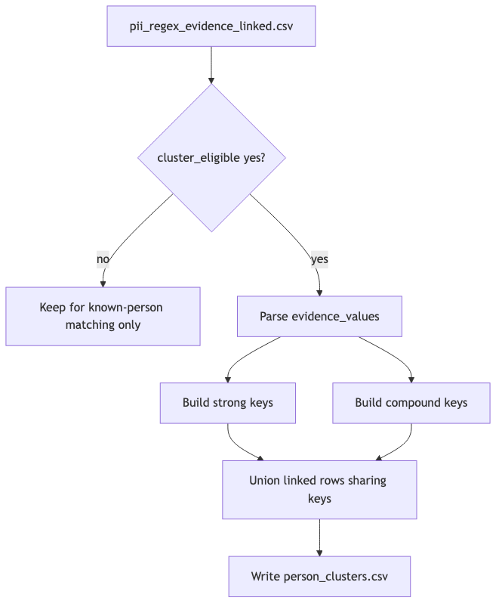
Person clustering and anchor merging
Figure footer: This diagram shows how strong keys, compound keys, and singleton keys produce inferred person clusters.

Person clustering uses:
rules/person_identity_anchors.json
During this phase, --progress-every controls status updates. The scanner reports how many linked-evidence rows have been read, how many are eligible, how many were excluded from clustering, how many merge keys have been seen, and then progress while writing person_clusters.csv.
For each cluster-eligible linked-evidence row, the scanner builds merge keys.

Strong Keys
For each configured strong anchor type:
strong:<Evidence Type>:<Value>
Example:
strong:Email:jane.smith@example.ac.uk
Rows sharing a strong key are merged.

Compound Keys
For each configured compound anchor set:
compound:<Type A>+<Type B>:<Value A>:<Value B>
Example:
compound:Email+Phone:jane.smith@example.ac.uk:07700900123
Rows sharing a compound key are merged.
For Name, if both full names and name fragments are present, the clustering key uses full names only.

Singleton Keys
If no strong or compound key can be built, the linked-evidence row gets a singleton key and becomes its own cluster.

person_clusters.csv
Fields:
person_cluster_id
cluster_confidence
risk_level
linked_evidence_count
file_count
row_count
anchor_types
anchor_values
cluster_merge_keys
identity_anchor_basis
evidence_types
evidence_values
risk_reasons
file_paths
file_names
source_rows
cluster_merge_keys is the main audit field for understanding why rows were linked.
identity_anchor_basis reports the non-value-bearing identity rule or rules satisfied by the cluster, such as strong:Institutional Email or compound:Phone+Name+Address. Unlike anchor_types, it describes why the cluster qualifies as an inferred identity.
evidence_values is useful for review but can be disclosive. It should be handled as sensitive output.

Known-Person Table Loading
When --person-table is supplied, the scanner loads the CSV and preserves its shape.
The person-table reader decodes the file from bytes before passing it to csv.DictReader. It tries UTF encodings first, then Windows-1252 and Latin-1. This is separate from dataset extraction and is specifically to make reference tables exported from Excel or institutional systems usable without manual re-saving.
The known-person table is read as a flexible CSV, then converted into internal anchors for matching.

Figure: Known-Person Table Loading And Anchor Extraction
This figure shows how flexible person-table columns become normalized matching anchors while original columns are preserved.
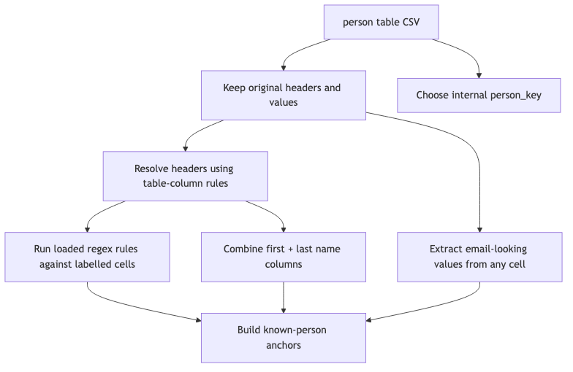
Known-person table loading and anchor extraction
Figure footer: This diagram shows how person-table rows become internal keys and matching anchors.

Internal Person Key
For each person-table row, the scanner creates an internal person_key.
It chooses the first usable value in this order:
- an exact ID column value, because the supplied person table is treated as authoritative for its own primary key;
- a column whose resolved evidence type is configured as a strong identity anchor;
- the first email-looking value in any cell;
- the first non-empty cell value;
- a fallback such as person_table_row_12.
If the key is duplicated, a suffix is added.

Person-Table Anchor Building
For each cell, the scanner:
- cleans the value;
- treats an exact ID column as an ID anchor directly;
- extracts email-looking values regardless of header;
- resolves the header through table-column rules;
- maps exact resolved headers to loaded evidence types where possible;
- runs loaded regex rules against labelled text like husid: 2411841234567;
- normalises matched values;
- stores (evidence_type, normalized_value) -> person_key.
If a field contains multiple values separated by | or ;, they are split and processed separately.

First/Last Name Columns
If table-column rules identify first and last name columns using name_part, the person table loader uses the same grouped name assembler as structured dataset rows. A simple pair adds:
Name = First Last
as a known-person anchor.
Repeated names separated by semicolons, pipes, or spaced slashes are paired positionally. Applicant, guardian, parent, contact, and similar header prefixes keep separate groups. The loader deliberately does not use first-name-only or surname-only values as standalone Name anchors when a column is marked as first or last.

Original Columns Are Carried Through
Known-person outputs include:
person_key
person_table_row_number
<every original person-table column>
<scanner output fields>
This means changing source column names will change output column names, but matching should still work if the table-column rules and regex rules can interpret the headers and values.

Known-Person Matching
Known-person matching checks three sources:
- person_clusters.csv;
- cluster-excluded rows from pii_regex_evidence_linked.csv;
- direct raw evidence rows from pii_regex_evidence/*.csv.
This is important. A row excluded from inferred clustering can still match a known person if it contains a known email, ID, phone, or other configured anchor. A single raw regex evidence row can also match a known person directly, even when it never became linked evidence.

Matching a Person Cluster
For each cluster, the scanner checks:
anchor_values
evidence_values
against the known-person anchor map.
If any (evidence_type, value) pair matches a person-table anchor, the cluster is linked to that known person.
One known person can match multiple person_cluster_id values.

Matching Direct Raw Evidence
After cluster and cluster-excluded matching, the scanner reads the atomic evidence rows under pii_regex_evidence/*.csv. Each row is checked against the known-person anchor map using its (evidence_type, normalized_value) pair. Direct raw evidence matches add evidence categories, risk-matrix flags, and matched_evidence_count for that known person.

Matching Cluster-Excluded Linked Evidence
For each linked-evidence row where:
cluster_eligible = no
the scanner checks its anchors and evidence values against the known-person anchor map.
If it matches, it contributes to:
unclustered_linked_evidence_count
known_person_individual_risk_matrix.csv
but it does not become a person cluster.

Known-Person Outputs

known_person_in_dataset.csv
One row per known person who matched at least one cluster, cluster-excluded linked-evidence row, or direct raw evidence row.
The output includes the original person-table columns plus:
person_cluster_ids
matched_cluster_count
unclustered_linked_evidence_count
matched_evidence_count
direct_raw_evidence_count
cluster_confidence
risk_level
linked_evidence_count
file_count
evidence_types
link_anchor_types
link_person_table_fields
It intentionally does not include raw evidence_values or file paths.
person_cluster_ids can contain multiple clusters for one known person. That means the person table linked multiple inferred clusters back to the same known person, but the clusters did not necessarily merge with each other under the configured identity anchors.
matched_evidence_count counts distinct raw atomic evidence rows assigned to that known person. It includes raw evidence behind matched clusters, raw evidence behind cluster-excluded linked-evidence rows, and direct raw evidence matches from pii_regex_evidence/*.csv.
direct_raw_evidence_count is the subset of matched_evidence_count that came directly from atomic regex evidence rather than through a linked-evidence row or person cluster.

known-person-evidence/
Written only when --write-person-evidence TRUE is supplied. One CSV per matched known person.
Each file contains rows with:
record_type = person_cluster
record_type = linked_evidence
record_type = raw_evidence
This gives the reviewer both the cluster-level evidence and the raw atomic evidence rows behind the linked evidence for that person.

known_person_individual_risk_matrix.csv
One row per person in the supplied person table, including people with no match.
Fields:
person_key
person_table_row_number
<original person-table columns>
overall_risk_score
overall_risk_level
has_<evidence_type>
Risk score mapping:

Table: Risk score mapping used by exposure and cluster summaries.
This table shows the numeric score assigned to each categorical risk level in summary outputs.
Risk level | Score
none | 0
low | 25
medium | 60
high | 90
Table footer: These scores are used when converting risk levels into a single numeric summary value.

The has_* columns are derived from loaded regex rules plus the code-derived Name and Address definitions.

Known_person_not_in_dataset.csv
One row per person-table row that did not match any person cluster, cluster-excluded linked-evidence row, or direct raw evidence row.
Includes:
person_key
person_table_row_number
<original person-table columns>
reason

Unknown-Person Outputs
Unknown-person outputs are only produced when --person-table is supplied, because “unknown” means “not found in the known-person table”.

unknown_person_in_dataset_clusters.csv
One row per person cluster that met the configured identity-anchor rules but did not match the person table.
Fields:
unknown_person_key
person_cluster_id
cluster_confidence
risk_level
linked_evidence_count
matched_evidence_count
file_count
evidence_types
cluster_anchor_types
identity_anchor_basis
cluster_anchor_values
cluster_merge_keys
file_paths
reason
This output intentionally includes cluster audit fields so a reviewer can understand why the unknown person exists.
Clusters that do not meet one of the configured identity-anchor patterns are not promoted into the unknown-person outputs.

unknown_person_in_dataset.csv
One row per unknown person cluster, with the direct cluster audit values removed.
Fields:
unknown_person_key
person_cluster_id
cluster_confidence
risk_level
linked_evidence_count
matched_evidence_count
file_count
evidence_types
cluster_anchor_types
identity_anchor_basis
reason
This is the non-disclosive summary view. It keeps the cluster identity, counts, evidence categories, representative anchor types, and the value-free identity-anchor basis, but omits direct cluster anchor values and merge keys.
matched_evidence_count counts the raw atomic evidence rows behind the linked-evidence rows in that unknown person cluster.

unknown-person-evidence/
One CSV per unknown person cluster.
Each file contains:
record_type = person_cluster
record_type = linked_evidence
record_type = raw_evidence
This gives the reviewer the cluster row, its linked-evidence rows, and the raw evidence rows behind those linked rows.

unknown_person_individual_risk_matrix.csv
One row per unknown person cluster.
Fields:
unknown_person_key
person_cluster_id
overall_risk_score
overall_risk_level
has_<evidence_type>

End-To-End Data Flow With Rule Usage
The following figures separate rule loading, scan-stage outputs, and person-stage outputs so each part of the end-to-end flow can be read independently.

Figure: Rule Inputs To Runtime Configuration
This figure maps persisted rule files to the runtime sets used by scanning, risk scoring, and clustering.
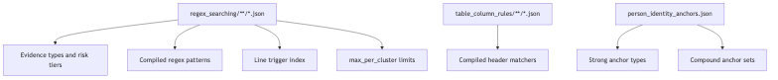
Rule inputs to runtime configuration
Figure footer: This diagram shows how rule files turn into runtime sets for evidence, risk, and clustering.

Figure: Dataset Scan Outputs
This figure identifies the artefacts created by extraction and evidence scanning before person processing.
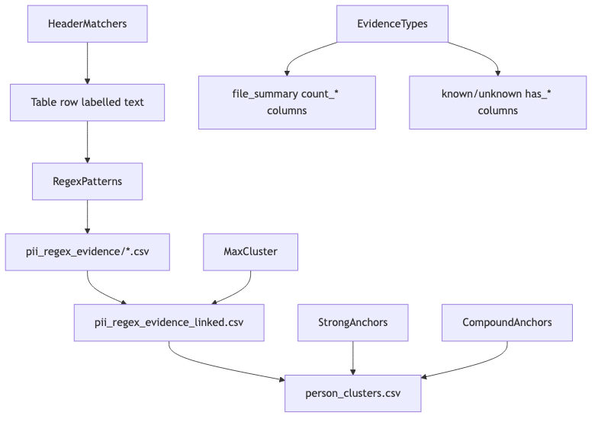
Dataset scan outputs
Figure footer: This diagram shows the outputs produced by the file-scan stage before person clustering.

Figure: Known And Unknown Person Outputs
This figure separates known-person, unknown-cluster audit, sanitized unknown summary, and optional detail outputs.
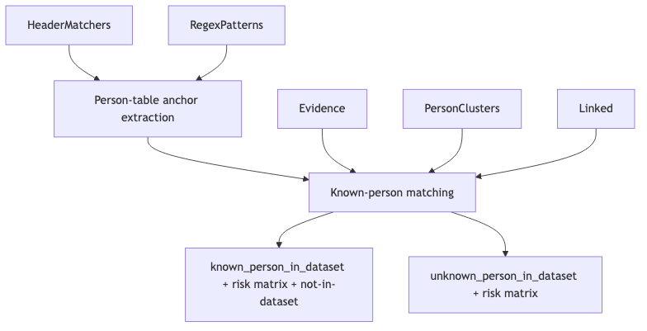
Known and unknown person outputs
Figure footer: This diagram shows how the clustered dataset is split into known-person and unknown-person reporting.

Output Inventory

Table: Output inventory and the upstream data each artefact is built from.
This table lists each scanner artefact, its immediate upstream source, and its intended review purpose.
Output | Built from | Purpose
pii_regex_evidence/ | Regex matches, assembled Name/Address evidence, and file signals | Atomic evidence, one match per row.
pii_regex_evidence/errors.csv | Extraction failures | File-level extraction/parsing errors.
pii_regex_evidence_linked.csv | Same-line/table-row evidence groups | Co-occurrence evidence used for clustering and known-person matching.
file_summary.csv | Per-file scan result | Counts, risk, detected extension, and cluster-exclusion warnings.
entity_summary.csv | All evidence rows | Totals by evidence type.
regex_summary.csv | All evidence rows | Totals and unique values by evidence type and pattern.
person_clusters.csv | Cluster-eligible linked evidence | Inferred people and audit keys for identity merging.
known_person_in_dataset.csv | Person clusters, cluster-excluded linked evidence, direct raw evidence, and known-person table | Known people found in the scanned dataset, including matched_evidence_count and direct_raw_evidence_count.
known_person_individual_risk_matrix.csv | Known-person exposure categories | One yes/no risk matrix row per known person.
Known_person_not_in_dataset.csv | Known-person table minus matches | Known people not found in the scanned dataset.
unknown_person_in_dataset_clusters.csv | Unmatched person clusters that satisfy identity-anchor rules | Cluster audit rows, including anchor values and merge keys.
unknown_person_in_dataset.csv | Unmatched person clusters that satisfy identity-anchor rules | Sanitized unknown-person summary rows, without direct cluster anchor values.
unknown_person_individual_risk_matrix.csv | Unknown clusters | One yes/no risk matrix row per unknown person cluster.
known-person-evidence/ | Known-person assignments plus raw evidence | Optional with --write-person-evidence TRUE; one CSV per known person with cluster, linked-evidence, direct raw-evidence, and raw-evidence detail rows.
unknown-person-evidence/ | Unknown clusters plus raw evidence | Optional with --write-person-evidence TRUE; one CSV per unknown cluster with cluster, linked-evidence, and raw-evidence detail rows.
Table footer: This inventory is the quickest guide to which stage produces each output and what the output is meant to support.

Running The Scanner
Full synthetic breach_dump run:
python3 PII_regex/pii_regex_scanner.threaded.v2.2.py \
--root PII_regex/Synthetic/inputs/breach_dump \
--output-dir PII_regex/Synthetic/Outputs/breach_dump \
--person-table PII_regex/Synthetic/inputs/synthetic_slim_contacts.csv \
--rules PII_regex/rules \
--email-suffix example.ac.uk \
--workers 4
Per-person evidence folders are not written by default. Add --write-person-evidence TRUE when you want the heavier known-person-evidence/ and unknown-person-evidence/ detail folders.
The scanner writes outputs by stage:
- search evidence outputs;
- entity and regex summaries;
- person clusters;
- known and unknown person outputs, when --person-table is supplied.
If a run stops part way through, rerun the same command with --continue. Completed extraction/search outputs are reused. Before clustering, v2.2 reconciles one-value strong-anchor candidates from the saved atomic evidence under pii_regex_evidence/. This allows changes to strong_anchor_types, including promotion of previously unlinked standalone emails, without reopening source documents.
The reconciliation uses a temporary disk-backed SQLite index rather than loading all atomic evidence into RAM. It adds missing one-value candidates, removes obsolete one-type candidates that are no longer strong, and leaves multi-type linked rows unchanged. If linkage changes, clustering and person outputs are regenerated automatically. If nothing changes and all downstream outputs exist, those stages remain skipped.
This rebuild can only use atomic rows that were written previously. If the earlier scan used a non-zero --max-findings-per-file, omitted findings beyond that cap cannot be reconstructed without rerunning the search stage.
Full synthetic exposed_dump run:
python3 PII_regex/pii_regex_scanner.threaded.v2.2.py \
--root PII_regex/Synthetic/inputs/exposed_dump \
--output-dir PII_regex/Synthetic/Outputs/exposed_dump \
--person-table PII_regex/Synthetic/inputs/synthetic_slim_contacts.csv \
--rules PII_regex/rules \
--email-suffix example.ac.uk \
--workers 4
Email-only default run:
python3 PII_regex/pii_regex_scanner.threaded.v2.2.py \
--root PII_regex/Synthetic/inputs/breach_dump \
--output-dir PII_regex/Synthetic/Outputs/breach_dump_email_only
Image OCR enabled:
python3 PII_regex/pii_regex_scanner.threaded.v2.2.py \
--root PII_regex/Synthetic/inputs/breach_dump \
--output-dir PII_regex/Synthetic/Outputs/breach_dump_ocr \
--rules PII_regex/rules \
--scan-images TRUE
Windows-style example:
python PII_regex\pii_regex_scanner.threaded.v2.2.py ^
--root C:\LeakedData ^
--output-dir C:\LeakedData\pii_regex_output ^
--person-table C:\LeakedData\person_table.csv ^
--rules C:\LeakedData\pii_regex_rules ^
--email-suffix example.ac.uk ^
--workers 8
In PowerShell, use backticks instead of ^, or put the command on one line.

Comparing Two Scanner Outputs
The comparison script is:
PII_regex/Compare_pii_regex_outputs.v0.1.py
It compares two completed scanner output folders. It does not rescan source data.
Example:
python3 PII_regex/Compare_pii_regex_outputs.v0.1.py \
PII_regex/Synthetic/Outputs/breach_dump \
PII_regex/Synthetic/Outputs/exposed_dump \
--person-table PII_regex/Synthetic/inputs/synthetic_slim_contacts.csv
By default it creates a comparison folder beside the two output folders:
PII_regex/Synthetic/Outputs/breach_dump_vs_exposed_dump/
and writes:
report.txt
known_in_both_datasets.csv
known_only_in_breach_dump.csv
known_only_in_exposed_dump.csv
known_in_neither_dataset.csv
Use --output-dir to choose a different comparison folder:
python3 PII_regex/Compare_pii_regex_outputs.v0.1.py \
PII_regex/Synthetic/Outputs/breach_dump \
PII_regex/Synthetic/Outputs/exposed_dump \
--person-table PII_regex/Synthetic/inputs/synthetic_slim_contacts.csv \
--output-dir PII_regex/Synthetic/Outputs/custom_comparison
The report filename is always:
report.txt
The comparison report includes count tables, not inline lists of person IDs. The person-level detail is written to the four known-person CSV files.

What The Comparison Measures
Evidence conservation compares evidence terms:
evidence_type=normalized_value
It ignores file path, row number, and source context. For example, if both datasets contain:
Institutional Email=jane.smith@example.ac.uk
that evidence term is counted as conserved even if it came from a different file or row in each dataset.
Person-cluster conservation compares cluster identity terms. The script uses cluster_merge_keys where present and falls back to anchor/evidence values for singleton-like clusters.
Known-person comparison uses the supplied --person-table as the reference universe. The report shows a matrix of:
known in both datasets
known only in the left dataset
known only in the right dataset
known in neither dataset
The four known-person detail CSVs carry through the person-table columns and add one column per evidence type. Each evidence-type cell is blank, the left dataset label, the right dataset label, or both.
Unknown-person comparison uses signature terms from the sensitive unknown_person_in_dataset_clusters.csv audit output and reports how many unknown rows in each dataset have at least one signature term seen in the other dataset. The sanitized unknown_person_in_dataset.csv does not contain the merge keys or anchor values required for this comparison.

How To Interpret The Main Outputs

Start with file_summary.csv
Use it to find:
files with extraction_error
files with skipped_extension
files with many findings
files with high risk
files with cluster_excluded_linked_evidence_count > 0
cluster_exclusion_reasons is useful for spotting rows that look like lists rather than individual records.

Then inspect regex_summary.csv
Use it to understand which regex rules are producing most findings.
unique_value_count helps distinguish:
one repeated value many times
many distinct values

Then inspect pii_regex_evidence_linked.csv
Use it to see whether evidence is co-occurring sensibly.
Important fields:
evidence_types
evidence_values
cluster_eligible
cluster_exclusion_reason
source_row

Then inspect person_clusters.csv
Use:
cluster_merge_keys
anchor_types
anchor_values
evidence_types
source_rows
to understand why linked rows were merged.

Then inspect person outputs
For known people:
known_person_in_dataset.csv
known_person_individual_risk_matrix.csv
Known_person_not_in_dataset.csv
For inferred unknown people:
unknown_person_in_dataset.csv
unknown_person_individual_risk_matrix.csv

Important Behaviour And Caveats

Changing Person-Table Column Names
Changing column names in the person table should not break matching if the new names can be resolved by rules/table_column_rules/**/*.json or the values are still recognisable by the loaded regex rules.
Examples:
ID -> primary key ID anchor
Primary Email -> email
UoN email -> email
Other Email(s) -> email
Student Number -> student id
Given Name -> first name
Family Name -> last name
Birth Date -> dob
The original column names are still carried into outputs.

Table-Column Rules Versus Regex Rules
Table-column rules identify and standardise headers.
Regex rules identify evidence values.
The table-column rule does not say “this value is definitely a DOB”. It says “label this column as dob”, then the DOB regex decides whether the value is actually a valid DOB.

Full Name In Compound Anchors
Use:
["Name", "DOB"]
not necessarily:
["Full Name", "DOB"]
The evidence type is Name; the value can be a full name.
Full Name is accepted as an alias to Name, but canonical configs should use Name.

Cluster Exclusion Does Not Mean Ignore
Cluster-excluded linked evidence is excluded only from inferred person clustering.
It is still:
reported
summarised
checked against --person-table
used in known-person risk matrices when matched

A Known Person Can Have Multiple Cluster IDs
This can happen when:
- several inferred clusters match the same person-table row;
- the configured identity anchors are intentionally conservative;
- the evidence did not contain enough shared anchors to merge those clusters automatically.
This is expected. known_person_in_dataset.csv aggregates them under one known person.

Names Are Weak Identifiers
Names should not generally be used as standalone strong anchors.
The scanner handles names cautiously by:
not clustering on Name alone unless configured as a strong anchor
using Name mainly in compound anchors
preferring full-name values over first/surname fragments for Name compounds
combining first/last columns only when table-column metadata identifies them

Regex Scanning Can Over-Match
Regex rules can over-match or under-match, especially contextual rules that capture nearby text.
Use:
regex_summary.csv
pii_regex_evidence_linked.csv
source_row
context
to tune rules.

OCR And PDF Limits
OCR and PDF extraction can produce odd text order or poor-quality text. Human review is still needed for final decisions.

Sensitive Outputs
These outputs can contain raw PII values:
pii_regex_evidence/
pii_regex_evidence_linked.csv
person_clusters.csv
unknown_person_in_dataset_clusters.csv
known-person-evidence/
unknown-person-evidence/
The two per-person evidence directories only exist when --write-person-evidence TRUE is used.
unknown_person_in_dataset.csv and unknown_person_individual_risk_matrix.csv are the non-disclosive unknown-person summaries. They contain cluster identifiers, counts, evidence categories, anchor types, risk levels, and evidence flags, but omit direct anchor values, merge keys, evidence values, source rows, and file paths.
Known-person summary outputs deliberately avoid raw evidence_values and file paths, but they still contain person-table data and exposure categories, so treat them as sensitive.

