GENERALIZED MOMENTS ESTIMATION FOR FLEXIBLE SPATIAL ERROR MODELS: A LIBRARY FOR MATLAB
Shawn Joseph Bucholtz
School of Computational Sciences
George Mason University

February 13, 2004

This document accompanies the SEMGM software library for Matlab. This library complements and builds from Mike Cliff’s MINZ program libraries and James LeSage’s Econometrics Toolbox. An overview of Generalized Moments Estimation of Flexible Spatial Error Models is followed by a discussion on how to use the library. A discussion of Mike Cliff’s MINZ program is also included.
Demo programs are provided for both of the core functions. The demo programs focus on using SEMGM1 and SEMGM2 functions. Users interested in exploring the different options available for optimization within the MINZ library are encouraged to visit Mike Cliff’s website.

1 Why Develop a Generalized Moments Estimator for Spatial Error Models?

Economic models that incorporate spatial effects have gained a foothold in mainstream economic literature. These models have been widely applied in regional science, labor economics, and real estate economics. The estimation of these models is commonly carried out using spatial econometric techniques. However, the large size of many of the data sets has caused significant estimation problems. Techniques have been developed to overcome these estimation problems, including ones that rely on sparsity of spatially-distributed observations.

One of the most promising methods of estimation of large spatial problems is the Generalized Moments estimation technique developed by Kelejian and Prucha (1999). This technique overcomes many of the estimation hurdles of other methods by using assumptions inherent in the model to develop a system of equations that can be quickly estimated via non-linear least squares.

In addition to estimation problems, one of the harshest criticisms of the spatial econometric models is the use of ad hoc spatial weighting matrices. The criticism stems from the lack of empirical justification for any type of weight matrix in particular and that small changes in the spatial weight matrix often result in changes to the model results. It has been suggested that flexibility needs to be incorporated into the specification of the spatial weight matrix. However, flexibility introduces further estimation issues.

The purpose of this paper is to summarize some previous work concerning how Kelejian and Prucha’s Generalizes Moments (GM) estimation technique can be used to incorporate a high degree of flexibility in the specification of the spatial weight matrix. This paper will extend this previous discussion by developing routines in Matlab for quick estimation of a spatial model using the GM technique. These methods will be tested for accuracy using Monte Carlo simulations. Include in this discussion will be the non-linear optimization routines written by Mike Cliff for which my routines will be based upon.

2 The Spatial Error Model

The general spatial model in this section follows directly from Anselin (1988, pg. 34):

Y = ρWY + Xβ + ε  ε = (I - λW)⁻¹μ  μ ~ N(0,Ω)  Ω_{ii} = h_{i}(Zα), | (2.1)

where Y is a n x 1 vector of dependent variables , ρ is the coefficient of the spatially lagged dependent variable, β is a k x 1 vector of parameters associated with exogenous variables, X is an n x k matrix of exogenous variables, ε is an n x 1 vector of disturbances, λ is the coefficient of the spatial autoregressive structure for the disturbance ε, and μ is an n x 1 vector of disturbances.

The disturbance μ is taken to be normally distributed with a general diagonal covariance matrix Ω. The diagonal elements allow for heteroskedasticity as a function of exogenous variables, plus a constant term. Z is an n x r matrix of exogenous variables, plus the constant term. The α term is an r x 1 vector of parameters associated with the terms. When α=0, it follows that h=σ², the classic homoskedastic situation.

A class of models termed “spatial” follows from this general spatial characterization and are presented in table 2.1. Four more specifications can be obtained by allowing heteroskedasticity of a specific form.

Parameter Values | Name
ρ=0, λ=0, α=0 | classic linear regression model
λ=0, α=0 | mixed-regressive-spatial autoregressive model, commonly called the Spatial Autoregressive Model (SAR)
ρ=0, α=0 | linear regression with a spatial autoregressive disturbance, commonly called the Spatial Error Model (SEM)
α=0 | mixed-regressive-spatial autoregressive model with spatial autoregressive disturbance, commonly called the General Spatial Model (SAC).

Table 2.1: A Taxonomy of Spatial Models

This paper focus exclusively on the linear regression with a spatial autoregressive disturbance (SEM). The model is:

Y = α + Xβ + ε  ε = (I - λW)⁻¹μ  μ ~ N(0,Ω)  Ω_{ii} = 0, | (2.2)

2.1 The Spatial Weight Matrix

The spatial weight matrix embodies the form of the underlying relationship between units of observations and/or their associated error terms. There are two basic types of spatial weight matrices. The first type establishes a relationship based upon shared borders or vertices of lattice or irregular polygon data, often called contiguity-based spatial weight matrices. The second type establishes a relationship based upon the distance between observations, often called distance-based spatial weight matrices. There are many applications of spatial econometric models in public finance where spatial relationships are based on jurisdictions that share borders, such as counties, census tracts and blocks, and states. However, there are few micro-level (land parcels) studies where spatial relationships are based on shared borders. This is due in large part to the lack of polygon micro-level data sets available.

A characteristic of both types of spatial weight matrices is two general parameters that need to be specified before their construction. The first is the spatial extent of the influence. In other words, the size and shape of the area that encompasses the “neighborhood”. For a particular county in the U.S., one needs to determine if the neighbors should be restricted to the other counties which border this county, the counties within a 100 mile radius, the counties that border the counties that border this county, or only the counties to the east. In the case of a house or parcel of land, neighbors could include all those in its sub-division, its neighboring sub-division, or its entire town.

The second parameter that needs to be specified before construction of the spatial weight matrix is the “power” of the influence. In other words, does every member of a neighborhood exert an equal influence, or does each influence the others differently? Suppose the neighborhood is defined as the counties that share a border. Does each of these counties exert the same influence, or would that influence be different, perhaps based upon the amount of border shared? Consider the case of a house or parcel of land where the neighborhood is defined as those other houses or parcels in its sub-division. Would every member of its sub-division exert the same influence?

The selection of a spatial weight matrix has been described as ad hoc and/or a priori. As an adjective, the term ad hoc is defined as “concerned with a particular end or purpose”. In most cases, it is not the intention of the model to predict which type of spatial weight matrix (or the parameter values used to build the spatial weight matrix) is correct. The purpose of including a spatial weight matrix is to correct potential problems due to spatial effects, such as inefficient parameter estimates. The term a priori is defined as “presupposed by experience; being without examination or analysis; formed or conceived before hand.” In most cases, the choice of the weight matrix is made prior to running the model. In other words, the spatial weight matrix is not estimated as part of the model. However, the type of spatial weight matrix chosen and the values of the parameters chosen may be based upon past experience or intuition.

2.2 Contiguity-Based Weight Matrices

The availability of polygon (or lattice) data permits the construction of contiguity-based spatial weight matrices. There are two basic types of contiguity: rook contiguity and bishop contiguity. Rook contiguity exists when two polygons share a common border. Bishop contiguity exists when two polygons share a common vertex (more often referred to in GIS as a node). In addition, queen contiguity is combination of rook and bishop contiguity. Figure 4.1 illustrates rook, bishop, and queen contiguity. Section A would be contiguous to only sections B and C if rook contiguity was imposed. Section A would by contiguous only to section D if bishop contiguity was imposed. Under queen contiguity, section A is contiguous to B, C, and D.

A
B
C
D
Figure 4.1: A Typical Lattice Structure

A typical specification of the contiguity relationship in the spatial weight matrix (W) is given in equation (2.3).

w_{ij} = 1, if i and j are contiguous  w_{ij} = 0 , if i and j are not contiguous  where w_{ij} is the i, jth element of W | (2.3)

Another type of contiguity is achieved when a block structure is imposed upon queen contiguity. An example would be contiguity between counties in a particular state but no contiguity between bordering counties which lie in neighboring states (Anselin, 2002; Case, 1991; Case, 1992).

The rook, bishop, and queen contiguity structure define the “neighborhood” parameter suggested previously. The power of influence in either of these general structures is straightforward. Each unit in the neighborhood exerts the same influence.

There are many examples of the use of contiguity-based spatial weight matrices in econometric literature. This is due in large part to the availability of polygon GIS data sets such as states, counties, watersheds, census tracts, and census blocks. The borders of these data sets are well defined and the polygons typically fill the entire landscape.

2.3 Distance-Based Spatial Weight Matrices

Another class of spatial weight matrices is distance-based. These types of spatial weight matrices are based upon the distance between observations. Distance-based spatial weight matrices are widely used in applications where the polygon data does not exist or is not appropriate. Examples include locations of houses, businesses, sales transactions, airports, parks, etc. The commercial availability of inexpensive Global Positioning Satellite (GPS) handheld units and the lifting of government restrictions on GPS signals have resulted in increased availability of point data. In addition, most statistical packages contain routines to build distance matrices from a data set containing latitude and longitude (or X,Y planer coordinates). A typical specification of the relationship in the W matrix is presented in equation (2.4).

w_{ij} = 1/ (d_{ij}) ^{θ} , if i ≠ j and d_{ij} < m  w_{ij} = 0 , if i ≠ j and d_{ij} ≥ m, or if i = j. | (2.4)

The term d_{ij} is the distance between two points i and j within the spatial unit. The point within the spatial unit is typically its geographic centroid. The θ parameter specifies the “power” of the influence described previously. It allows the decay effect to be linear if θ = 1 or of higher order for values greater than one. As θ increases, the influence of nearby points becomes greater than points further away.

The parameter m is the “neighborhood” of influence. The choice of a value for m is an empirical question that depends on several factors, including the scale of the data and the extent of the perceived neighborhood. Bell and Bockstael (2000) provide an example of a hedonic model in which the size of the neighborhood was picked based upon the average size of housing developments in an area.

2.4 Cliff and Ord’s Weight Matrix

The spatial weight matrices presented in the previous two sections are cases of the more general specification presented by Cliff and Ord (1973). The formal expression of the relationship in Cliff and Ord’s spatial weight matrix is presented in equation 2.5.

w_{ij} = [d_{ij}] ^{-θ} * [B_{ij}]^{δ} | (2.5)

In equation 4.3, d_{ij} = distance between spatial units i and j; B_{ij} = the proportion of the interior boundary of unit i in contact with unit j, and θ and δ are parameters. In the case of counties, equation 2.5 would take into account both the distance between their centers and the length of their common border.

2.5 Row-Standardization of the Spatial Weight Matrix

It is common practice in maximum likelihood (ML) estimation of spatial models to row-standardize the weight matrix. Row-standardization is the process of normalizing each of the weights in a row such that they sum to one. Row-standardization is appealing from both a statistical and computational standpoint. Although row-standardization is useful, it may change the intended “economic” relationship between observations. Consider the following top two rows of a 4 x 4 spatial weight matrix:

Actual Distance |  |  |  |  | 1 / Actual Distance |  |  |  |  | Row-Standardized Distance
0 | 3 | 6 | 9 |  | 0 | .33 | .17 | .11 |  | 0 | .54 | .28 | .18
3 | 0 | 20 | 30 |  | .33 | 0 | .05 | .03 |  | .81 | 0 | .12 | .07
. | . | 0 | . |  | . | . | 0 | . |  | . | . | 0 | .
. | . | . | 0 |  | . | . | . | 0 |  | . | . | . | 0

Figure 2.1: Comparing the Top Two Rows of Actual, Inverse, and Row-Standardized Inverse Distance Weight

The distance between unit 1 and unit 2 is 3 meters. However, the row-standardized “distance” between them is considerably different. While unit 2 has a potential spatial dependence with unit 1 of .54, unit 1’s potential spatial dependence with unit 2 is .81. Consider unit 4’s potential influence on unit 1. It is nearly equal to unit 3’s potential influence on unit 2. However, unit 3 is more than twice as far away from unit 2 as unit 4 is from unit 1. These two examples show that row-standardizing changes the hypothesized influence. Careful consideration needs to be applied when interpreting results on the parameters of row-standardized weight matrices.

2.6 Introducing Flexibility into the Spatial Weight Matrix: The Generalized-Banded Spatial Weight Matrix

Bell and Bockstael (2000) proposed a generalized-banded approach to developing a spatial weight matrix. Motivated mainly by the desire to address row-standardization issues, they suggested a flexible spatial weight matrix (contains three separate weight matrices) built with bands that are based on distance. Figure 2.2 shows how the bands are built.

Figure 2.2: Bell and Bockstael’s Bands of 0-200, 200-400, and 400-600 meters

The inner band represents an area of 200 meters around the parcel; the middle band represents an area between 200 and 400 meters around a parcel; the outer band represents an area between 400 and 600 meters from the parcel. The full weight matrix is row-standardized by row-standardizing each of the individual weight matrices. Parcels that are these distances from the each parcel are given equal weights; the off-diagonal term is set to 0.

Bell and Bockstael developed a hedonic model of residential parcel prices that included measures of the spatial pattern of land use surrounding each parcel. Their model was estimated using the generalized-moments approach. This approach allows a spatial dependence parameter to be estimated for each weight matrix. Using the flexible form of the spatial weight matrix, they found that eight of their estimated coefficients were significant, compared with five in an inverse-distance based specification of a spatial weight matrix.

2.7 Spatial Error Model with Flexible Spatial Weight Matrix

The linear regression with a spatial autoregressive disturbance (SEM) is presented below. Unlike the model presented in the first section of Chapter 2, this model allows for a flexible specification of the spatial weight matrix.

Y = α + Xβ + ε  ε = λ₁W₁ε + λ₂W₂ε …+ λ_{k}W_{k}ε + μ or,  ε = (I - λ₁W₁ - λ₂W_{2-…} λ_{k}W_{k})⁻¹μ  μ ~ N(0, σ²I) , | (2.6)

where Y is a dependant variable; X is a matrix independent variables; W_{i} are spatial weight matrices; α and β are the corresponding parameter vectors; λ₁ and λ₂ are the spatial autoregressive parameters; and μ is a vector of random error terms. W₁ and W₂ and all other W_{k} are mutually-exclusive…a neighbor who appears in W₁ will not appear in any other W_{k}.

3 The Theory Behind Generalized Moments Estimation of the Flexible Spatial Error Model

Kelejian and Prucha (1999) developed a generalized-moments (GM) estimator that can be applied to spatial models. GM uses moment conditions implied by the model of interest to form a system of equations to be estimated. Kelejian and Prucha’s estimator is based on three moments of the error term ε. The key advantage of this estimator is that the calculation of the estimator for even very large data sets is quite straightforward (Bell and Bockstael, 2000). The method requires some matrix multiplication and the calculation of the trace of W’W. However, it does not require the calculation of the determinant or the eigenvalues of W, problems which plague the maximum likelihood (ML) estimating procedure. However, the GM estimator does not permit the calculation of standard errors for the spatial autocorrelation parameter. However, estimates of the spatial autocorrelation parameter(s) are consistent. Therefore, the resulting estimates of the β and σ in the economic model have the large sample properties of the feasible generalized-least squares (FGLS) estimator.

The parameters of the models presented in equations 2.2 and 2.6 can be estimated using the GM estimator. GM estimation is used because it is both amenable to using flexible forms for the spatial weight matrices and is computationally feasible for large numbers of observations.

3.1 Generalized Moments Approach Applied to the Spatial Error Model with One Spatial Weight Matrix

Consider the spatial error model (SEM) with one spatial weight matrix in equation 2.2. The GM estimator for the spatial error model is based on three moments of the error term, μ. The following section is based on a summary of the work of Kelejian and Prucha (1999).

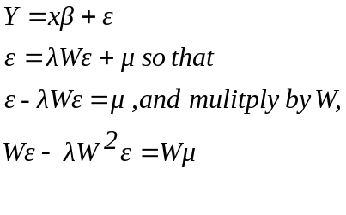 | (3.1)

The two representations of the error structure in (3.1) can be written and simplified as follows,

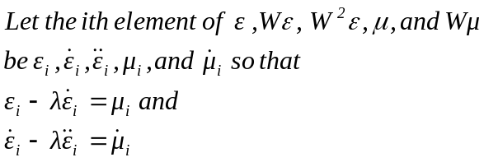 | (3.2)

Squaring, summing, and dividing by N gives,
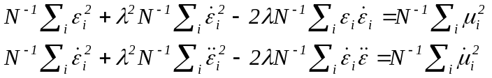 | (3.3)

Multiplying both representation of the error together and dividing by N gives,

(3.4)

The three equation system represented in (3.3) and (3.4) includes three moment conditions on the right hand side. These moment conditions can be expressed as

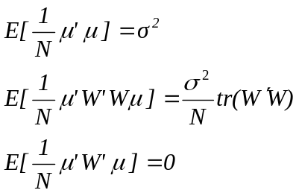 | (3.5)

The third equality is implied because the diagonal elements of W are always set to zero.

The system of equations and moment conditions can be rearranged in matrix form as,

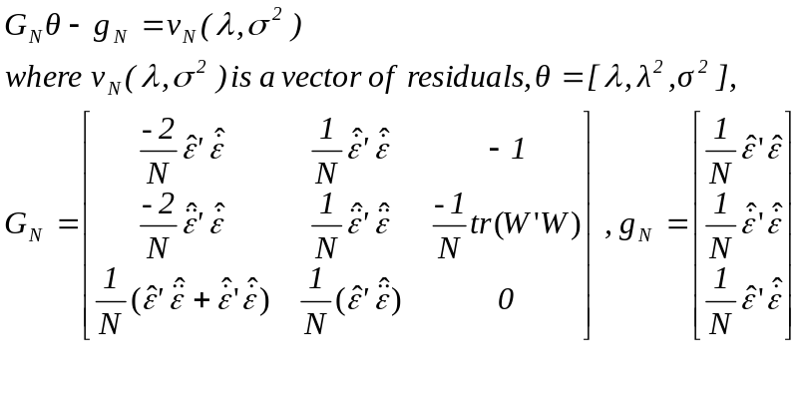 | (3.6)

G_{N} contains the predictors of ε, denoted with a “^” symbol. The vector θ contains the parameters to be estimated. The vector g_{N} is a vector of residuals. The GM estimator is derived from the quadratic in the residuals, ν_{N}(λ, σ²)' ν_{N}(λ, σ²).

Kelejian and Prucha (1999) have shown that the GM estimator is both consistent and asymptotically efficient. The OLS residuals are used as predictors of ε. Once OLS has been estimated, the system can be solved using non-linear least squares, imposing the necessary additional restriction between the parameters λ and λ². The solution for the spatial parameter is both consistent and asymptotically efficient. Once a solution for the spatial parameter is found, estimates for the vector of exogenous variables and model variance can be derived using feasible generalized least squares (FGLS). The feasible and true GLS estimator will be asymptotically equivalent.

3.2 Generalized-Moments Approach Applied to the Spatial Error Model with Two Spatial Weight Matrices

Consider the general spatial error model with two weight matrices in the error term, present in equation 2.6. The GM estimator for the spatial error model is based on six moments of the error term, μ. The following section provides the equations for the case of two weight matrices.

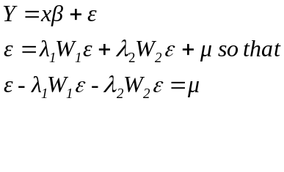 | (3.7)

Two additional representations of the error term can be achieved by multiplying the representation in (3.7) (in terms of μ) by W₁ and W₂.

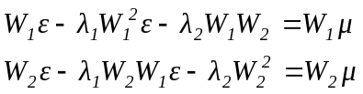 | (3.8)

The three representations of the error structure in (3.7) and (3.8) can be written and simplified as follows,

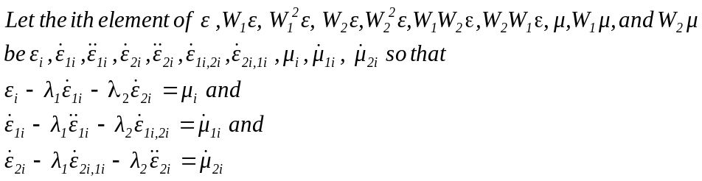 | (3.9)

Squaring, summing, and dividing by N gives three equations. Multiplying these three equations by each other gives another three equations. The resulting six equation system includes six moment conditions on the right hand side. These moment conditions can be expressed as
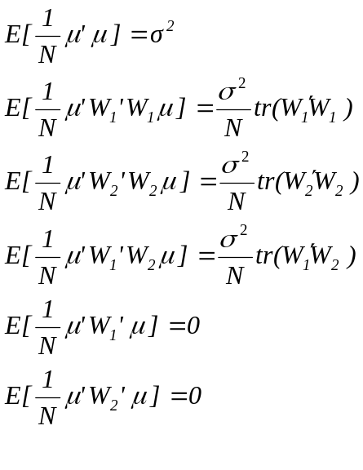 | (3.10)

The fifth and sixth equalities are implied because the diagonal elements of W₁ and W₂ are always set to zero.

The system of equations and moment conditions can be rearranged in matrix. The GM estimator is derived from the quadratic in the residuals, ν_{N}(λ₁, λ₂, σ²)' ν_{N}(λ₁, λ₂, σ²).

4 The Spatial-GMM Library

The parameters of the two models presented in chapter 3 can be estimated using the Generalized Moments approach. The majority of the computations (and hence, the code) are the same for the model with one spatial weight matrix, compared to the model with two spatial weight matrices. The following chapter details a library of routines written in Matlab to estimate the parameters of both models.

4.1 Flow Chart of the Matlab Functions

Figure 4.1 contains a flowchart of the computational process and sub-functions used in the Matlab function SEM_GMM (or SEM2_GMM). The functions accept as inputs a vector of a dependant variable (y), a matrix of independent variables (x), and one or two sparse, row standardized, spatial weight matrices (W₁, W₂).

The first portion of the function calculates the OLS residuals. The second portion of the code sets the parameters for using the MINZ function, including passing to it the function that is to be minimized (e = G_{n}θ- g_{n}). The MINZ function is written by Mike Cliff. The user need not change the parameters passed to the MINZ function. Please consult the documentation on the MINZ function for further details.

Figure 4.1: Flow Chart of SEM_GMM and SEM2_GMM Functions

Iterate between steps 3, 4 and 5 using new errors from EGLS until tolerance is achieved.

FUNCTION NAMES
SEM_GMM (Y, X, W)
SEM2_GMM (Y,X,W₁,W₂)
1. RUN OLS TO GET RESIDUALS
Inputs: Y, X
Outputs: Error terms (calculated using \ operator)
3. Build system of equations and moment condition vector
Inputs: Error Terms
Outputs: System of Equations (Gn,Gn2)
Moment Conditions:
nllsrho_minz.m for case of 1 weight matrix
nllsrho2_minz.m for case of 2 weight matrices
4. RUN MINZ FUNCTIONS
Inputs: Initial Parameter Guesses (preset)
INFOZ structures
System of Equations(Gn,Gn2)

Outputs: lambdahat1 (and lambdahat2)
Variance

5. Estimate Model Parameters using EGLS
Inputs: lambdahat1 (and lambdahat2)
Variance (GMM)
X,Y, W₁, W₂
Outputs: Beta
T-stats
Lambda (and Lambda #2)
T-stats for lambda*
Yhat
Residuals
Variance
R²
Rbar²
Variance (EGLS)

MINZ functions (and other associated functions) contained in separate M-files
2. Build INFOZ structure to be used with MINZ function
infoz2.hess='marq';
infoz2.func = 'lsfunc';
infoz2.momt = 'nllsrho_minz';
infoz2.jake = 'numz';%For numerical derivatives
infoz2.call='ls';
*T-stats for lambda are based on numerical Hessian and assume normality of the errors (which is not an assumption of the model).
The third portion of the code builds the system of equation. The fourth portion of the code minimizes the function using MINZ and outputs estimates for the parameters.

The fifth portion of the code estimates the vector of parameters for the independent variables and a consistent variance. It uses the Estimate Generalized Least Squares estimator. The residuals from step 5 are fed back into step 4 to compute new estimates from the MINZ function. This process is repeated until the difference in the error terms from one iteration to the next is less than a tolerance level. The tolerance level is preset to .001, which should be more than sufficient to assure convergence. Once convergence is achieved, the remaining parameters of the model estimated.

4.2 The Pdweight Function for Building Spatial Weight Matrices

The SEM-GMM library contains a function called pdweight. The purpose of this function is to allow the use to easily build spatial weight matrices based on distance. The user is required to enter five arguments into the function. The first two arguments are the X and Y coordinates of their observations. It is important to note that these coordinates must be planer, i.e., they must be project coordinates. It the X and Y coordinates are actually latitude and longitude, then the distance measure will be inaccurate.

The third and fourth arguments to the pdweight function are called lower and upper. These represent the lower and upper bounds for the user’s desired neighborhood. For instance, if the user believes that one observation has potential spatial dependence with all observations within 500 meters, then the user should enter 0 and 500 for lower and upper, respectively. Distances d are calculated based on the following equation:

lower < d ≤ upper (4.1)

If the user desires to build two weight matrices for use in the SEM2_GMM function, they must pay attention to which cutoffs they use for lower and upper in order to ensure that any members included in the 1st weight matrix are not included in the 2nd weight matrix. Lastly, if two observations have the same X and Y coordinate, such as the case when two condos are in the same building and their X,Y is that of the building, then their distances is defaulted to 1. The user is cautioned against changing this default back to 0. This will result in values of ‘NaN’ when row-standardization is utilized (due to division by 0). Values of ‘NaN’ are not acceptable to the SEM_GMM or SEM2GMM functions. If a user would like to remove observations that have the same X,Y coordinates, they must write their own functions.

The fifth argument to the pdweight function is called RowStOpt, a flag for row-standardization of the weight matrix. If RowStOpt = 1, then the weight matrix will be row-standardized. If RowStOpt = 0, then it will not be row-standardized.

This function is much slower at computing distances than other programs such as Arc Info. For very large weight matrices, it is suggested that the user use another program to calculate distance, the use the Matlab function spconvert.

4.3 The PRT_GMM Function

The SEM-GM library includes a function to print the output of both the SEMGM1 and SEMGM2 functions. The prt_gmm function requires one argument and has two additional arguments available. The code for this function is adopted from the prt_spat function written by James LeSage. Also note that simply using prt(results) or prt(results,vnames) or prt(results.vnames,fid) will work to produce a printout of the estimation results. The function prt() in the econometrics toolbox is simply a large switching program that calls the appropriate printing function for various estimation methods.

The required argument is a structure variable containing the output of SEM_GMM or SEM2_GMM. The optional second argument is a string vector containing the names of the dependant and independent variables in the model. An example is:

vnames = strvcat('y','const','x1','x2');

The optional third argument is an optional file-id for printing results to a file. Examples would be:

results = sem_gmm(y,x,W);
prt(results);

results = sem_gmm(y,x,W);
vnames = strvcat('y','const','x1','x2');
prt(results,vnames);

fid = fopen(‘myoutput.txt’,’w’);
results = sem_gmm(y,x,W);
prt(results,vnames,fid);

5 MINZ Program

The MINZ optimization library provides a flexible environment for general optimization problems. Although many of the algorithms employed are good" [typically drawn from Gill, Murray, and Wright (1981) or Press, Teukolsky, Vetterling, and Flannery (1992)], they may not always be “best" for the situation at hand. The overall flexibility of the software makes it relatively easy for the user to substitute their own algorithms.

The focus is on applications where parameter estimation and hypothesis testing are of primary interest. Econometrics is of course one such field. The library consists of a “control" program minz and a number of helper functions which are called by minz. The user issues a command such as [b,infoz,stat] = minz(b0,infoz,Y,X). b0 represents the parameter starting values, infoz is the structure variable containing information about the specific procedures used, convergence criteria, etc., and Y and X represent data. The number of arguments given to minz is variable depending on the needs of the objective function of interest, so additional data/variables can be passed. The important thing is that the input arguments must be consistent with the function specified in infoz.func. The routine returns the parameter estimates b, the infoz structure (with any updates) and stat which contains a number of fields with information on the status of the solution (e.g., the inverse Hessian). We will examine the components of the infoz and stat structures then discuss each of the supporting functions.

The infoz structure contains the following fields
---------------------------------------------------------------------------------------------------------------------
%infoz.s t r u c t u r e
%infoz.call Calling program: 'gmm' , ' ls ' , ' mle ' , ' other '
%infoz.func What to min: ' l s f u n c ' f o r LS/GMM
%infoz.momt Orthog. conditions m of m m'Wm for GMM
%infoz.jake Jacobian of momt
%infoz.grad Gradient : ‘gradfile’ for analytic, else [‘numz’]
%infoz.delta Increment in numerical derivs [.000001]
%infoz.hess Hessian : [‘dfp’] , ‘ bf g s’ , ‘gn ' , 'marq ' , ' sd '
%infoz.H1 Initial Hessian in DFP/BFGS. [1] = eye, else evaluate
%infoz.maxit Maximum iterations [100]
%infoz.step step size routine [‘step2’]
%infoz.lambda Minimum eigenvalue for Hessian for Marquardt [.001]
%infoz.cond Tolerance level for condition o f Hessian [1000]
%infoz.btol Tolerance for convergence o f parm v e c t o r [1 e-4]
%infoz.ftol Tolerance for convergence o f objective function [1 e-7]
%infoz.gtol Tolerance for convergence o f gradient [1 e-7]
%infoz.prt Printing: 0 = None , 1 = Screen , higher = f i l e [1 ]
---------------------------------------------------------------------------------------------------------------------

The user must provide infoz.func or, in the case of GMM/LS, infoz.momt. All other fields are optional and use the default values (in brackets) unless specified otherwise. If the user would like analytic derivatives, these are specified in infoz.jake for GMM/LS, and infoz.grad for other problems. If these are left blank, or if they are set to numz, then numerical derivatives are used. Next are a number of controls for the (approximate) Hessian, including infoz.hess, infoz.H1, infoz.lambda and infoz.cond. These are discussed in detail in the Hessian step below. The user may also specify a file for the step size in infoz.step and its option infoz.stepred. See the step size description below for more details. Next are a series of settings for convergence criteria. Iterations will stop when any one of the four criteria are met: maximum iterations (infoz.maxit), change in parameter values (infoz.btol), change in the objective function (infoz.ftol), or change in the gradient (infoz.gtol). The procedure will tell you which criteria caused the program to stop. infoz.prt controls printing during the optimization procedure and infoz.call tells the optimization program the kind of problem it is solving: GMM/LS, or other (the typical user does not need to worry about this but it is the mechanism that lets minz know when to use the momt and jake fields).

Steps in Optimization Library

1. Evaluate Criterion Function given in infoz.func

The func field specifies the file with the objective function. This file can require any number of inputs but must have the form scalar = myfunc(b,infoz,stat,varargin). The infoz and stat structures need not be used by the function but they must be included as arguments. In the case of least squares and GMM problems, the code sets infoz.func = 'lsfunc' to use a standard file. The user then provides a moment conditions file of the form [m,e] = myfunc(b,infoz,stat,varargin).

2. Evaluate Gradient in infoz.grad

In all cases, gradient refers to the first derivative of the objective function with respect to the parameter vector. For GMM/LS, it is more convenient to work with the Jacobian: the first derivative of the moment conditions or model error.

Handling of the gradient works much like the objective function. For GMM/LS problems, a default gradient file lsgrad is used but the user can specify the Jacobian in infoz.jake. For all other problems, the user can set infoz.grad for analytic derivatives. If the user wants numerical derivatives, he can leave these fields blank or set the appropriate field to numz. Again, for GMM/LS the field to set is jake whereas in other problems the relevant field is grad.

3. Calculate/update Hessian in infoz.hess (e.g., hessz)

To choose the search direction method, set infoz.hess to 'dfp' for Davidon-Fletcher-
Powell, 'bfgs' for Broyden-Fletcher-Goldfarb-Shanno, 'gn' for Gauss-Newton, 'marq'
for Levenberg-Marquardt, or 'sd' for Steepest Descent. Any one of these choices will result in a call to the file hessz. A user can substitute a different method be setting infoz.hess. The procedure for adding a new method will be discussed shortly. Note that hessz actually returns the inverse Hessian, since this is the object of interest in both the optimization routine and in hypothesis testing. For the DFP/BFGS methods, the inverse is calculated directly. The other methods calculate the normal Hessian then invert it (actually use Gaussian elimination using the Matlab n operator). There are a number of options that can be passed to hessz. To specify the initial Hessian to use in the DFP/BFGS algorithms, set infoz.H0 = 1 for the identity matrix. In the Levenberg-Marquardt algorithm the user can specify the value added to the diagonal of the Hessian when it is ill-conditioned. This is done by setting infoz.lambda = value. Finally, the user can set the criteria for determining ill-conditioning with infoz.cond.

4. Determine Step Direction

The step direction is calculated within minz as the product of the inverse Hessian and the gradient.

5. Determine Step Size specified in infoz.step (e.g,. step2)

Once a step direction is calculated, the program must determine how far to move in this direction. The default is to use the file step2 for the line minimization. This file uses a simple algorithm which reduces the step size by a fixed fraction (infoz.stepred, 90% by default) until the objective function decreases. A different file is referenced by setting infoz.step to the appropriate filename. An alternative routine, based on the LNSRCH algorithm in Press, Teukolsky, Vetterling, and Flannery (1992, page 378), is provided in stepz.m but I have had difficulty with this algorithm in some cases.

6. Program Control minz

After performing the preceding steps, minz then recalculates the objective function and checks the convergence criteria. If none of the convergence criteria are met, repeat the steps. At each iteration some summary information is printed, if desired. As shown in Figure 2, the output contains the iteration number, the condition number of the Hessian in cond(H), an asterisk if the Hessian is poorly conditioned (infoz.cond, 1000 by default), and the value of the objective function. The output contains a message about the reason the iterations stopped (e.g., CONVERGENCE CRITERIA MET: Change in Objective Function). For GMM estimation, the parameter estimates at intermediate GMM iterations (not optimization iterations) is also displayed to track the progression of the estimation process.

Each of the steps above is essentially self-contained. Although one function may make calls to another, the structure is such that it is easy to add a new function. In general, these helper functions take the form of helper(b,infoz,stat,varargin). The first argument is always the parameter vector, the second the infoz structure, the third is the stat structure, and the final arguments are the inputs needed by the user's objective function. So long as this framework is preserved, adding a user's helper function should be simple.

The following is a brief description of how to incorporate a user's function rather than
a provided one. First, the user needs to write the m-file for the helper function. Give it a name that will not conflict with existing m-files (e.g., don't call a new Hessian algorithm
hess.m). Make sure the function returns the same thing as the helper function it replaces.
A Hessian algorithm should return the stat structure variable with the new inverse Hessian, a step size algorithm returns a scalar step size, etc. Then just change the value in the appropriate infoz field to point to your function. For example, a new Hessian algorithm called greathess.m requires setting infoz.hess = 'greathess'. If a user has an existing function which has different arguments, I suggest writing a short conversion function. This new function would have the input and output argument structure required here, make the necessary conversions, and call the user's existing function.

As minz is iterating the above steps it passes information on the status of the procedure
to the different functions it calls. This information is conveniently stored in infoz.stat. Upon completion of the procedure, this structure variable is returned to the program calling minz. Of particular interest is the inverse Hessian, since it is useful for hypothesis testing. The fields are fairly self-explanatory.
%stat. structure
%stat.G Gradient
%stat.f Objective function value
%stat.Hi Inverse Hessian
%stat.dG Change in Gradient
%stat.db Change in Parm v e c t o r
%stat.df Change in Objective Function
%stat.Hcond Condition number for current Hessian
%stat.hist History of b at each iteration

6 Demo Program Results

The SEM-GM library contains one demo program for both SEMGM1 and SEMGM2. The demo programs are designed as Monte Carlo simulations. The demo programs can be run using a the data set that is included with the SEM-GM library. These programs are contained in the files: sem_monte1.m and sem_monte2.m

Other demonstration programs can be found in: sem_gmmd.m, sem_gmmd2.m, sem_gmmd3.m, sem_gmmd4.m

As with any new routine, it is a good idea to test the results of the routine using Monte Carlo simulation. Monte Carlo simulation will let you measure the accuracy of your routines. Monte Carlo simulations are based on equations in the spatial error model presented in sections 2 and 3. The models used to test SEM_GMM and SEM2_GMM are as follows:

SEM_GMM:  Y = α + β₁X₁ + β₂X₂ + ε  ε = λWε + μ or,  ε = (I - λW )⁻¹μ  μ ~ N(0, σ²I) ,  SEM2_GMM:  Y = α + β₁X₁ + β₂X₂ + ε  ε = λ₁W₁ε + λ₂W₂ε + μ or,  ε = (I - λ₁W₁ - λ₂W₂)⁻¹μ  μ ~ N(0, σ²I) , | (6.1)

Testing for the speed of the SEM_GMM and SEM2_GMM functions was conducted on a Pentium 4 with 2.4 gigahertz processor and 1 gigabyte of RAM.

6.1 Monte Carlo Results for SEM_GMM

The first Monte Carlo simulation is to test the SEM_GMM function with a predetermined number of observations and parameters values. This will tell you how close, on average, the estimated parameter values are to the actual parameter values. For the first Monte Carlo simulation 1000 observations were used and parameter values of .3, 1, -.5, .5, .5 were used for λ, σ², and a 1x3 vector of βs, respectively. Table 6.1 gives the mean and standard deviation of the parameter values for the SEM_GMM function. Figure 6.1 is a histogram of the λ values.

Parameter | Actual Value | Mean Value | Standard Deviation
λ | .3 | .296 | .048
σ² | 1 | .996 | .043
α | -.5 | -.500 | .042
β₁ | .5 | .499 | .031
β₂ | .5 | .499 | .031

Table 6.1: Statistics for Parameters when N=1000, SEMGM1

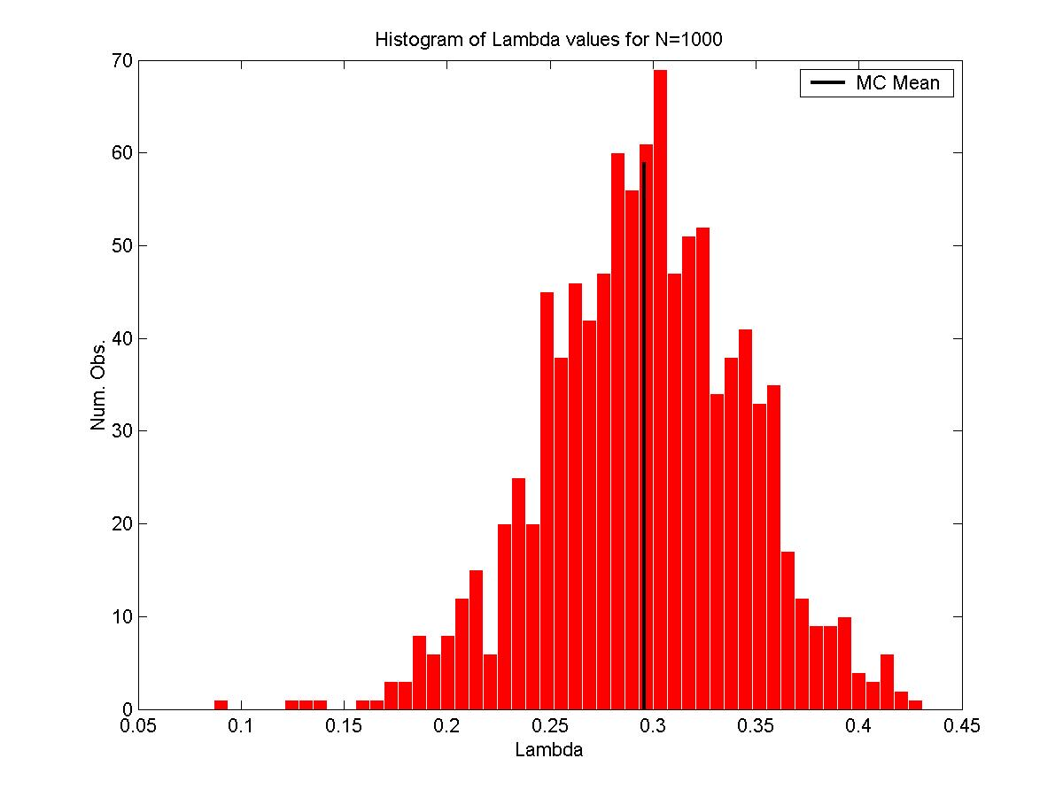

Figure 6.1: Histogram of the λ values based on 1000 Monte Carlo runs.

Table 6.1 shows that the function performs well, on average. There appears to be a slightly greater concentration of observations below the actual value of .3.

The second Monte Carlo simulation is to test the speed of the function. The function is tested with the same values for λ and the β’s as above. However, instead of making several iterations with the same parameters, iterations are based on an increasing number of observations. The first iteration is with 1000 observations. Each subsequent iteration increases the number of observations by 500 with the last iteration using 10,000 observations. A plot of number of observations versus speed reveals that the computational time is nearly linear in the number of observations. For every additional 500 observations the speed increases by about .13 seconds.
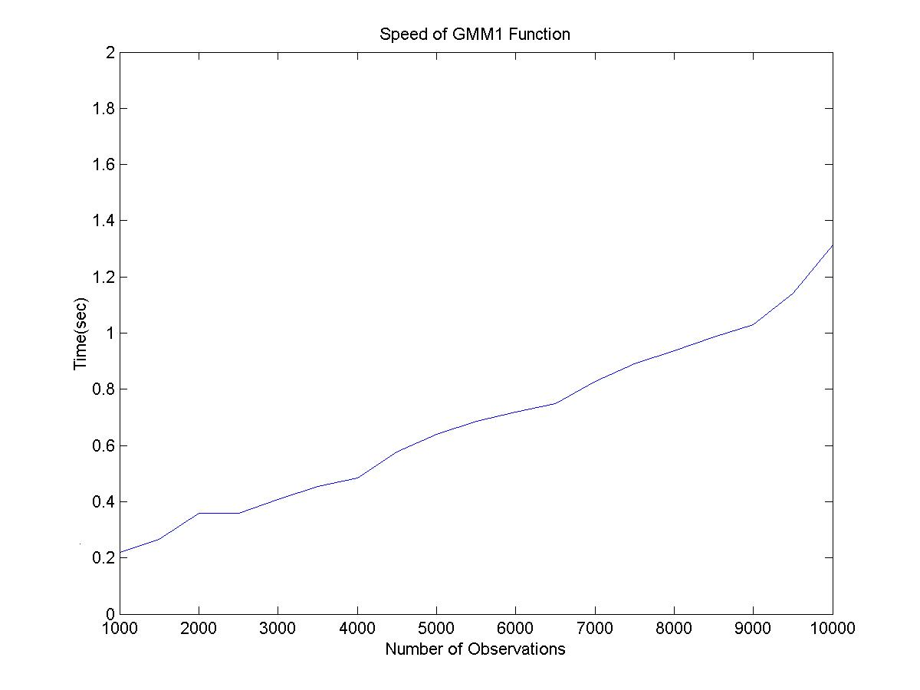
Figure 6.2: Computational Speed of SEM_GMM for Varying Number of Observations

6.2 Monte Carlo Results for SEM2_GMM

The first Monte Carlo simulation is to test the SEM2_GMM function with a predetermined number of observations and parameters values. This will tell you how close, on average, the estimated parameter values are to the actual parameter values. For the first Monte Carlo simulation 1000 observations were used and parameter values of .3, .5, 1, -.5, .5, .5 were used for λ₁, λ₁, σ², and a 1x3 vector of βs, respectively. Table 6.2 gives the mean and standard deviation of the parameter values for the SEM2_GMM function. Figure 5.3 and 5.4 are histograms of the λ₁ and λ₂ values.

Parameter | Actual Value | Mean Value | Standard Deviation
λ₁ | .3 | .298 | .035
λ₂ | .5 | .498 | .040
σ² | 1 | .997 | .031
α | -.5 | -.499 | .081
β₁ | .5 | .500 | .022
β₂ | .5 | .500 | .022

Table 6.2: Statistics for Parameters when N=1000, GMM2

Table 6.2 shows that the SEM2_GMM function performed very well. The only somewhat puzzling result was the high standard deviation for the β₁ coefficient.
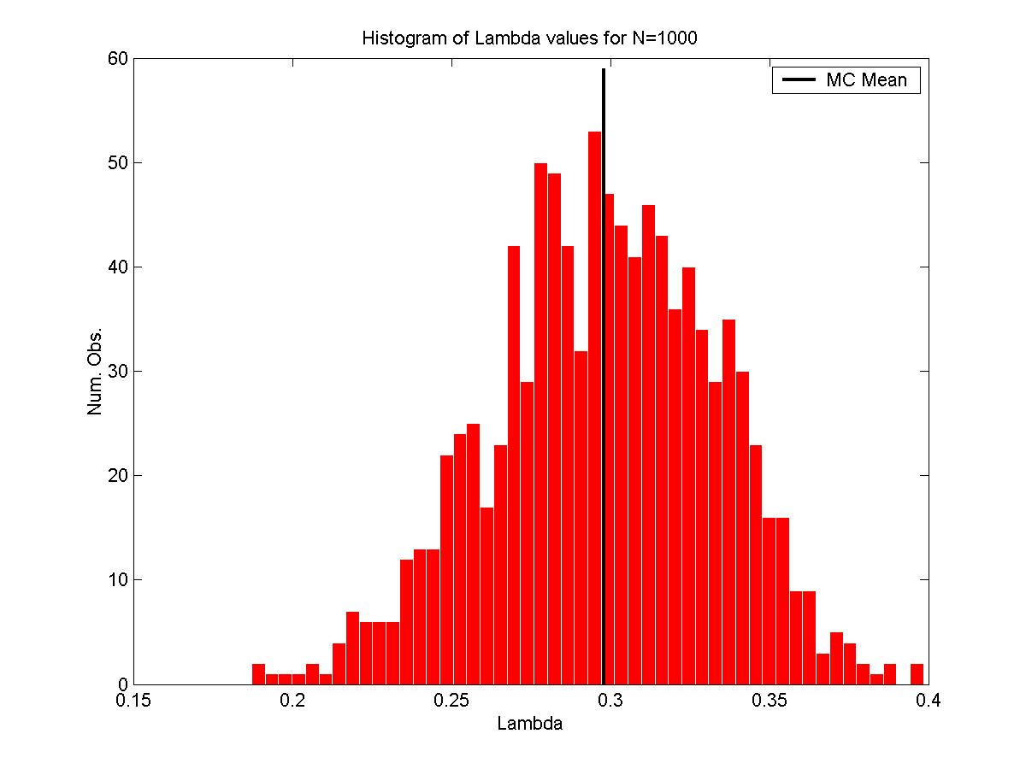
Figure 6.3: Histogram of the λ₁ values based on 1000 Monte Carlo Runs.

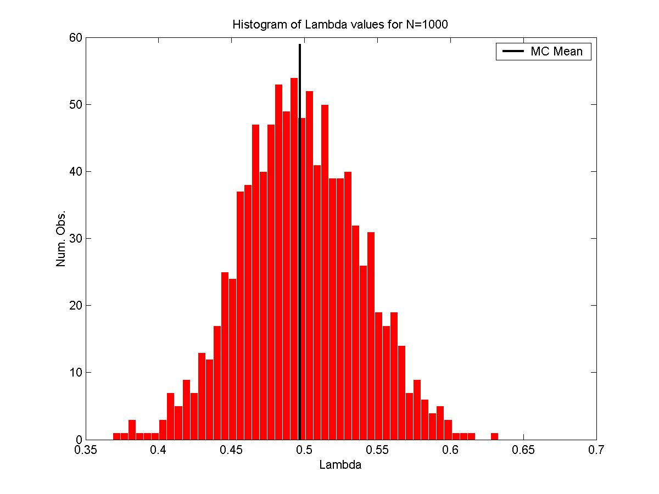

Figure 6.4: Histogram of the λ₂ values based on 1000 Monte Carlo Runs

The second Monte Carlo simulation is to test the speed of the SEM2_GMM function. The function is tested with the same values for λ’s and the β’s as above. However, instead of making several iterations with the same parameters, iterations are based on an increasing number of observations. The first iteration is with 1000 observations. Each subsequent iteration increases the number of observations by 500 with the last iteration using 10,000 observations. A plot of number of observations versus speed reveals that the computational time is linear up until 9000 observations with an increase of .7 seconds for every 1000 additional observations. After 9000 observations it appears that the computation time increases dramatically.

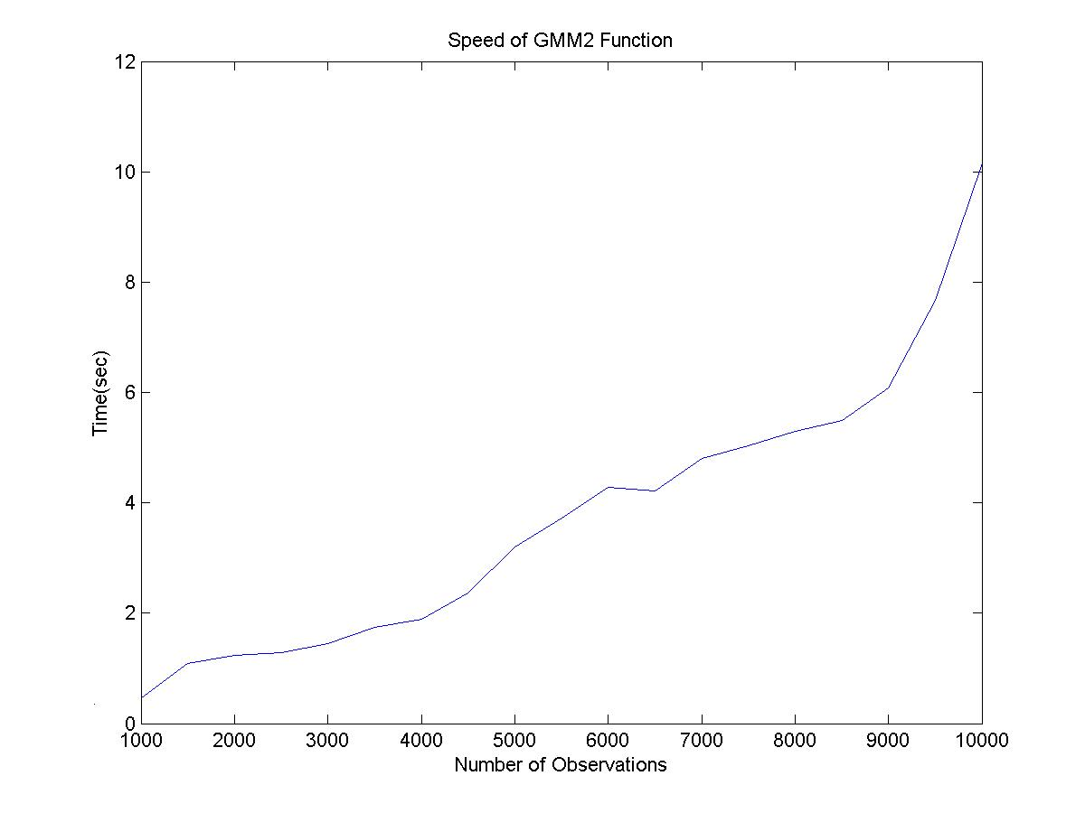
Figure 6.5: Computational Speed of SEM2_GMM for Varying Number of Observations

6.3 Conclusion

Based on Monte Carlo simulations it can be concluded that the SEM_GMM and SEM2_GMM Matlab functions perform well. The mean values of the parameters were close to the true values. Standard deviations were well within acceptable range, given the type of model that is being estimated.
References

Anselin, L. 1988. Spatial Econometrics: Methods and Models. Dordrecht: Kluwer Academic Publishers.
Anselin, L. 2002. “Under the Hood: Issues in the Specification and Interpretation of Spatial Regression Models.” Agricultural Economics 27(3): 247-67.
Bell, K.P. and N.E. Bockstael. 2000. “Applying the Generalized Method of Moments Estimation Approach to Spatial Problems Involving Microlevel Data.” Review of Economics and Statistic 82(1): 72-82.
Case, A.C. 1991. “Spatial Patterns in Household Demand.” Econometrica, 59: 953-965.
Case, A.C. 1992. “Neighborhood Influence and Technological Change.” Regional Science and Urban Economics, 22: 491-508.
Cliff, A. and Ord, J.K. 1973. Spatial Autocorrelation. Pion, London.
Cliff, M. T. 2003. “GMM and MINZ Program Libraries for Matlab.” http://www/mgmt.purdue.edu/faculty/mcliff/progs.html.
Green, W. H. Econometric Analysis. 2000. Fourth Ed, Prentice Hall, NJ.
Kelejian, H. H. and Prucha, I. 1999. “A Generalized Moments Estimator for the Autoregressive Parameter in a Spatial Model.” International Economic Review 40: 509-533.
LeSage, J. Econometrics Toolbox. http://www.econ.utoledo.edu/matlab_gallery

Shawn Bucholtz is also a contract employee for the Economic Research Service, USDA. ERS is not responsible for any claim made in this publication or any work related to the SEM-GMM library.
James P. LeSage’s Econometric Toolbox contains a spatial econometrics library that employs many of the most recent techniques, including functions built on Matlab’s sparse matrix routines.
Kelejian and Prucha (1999) refer to the SEM model as the SAR model .
This summary was kindly provided to me by Mark Fleming.
I would like to thank Kathleen Bell for her assistance in completing this section. Any errors are the fault of the author.
MINZ Program Library available at www.mgmt.purdue.edu/faculty/mcliff.
The text in this section is copied verbatim from Mike Cliff’s paper on the GMM and MINZ routines. This paper is available at www.mgmt.purdue.edu/faculty/mcliff/progs/gmmdoc.pdf

