Portfolio Optimisation Demo using MATLAB Builder for Java.

Description
This demo uses functions from the Financial Toolbox to perform mean-variance portfolio optimisation and generate an efficient frontier. The graphical interface is written using the Java Swing libraries, and the underlying mathematics is performed by a MATLAB-generated Java component. Plots of graphs are generated by MATLAB and shown in the Java GUI by printing the MATLAB figure to memory (as an RGB image), and pasting this image into a Java window.

The demo imports the closing prices of a selection of stocks from an Excel spreadsheet. The format of the spreadsheet is as follows:
Row 1: Names of stocks
Column 1: Dates

We then calculate a set of asset investment weights such that we minimise the overall portfolio risk for a specified portfolio return. (Portfolio risk is synonymous to the variance of the portfolio.) The user is able to specify the expected return for each individual asset, and also the minimum and maximum weighting for each asset in the portfolio.

The Efficient Frontier shows the intersection of the portfolios with minimum variance and the portfolios with maximum return. An investor will try to place their portfolio on the Efficient Frontier, in order to ensure that they can achieve the lowest risk portfolio for a given return.

More details on portfolio optimisation and the efficient frontier can be found on Wikipedia: http://en.wikipedia.org/wiki/Modern_portfolio_theory.

The demo files
There should be three directories of files for this demo.
- matlab_src contains all of the MATLAB source code
- JavaCode contains the required Java files and libraries
- compile contains some helpful MATLAB functions to compile and clean up the demo

In addition, all of the output files required to run this application should be in the distrib directory (if you use the MATLAB files in the compile directory to compile the application).

Changing the language of the demo
It is possible to change the demo so that the menu items and window names are in your local language. These settings are all defined in the PortOptDemo*.properties files in JavaCode\src; the properties file that is used when you run the demo is determined by the local settings for your particular machine. (On a Windows XP machine, this would be dictated by the Regional and Language Options in the Control Panel.) You can find out which locale you are using by typing the following in the MATLAB command window:
>>java.util.Locale.getDefault

Two properties files have been provided for US and UK English (the default language is UK English!). To add a properties file for your own language, simply make a copy the PortOptDemo.properties file and call this new copy:
PortOptDemo_<language>_<country>.properties
where <language> is a lower case, 2 letter ISO Language code that you wish to use
<country> is an upper case, 2 letter ISO Country code. The country code is optional.

You can find a full list of language codes at http://ftp.ics.uci.edu/pub/ietf/http/related/iso639.txt and country codes at http://userpage.chemie.fu-berlin.de/diverse/doc/ISO_3166.html.

e.g. for French, use the filename PortOptDemo_fr.properties. For Canadian French, use the filename PortOptDemo_fr_CA.properties

You can then modify all of the strings in the new properties files to reflect the strings that you wish to see in the menu items and window titles.

How to build the demo
- Ensure that you have the Java development kit installed on your system (download from java.sun.com). I am using JDK v1.5.006.
- Run compilePortOptJavaDemo.m in the compile folder. This will:
  - compile the m-files into a jar file using Builder for Java
  - compile the Java source code in JavaCode\src
  - generate a JAR of the final application in the distrib directory

If you wish to change the locations of the output files for this demo, edit the values in getportOptJavaDemoSettings.m. For details on how to generate this demo manually, please refer to Appendix I.

Note that the compilation process may not work correctly if there are spaces in the path for the demo.

Running the demo
To run the application, open a console window and navigate to the directory containing portOptDemo.jar. Run the application by typing:
java –jar portOptDemo.jar

You should also be able to double-click on the distrib\portOptDemo.jar file to run the application. Ensure that the following files are in the same directory as portOptDemo.jar:
Javabuilder.jar (shipped with MATLAB Builder for Java)
portOptDemoJava.jar (generated by MATLAB Builder for Java)
portOptDemoJava.ctf (generated by MATLAB Builder for Java)

Note that all of these files are automatically copied to the distrib directory when you run compilePortOptJavaDemo.m.

Using the application:
The application consists of a single desktop with multiple windows. The display of the various windows can be toggled using the View Menu and the layout of the desktop can be changed using the Window Menu. You can also reposition the windows manually by dragging them around on the desktop.
The windows are:
- Data Statistics – this shows the mean return and standard deviation of the returns for each stock.
- Covariance Matrix – this shows the covariance matrix for the stocks
- Prices – this shows a plot of stock prices
- Optimisation Parameters – this allows the users to change the expected return values and asset weight limits for each stock.
- Portfolio Optimisation Results – this shows the computed risk/return pairs and the associated stock weights for each risk/return value.
- Efficient Frontier – this shows a plot of the Efficient Frontier.

Note that because the plots of the Prices and Efficient Frontier are simply snapshots of MATLAB images, it is not possible to zoom or pan the figures.

The size of the font in the application can be changed using File->Change Font Size…. Note that this only changes the font size in the tables; the size of the fonts in the menus and window titles will reflect the desktop settings for your current machine.

When the application is opened, all of the windows are disabled since there is no data to display. Use File->Import Data… to import an Excel spreadsheet into the application. (randomData.xls is provided with this demo, but you are free to choose your own set of stocks.) Once the data has been imported, the tables in the Data Statistics, Covariance Matrix and Optimisation Parameters should be populated and the Prices window should show a plot of the prices in the spreadsheet. (The data takes a short while to import into the application.)

You can then change the expected returns and asset weight bounds in the Optimisation Parameters window. Note that when the “Use Defaults” check boxes are checked, the corresponding values in the table are not editable. Once you are happy with the parameters, you can perform the optimisation by clicking on the “Optimise Portfolio” button on the Optimisation Parameters Window, or by selecting Run->Portfolio Optimisation.

Once the optimisation has been performed, the Efficient Frontier figure will be displayed and the Portfolio Optimisation Results window will show the risk/return pairs and stock weights for each stock. Selecting a different risk/return pair in the Portfolio Optimisation Results Window will display the corresponding stock weights.

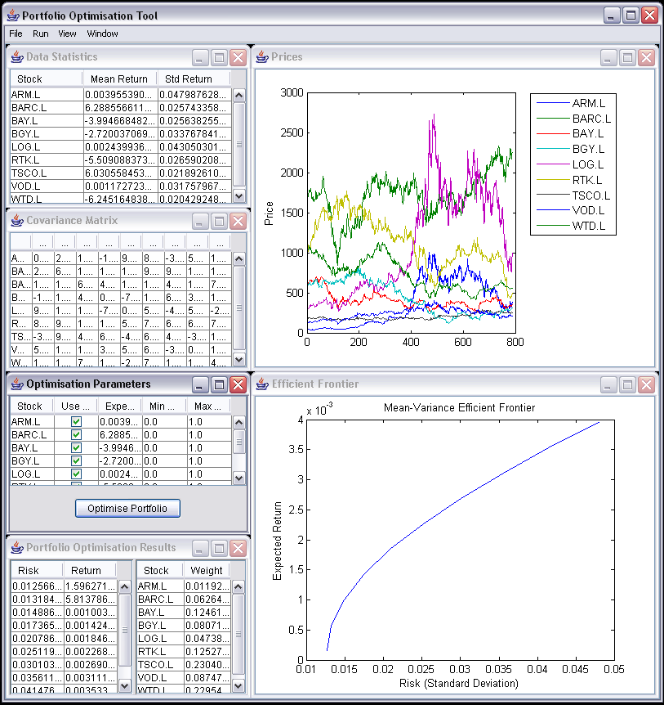
Figure 1: Screenshot of the demo

Appendix I

Compiling the MATLAB Code
Use deploytool to compile the files in matlab_src into a Jar file:
- In the MATLAB command window, type “deploytool”. This should bring up the Deployment Tool. Create the Builder for Java project:
  - Click on the New Deployment Project Icon
  - In the left hand pane of the window, choose “MATLAB Builder for Java”
  - Change the name of the project to portOptDemoJava
  - If necessary, change the file location of the project
  - Click OK

- In the Deployment Tool window, right-click on the portOptDemoJavaclass item in the tree, and select “Rename Class”. Rename this to portOptDemoJavaClass (case sensitive).
- Right-click on portOptDemoJavaClass and select “Add File” (or use the toolbar buttons along the top of the Deployment Tool window). Add the following m-files in matlab_src to the class.
  - readStockDataFromFile.m
  - optimisePortfolio.m

- Build the project by clicking on the “Build” Toolbar button. This will create portOptDemoJava.jar and portOptDemoJava.ctf in the portOptDemoJava\distrib directory

Compiling the java source
Use the Java programming language compiler (javac) to compile all of the java source files in JavaCode\src. javac.exe should be located in the bin directory of your JDK installation. Ensure that the classpath is set to include
- javabuilder.jar (shipped with MATLAB Builder for Java)
- portOpJavaDemo.jar (generated using MATLAB Builder for Java)

For more details on javac, please refer to http://java.sun.com/j2se/1.4.2/docs/tooldocs/windows/javac.html.

Producing the final JAR for the demo
Use the jar command and the manifest file in JavaCode to generate the final JAR. For more details on the jar command, please refer to http://java.sun.com/docs/books/tutorial/deployment/jar/basicsindex.html.

e.g. jar cmf manifest.mf portOptDemo.jar –C build\classes .

