TABLE OF Contents
1 Overview 4
1.1 Introduction 4
1.2 Terminology 4
1.3 Goals 4
1.3.1 Build Reproducibility (Safety) 4
1.3.2 Build Stability 4
1.3.3 Build-Manager Developer Synergy 4
1.3.4 Low Turnaround Time 5
1.4 Principles 5
2 Process Workflow 6
2.1 Intermediate Release Planning 6
2.2 Getting tasks done (Developer) 6
2.3 Validation of the tasks (Integrator) 7
2.4 Task-Set Promotion (Build Manager) 9
2.5 After the Release 9
3 Roles 9
3.1 Developer 9
3.1.1 Responsibility 9
3.1.2 Knowledge level 9
3.1.3 Checklists before sending tasks for Integration 10
3.2 Integrator 10
3.2.1 Responsibility 10
3.2.2 Knowledge level 10
3.3 Build Manager 10
3.3.1 Responsibility 10
3.3.2 Knowledge level 10
4 Entities 11
4.1 Baselines 11
4.2 Containers (Folders) 11
4.2.1 Build Manager Containers 11
4.2.2 Integrator Containers 11
4.2.3 Module Specific Containers 11
4.2.4 Personal Containers 11
4.3 Client View (Reconfiguration Template) 11
5 Activities 12
5.1 Development build 12
5.1.1 Modification (Adding functionality) 12
5.1.2 Collaboration (Getting Others’ Changes) 12
5.1.3 Task Creation 12
5.1.4 Task Submission 13
5.1.5 Checking out projects 13
5.2 Integration Build 13
5.2.1 Task-management 14
5.2.2 Fixing build-issues 14
5.2.3 Functional testing 14
5.2.4 Checkpointing 14
5.3 Mainline Build 15
5.3.1 Regression Testing 15
5.3.2 Task Promotion 15
5.3.3 Release 15
6 Release Procedure 16
6.1 Create Release table 16
6.2 Check out from previous baseline 16
6.3 Create reconfiguration template: 16
6.3.1 Copying one reconfiguring template to another 16
6.3.2 Adding new folder to reconfiguration template. 18
6.4 Reconfigure to get the changes 18
6.5 Check for conflicts 18
6.6 Check-in the project 19
6.7 Changing the state to released 21
7 FAQs (Frequently Asked Questions) 22

Overview
This document details and explains a software development process based on continual integration and validation. The process recommends intermediate releases and subsequent integration.

The audience is expected to have an understanding of software configuration management concepts. The implementation is explained with respect to Telelogic’s Synergy CM tool.

Introduction
Development progresses. But what is working on one build might not work on another.

Terminology

Build Manager | Person responsible for stability of build, synchronization between developer, regulating changes to database
Developer | One who introduce changes to repository to achieve functionality or feature or to fix bug
Integrator | Person who integrate changes done by developer by resolving the conflicts
Task | A logical change that needs to be made in your software application
Mainline | Main branch of repository on which the development is going on.
Build | Process of generating a file from existing source files
CM Tool | Software used for configuration management.
Container | Folders that has completed tasks

Goals

Build Reproducibility (Safety)
To ensure the reproducibility of builds.

  - It must be possible to backtrack to a previous version of the build.

Build Stability
To ensure the stability of builds.

- Introduce changes in a phased manner after validation.

Build-Manager Developer Synergy
Ease of process-adherence for both developers and build-managers (GX:)

- Enable efficient usage of the CM Tool by build-managers. (GX: EfficientCMUsage)

- Minimize the CM-Tool knowledge entry-barrier for developers. (GX: LowEntryBarrier)

Low Turnaround Time
To enable better collaboration; the process should never block work. (GX:)

- To model the development activity as closely as possible (GX: NaturalDevelopment)

- To use the CM tool as far as possible for achieving such collaboration. (GX: MinimizeOutOfCMActivity)

Principles
What is working on one build might not work on another. We must retain information regarding important working builds to facilitate later investigation!

Find errors and fix problems at the earliest. Get close to the mainline, at the earliest possible stabilization point. Find errors and fix problems on a build that is as close to the mainline as possible. To paraphrase a proverb, “Early to merge and early to fix makes the release smooth and nice!” ☺

Documentation: every bit helps, and a little bit of documentation at every step doesn’t hurt! If an artifact is worth keeping, save it. If it is not worth keeping or it is not likely to be used, remove it.

Process Workflow
Let us consider the addition of ‘f’ functionalities to the mainline build. We assume that developers (D1, D2, D3) are involved in the development of these functionalities already have a version of the previous build (B0).

Intermediate Release Planning
  - If there are ‘f’ functionalities to be added between build B(r) and B(r+1), the functionalities must be grouped into coherent subsets, and intermediate releases based on such subsets should be planned.
    - It is recommended that each Intermediate Release should have a main functionality to demonstrate.

  - The intermediate release must be planned on the basis of functionalities and not on the basis of tasks. Tasks should be created on an as needed basis by developers for achieving the functionalities.
    - Number of tasks (t) will not correspond with the number of functionalities (f) to be achieved. “t<>f”
    - Planning to the level of tasks is recommended in the case of maintenance releases.

Getting tasks done (Developer)
- Each developer checks out a version of the build as Dx_B0.1

- Each developer based on what functionalities he must achieve creates a task in his personal CM folder and the module’s CM folder.
- Writes a proper synopsis for the task.
<ModuleName> - <What for/Why being modified>
- Select the appropriate release tag during task creation.
- The personal CM folder must be part of the developer’s reconfigure-template to enable collaboration and also to ensure the changes are retained by the developer when he reconfigures his working copy

- The developer makes modifications to files after checking them out against a created task.

- The developer should check in the files on which modification can be considered complete. This is essential for achieving point 5) below.

- If there are any tasks which the developer depends on for completing his functionality, such tasks must be added to the developer’s personal folder.

- The developer should then get the files required by reconfiguring at the level of the functionality-providing module.

- The developer should then get the functionality working on his build – by making further checkouts and modifications if required.

- Only after verifying the functionality on his build must the developer check in the task.
- If the functionality developed is significant, the developer should also check in his project so that it is available as a fallback option/material for investigation, before continuing on other tasks, after checking out the build as B0.y_ Dx.

- The developer must then send the integrator and all task stakeholders an integration-request email, marked as “INTEGRATION – Task ID – Synopsis”. Why email?
- Errors may have been made in the task entry.
- To prevent tasks being missed out accidentally– the interface of the CM tool might be error-prone.
- Not all stakeholders may be actively checking the status of the task.

So, at this point, the developer has gotten a task working on his build. Any task has to be working on at least one build before it can be “completed”. Fixes might be required on the integration/mainline build. The developer always retains the responsibility for getting “his” functionality working on any build.

Validation of the tasks (Integrator)
- Task collection. The Integrator shall maintain a folder in which he will collect completed tasks which have been submitted for integration.
  - This folder should be writable and usable only by the owner and should be named like “B0+1_TaskSetName”. For example, if the released version of the build was B2.2 and the main functionality is streaming, the integration folder should be called “B2.21_Streaming”
  - This folder should be included in the Integrator’s reconfigure template.

- Task information validation. After getting the Integration Request mail, the Integrator should do the following checks –
  - Is the task in the correct folder?
  - Is the release tag proper?
  - Is the synopsis according to the conventions followed?
  - Does the task have objects that belong to more than one module?

If such problems with the task-information are identified, the Integrator should take corrective action.

- Change validation. The Integrator should do a reconfigure to get the latest changes. The granularity (number of tasks to be reconfigured for at a time) is left to the choice of the Integrator. But he must make the following checks.
  - Is the build OK?
  - If unit test scripts are available, these should be run.

If problems are found at this stage, the Integrator should inform the developer who submitted the erring task. The developer must then submit a fix task, which the Integrator should place in an integration folder.

Optional: The fixes may be collected in a separate folder named like “B0+1_Fixes” if the information about which fixes were made at what stage need to be captured.

- Functional validation. The Integrator is responsible for checking that the new functionality is working on the integrated build. It is recommended that such functional validation be done at a suitable interval before submission of the task-set for promotion, at the end of task collection for the intermediate release.
  - Optionally, this can be done periodically during the task collection phase, with regression testing for the previously added tasks. This option is recommended for cases where there are large gaps between intermediate releases and when we are in the initial stages.
  - The integration build can be reproduced at a test machine and the check may be done at the test machine.

Problems found in this stage should also be informed to the developer and the fix collected by the Integrator.

- Stabilization. When all the collected tasks are validated as mentioned in the steps above, the Integrator should place the tasks and fixes collected in a folder for the Build Management.
  - The submission folder should be named like “IntegrationFolderName+1_TaskSetName_Stable”. If the Integrator folder was B2.21_Streaming, call the submission folder B2.22_Streaming_Stable.
  - The submission folder should be writable by the Integrator and usable by the Build Manager.
  - Optionally, the Integration folders can be locked for modification, no more addition of tasks possible.

- Submission of task sets for promotion. After performing the activities mentioned in this section, the Integrator should send a Promotion Request mail to the Build Manager and, optionally, to all the stakeholders.
  - Explain the new functionalities being added.
  - List of all the tasks that have been submitted for promotion, for the sake of reference.

- Mainline build fixes. The Integrator shall also collect tasks related to the problems found during regression testing on the mainline build. This folder should be named as “<SubmissionFolderNumber+1>_Regression”. If the submission folder was B2.22_Streaming_Stable, call the fix-folder B2.23_Regression.
  - The steps 1) through 6) shall then be followed, as many times as deemed necessary for the mainline build to be considered stable.
  - During the regression-fixing phase, the Integrator is required to functionally validate the tasks submitted previously as well. This is because the chances are high that the regression-fixes will affect the new functionality too (the reverse had happened!).

Task-Set Promotion (Build Manager)
- After the Integrator sends the Promotion Request mail, the Build Manager adds the submission folder to his reconfigure template.

- Regression testing. Based on the time available, the regression testing should be done with either
  - The complete ATP test-suite. This will give us an indication of the maturity of the build.
  - A set of main use-cases that the previous build supported and the final release must support. This will give us an indication of the validity of the build.

- Problems found in this phase should be reported to the Integrator.

- Steps 1) through 3) are followed until the mainline build is considered stable by the Build Manager.

- After the mainline build stabilizes, the Build Manager shall promote the tasks to the respective Build Manager folders, based on the module for which the task was completed.

- The Build Manager then baselines the build as B(r) + 0.1. If the previous release was B2.2, the new baseline shall be called B2.3

- The Build Manager sends a mail to all the project stakeholders regarding the Intermediate Release.

After the Release
Once the release is done in CM Synergy, the build manager sends out a mail to all the project stakeholders regarding the Release and all are addressed to checkout the project for further development process.

Roles

Developer

Responsibility
- Develop functionality on the development build.
- Collaborate with integrator to ensure that the developed functionality is working on the integrated build.
- Fix bugs/defects found in the developed modules at any stage.

Knowledge level
- Basic knowledge of CM Tool
  - Check-in
  - Check-out
  - Sync
  - Creation of tasks

- Merge tools

Checklists before sending tasks for Integration
- Check whether the state of task is “completed”.
- Check whether the task is present in module specific folder and personal folder.
- Check task for appropriate synopsis (<Modulename>: <Synopsis>).
- Check whether proper Release tag is selected.
- Check whether only module specific objects are associated with the task.

Integrator

Responsibility
- Collecting tasks from the developers.
- Maintain the integrated build in an unbroken state.
- Validate the added functionality in the integrated build. (Stabilizing the build)
- Hand over stabilized tasks to Build Manager for promotion.

Knowledge level
- Good knowledge of CM Tool
  - Folder manipulations
  - Task manipulations
  - Addition of folders into integration reconfigure templates
- Working knowledge of the tasks and functionality being added.
- Ability to identify and correct common integration problems.

Build Manager

Responsibility
- Ensuring the stability of the mainline build.
- Documentation of the capabilities of the mainline build at any point.
- Reproducing functionality milestone builds

Knowledge level
- Advanced knowledge of CM Tool
  - Releases and Baselines
  - Ability to troubleshoot CM problems
- Working knowledge of the functionality being added.

Entities

Baselines
Baseline is a project version. This baseline is done between two releases. It is a collection of milestones. The latest baseline is taken for further development process.

Containers (Folders)
Containers (Folders) are collection of completed tasks I.e. the place holder for tasks. There are 3 different types of containers: Build Manager Containers, Integrator Containers and Developer Containers.

Build Manager Containers
The build manager containers are created according to module names. Here the containers have write permission to build manager and read permission to all. These containers are part of reconfiguration template. Build manager containers have only promoted tasks moved into the containers.

Integrator Containers
The integrator containers are created according to release requirements. Here the containers have only read permission to integrators. These containers contain the developer’s tasks taken from corresponding developers containers.

Module Specific Containers
The Module Specific Containers are created according to module names. Here the containers have both read and write permission to developers. Tasks are created in corresponding containers.

Personal Containers
The Personal containers are created with the respective developer’s name by the build manager. These folders are to be used by the developer where in they take a copy of the whole project from Module Specific Containers into their personal container (folder) and start working on their changes.

Note: The tasks that were used for checking in the changes by the developers in their personal folders should also be taken into the module specific containers compulsorily.

Client View (Reconfiguration Template)
To get the latest changes of the project, Reconfiguration Template is required.
The developers and build manager’s do a reconfigure of the project, thus the latest changes are acquired and developers can work for further development process and testing team for testing/validation process respectively.

Activities

Development build
Build is of different kinds. One is the mainline line build which is a stable build and other is unstable build called as Development build. The developer is responsible for the functionality and maintenance of the development build. Development build takes place between two releases. Here the tasks are sent by the developers for the changes added by them to integrator and these tasks are validated by the integrator and finally sent to the build manager for promotion of tasks.

Modification (Adding functionality)
- Create a task in the developer container of the module being modified.

- Check out the Object(s) that need to be changed.

  - Do this one object at a time, as and when needed only.

- Make the required modifications in the Object(s).

- Validate your changes as thoroughly as possible.

- Check in all the objects, after validation.

Collaboration (Getting Others’ Changes)
- Each developer shall have his own collaboration folder. This folder shall be a part of each developer’s reconfiguration template.

- Add the tasks that you need to get your module working to your collaboration folder.

- Reconfigure to get the changes that you are interested in. Do this at the lowest possible level.

Task Creation
The proposed task synopsis format is:
"<ModuleName> - <Task Description>"

The synopsis in its entirety should be at the most 50-60 characters. Anything more should be part of the description and/or communicated to the Integrator.

Justification
- The Build Managers and Integrators can conveniently come to know about the module the task belongs to. Aids in promotion, less effort for them.
- More focus on the description, which is important from a build documentation perspective

Task Submission
After the completion of a task and checking that it verifiably works on the development build, the developer should send in an Integration Request mail to the Integrator.

----------------------------------------------------------------------------------------
To: <Integrator>
CC: <PL>, <Consumer1>, <Consumer2> ... <ConsumerN>
Subject: <INTEGRATE / FIX> - <TaskID> : <TaskSynopsis>
[Body]
<Relevant information 1> // Will help in documenting the build
<Relevant information 2> // Will help in documenting the build
.....
<Relevant information N> // Will help in documenting the build
------------------------------------------------------------------------------------------

Justification
- This much information should suffice for the integrator to complete his activities.
- This format will be easy for the developer to fill in.
- The build-manager need not be unnecessarily burdened with mails related to integration. All the information in these mails will be given to the Build Manager at the end of integration by the integrator.

Why mail?
Even though the above information can be got from within CM Synergy itself, we would still prefer to have such a mail to be sent because –
- Errors may have been made in the task entry.
- To prevent tasks being missed out – the interface of the CM tool

Checking out projects
Developers should check out released projects as:
<DeveloperName>_<ReleasedProjectName>.1

For example, if I am checking out the Intermediate Release USB4.1, I will check it out as Thomas_USB4.1.1. Or, if I am checking out the project BT3.0, I will check it out as Thomas_BT3.0.1

Justification
The version number in the name should reflect the history of the build. So, if the project version is <Name>_x.y.z,
x would be the customer-release version on which it is based
y would be the intermediate release on which it is based
z would be the developer version number of the project

Integration Build
The integrator is responsible for the functionality and maintenance of the integration build.

Task-management
Tasks are sent by the developers to the integrator for Integration build. Integrator checks these tasks sent to him by performing basic functionality testing and finally integrates the tasks.

Fixing build-issues
After the integration, the build issues where only one developer is able to build the project and others not able to do a build are fixed by the integrator. Thus availing all the developers to do a build to obtain the latest changes for further development process.

Functional testing
After the tasks are integrated, the integrator tests for the basic functionality and intimates the build manager for further testing process.

Checkpointing
Backups of project configurations / Checkpoints
-----------------------------------------------------------------------
We also recommend the checking in of projects by developers. For example, if a developer finds that he is able to do something significant on his version of the build and his configuration is worth saving, he should do a check-in of his project. These are called "checkpoints".

This is safer and guarantees better reproducibility than the alternate workaround of the developer taking a snapshot of his work-area and storing it on his hard disk as a "backup". In that scenario, the information of what had worked would not be available within CM Synergy.

Numbering for check-outs of checkpoints
-------------------------------------------------------------
When the developer wants to continue his work from the checkpoint version, he must check out from that version and increment the developer version portion of the name.

For example, if I have checked in my thomas_USB7.3.1 project, after say completing the functionality for playing OGG audio files and I want to continue work on that checkpoint (say adding pause support), I would check it out as thomasUSB7.3.2 and work.

Incrementing is recommended rather than suffixing ".1" for such developer-level checkouts, to avoid project versions looking like thomas_USB8.3.1.1.1.1....! :-)

Such .1 suffixing should be used only in case you really want parallel branches for the checkpoint for trying out theories or things like that, but there must be a limit; maybe you would be better off starting a new project in such a scenario! :-)

Mainline Build
The Build Manager is responsible for the maintenance and the functionality of the mainline build.

Regression Testing
All the changes done by the development team with basic testing done by the developers are taken and these new changes have to be tested and also made sure that old unchanged functionalities still works with new changes added . The testing team is responsible for regression testing on the new changes acquired and if any bug is encountered it has to be reported immediately for fix.

Task Promotion
Task promotion is a checkpoint where the changes added by one developer are made available to the other developer only after validating those changes. These changes are validated by the integrator who sends all these integrated tasks to the build manager. Task promotion is a process where the build manager moves all the validated tasks into build manager’s containers (folders). Build manager is responsible for task promotion and promotes only completed tasks after all the tasks are validated which are sent by the developers.

Release
A release is made only when most of the functionalities are achieved. If some of the functionalities that were not achieved in the release made are taken into consideration in intermediate releases. Intermediate releases are made so that all the functionalities are obtained for next milestone release. This milestone release is one which has almost all the functionalities supported. There may still be source code changes to fix defects, enhancements on functionalities and to the code for test cases or utilities. New codes are added in a future release.
Thus the term release refers to a version with potential to be a final product, ready to release unless fatal bugs emerge. In this stage, the product features all designed functionalities and no known bugs. At this phase the product is usually code complete.

Release Procedure

Create Release table
Change the role in CM Synergy to Build Manager (build_mgr)

Create the release table with the release number required. Add previous release table in “Release to Include” list as shown in Figure 1

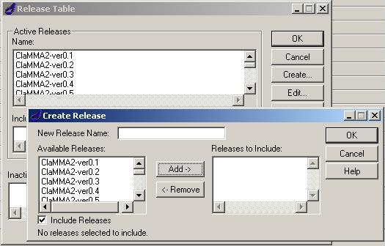
Figure 1 Creating release table

Check out from previous baseline
Check out with new release tag from previous base in build manager role so the checked out version will be in “prep” state.

Create reconfiguration template:
The previous reconfiguration template can be copied into this new template and the containers for next projects can be added now.

Copying one reconfiguring template to another
Select the reconfiguration template from Admin-> Reconfigure Template as shown in Figure 2

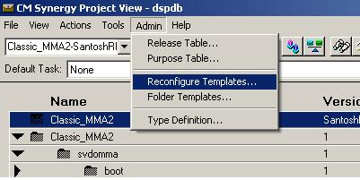
Figure 2 Opening Reconfiguration Template

In the reconfiguration template select the release tag from where the template has to be copied and the select option “Copy” as shown in Figure 3.Here check that the ‘baseline Release’ is selected as previous baseline and main ‘Release’ tag is same as the current release
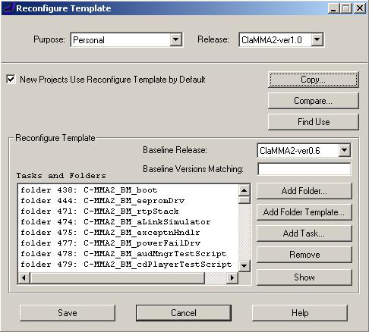
Figure 3 Reconfiguration Template
The new window will appear and now select the release tag of new reconfiguration template to where the template has to be copied.
Copy in both Personal and Integration scope as shown in Figure 4.

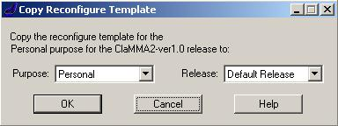
Figure 4 Reconfiguration Template copy option

Adding new folder to reconfiguration template.
After coping the reconfiguration template the new containers, which are required for the next release, can be added using option ‘Add Folder’ in reconfiguration template see Figure 3.Make sure that the new folders are added in both personal and integration scope.

Reconfigure to get the changes
Now with the new reconfiguration template do a reconfigure to get all changes which are needed for promotion.

Check for conflicts
On the project which is in prep state right click and select show conflicts as shown in Figure 5

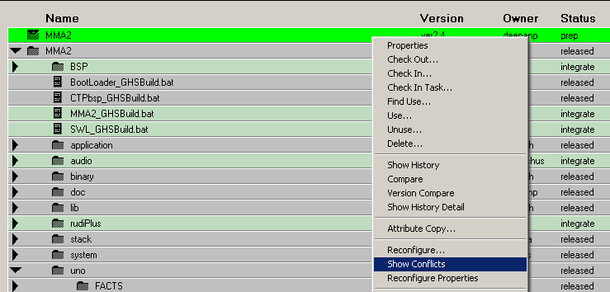

Figure 5 Reconfiguration Template copy option
If there are any conflicts such as object not associated to a task, objects in working state and parallel versions are found in the conflict window, all the conflicts should be resolved before doing a release.

Check-in the project
On the project which is in prep state right click and select Check In as shown in Figure

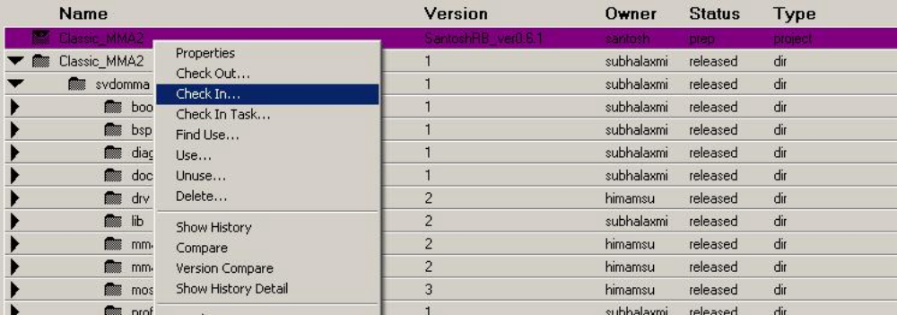Figure 6 Check-In prep project

The Check In window will appear as shown in Figure 7 now selects Advanced option

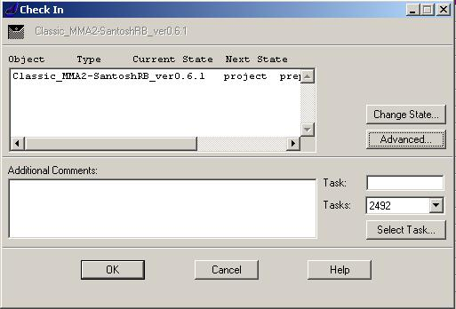
Figure 7 Check-In window

In advanced Check In Options menu select Project Members tick Source, Project and Products option as shown in Figure 8 and select OK

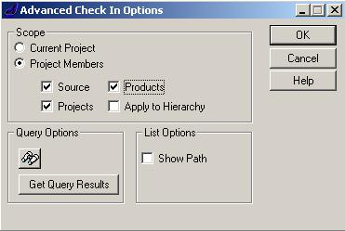
Figure 8 Advanced check In Option

Changing the state to released
After selecting Advanced Check In Options, Check In window (Figure 7) will appear again. Now select Change State. In Change State window select Source as ‘released’ as shown in Figure 9 and select OK

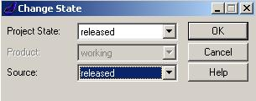
Figure 9 Changing the state to Released

Note: * After the release, all the objects are checked for released state.

FAQs (Frequently Asked Questions)
Q1. How the developer gets the access to his changes from one machine to another
Machine before the task is promoted?
Steps as Developer
- Make changes and check in those changes made (Task check in is not compulsory)
- Go to second (personal) machine and login to CM Synergy with same his/her User ID and password
- Select the corresponding checked out version of project in the Project View window (Go to Show History and select the checked out version)
- In Project View the selected checked out version of the project is displayed, right click on that checked out version and select Sync
- In Synchronize Work Area window click on the Sync button as shown in the below figure 1
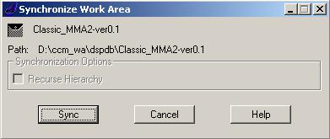
Figure 1
- After Sync, all the changes done by the developer on the first machine is
Obtained on the second machine

Q2. How to create and use a task using CM tool?
Steps used in CM tool
- In Project View window, go to Tools, select Task in the drop down list and select Create as shown in the below figure 2
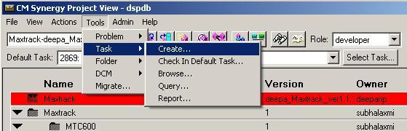 Figure 2
- Create Task window is displayed
- In Task synopsis text box, give the appropriate module name and also state the purpose of the task what for or why it is being used
- Select the appropriate (current) release tag during task creation in the Release drop down list
- Give the Task description in the text box provided (Not Compulsory)
- Click Assign, task is created!!!!!!!!!
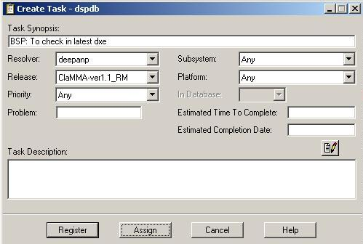
Figure 3 (Steps 2-6)
- Once the task is created, click the Select Task button in Project View window and select the task by clicking OK
- Task gets displayed in the Default Task drop down list
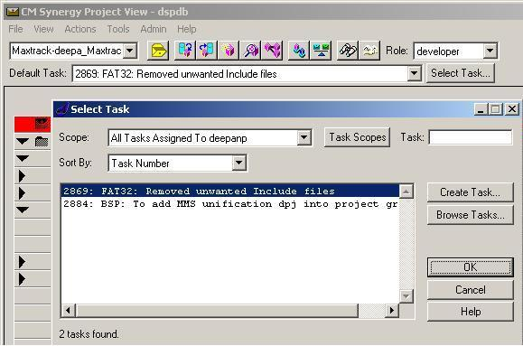
Figure 4 (Steps 7 & 8)
- Now check out the object against the task selected in Default Task drop down list
- Do the changes, verify these changes by performing some basic testing
- Once the changes are verified, check in these changes
- To check in the changes, right click on the checked out object select Check In Task
- In displayed Check In Task window, select the object that has to be checked in and click OK
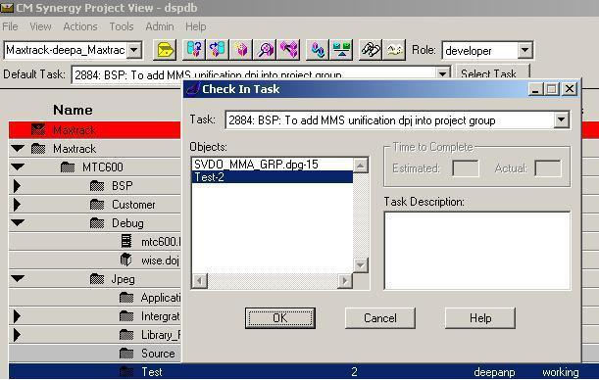
Figure 5 (Steps 9 -13)
- Task (created) selected is checked in for that particular object
- In Status column, working state changes to integrate state as shown in the below figure 6
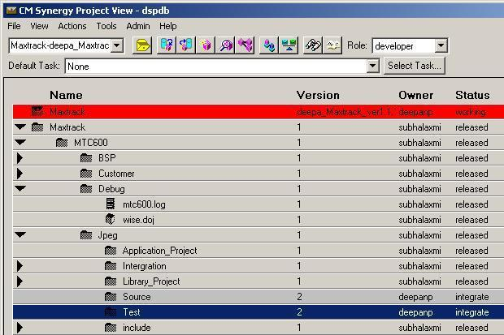
Figure 6
Note:*The task that is not used becomes a hanging task. Avoid non-usage of the task that is created
*Always a good procedure to follow is – Create a task first, then do a check out
of any object against that task and do a check in at the end after verification

Q3. How to keep track of tasks created?
Steps with respect to Integrators
- Tasks are created and checked in by the developers
- Developers send these tasks to the integrator after basic functionality testing of the changes added
- Integrator creates an integration folder in his personal container and adds all the tasks into it and checks for basic functionality
- After basic testing integrator dispatches the integration folder to build manager for regression testing and promotion of tasks
- Tasks are thus kept in Integration folder

Steps with respect to developers
- Tasks are created by Developers
- Developers can keep track of these tasks in a folder
- Developers can put all tasks which are in complete state or opened state into a personal folder that is created by build manager
- Tasks are thus kept track in personal folders of respective developers template

Q4. How to associate and disassociate objects to different tasks?
Steps to disassociate and associate a task
- In Project View window, go to Tools then to Task and later select Browse as shown in the below figure 7, Task Browsing View window is displayed as shown in figure 8
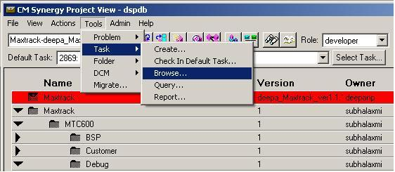
Figure 7
- Give the task number in the Task text box and click Enter
- Description of the task is displayed in the Active Task set text box and the corresponding affected objects are displayed in Affected Objects for Task text box
- Select an object that you want to disassociate the task by clicking Disassociate button
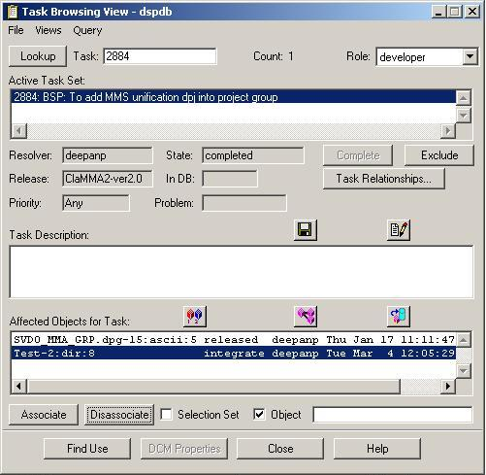
Figure 8 (Steps 2 -4)
- A new task can be checked in for that object whose task was disassociated and that disassociated task can be used for a different object
- Select an object that you want to associate the task by clicking Associate button
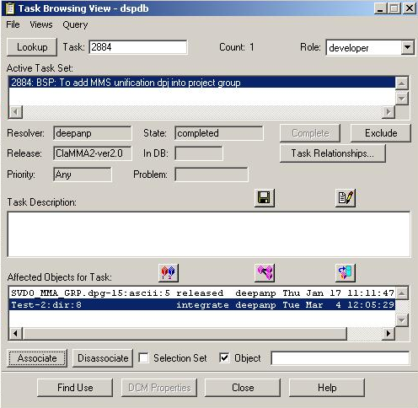
Figure 9
- Task is associated for the object selected
Note:*A task can be associated or disassociated only if it is in open state i.e. a
task cannot be in complete state
*If the task is not associated to any of the objects becomes a hanging task

Q5. How do we get the working copy?
Steps to obtain the working copy
- Login with your user id and password
- Click on the open project icon, select the corresponding project and click
Open
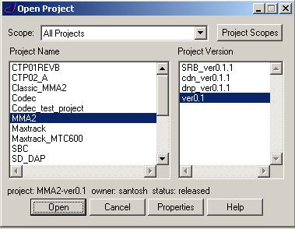
Figure 10
- Right click on the project that gets displayed in Project View window, select
Work Area Properties in the list
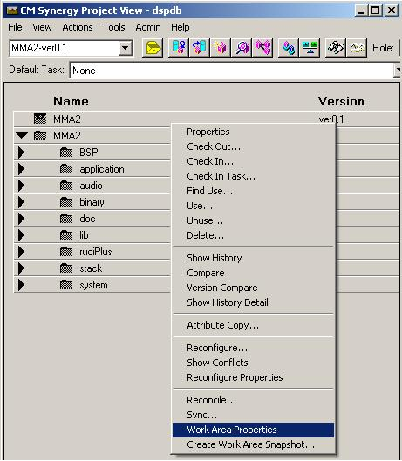
Figure 11
- In Work Area Properties window give the desired path in Directory text box
and click OK
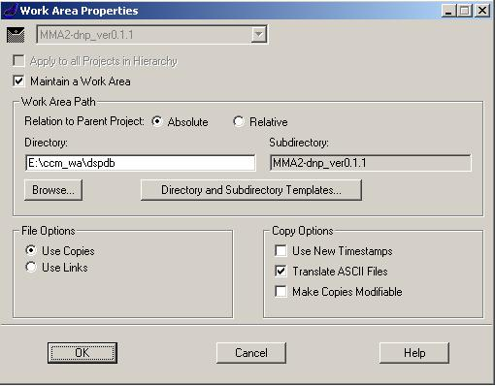
Figure 12
- Once the project is checked out the working copy is obtained in the desired
path mentioned in Work Area properties

Q6. How to obtain a working copy that is deleted from the desired path (work area)
or to obtain in a different desired path?
Steps to change the work area path
- Go to Work Area Properties by right clicking on the selected project
- In Work Area Properties window give the new desired path in the Directory
text box and click OK
  - first desired path -> E:\ccm_wa\dspdb as shown in the above figure 12
  - New desired path -> D:\Working_Area\ccm_wa\dspdb as shown in the
below figure 13
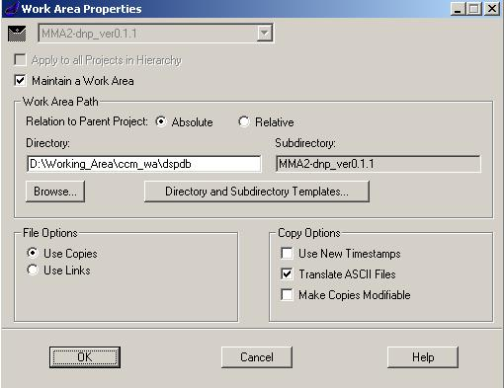

Figure 13
- Now right click on the selected project in Project View window, select Sync
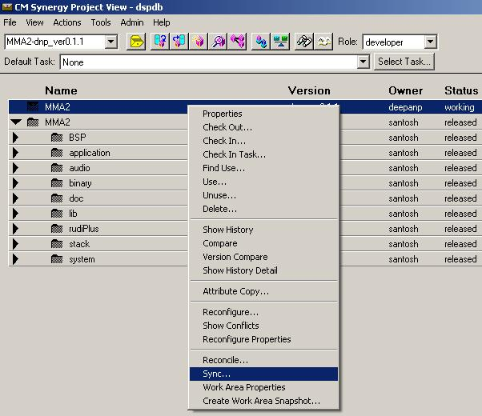
Figure 14
- Click on Sync button in Synchronize Work Area window and the working
copy is obtained in the desired path mentioned i.e.
D:\Working_Area\ccm_wa\dspdb
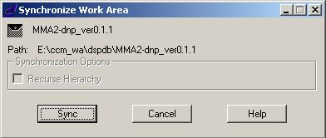
Figure 15

Q7. How to create a file and a directory?
Steps to create a file
- First in your working copy that is available after check out of the required
project, create a file in the desired path Eg: test1.c in Test directory of
working copy
- Login to CM Synergy with your user id and password
- Open the required checked out project
- Create a task (See Q2)
- Select the dir from the checked out project
- Right click on the directory where you want to add the file and select Create
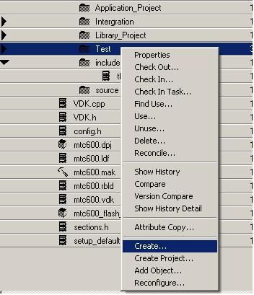
Figure 16
- In Create window browse the file to be added in Name box and click
Create
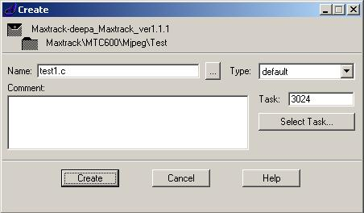
Figure 17
- New file called test1.c is created under Test dir where the status is Working
- Check in this file i.e. test1.c in CM Synergy using the task that was created
for test1.c file (to do check in of task see Q2)
Steps to create a directory
- Follow the steps from 2 to 5 same as file creation
- Right click on the directory where you want to add the directory and select Create
- In Create window type the name of the directory Eg: demo, which is required to add in Name box then select the type as dir in Type drop down list and click Create
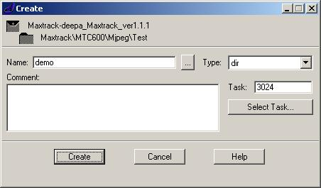
Figure 18
- New directory called demo is created in the desired directory (as in figure 18 directory gets created in Test) and its status is in Working state
Check in this directory i.e. demo in CM Synergy using the task that was created for demo directory (to do check in of task see Q2)

Q8. How to do a check out for a new baseline?
Steps for Checking out a new baseline
- Login with your user id and password
- Click on the open project icon, select the project Eg: MMA2 ver0.1 and click
Open
Figure 19
- Right click on the MMA2 ver0.1 project and select Check out

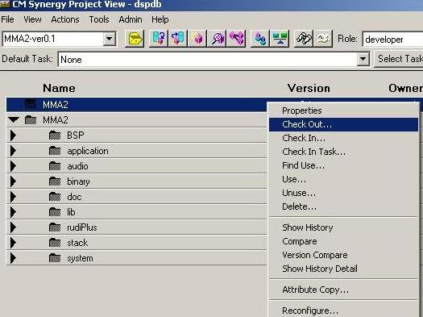
Figure 20
- In Check Out Project window, click Edit Versions
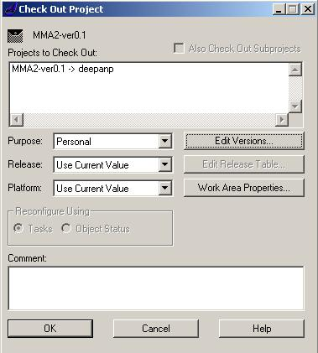
Figure 21
- In Edit Project Versions window, select Use and change the version as
<Abbreviated Name>_ver0.1.1.Click Update and OK button.
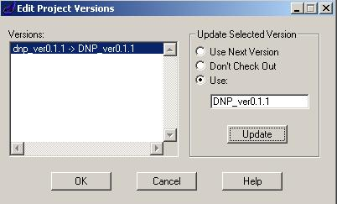
Figure 22

- Check for the updated version in Check Out Project window and click OK
button and the project is checked out as shown in the Figure5
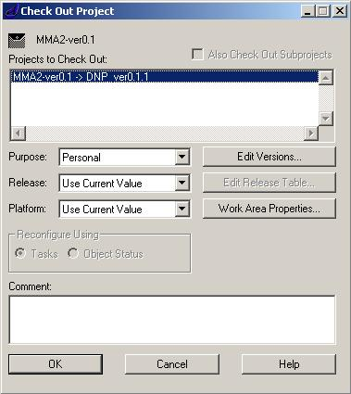
Figure 23

Q9.How to re-“assign” a task which is in “registered” state?
Steps to re-assign a task
- Login with your user id and password and got to the required project where the changes has to be done
- Create a task by clicking Register instead of Assign button
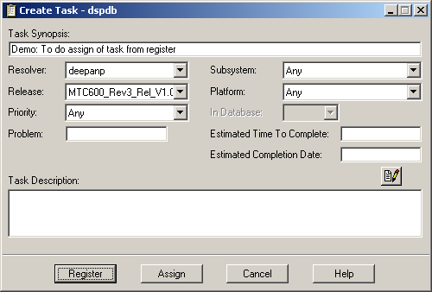
Figure 24

- The task gets registered
- When we try to select the task, the task is not displayed as it is not assigned task
- To assign this task, right click on Tools, select Task and click Browse
- In Task Browsing View window the registered task is displayed
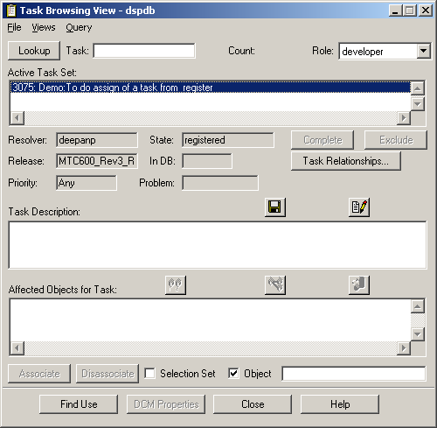
Figure 25
- In Task Browsing View window, go to Views, select Information
- In Task Information window click on Assign button and the task that was in registered state changes to Assign
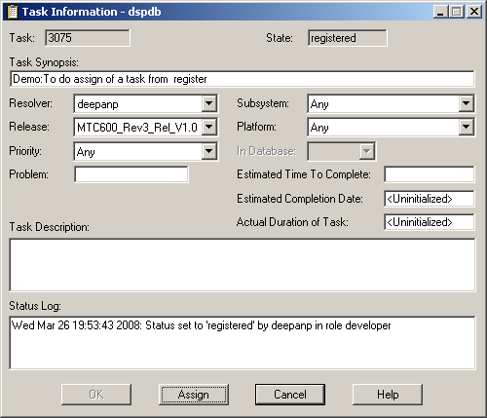
Figure 26
- This task can be used for checking out of objects for further development process

Q9.What is the difference between check in of task and check in of file?
Steps for Task check in
- Follow all the steps as given in Q2 to check in a Task
- Check in task is nothing but checking in the task after the completion of changes made to a file(s)
Steps for File/ Object check in
- Follow the steps from 1 – 6 as given in Q2
- Once the task is created, check out the files/objects against the created task
- Make changes to the checked out files
- To check in the files/objects without a task is just to right click on the checked out object and select Check In.

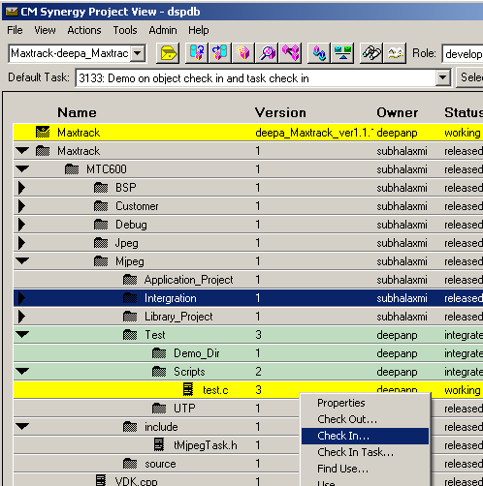
Figure 27
- In Check In click Ok button and check for the task id that is displayed in Tasks drop down list
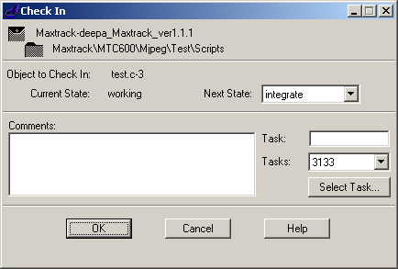
Figure 28
- In Project View window the task can be still viewed in Default Task drop down list but still the object is in checked in state i.e. integrate
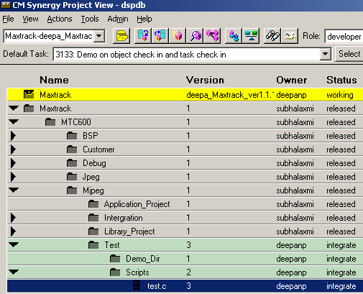
Figure 29

- Task can be checked in after the completion of that particular file
- To check in the task select Check In Task by right clicking the file that was checked in without using a task
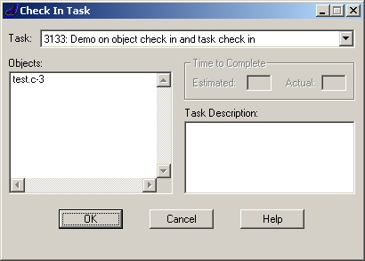
Figure 30
- In Check In Task window click OK button and the task is checked in for the objects that are displayed in Objects box

Q10. What happens when a task is not added into the personal folder and do a
Reconfigure?
Steps to resolve if a task is not added
- Do a reconfigure by adding all the tasks into the personal folder
- If by mistake we forget to add tasks into the personal folder and do reconfigure the changes are not obtained
- Don’t panic, just add the task into your personal folder and just do
reconfigure once again…all changes that are made are got back
- If all tasks are added into the personal folder and you forget to add your
personal folder into Reconfigure Properties -Tasks window template and do
reconfigure the changes are lost or not seen
- So even in that case also just add the personal folder into the Reconfigure Properties -Tasks window template and do a reconfigure all changes that were made are got back

Q11.How to resolve when there is a conflict as we try to do reconfigure after taking
other changes?
Steps to resolve conflicts
- Add all the required tasks into Reconfigure Properties – Tasks window and do a Reconfigure
- A warning window appears on the screen saying that there is a conflict in work area say Ok
- Check in all the files first if you are doing some changes on that file as when we try to resolve the conflict all the changes are lost
- Right click on the project which is in working state, select Reconcile

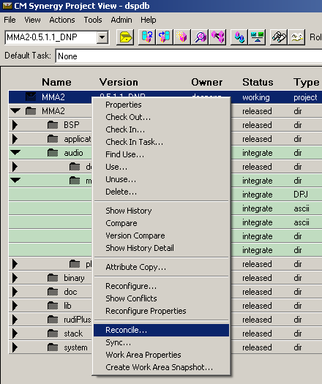
Figure 31
- Under Reconcile Work Area window, in Conflict Handling select Update Work Area from Database and in options check the options as seen in the figure 32 and click Reconcile button
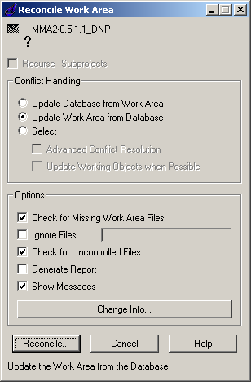
Figure 32
- Once Reconcile is done right click on the project and do a Reconfigure by adding all the tasks (i.e. by taking the changes)
- Reconfigure is successful
Note:*If step 3 is missed and Reconcile is done without checking in the changes all the changes are lost. To avoid this donot forget to check in your changes
before doing a Reconcile

Q12. How to rename an object?
Steps for renaming an object/file
- In the local work area take a copy of the file that has to be renamed as the text remains same except the file name
- Create a task (See Q2)
- Check out the object that has to be renamed
- Right click on that object/file and select Unuse
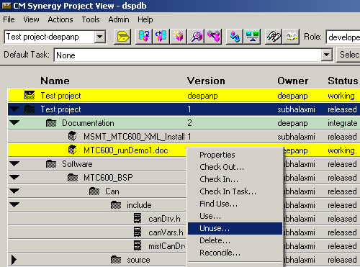
Figure 33
- In Unuse window select Unuse and Delete option and click on Unuse button
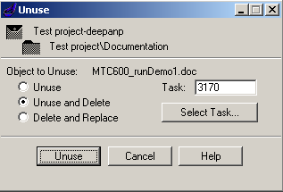

Figure 34

- In Project View window the desired file gets deleted, when compared to figure 34 and figure 35 MTC600_runDemo1.doc is deleted after step 5
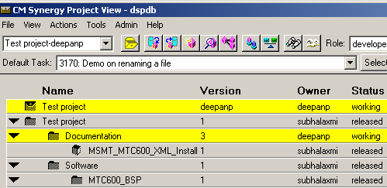

Figure 35
- Copy back the file into the work area (see step1) and in CM synergy right click on the required file and select Create
- In Create window browse and select the renamed file that has to be added into the required directory and click Create button
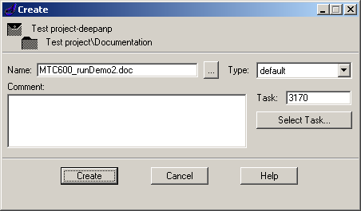

Figure 36
- A new renamed file is added as shown in figure 37 i.e.
MTC600_runDemo1.doc is renamed as MTC600_rundemo2.doc

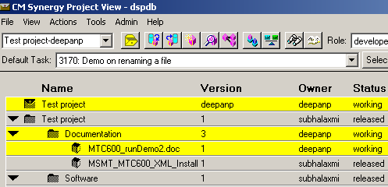
Figure 37

- Last but not the least check in the Task and the status is Integrate

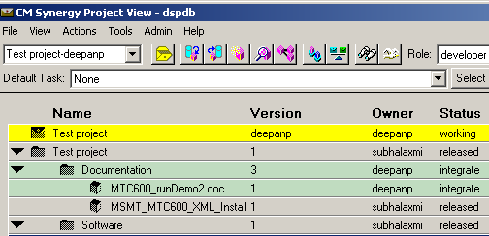

Figure 38

- To verify whether the changes i.e. renaming of the file is obtained, just select that object and click on History icon in Project View window.
- In History View window the file that was added is displayed and the version is 1 and the old file history is deleted
Note:*History of file MTC600_runDemo1.doc is deleted and history of the new renamed file MTC600_runDemo2.doc is maintained

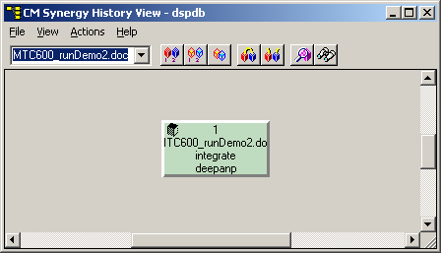

Figure 39

Q13.How to know what were the tasks that were created by a developer?
Steps to view all the tasks created by a developer
- Go to Tools, select Task and next select Query

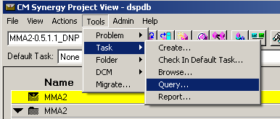
Figure 40

- In Task Query Dialog window select the State, Release, Task Events and in user text box give the name same as CM Synergy login ID. In Query String the query is displayed as we select the options and click on Query button

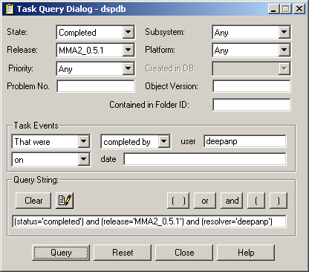
Figure 41

- In displayed Task Browsing View window, go to Query and select Reports,
Report Generator window is displayed
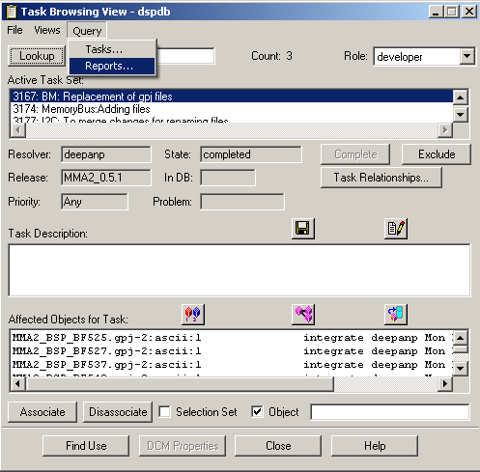
Figure 42

- In Report Generator window click Define button

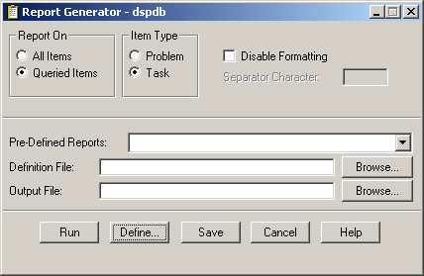
Figure 43
- In displayed Define New Report, select the fields required in the second list displayed and click Page Layout
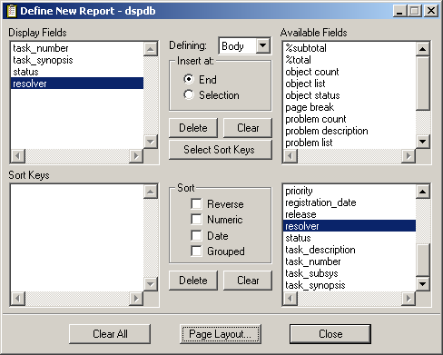
Figure 44

- In Report Page Layout window, change the width depending on the fields selected and click Apply and Ok button
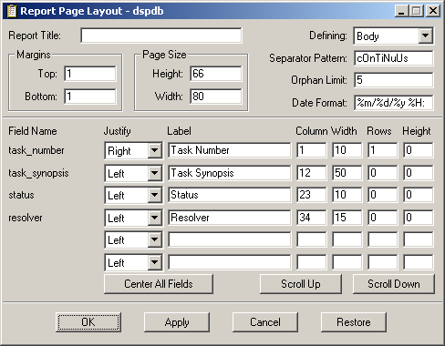
Figure 45

- In displayed Report Generator window click Run button

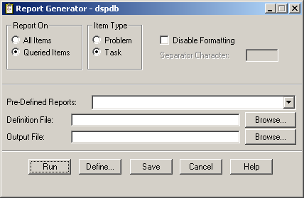
Figure 46

- The output of this is obtained in a notepad giving the fields details that were selected
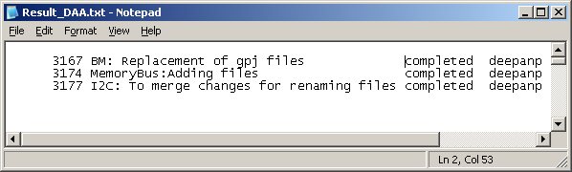

Figure 47

