W07 Report: Digital Profile or ePortfolio

**Name**: Thomas Johnson

# Overview

A professional *digital profile* helps you in two ways. First, it allows you to make digital contacts and network with the right people. Second, it allows others to see your professional information and resources in an organized page from anywhere in the world. An *ePortfolio* compiles your professional works and resources, and allows more controlled and targeted sharing than a “public” profile. See the [Digital Profile or ePortfolio](https://content.byui.edu/integ/gen/8f42baa7-78c0-4a04-bf7f-98dfeda0e82e/0/gs170_help_DigitalProfileOrPortfolio.pdf) help page.

In this report, you will share a screenshot of either your digital profile or your ePortfolio, which includes your education, experience, and a professional summary or description that demonstrates your expertise or experience (Part 1). You will also make at least 10 digital connections or share your ePortfolio with 10 contacts from your Contacts & Opportunities sheet (Part 2).

# Instructions

Please complete all questions in each section below. *Answers or boxes left blank will reduce your score on this assignment.*

## Part 1: Digital Profile or ePortfolio

1. **Paste** a screenshot of your digital profile or ePortfolio you created.
2. 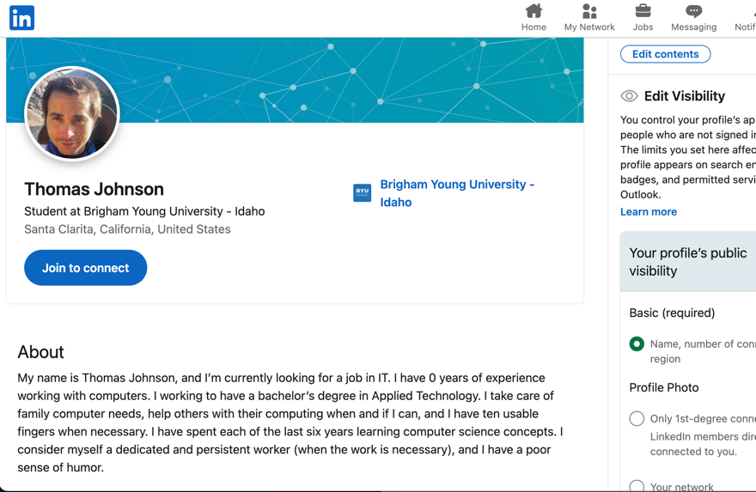
3. **Indicate what you included** in your profile/portfolio. It should have at least the following items. For each of the items below give simple instructions on where to find it:
   1. Education Certificate or Degree

I added what little education I have. I’m not going to lie to anyone.

* 1. Summary/Description (similar to Me in 30 Seconds):

I pretty much copied and pasted the Me in 30 I made before, but made a few professional tweaks and made it look better.

* 1. Professional or Volunteer Experience

I mentioned what I’m currently doing, being a caregiver. I haven’t done much else.

## Part 2: Digital Networking

1. **Connect** with at least 10 people through your digital profile. If you are using an ePortfolio, then **share** it with at least 10 professional contacts. If a contact is not on your Contacts & Opportunities sheet, then add them. A few suggestions:
   1. Include a brief introduction of yourself. Use your Me in 30 Seconds statement.
   2. Explain your job search status and ask them about job opportunities.
   3. Refer to the W07 Act page in your course for ideas on reaching out and networking with your contacts.

How many people did you connect with or share your ePortfolio with?

I added 10 random people(related to IT). Is that what you guys wanted?

1. **Write** a brief reflection (50 to 150 words) on your experience networking with these contacts. Include at least the following in your reflection:
   1. What went well? What did not go so well?
   2. What did you learn that you can apply to future digital networking efforts?

To be honest, this whole adding people I don’t know, trying to get a job I’m not certified in, putting myself out there when I’m completely ill prepared and lacking any degree or certification is making me feel like my skin is falling off. This is not a pleasant or helpful experience. If I had anything to bring to the table, I’d be happy to do all this and really I can’t wait till I have something to offer, but this just doesn’t feel helpful to me right now.

**Save** this document with your name in the filename and follow the instructions in your course to **submit** it for grading and feedback.