Chord to Note

Example 1: Print all chords in C major and C minor.

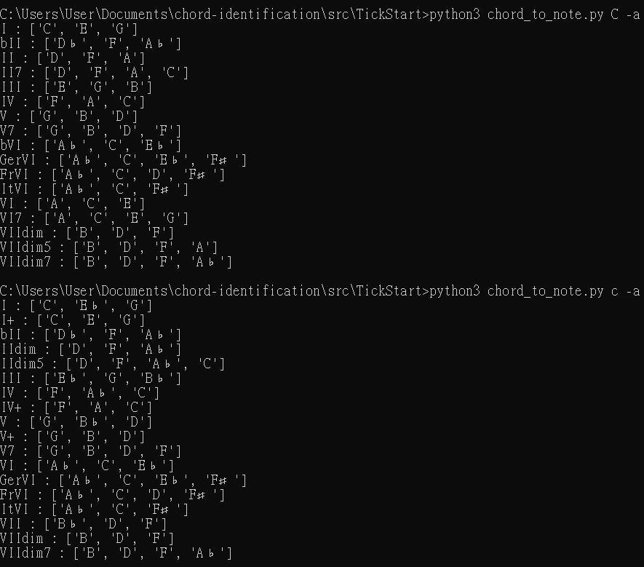

Example 2: Print all chords in F♯ major and F♯ minor.

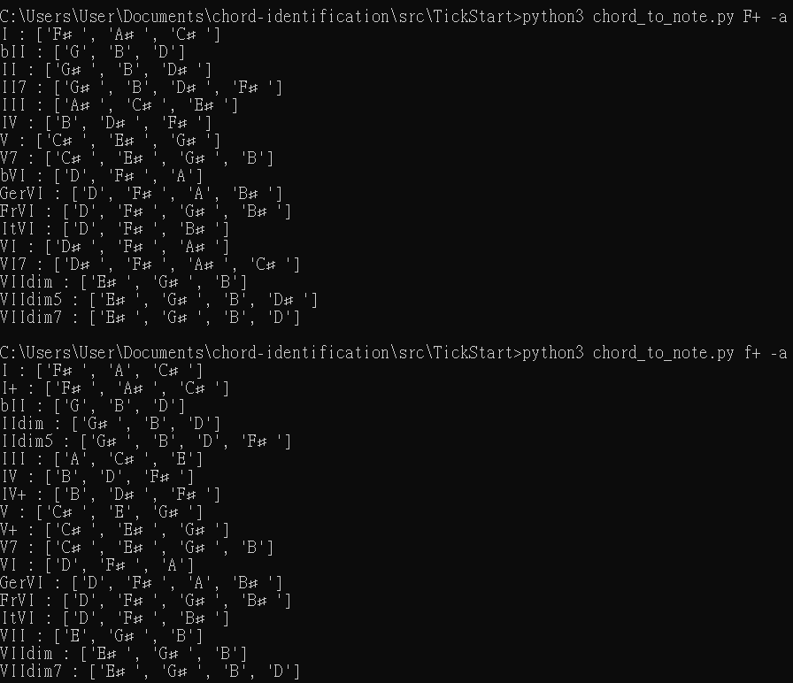

Example 3: Print all chords in D♭ major and D♭ minor.

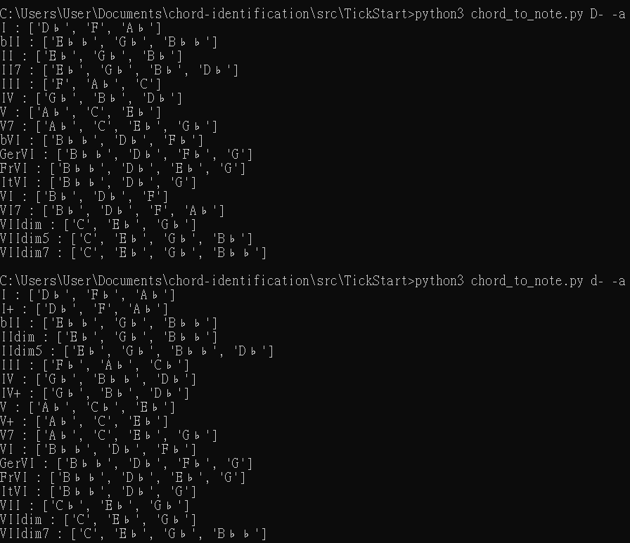

Notes to Chord

Example 4: Print all possible chords for

1. C, E, G
2. C, E♭, G
3. C, E♭, G♯

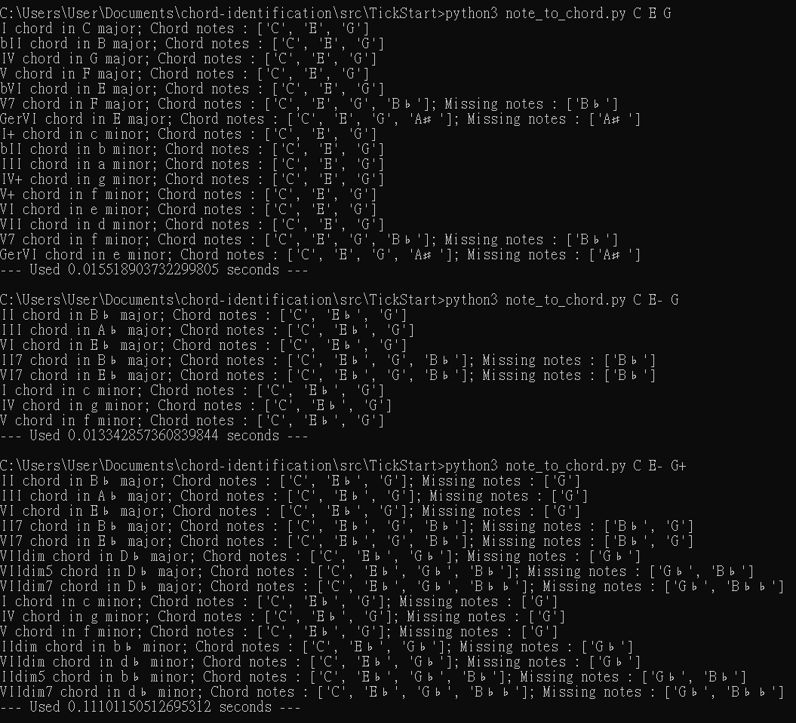

Example 5: Print all possible chords for

1. C, A♭
2. C, A♯

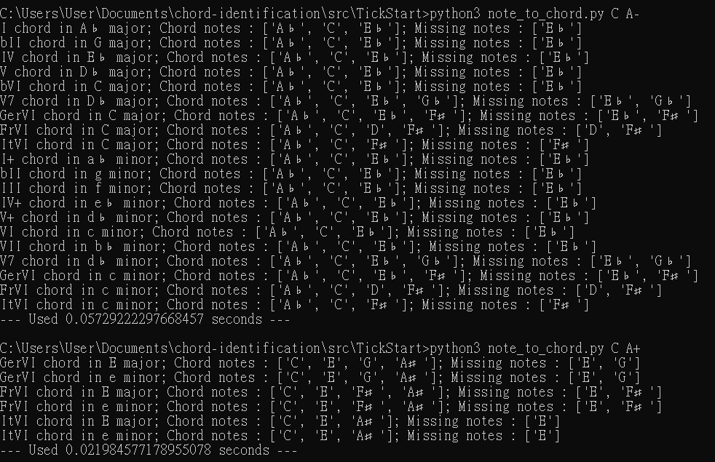

Example 6: Print all possible chords for C♯♯, D, E and F♯.

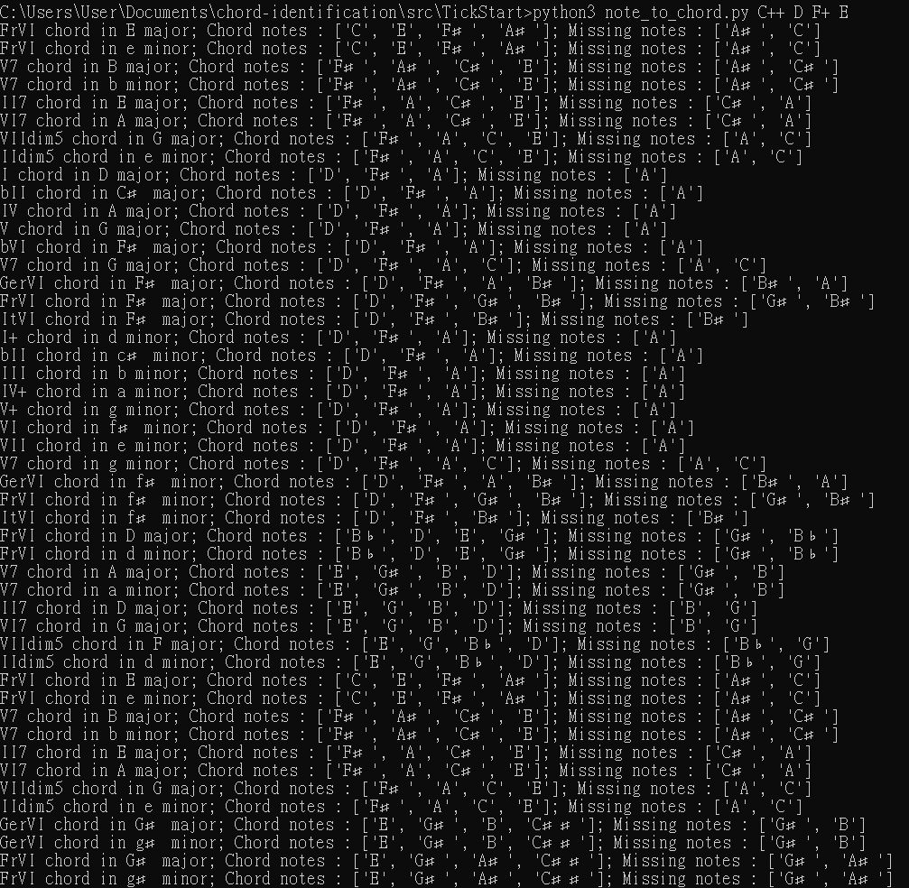

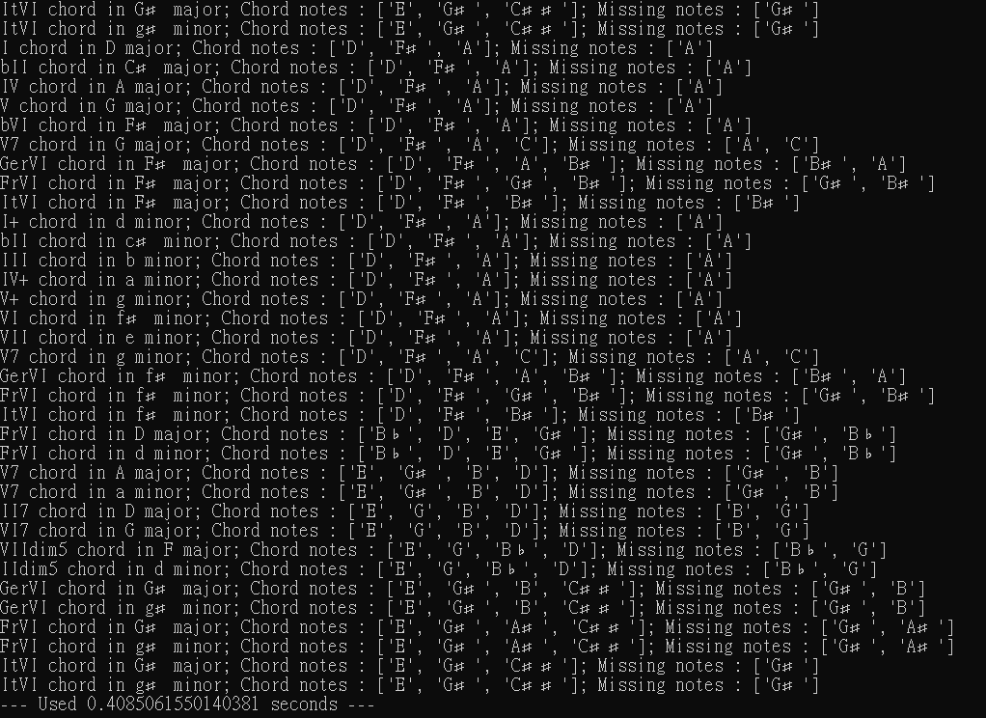

Example 7: Print all possible chords for D, D♯ and D♯♯.



Example 8: Print all possible chords for C♭ and A♭♭, with the specification of C♭ major.

