appe
Appendix E - χ² Testing of Correlation Between Cold Shuts and Leakers
Table E.1 gives the number of leakers detected on castings divided into groups of different severity of cold shutting.
Level of Cold Shutting | None | Small | Moderate | Extensive | Severe
Number of Castings | 24 | 15 | 13 | 9 | 4
Number of Leakers | 2 | 4 | 6 | 6 | 4
Leaking Castings/Castings | 0.083 | 0.27 | 0.46 | 0.67 | 1
Table E.1 Relationship Between Level of Cold Shuts and the Occurrence of Leakers.
We can test whether the relationship evident in the data in Table E.1 is likely to occur due to random sampling in a population where there is in fact no relationship between cold shuts and leakers, this is referred to as the “Null Hypothesis”. This can be done using a χ² test in a similar manner to that used in Chapter 4.
Initially we determine a χ² value using Equation E.1. This can then be compared with tabulated values to give a probability of the null hypothesis being correct.
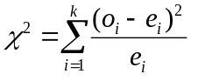 Equation E.1 [E1]
The terms o_{i} and e_{i} represent the observed and expected frequencies for the ith cell. The term k represents the number of groups of data. The observed values are found from the actual data, in our case the number of leakers at each level of cold shuts. The expected value refers to the value we would expect to occur if the null hypothesis were true. For each level of cold shutting this can be found by multiplying the overall leaker rate by the number of castings at each cold shut level. However, when we do this we find that the expected values for cold shut levels moderate, extensive, and severe, are less than 5. It is a requirement of the χ² test that the expected value of each sample must be greater than 5, [E2]. In order to overcome this problem we can regroup the data as shown in Table E.2. This will allow us to perform a χ² test on the data. Should the null hypothesis be proven unlikely on this regrouped data, it will be similarly unlikely on the original data, Table E.1.

Cold Shuts | None | Small | Moderate to Severe
Castings | 24 | 15 | 26
Leakers (Observed Value) | 2 | 4 | 16
Expected Value | 8.123 | 5.077 | 8.800
Table E.2 Regrouped Cold Shut Levels and Expected Values.
Using the expected values given in Table E.2 we can now calculate a χ² value as follows.
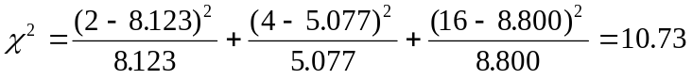
We can compare this value with tabulated χ² values on [E1]. For 2 degrees of freedom we see that the probability of χ² exceeding 10.597 is 0.5 %. This indicates that the probability of the null hypothesis being true is slightly less than 0.5%. Thus in all probability, there exists a relationship between the occurrence of cold shuts and the occurrence of leakers.

References
E1 Walpole and Myers, ‘Probability and Statistics for Engineers and Scientists’, Fifth Edition, Macmillan Publishing Company, 1993.
E2 Moroney, ‘Facts from Figures’, Second Edition, Penguin Books Ltd., 1957.

The number of degrees of freedom is defined as the number of classes whose frequencies may be arbitrarily assigned [E2] without changing the overall frequency. In this case it is given by k-1 = 2. If we arbitrarily assign the number of leakers in two of the groups in Table E.2 then the number of leakers in the third group is determined by the fact that there must be 22 leakers overall.

