Chapter 4
Determination of Effect of Die and Metal Temperature on Casting Quality

Aims of Experiment
Having established in the previous chapter that the formation of cold shuts near the casting extremity appears to be the major reason for the formation of leakers, this trial is aimed at changing the casting conditions to encourage the formation of cold shuts and examining the effect of these changes on the proportion of leakers produced.
To encourage the formation of cold shuts the rate at which the solidifying alloy gives up its heat can be increased and/or the amount of heat the alloy has to give up before it fails to flow can be decreased. These can be controlled directly by using fluid cooling of the die and by varying the metal temperature.

Description of Trial

Control of Heat Removed Using Cooling Channels
The design of the die allows cooling to be applied independently to a number of different regions. This feature can be used to cool one cavity while the other remains at relatively normal conditions. Figure 4.1 shows how this can be done.
Figure 4.1 Diagram of Cooling Line Setup During Trial.
Oil is pumped through the marked lines to remove or add heat to the cavity depending on the relative temperatures of the die and the oil. The use of oil as a heat transfer medium allows greater control of the input temperature and the flow rate using a standard oil heater/cooler unit, when compared to water pumped directly from the mains supply. Water is pumped through cooling lines within the sprue post on the moving die half and through a sleeve around the shot sleeve on the fixed die half. This maximises cooling of the biscuit, reducing the cycle time of the die. This approach to cooling around the biscuit is standard practice during production of this casting.
The oil input temperatures used were selected based on knowledge of the usual operating conditions of the die. 180 °C was used for the “Low” oil cooling level. This oil temperature is commonly used to warm the die before the first shot and to keep the die running at reasonable temperatures during interrupted production. When used in such a manner the oil is usually run through channels further from the cavity surface than the channels used during this trial. This results in a bulk heating of the die rather than the more localised control used in this trial. 100 °C was used for the “High” oil cooling level. This oil temperature should simulate a cold die without cooling it to a point where it becomes inoperable.
Referring to Figure 4.1 we note that only cavity 2 is directly cooled by the oil. Leaving cavity 1 un-cooled gives us an extra “Zero” oil cooling level. To compare this directly with the castings made in cavity 2 we need to make the assumption that under equivalent thermal conditions the two cavities would produce equal numbers of leakers. Common sense suggests that this would be the case, but previous observations and experiments have yielded insufficient numbers of leakers to confirm this assumption.

Control of Casting Alloy Temperature
The temperature of the molten alloy prior to casting can be readily controlled using the metal holding furnace control system. This allows the metal temperature to be set over a wide operating range. The normal operating temperature for the casting in question is 680 °C. This value was selected as a “high” operating point, while a value 20 °C below this, 660 °C, was used as a “low” operating point.
Lowering the alloy temperature would be expected to reduce the amount of heat the alloy can surrender before it fails to fill the cavity, ie. it will reduce the solidification time of the alloy. By changing the thermal state of the die it will also impact upon the heat transfer rate and the observed die temperatures.

Summary of Experiment Design and Expected Effects
We have proposed the use of three levels of die cavity cooling and two levels of alloy temperature. Such a design lends itself to the use of a six point experiment. Figure 4.2 summarises this experimental design and the expected effects of varying parameters in this way.
Figure 4.2 Summary of Experimental Design and Expected Effects.
By producing castings at each of these six points we will be able to test the effects of each control input on the castings.
We wish to produce as many castings at each operating point as possible to maximise the accuracy of the results. The number of castings that can be made practically will be limited by the amount of time we have access to the machine. In this case a target of 30 to 40 castings representative of steady production conditions at each operating point was judged to be reasonable. To achieve this a target of 50 castings per operating point was set. Due to the use of a 2 cavity die and the experimental design, twice as many castings will be made at operating points 5 and 6, ie.
- Operating Points 1 - 4 : 50 Castings Each
- Operating Points 5 - 6 : 100 Castings Each.
Of the 50 castings a number will be removed. Castings removed will include those made at the start of the operating condition when the die temperature is much lower than that encountered during steady production. This accounts for “warm up” shots which are usually discarded as standard production practice. Any other castings that show up as anomalies will also be removed if justified. Most of these were castings where the shot numbering on the casting appeared unreliable, making it hard to match these castings with the shot monitoring data.

Measurement of Casting Parameters
In order to correlate the occurrence of leakers with the condition of the casting machine and die at the time of casting, it is necessary to measure selected parameters to quantify the machine condition.
The high pressure die casting machine used in the trial is equipped with transducers that measure the displacement of the plunger throughout the shot and the hydraulic system pressure. These transducers are connected to data acquisition and analysis software that allows the data to be converted into series of parameters that represent the state of the machine shot end. Table 4.1 lists these parameters.
Machine Shot End Parameters
Casting Cycle Time
Plunger Displacement During First Stage Injection
Plunger Displacement During Second Stage Injection
Average Plunger Speed During First Stage Injection
Average Plunger Speed During Second Stage Injection
Maximum Plunger Speed During Second Stage Injection
Delay Between End of Second Stage Injection and Application of Intensification Pressure
Maximum Hydraulic Pressure During First Stage Injection
Maximum Hydraulic Pressure During Second Stage Injection
Plunger Displacement at End of Injection Cycle
Table 4.1 Shot End Data Recorded During Trial.
We also need to quantify the thermal condition of the die. This can be done by measuring the cavity temperature in a number of locations. As the cavity temperature will vary throughout the casting cycle it is necessary to measure the temperature at the same point of time in each cycle to compare shots. The temperature in each cavity was measured in four representative locations. Figure 4.3 shows the location of these points.

During the trial these temperatures were measured every 10 shots using a hand held surface probe and recorded on paper as cavity 1 temperatures and cavity 2 temperatures. Measurements were taken immediately after the die opened, before the application of die spray, to minimise effects of any inconsistencies in die spray application. The order of measurement was controlled to ensure that measurements in each spot were taken at a consistent point in time during each cycle. After the trial these temperatures were linearly interpolated to give an approximate temperature for each location for every shot. For each casting made we therefore have a measure of the die surface temperature. The molten metal temperature was also measured every 10 shots and interpolated for each casting. This gives a more accurate reading of this important variable than the set metal temperature. Table 4.2 lists the temperature related parameters for each casting.
Figure 4.3 Locations of Temperature Measurements in Cavity.
Temperature Parameters for Every Casting
Casting Cavity Sliding Core Temperature
Casting Cavity Moving Cavity Temperature
Casting Cavity Gate Temperature
Casting Cavity Fixed Cavity Temperature
Measured Metal Temperature
Table 4.2 Temperature Parameters for Every Casting.
The variables in Table 4.1 and Table 4.2 can be regarded as casting inputs. The output variable is whether the casting leaks or not. As the test used in production is a pass/fail test it is of little value to complicate the results by scaling the amount of leakage per casting. The production leak test, see Appendix A.4, was used to assign a pass/fail output variable to each casting.

Results of Trial
The trial produced roughly 220 shots, ie. 440 castings, of which about 80 shots, ie. 160 castings, were discarded, leaving a final sample of 133 shots, ie. 266 castings. Most of the castings removed were warm-up shots. Analysis of the data indicated that removal of the first 10 shots for each condition would be appropriate. It was apparent that the stoppages occurring every 10 shots to measure the die temperatures had a significant effect, thus 2 shots after each such stoppage were removed from the data. A handful of other castings were removed from the data due to problems with identification. In these cases the shot number was either illegible or suspicious in relation to other castings.
The number of castings made and the number of leakers made at each operating point are summarised in Table 4.3.
 | Op. Point 1 | Op. Point 2 | Op. Point 3 | Op. Point 4 | Op. Point 5 | Op. Point 6
Cast | 33 | 34 | 35 | 31 | 67 | 66
Leak | 7 | 3 | 1 | 6 | 5 | 1
Table 4.3 Summary of Casting Results.
We can now analyse the results of the trial. The most direct approach to take is the use of statistics to see if there is a correlation between the control inputs, (the set metal temperature and the oil cooling level), and the occurrence of leakers. Following on from this we can test for correlation between the production of leakers and the measured input variables, (Table 4.1 and Table 4.2).

Correlation Between Oil Cooling Level and Leaking Castings
We can break the data into three groups depending on the oil cooling present during casting. These are;
- Castings made at operating points 1 and 4 Ø High Oil Cooling Level.
- Castings made at operating points 2 and 3 Ø Low Oil Cooling Level.
- Castings made at operating points 5 and 6 Ø No Oil Cooling.
Table 4.4 shows the data divided into these groups. The term Leaker Rate refers to the number of leakers made divided by the number of castings made at that condition.
 | No Oil | Low Oil Cooling Level | High Oil Cooling Level
Number of Castings | 133 | 69 | 64
Number of Leakers | 5 | 4 | 13
Leaker Rate | 0.03759 | 0.06250 | 0.1884
Table 4.4 Number of Leakers at Differing Oil Cooling Levels.
We can see that the maximum number of leakers per casting is produced at conditions of maximum cooling via the oil while the smallest number of leakers per casting is produced under conditions without oil cooling. We need to test whether this trend is likely to be due to a real difference in the probability of a leaker occurring between each level of cooling or whether such a result is likely in a sample where the probability of a leaker at each oil cooling level is equal. We can test this using a statistical approach known as the χ² test.
To carry out a χ² test on our sample we use the following approach.
The value of χ² for our data and hypothesis can be found from Equation 4.1.
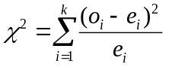 Equation 4.1 [39]
The terms o_{i} and e_{i} represent the observed and expected frequencies for the ith cell. The term k represents the number of groups of data. The observed values are found from the actual data, in our case the number of leakers at each operating point. The expected value refers to the value we would expect to occur if a given hypothesis is true. In our case we wish to test the hypothesis that there is no difference in leaker rates between each condition, referred to as the “null hypothesis”. So the expected value for each condition can be found by finding an overall leaker rate, ie. total number of leakers divided by the total number of castings, and multiplying this by the number of castings at each condition. Table 4.5 shows the expected frequency for each condition as well as the corresponding observed frequency.
 | No Oil | Low Oil Cooling Level | High Oil Cooling Level
Expected Value (e_{i}) | 11 | 5.707 | 5.293
Observed Value (o_{i}) | 5 | 4 | 13
Table 4.5 Observed and Expected Frequencies for Different Oil Cooling Levels.
Thus the value of χ² can be found.
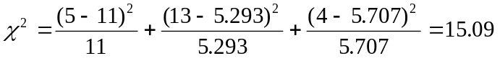
We can now compare this value with statistical tables which state the probability of a χ² value of this magnitude or greater occurring if the assumed hypothesis were true.

From pg 706 [39] we see that the probability of χ² exceeding 13.815 for 2 degrees of freedom is 0.1%. This indicates that were the null hypothesis true, the probability of the observed distribution of leakers occurring is less than 0.1%. This effectively disproves the null hypothesis. Therefore we can say that the use and magnitude of oil cooling has a significant impact on the probability of producing a leaker.

Correlation Between Metal Temperature and Casting Leakers
We can also break the data into groups depending on the temperature of the metal at which the casting was made. These are;
- Castings made at operating points 1, 2, and 5 Ø Low Metal Temperature.
- Castings made at operating points 3, 4, and 6 Ø High Metal Temperature.
Table 4.6 shows the data divided into these groupings.
 | Low Metal Temperature | High Metal Temperature
Number of Castings Made | 134 | 132
Number of Leakers Made | 14 | 8
Leaker Rate | 0.1045 | 0.06061
Table 4.6 Number of Leakers Made at Different Metal Temperatures.
We can see from Table 4.6 that there is an increase in the rate of leakers being formed as the metal temperature is reduced. We can test to see if this difference is likely to have occurred by chance if there were no difference in the probability of forming a leaker at the different metal temperatures (the null hypothesis). Table 4.7 shows the expected and observed frequencies for this data and hypothesis.
 | Low Metal Temperature | High Metal Temperature
Expected Value (e_{i}) | 11.08 | 10.92
Observed Value (o_{i}) | 14 | 8
Table 4.7 Expected and Observed Frequencies at Different Metal Temperatures.
As this situation has only one degree of freedom, the accuracy of the result will be improved if we use a function known as Yates’ Correction [40] when determining the appropriate χ² value. Yates’ correction involves subtracting 0.5 from the absolute value of each (o_{i} - e_{i}) term in Equation 4.1 prior to squaring. Solving Equation 4.1 with this correction;
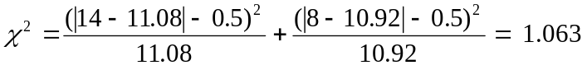
From pg 706 [39] we see that the probability of this value of χ2 being exceeded if the null hypothesis applies is greater than 30%. A probability this high means we cannot discount the null hypothesis. On the basis of this data we cannot claim that the temperature of the metal has a significant effect on the probability of a leaker being formed.

Use of Trial Results to Predict Casting Output
Having shown a strong link between the use of cooling oil in this trial and the occurrence of leakers we now seek to quantify this relationship. Following on from this we will use the values of the measured parameters, Table 4.1 and Table 4.2, to try and predict the formation of leakers during our trial. Such an analysis will provide a powerful tool for the prediction of leakers during production.
To look for relationships between input parameters and the formation of leakers we will use the method of least squares to fit linear regressions between the casting quality output variable, (y), and the selected input variables, (x_{i}). The general form of such an equation is given in Equation 4.2. Descriptions of how to use the method of least squares can be found in Chapters 11 and 12 of [39].
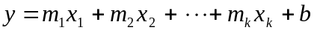 Equation 4.2

Relationship Between Control Variables and Casting Output
Using the method of least squares we can fit a linear regression that predicts the casting output from the controlled inputs, oil cooling level and set metal temperature. To fit such a curve it is necessary to assign a value to each of the possible input and output states. The values used are shown in Table 4.8. For the oil lines the variable we are changing is the rate of heat transfer from the cavity. At present we have no physical measure of this rate. Given this lack of knowledge it is appropriate to use the simplest possible method of differentiating between the levels, ie. 0, 1, and 2. For the metal temperature the choice of values is unimportant as with only two levels the linear regression will account for any changes.
Oil Cooling Level | No Oil | Oil at 180 °C | Oil at 100 °C
Value of x₁ | 0 | 1 | 2
Set Metal Temperature | 660 °C | 680 °C
Value of x₂ | 0 | 1
Casting Output | Casting Sound | Casting Leaks
Value of y | 0 | 1
Table 4.8 Values of Equation Parameters for Different Conditions.
Using the method of least squares to fit the most accurate linear regression possible for this data results in Equation 4.3.
Equation 4.3
If we divide the data into the six operating points defined in Section 4.2.3 we see that for each operating point the value of y will be constant. Therefore Equation 4.3 will be of limited use in predicting the occurrence of an individual leaker, but may be of some use in predicting the proportion of leaking casting produced under given operating conditions. Figure 4.4 is a plot of the output of Equation 4.3 versus trial shot number, with the observed rate of leaker formation overlaid.
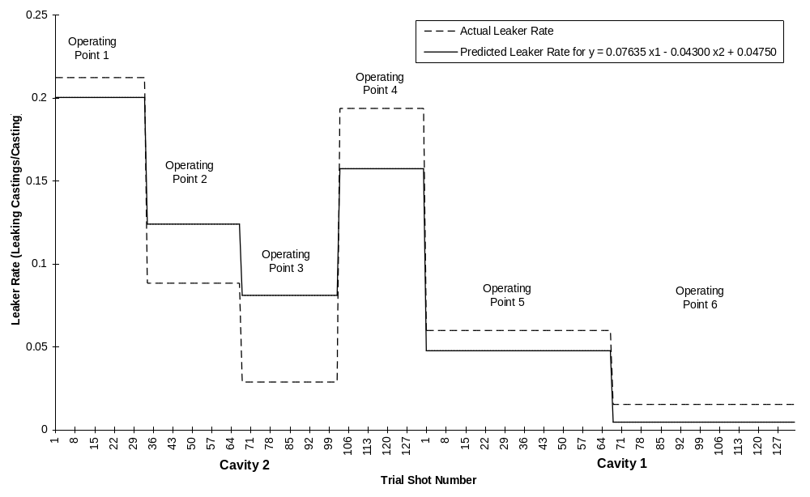
Figure 4.4 Plot of Predicted Leaker Rate, Using Equation 4.3, Versus Shot Number.
The trial shot number does not correspond to the shot number recorded for each casting during the trial. This is due to the fact that a number of castings were removed from the data, such as warm up shots, etc. Table 4.9 lists groups of trial shot numbers and the corresponding groups of castings. Within each group the shot numbers are in chronological order, though due to the removal of some castings from the data, consecutive shot numbers do not necessarily represent consecutive castings.
Shot Number | Corresponding Casting
1 to 33 | Castings Made in Cavity 2 During Operating Point 1
34 to 67 | Castings Made in Cavity 2 During Operating Point 2
68 to 102 | Castings Made in Cavity 2 During Operating Point 3
103 to 133 | Castings Made in Cavity 2 During Operating Point 4
1 to 67 | Castings Made in Cavity 1 During Operating Point 5
68 to 133 | Castings Made in Cavity 1 During Operating Point 6
Table 4.9 Groupings of Castings Numbers.
An examination of Figure 4.4 shows that the formula is reasonably successful in predicting the rate of leaker formation for a given operating point. The effect of metal temperature differences appears well predicted, however our prediction of effects due to the oil cooling level could be improved. Operating points 1 and 4 are underestimated while 2 and 3 are overestimated. This is due to the difference in leaker rates between low oil cooling level and high oil cooling level being greater than the difference in leaker rates between no oil and low oil cooling level, ie. the relationship between oil cooling level and leaker rates is non-linear. This suggests that the fit of the regression curve could be improved by introducing a non linear term into the regression equation. If we introduce an x₁² term and use the method of least squares to fit a new regression we get;
Equation 4.4
where y, x₁, and x₂ are as defined in Table 4.8. This relationship is plotted alongside the observed leaker rate in Figure 4.5.
Figure 4.5 displays a considerably better fit than that shown in Figure 4.4. The good fit shown by Figure 4.5 indicates that the results of our trial can be readily explained by variation in the controlled parameters.
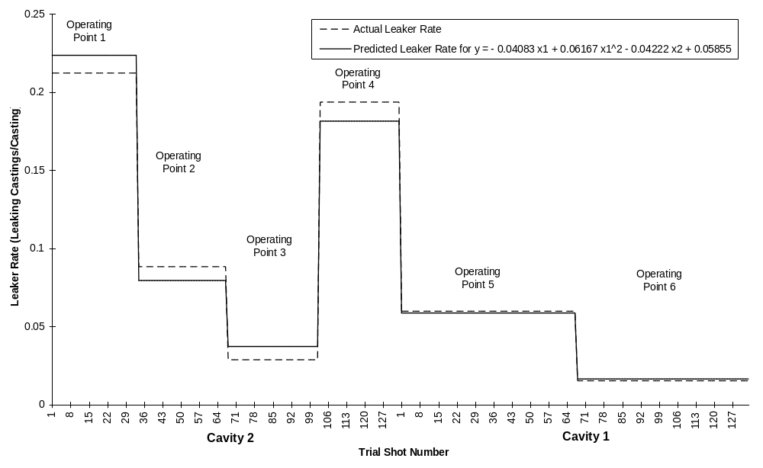
Figure 4.5 Plot of Predicted Leaker Rate, Using Equation 4.4, Versus Shot Number.

Relationship Between Measured Variables and Casting Output
While the relationships developed in Section 4.5.1 are of use in judging the effects of the control inputs in this trial, it will be of more use in practice if we can relate the occurrence of leakers to measured die temperatures, measured metal temperatures and shot end parameters, Table 4.1 and Table 4.2. While we know that the formation of leakers will not be governed by variation of a single parameter, it should be possible to observe trends that occur between leaker rates and individual parameters. There are two ways of doing this. The first is to plot the given parameter versus casting number and observe its variation over the course of the trial, overlaying the observed leakers. This will highlight any obvious correlation. Fitting linear regressions between each parameter and the occurrence of leakers will allow us to assess the strength of any possible linear relations that may exist.
In order to test the strength of a linear regression we require a measure of the accuracy of the regression. A commonly used statistic to assess the accuracy of a linear regression is the “Coefficient of Determination”. This assesses what proportion of the variation in the y output is explained by the regression. It is given by the formula;
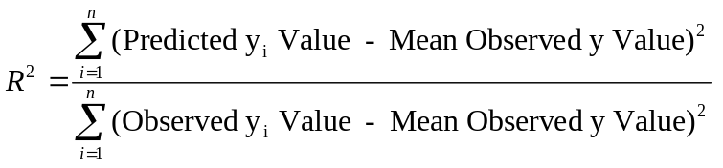 Equation 4.5
This is detailed on Page 434 of “Probability and Statistics for Engineers and Scientists” [39]. The value of this statistic will vary between 0 and 1. A value close to zero indicates that the variation in the y values is not explained well by the regression, while a value close to 1 suggests a good match between the observed y values and those predicted by the regression equation.
Linear regressions were fitted for each parameter and the coefficient of determination found. The results are ranked in Table 4.10. The slope value refers to the slope of the regression curve. A positive slope indicates that an increase in the value of a given parameter will increase the chances of a leaker occurring, while a negative slope indicates that an increase in the value of the parameter will reduce the chances of a leaker occurring.
Parameter | Coefficient of Determination | Slope
Casting Cavity Gate Temperature | 0.089667 | -ve
Casting Cavity Fixed Cavity Temperature | 0.085314 | -ve
Casting Cavity Moving Cavity Temperature | 0.08222 | -ve
Casting Cavity Sliding Core Temperature | 0.043636 | -ve
Plunger Displacement at End of Injection Cycle | 0.031863 | +ve
Maximum Hydraulic Pressure During First Stage Injection | 0.01667 | -ve
Maximum Hydraulic Pressure During Second Stage Injection | 0.013227 | -ve
Average Plunger Speed During Second Stage Injection | 0.012056 | +ve
Plunger Displacement During Second Stage Injection | 0.00947 | +ve
Measured Metal Temperature | 0.006643 | -ve
Maximum Plunger Speed During Second Stage Injection | 0.005686 | +ve
Delay Between End of Injection and Intensification Pressure | 0.002428 | -ve
Plunger Displacement During First Stage Injection | 0.00039 | -ve
Average Plunger Speed During First Stage Injection | 0.000174 | +ve
Casting Cycle Time | 4.86E-05 | -ve
Table 4.10 Coefficients of Determination for Measured Inputs.
To understand what the values mean it is helpful to plot curves of the value of the relevant regression equation against the trial shot number with the observed leakers overlaid. Such plots are included in Appendix F. Note that as the regression value is a linear transformation of the parameter value the shape of the regression curve is identical to the that of a plot of the parameters, only the magnitude and direction may change. For this reason plots of the parameters have not been included.
The parameters can be grouped depending on their coefficient of determination.
Coefficient of Determination < 0.01
In these cases there appears to be very little correlation between the input and output. Within the limits of this trial we can safely discount the effects of these inputs. An interesting member of this group is the measured metal temperature. This parameter is plotted in Figure 4.6.
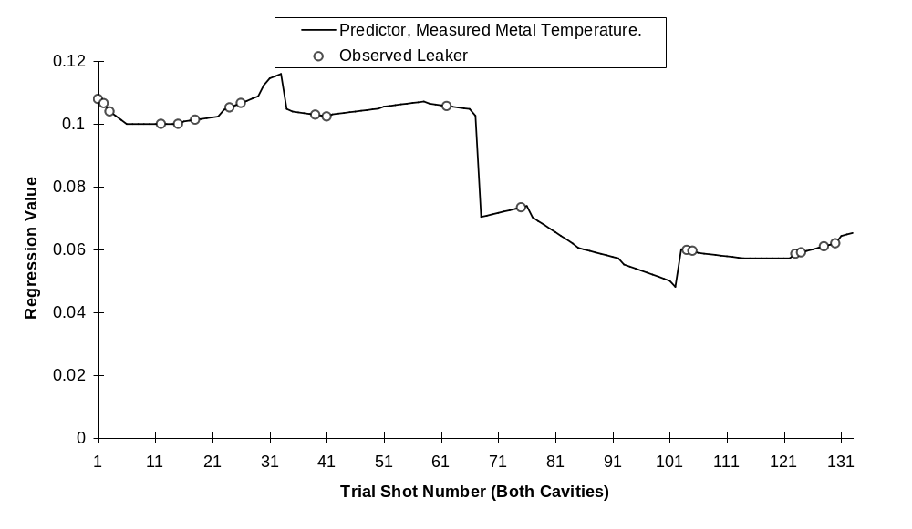
Figure 4.6 Plot of the Value of Linear Regression Based on Measured Metal Temperature Versus Trial Shot Number.
We can see that although the increase in metal temperature corresponds to a drop in the number of leakers from 14 to 8, within each group there appears to be no relation between the measured metal temperature and the occurrence of leakers. Thus a relatively steady input leads to an unpredictable output, hence the low coefficient of determination.
0.01 < Coefficient of Determination < 0.02
In these cases significant variation of the parameters occurs and a number of leakers occur on peaks of the predictor curve. However, a similar number of leakers occur in troughs or in areas where the curve is at a ‘normal level’ This indicates that in some cases an exceptional value of this parameter may be linked to the formation of a leaking casting, but that in a great many other cases there appears to be no relation. Thus these parameters are of very little use in predicting leaker formation.
Plunger Displacement at End of Injection
This parameter displays a few peaks where leakers occur. It is likely that a relationship between the total plunger displacement and the formation of leakers does exist and that the variation within this parameter within the trial was enough to witness this relationship. The presence of such a relationship would be due to the fact that the plunger displacement at the end of injection is directly related to of the amount of alloy ladled into the shot sleeve. This will affect the amount of heat entering the die and shot sleeve, the formation of waves and thus gas entrapment within the shot sleeve as well as the points at which the cavity begins to fill.
Coefficient of Determination > 0.04, Casting Cavity Temperatures
In these cases we begin to see reasonably good correlation between temperatures and leaking castings. The sliding core temperature appears to be largely influenced by the temperature of the oil flowing through it. Of the four temperatures this is the most stable from shot to shot. This explains its lower coefficient of determination. Its variation somewhat shadows the actual leaker rates shown in Figure 4.5. Figure 4.7 shows the regression line using this temperature.
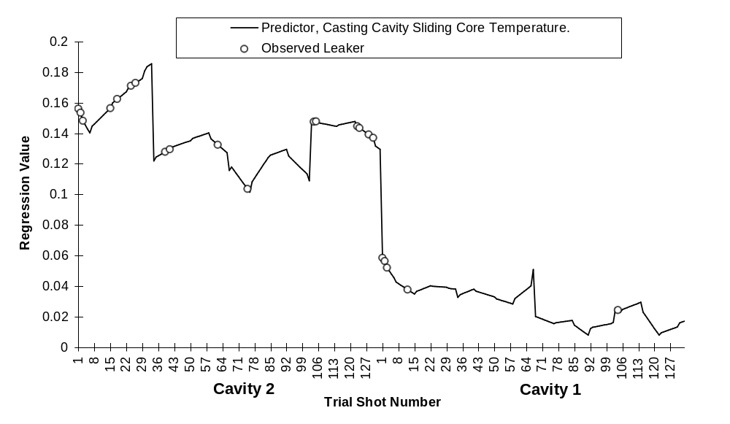
Figure 4.7 Plot of the Value of Linear Regression Based on Sliding Core Temperature Versus Trial Shot Number
It is, however, less successful in predicting individual leakers than the other temperatures. This appears likely to be due to the temperature in the other locations being more readily affected by the stop/start nature of the trial. So while the temperature of the sliding core reflects the state of oil through the die the other in-cavity temperatures are mainly controlled by heat added by the molten alloy and rapidly lost through normal conduction through the die. The reasons for this are discussed later. Figure 4.8 shows the regression line for the moving cavity temperature.
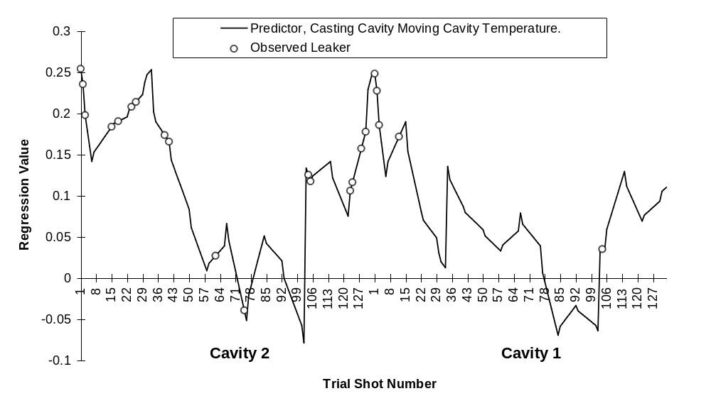
Figure 4.8 Plot of the Value of Linear Regression Based on Moving Cavity Temperature Versus Trial Shot Number

Increasing the Accuracy of the Linear Predictors
By using a combination of input parameters we can improve the accuracy of the linear regression. In this case we could use the four in-cavity temperatures and the plunger displacement at the end of injection. As discussed each of these parameters appears to be related to a given aspect of leaker formation, so using a multiple linear regression taking into account each of these variables we should be able to a achieve a more accurate prediction of the occurrence of a leaker. Figure 4.9 shows that this is indeed the case.
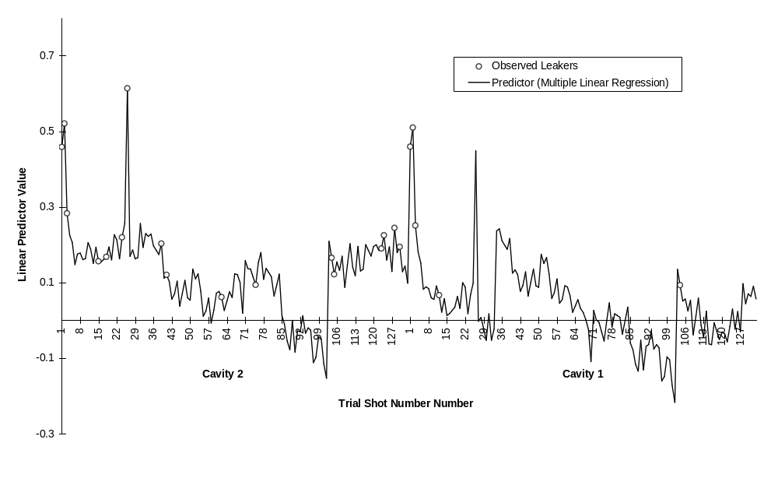
Figure 4.9 Prediction of Leakers Using Multiple Linear Regression.
The regression shown in Figure 4.9 appears to predict the occurrence of leakers to a reasonable degree of accuracy. Most observed leakers occur at points high on the regression curve. There are no observed leakers occurring at low extremes of the regression. The regression is still unable to predict whether an individual casting will leak given the inputs, but it appears to be quite useful in predicting a general rate of production of leakers. In this respect it may be useful to compare the average value of this regression over each operating point with the observed leaker rates over each operating point. This is done in Figure 4.10.
Figure 4.10 shows a very good match between the predicted and observed leaker rates for the first three operating points. The other operating points are not as accurately predicted but the general shape of the curve is correct. Together, Figure 4.9 and Figure 4.10 indicate that measured casting parameters are useful in predicting leakers formed during the trial. In this case the parameters that have the greatest impact on the formation of leakers are the die temperature in different locations and the total plunger movement, which indicates the amount of metal cast per shot.
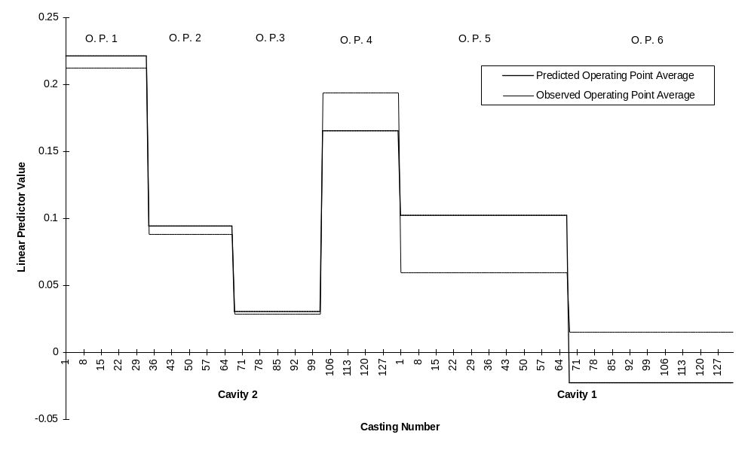
Figure 4.10 Average Values of Multiple Linear Regression.

Discussion

Quantifying the Thermal Condition of the Die
We have shown that the number of leakers formed over a given period is dependent on the rate of heat removal from the die, ie. the oil cooling level. Relating the formation of leakers to cavity surface temperatures allows us to broaden the result to cases where oil cooling is not used. Both the die temperatures and the rate of heat removal are related to the thermal condition of the die. The thermal condition of the die will be changed by the thermal forces acting upon it and is defined by the distribution of temperature throughout the die. In this case we have relative measures of two of the thermal forces acting upon the die, the oil cooling level and the metal temperature, and a measurement of the temperature in four locations in the cavity. Other major factors that will alter the thermal condition of the die will include;
- The amount of heat lost due to die spray.
- The cumulative heat in the die from previous shots, ie. a function of metal temperature, cycle time, and heat removed from the die after each shot.
To these we can add a great many variables that will have a minor, and for our purposes negligible, effect.
The point we want to make is that a simple measure of die temperature, such as we made, provides sufficient information about the thermal condition of the die to enable it to be used as a predictor of leakers. Figure 4.10 suggests that within limits this is the case. Next we will examine the effects of the four main heat transfer effects acting on the thermal condition of the die and whether these effects were significant within this trial and if they can be accounted for using the die temperature measurements.

Relationship Between Oil Cooling Level and Die Cavity Temperature
A strong relationship was observed between the oil cooling level and the measured surface temperature of the sliding core. This is illustrated in Figure 4.11.
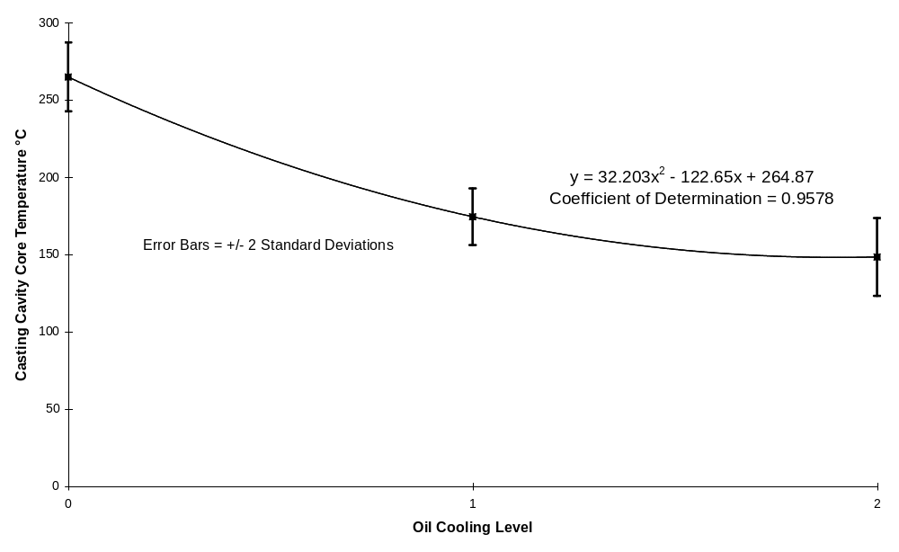
Figure 4.11 Relationship Between Casting Cavity Core Temperature and Oil Cooling Level.
The temperature in the other three in-cavity locations does not appear to be greatly influenced by the oil cooling level. Reasons for this include the distance of the oil lines from the cavity surface and the geometry of the die.
The oil line through the sliding core is located close to the cavity surface, and therefore its effect on the temperature of the cavity will be strong. The core is also thermally isolated from the rest of the cavity block. This means that there will not be a great deal of heat loss due to conduction through die steel. Most of the heat will be removed by the cooling medium. Together these factors lead to a sliding core that heats up rapidly due to heat transfer from the molten alloy, but cools down slowly when no cooling fluid is present. When the oil is present it is effective in controlling the core temperature due its proximity to the surface.
The other sections of the die are all capable of losing heat rapidly due to conduction through the die block. The cooling lines are placed further from the surface which means that their effect will be less immediate. It is to be expected that within these areas the heat removed by conduction through the die block may be the dominant mechanism of heat removal from the cavity. The effect of the oil cooling may not be noticeable until the die attains steady operating conditions. Due to relatively frequent stoppages during this trial the die never fully attained consistent operating conditions. Therefore the effect of oil is less noticeable in these areas than upon the sliding core.
The result of these differences in oil line and die geometry is that within each cavity there are two distinct thermal zones. The relatively isolated sliding cores provide a strong correlation with the oil cooling level, while the other cavity temperatures fluctuate based upon the effects of the other variables.

Effect of Metal Temperature on Die Temperatures
Although the results of the trial were not statistically conclusive in terms of the effect of metal temperature on leakers, it is noticeable that more leakers were made at the lower metal temperatures than at the higher metal temperatures. Examination of Figure 4.7 shows a slight drop in the sliding core temperature corresponding to the drop in metal temperature. The suggestion is that reducing the metal temperature by 20 °C leads to a relatively small drop in die temperatures and a corresponding small increase in leaker rate.
Direct examination of the relationship between metal temperature and the various die temperatures showed that in all locations the die temperatures increased as the metal temperature increased. In the case of the sliding core temperature the effect was masked by the effect of the oil cooling, ie. no effect was apparent until the data was broken up into the various oil cooling levels as well as the metal temperature level.
The most simple demonstration of the effect of metal temperature on die temperature is to take a die average of the temperatures. This involves averaging the temperature over the four measured points in both cavities. This eight point average is less affected by the oil cooling level than the sliding core temperature. Error: Reference source not found shows the relationship between metal temperature level and the average die temperature graphically. We see that the higher metal temperature produces higher die temperatures, although the effect is less than the effect of the oil cooling level on the sliding core. Due to the relatively small effect we should ask whether this observed trend may be due to the influence of chance in our sampling. ie. Is it likely that metal temperature actually has no effect on the die temperatures and that the trend we have observed could result from random sampling of a single population with the observed standard deviation? This hypothesis can be readily tested using a t distribution. To do this we determine a t value using Equation 4.6.
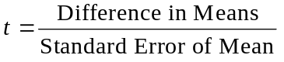 Equation 4.6 [41]
This value is then compared to a table of t values to give the probability that the observed difference in means would occur due to random sampling of a population with given standard deviation.
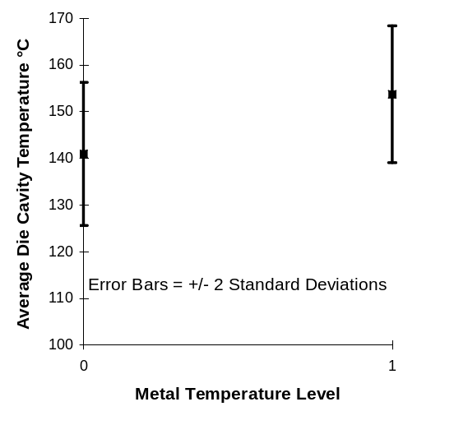
Figure 4.12 Effect of Metal Temperature on Average Die Temperature.
In our case;
Difference in Means = 12.78
and
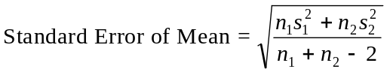 Equation 4.7 [41]
where n_{i} indicates the number of observations in the given sample and s_{i} indicates the standard deviation of the sample. Thus;
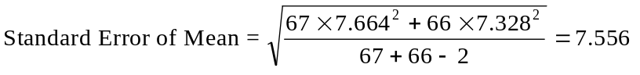
Solving Equation 4.6 for t we get;
t = 1.692
from page 703 of [39] we find that the probability that this difference in sample means would occur by chance is slightly less than 5%. A probability this low indicates that in all likelihood the metal temperature has a measurable effect on the overall temperature of the die.

Effect of Die Spray on Measured Die Temperatures
In normal production a large amount of heat is removed due to the use of die spray. This is applied manually by the machine operator. Die spray removes heat rapidly from the surface of the die. When the spray ceases the die surface temperature will climb slowly due to the heat remaining in the die. There is no way of telling what the effect of die spray and changes in die spray will be from the result of the trial. However, we can say that it is likely that the effect of die spray did not vary greatly over the trial. Although the spray is applied manually and thus there is potential for large variation, this will not occur in the main. A single operator will vary their spray pattern slightly from shot to shot over the course of a shift, but we would expect that such variation would be fairly random around a given mean value, leading to no long term effect on the die temperature. A change in operator would most likely change the mean heat removal by die spray leading to a change in die thermal condition over time. For this reason an effort was made to complete the trial using the same operator. It is likely that the variation from shot to shot is also limited by the fact that in general the application of die spray is quite heavy. Die spray is most effective when it is first applied to the die. With time the die cools and the heat transfer rate drops rapidly, [9]. Therefore variation of the spray time of a heavy spray will have less effect than variation of the spray time where the spray time is shorter.
Regardless of these considerations it is likely that variations in the amount of heat removed have occurred during the trial. As the effect of a change in die spray will act immediately on the shot following its application, it is unlikely that our temperature measurements will account for it due to the fact that they were only taken every 10 shots. This may lead to leakers occurring that are not easily explained by the various measured parameters. When leaker rates are considered rather than the occurrence of individual leakers this effect should cancel itself out.

Effect of Casting History on Thermal Condition
Heat in the die accumulates over a number of shots. Thus it is not only the heat inputted during the current shot that affects the die’s thermal condition but the history of the die. If the shots leading up to the present have been interrupted leading to longer than usual cycle times then there will be a noticeable effect on the die temperatures. These effects were masked in the trial due to the removal of warm up shots and two castings after stoppages to measure metal temperature. Observed fluctuations of the three in-cavity die temperatures are largely due to this effect.
Due to this cumulative effect on the die thermal condition small changes in machine parameters may lead to larger changes in die temperatures over time. A slightly longer than usual cycle time could lead to a decrease in the die temperature over time. No such effect was noted during the trial. Similarly a small but consistent change in the amount of alloy ladled into the shot sleeve will also lead to a change in the die thermal condition. During the trial there was significant variation in this parameter but there did not appear to be a trend that would lead to a change of die temperature over time.

Summary: Using Multiple Die Temperatures to Determine the Thermal Condition of the Die.
From the above we can see that although our information on the thermal condition of the die is far from complete, we still have a good representation of some critical aspects of the die. The sliding core temperature provides an indication of the heat removal due to the oil cooling level. Temperatures at other points of the cavity vary largely based on the recent thermal history of the die. All temperatures are slightly affected by the metal temperature. Other, more transient effects on the die thermal condition may not have been observed from the die temperature measurements but their effects, being short term by nature, should not greatly influence the results of the trial.
As the three in-cavity temperatures are all affected by the same thermal inputs there is a degree of interrelation between them. This can be observed on the plots in Appendix F. It was noted that if one of the three was removed from the multiple linear regression to predict the occurrence of leakers, the remaining two, plus the core temperature and the plunger displacement, continued to predict the occurrence of leakers to a reasonable accuracy. So while their variation is by no means identical it is reasonable to say that they are closely linked. This indicates that it is not necessary to know the temperature at every point in the cavity, merely at some representative points.
In summary the above indicates the need for some sort of die temperature measurement in production if the occurrence of leakers over the long term is to be understood. Thermocouples embedded in the sliding cores and at least one location near the cavity would provide enough feedback on the die thermal condition to be of significant use during production. Such information would be of use for any high pressure die casting. A given die can be divided into discreet thermal zones within which the mechanisms affecting the thermal condition can be understood. Thermocouples placed within each of these thermal zones will then provide a useful record of the thermal condition of the die at a given time. This record could then be used to help predict the casting output.

Effect of other (Shot End) Parameters on leakers
We have established that the thermal condition of the die has a significant effect on the formation of leakers. During the trial we also measured a number of other parameters based on the injection system of the machine. Of these only the total plunger displacement during injection appeared to have an noticeable relationship with the formation of leakers. The reasons why this effect was observed are;
- Variation of plunger position beyond certain limits will affect the rate of leaker formation.
- These limits were exceeded during the trial.
The second of these two points is significant as it tells us that in the case of the other shot end parameters even if the first point is true, no relation between the parameter and the occurrence of leakers may have been observed due to the given parameter remaining in controlled limits. The aim of the trial was to alter the thermal state of the die, ie. the die temperatures, and no other parameters were intentionally altered. Although the bulk of shot end parameters were recorded and shown to have little relation to the formation of leakers these results will only hold true within the limits used during this trial.
While the results of this trial show the importance of controlling the die temperatures, it also remains important to control the shot end parameters. As the total plunger displacement had a significant effect on the probability of forming a leaker we will briefly discuss its effects.
Effect of Variation in Total Plunger Displacement During Injection.
During the trial it was noted that there was a correlation between longer-than-usual plunger displacements and the occurrence of leakers. This situation represents a case where there is less metal ladled than usual, resulting in a thin biscuit. This will tend to reduce any benefits derived from the application of intensification pressure. As the parameter represents the amount of alloy in the system a long plunger displacement will also correspond to less metal in the shot sleeve, leading to different patterns of wave formation, different flow through the runner system and thus different filling of the cavity. Less metal ladled will also lead to less heat in the die and shot sleeve. In short it is not surprising that variation of this parameter leads to changes in reject rates. This highlights the importance of a good quality, well maintained, metal ladling system.

Conclusions
The trial has successfully shown that the thermal condition of the die, quantified using die temperatures, has a critical effect on the formation of leakers in this casting. We have established the bottom limit of a temperature operating window. It appears desirable to keep the temperature of the sliding core over about 200 °C while the rest of the die should be kept over about 150 °C. Below these limits we will experience increases in the formation of leakers. We have not determined upper limits, though it is likely that such limits exist.

Recommendations
Having highlighted the importance of thermal control of the die it would be useful to be able to monitor changes in this variable over time. The use of limited monitoring of die temperatures using thermocouples embedded in the cavity blocks is recommended. Information gained from this equipment would facilitate the assessment of the various causes of variation in die temperature and their effect on leaker formation.

Further Work
While this trial has provided useful data, there are many areas where our knowledge of leaker formation could be improved through similar experiments looking at different variables.
A particularly useful experiment would be to attempt to establish an upper limit on the allowable die temperatures. This would involve the use of oil at 180 - 200 °C through the cavity lines but not through the sliding core. Running the die continuously in such a manner would result in an accumulation of heat in the die. Any changes in the leaker formation rate as the temperature increases could be observed.
As discussed earlier the comparison of oil cooling levels between the two cavities relies on the assumption that the two cavities would produce equal number of leakers if the thermal conditions were identical. This assumption could be tested by performing a similar trial with cavity 1 cooled and cavity 2 left un-cooled.

The number of degrees of freedom is defined as the number of classes whose frequencies may be arbitrarily assigned [41] without changing the overall frequency. In this case it is given by k-1 = 2. If we arbitrarily assign the number of leakers in two of the groups in Table 4.4 then the number of leakers in the third group is determined by the fact that there must be 22 leakers overall.

