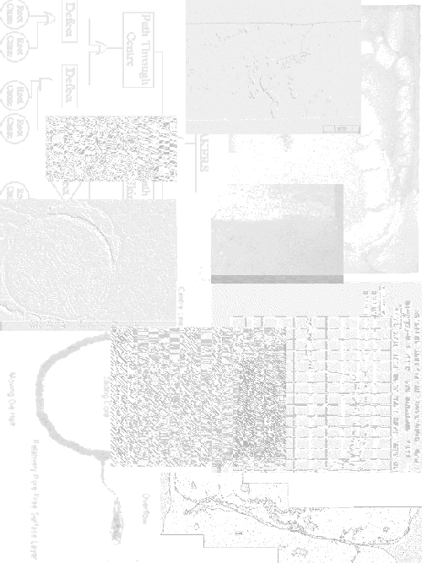

Appendices

Appendix A: Details of Casting Manufacture

Details of Casting Alloy
Alloy designated CA313 is used to manufacture the water inlet casting. This is a general purpose aluminium die casting alloy. Table A .1 lists the amount of the most important constituents present in castings collected during this study. These values are based on analysis of eight castings. Three were taken from the trial discussed in Chapter 4, the remaining five were collected from three other trials performed during the term of this work, (between March 1996 and May 1997). By presenting the maximum, minimum, and mean values found an insight is gained into the amount of variation that occurred within the process over time. Note that when only castings from a single trial were analysed, eg. Chapter 4, the variation in alloy composition was significantly less, see Appendix F.
 | Mean (Weight %) | Maximum (Weight %) | Minimum (Weight %)
Aluminium | Balance (85.44) | Balance (86.00) | Balance (84.55)
Silicon | 8.92 | 9.37 | 8.34
Copper | 3.17 | 3.35 | 3.05
Iron | 0.96 | 1.06 | 0.86
Magnesium | 0.20 | 0.27 | 0.09
Zinc | 0.86 | 1.15 | 0.45
Lead | 0.06 | 0.06 | 0.04
Chromium | 0.03 | 0.04 | 0.03
Nickel | 0.10 | 0.21 | 0.05
Manganese | 0.23 | 0.29 | 0.2
Titanium | 0.021 | 0.028 | 0.018
Tin | 0.02 | 0.02 | 0.01
Strontium | <0.001 | <0.001 | <0.001
Zirconium | <0.005 | 0.005 | <0.005
Table A.1 Casting Alloy Compositions Detected During Study.
In all cases the alloy composition fell within ADC’s in-house limits.
No extraordinary processes such as degassing or filtering are used to prepare the alloy prior to deposition into the casting machine’s shot sleeve.

Details of Casting Process
After a short settling period in the shot sleeve, metal injection begins. Figure A .1 and Figure A .2 show “Shot Profiles” of four castings. The shot profile is recorded by a displacement transducer mounted on the plunger and a pressure transducer in the machines hydraulic system. A trace of plunger displacement and machine hydraulic pressure results. Differentiation of the displacement curve results in a plunger velocity curve.

Figure A.1 Full Shot Trace for Water Inlet Casting.
Figure A .1 shows the full injection cycle. Figure A .2 zooms in on the cavity filling period for three different shots. To the right of each profile are a number of important injection parameters. Some of these parameters can be read directly off the shot trace while others are calculated from the shot profile data using a knowledge of the casting and machine dimensions. The listed parameters together with the shot profiles give a good description of the process used to manufacture these castings.
A detailed description of the die design is not included. Figure A .3 shows a dimensioned casting complete with runners and overflows. The machine used to make the castings was a Buhler H-250B, details of important machine dimensions were taken from the operating manual for this machine, [A1].

Figure A.2 Close Ups of Cavity Filling Period of Three Shot Traces.

Figure A.3 Water Inlet Casting With Runners and Overflows.

Details of Secondary Operations
After removal from the die casting machine the castings are quenched in a water bath. From there they are placed in a trim press and the runners, overflows, and any casting flash are removed from the casting.
Castings are then shot blasted. This process removes any sharp edges and gives the castings a more salable surface finish. Any shallow surface blemishes on the outside face of the tube are removed, leaving a consistent dimpled surface. The effect on the inside surface of the tube is much more limited due to the fact that shot particles cannot impact directly onto the surface. The number and severity of impacts drops very rapidly as the distance from the open end of the tube increases. The small impacts left by shot particles are visible in the figures in Appendix D.
The casting is now machined in a number of areas. Machining of the base of the casting in performed to leave a smooth flat face for mounting onto the engine block. A thread is machined in the small tube at the top of the casting. The end of the tube is then machined. The purpose of this operation is to remove the raised seam formed along the parting line of the die. If this were not removed it would provide room for leakage between the casting and the hosing to be fitted onto the tube end.

Details of Pressure Tightness Testing Procedure
Castings are placed two at a time on a customised pressure testing rig. This blocks the three openings of the casting with rubber sealing surfaces. The casting is then filled with air, pumped through a hole in the rubber sealing face on the tube base, to a pressure of 300 Kpa. The casting is submerged in water and examined by an operator under strong lighting. Any bubbles forming on the outside of the tube result in casting rejection.

Limitations of Pressure Testing
- Due to the simultaneous testing of two castings, one side of each casting is slightly obscured from the operator. Detection of leakers on the obscured faces is often difficult. This can probably be overcome by operator experience.
- As well as support at the three sealing faces the casting is supported underneath the tube section. This support covers some of the machined surface of the tube. Figure A .4 shows this obscured area. It is unlikely that leakers occurring in this area will be detected during testing. As noted in Chapter 3, most leakers occur on the machined area of the tube around the die parting lines. Thus the obscured area is away from the main areas where leakers are found but is still on the machined surface. If it is essential to support the casting it may prove beneficial, in terms of reducing the number of leakers returned by the customer, to move the support back onto the non-machined area.

Figure A.4 Area of Casting Obscured by Support During Pressure Testing.
For the purposes of this study, the impact of a failure to detect what would be expected to be a very small number of leakers should be minimal, as long as the testing method remains consistent.

References
A1 Buhler, ‘Operating Manual for Buhler H250B-P Horizontal Cold Chamber Die Casting Machine’, Buhler.

