Appendix C - Determination of Optimum Shot Profiles

Calculation of Optimum Shot Profiles
In order to determine optimum shot profiles we need to know the volumes of the various parts of the castings and the dimensions of the shot sleeve. We can convert masses to volumes using a density for aluminium 380 alloy of 2710 Kg/m³ [C1]. Table C .1 gives the volumes of each casting part for the selected water inlet casting. The shot fill percentages are obtained by dividing the total casting volume by the shot sleeve volume, ie. plunger area × length.
 | Casting Volumes (m³) |  |  | Shot Sleeve Dimensions
 | Runners and Biscuit | Cavity and Overflows | Total Volume | Length (mm) | Diameter (mm) | Shot Fill Percentage
 | 1.401 × 10⁻⁴ | 1.331 × 10⁻⁴ | 2.732 × 10⁻⁴ | 413 | 59.5 | 23.79
Table C.1 Casting Data.
Using the above data we can determine the optimum first stage velocities and acceleration using the approximate formulae presented by Herman;
[C2]
Where;
v= Critical slow shot velocity, m/s.
f = Percentage of shot sleeve initially filled with molten alloy, %.
D = Plunger diameter, mm.
C = Constant, 0.579 m/s.
and;
[C2]
To determine the change over point we need to determine the point at which the shot sleeve is full and the point at which the metal is at the gate.

Here both plunger displacements are measured from the plunger position at the start of the shot.
A value between these two will be taken as the change-over position. If there is a large gap between the two points then a value 10 mm after the shot sleeve full point will be used to allow for variations in the amount of metal ladled.
The biscuit thickness for the selected casting is 37 mm.
Finally we will select a second stage velocity roughly equal to the existing second stage velocity which appears sufficient for this castings. Table C .2 shows the calculated optimal shot profile parameters for this casting.
 | First Stage Velocity (m/s) | Acceleration (m/s/m) | Shot sleeve full point (mm) | Metal at Gate Point (mm) | Change over Position (mm) | Second Stage Speed (m/s)
 | 0.675 | 2.35 | 315 | 328 | 320 | 3.5
Table C.2 Optimum Shot Profile Parameters for Castings.
We can now compare this optimum shot profile with an actual shot profile.

Comparison with Actual Shot Profile
Comparisons between the actual and optimum shot profiles are presented in Table C .3, Figure C .1, and Figure C .2. A small starting velocity was used to begin the optimal shot. This was necessary due to the fact that initial velocity is proportional to displacement, so if both started at zero then no movement would occur. 0.05 m/s was chosen as a suitably small starting velocity based on actual shot data.
 | First Stage Velocity (m/s) | Acceleration (m/s/m) | Change Over Position (mm) | Second Stage Speed (m/s)
Optimal Profile | 0.675 | 2.35 | 320 | 3.5
Actual Profile | 0.60 | 2.26 | 265 | 3.6
Table C.3 Comparison of Critical Values Between Optimal and Actual Shot Profiles.
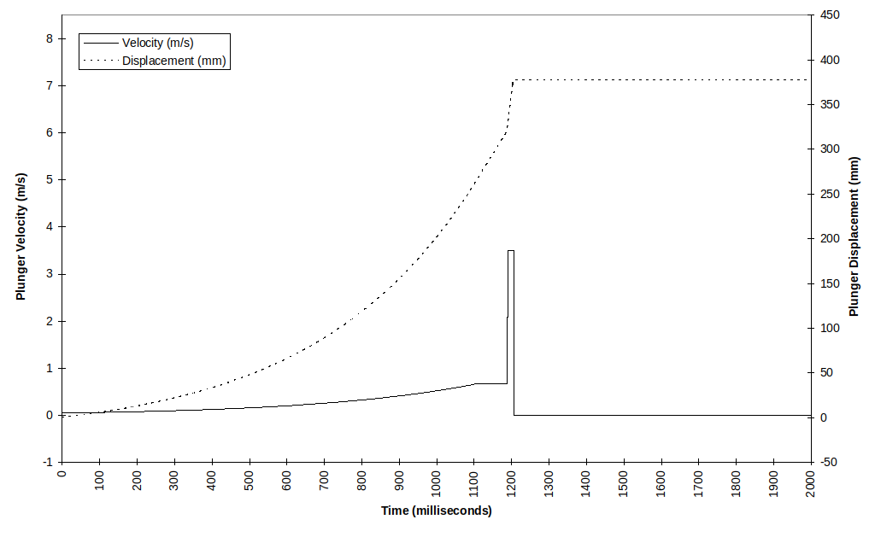
Figure C.1 Optimum Shot Profile for Water Inlet Casting.

Figure C.2 Actual Shot Profile for Water Inlet Casting.
Both the initial acceleration and the first stage velocity are fairly close to what is considered optimum. The main difference is the change over position. The actual change over position occurs at a lesser plunger displacement than our calculations would suggest. Calculating the percent shot sleeve full when the plunger has moved 265 mm indicates that the shot sleeve is only about 70 % full when the high velocity second stage begins. So assuming that a minimum of air entrapment will occur during the first stage due to the choice of velocities and accelerations used, when second stage starts 30 % of the remaining shot sleeve volume will be air and most of this will become entrapped in the casting.

References
C1 ASM International, ‘Metals Handbook - Volume 2, Properties and Selection: Nonferrous Alloys and Special-Purpose Materials, 10th Edition’, ASM International, 1990.
C2 Herman, ‘Die Casting Technology - Calculations’, Die Casting Education Project RMIT University, 1995.

