Appendix F: Data from Casting Trial

Linear Regressions Between Input Parameters and Leaker Occurrence
The following plots detail the likelihood of leaker occurrence as predicted by the single parameter named in the legend of each plot. The mean, minimum, maximum, and standard deviation of the parameter values recorded during the trial are also given for reference. The plots are listed in order of the strength of the correlation between the input parameter and the occurrence of leakers.
The plots for the die temperatures detail the results for each cavity and trial shot number. The remaining plots group the cavities together as for the shot end parameters and the metal temperature the regression value is the same for each cavity. An observed leaker on these plots indicates that either or both cavities produced a leaking casting.
 | Casting Cavity Gate Temperature, °C.
 | Mean | Minimum | Maximum | Standard Deviation
 | 141 | 94 | 167 | 13.20
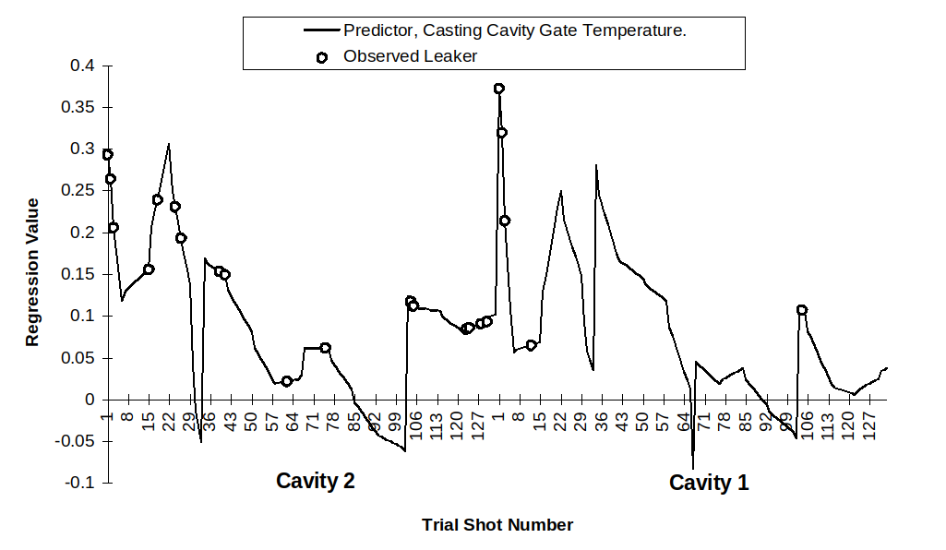

 | Casting Cavity Fixed Cavity Temperature, °C.
 | Mean | Minimum | Maximum | Standard Deviation
 | 117 | 71 | 146 | 12.77
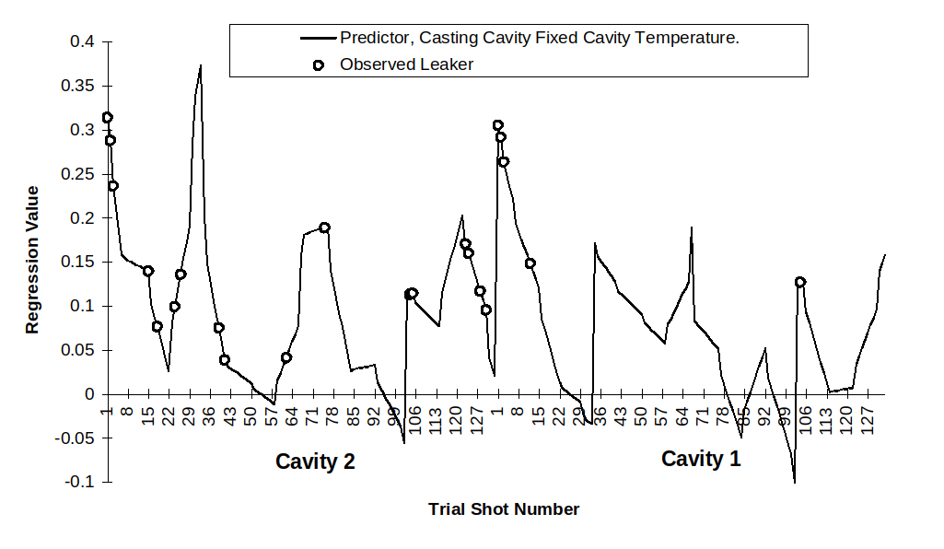
 | Casting Cavity Moving Cavity Temperature, °C.
 | Mean | Minimum | Maximum | Standard Deviation
 | 118 | 89 | 145 | 13.10
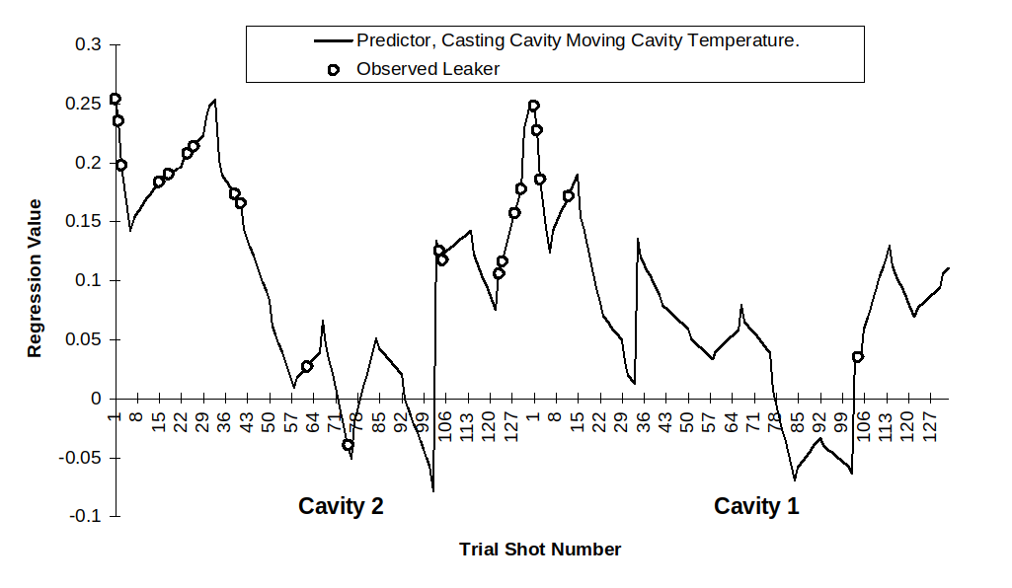
 | Casting Cavity Sliding Core Temperature, °C.
 | Mean | Minimum | Maximum | Standard Deviation
 | 213 | 118 | 283 | 53.45
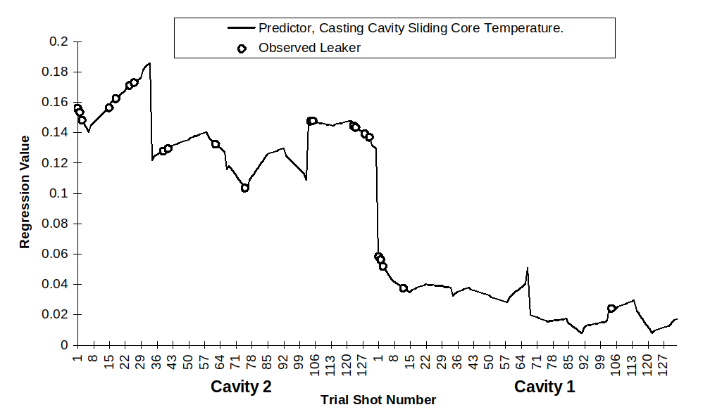

 | Plunger Displacement at End of Injection Cycle, mm.
 | Mean | Minimum | Maximum | Standard Deviation
 | 365 | 359 | 383 | 2.75
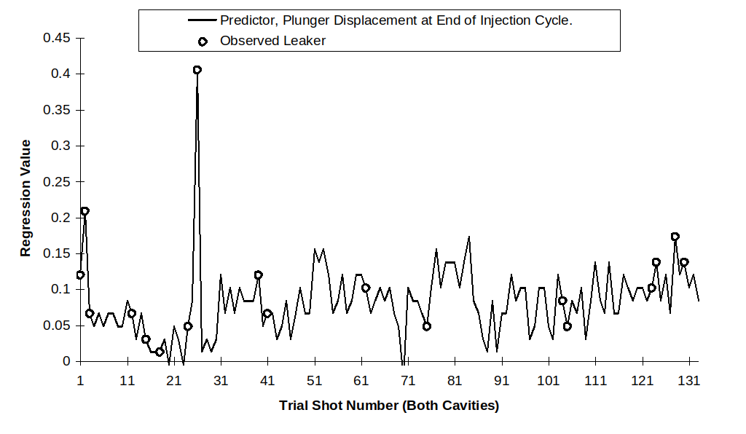
 | Maximum Hydraulic Pressure During First Stage Injection, Bar.
 | Mean | Minimum | Maximum | Standard Deviation
 | 5 | 0 | 19 | 3.07
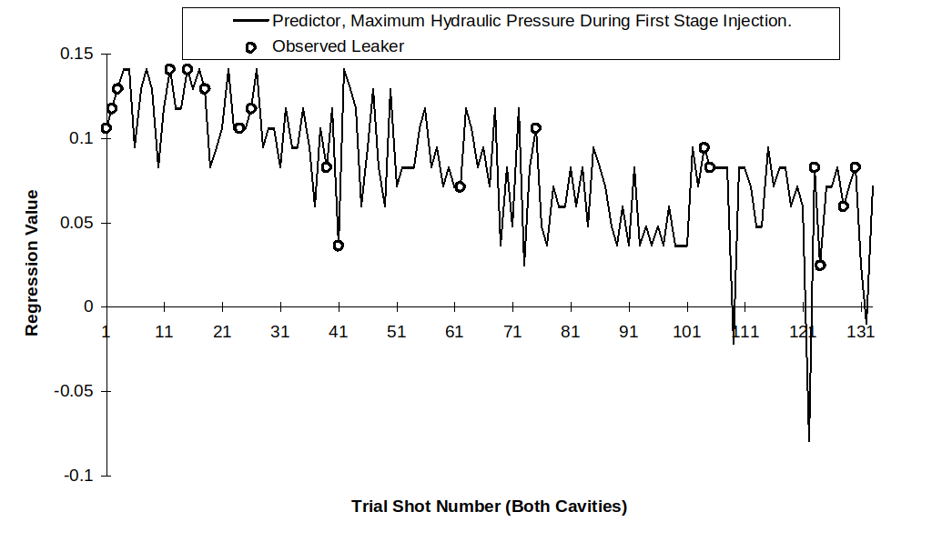
 | Maximum Hydraulic Pressure During Second Stage Injection, Bar.
 | Mean | Minimum | Maximum | Standard Deviation
 | 134 | 117 | 159 | 6.70
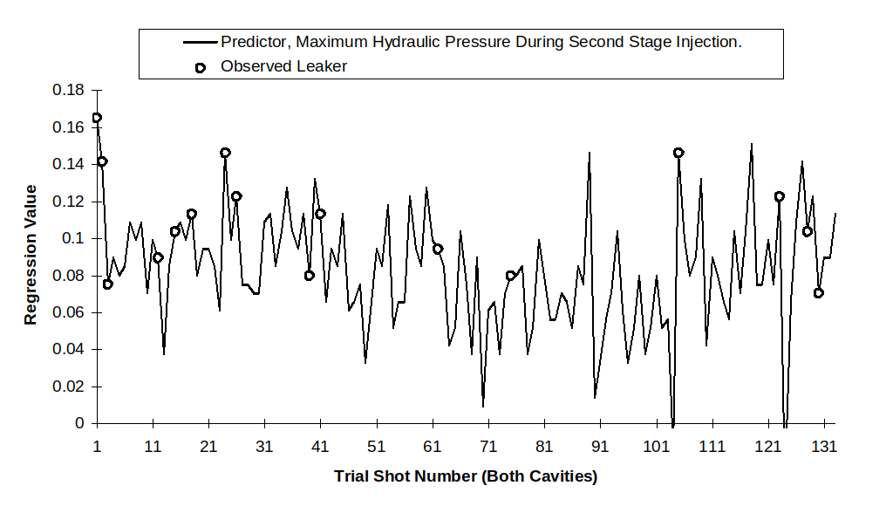

 | Average Plunger Speed During Second Stage Injection, m/s.
 | Mean | Minimum | Maximum | Standard Deviation
 | 1.93 | 1.77 | 2.15 | 0.08
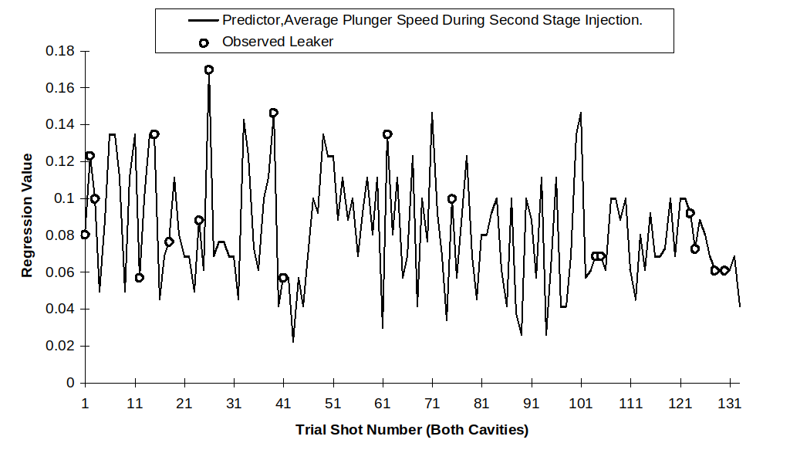
 | Plunger Displacement During Second Stage Injection, mm.
 | Mean | Minimum | Maximum | Standard Deviation
 | 71 | 64 | 88 | 2.68
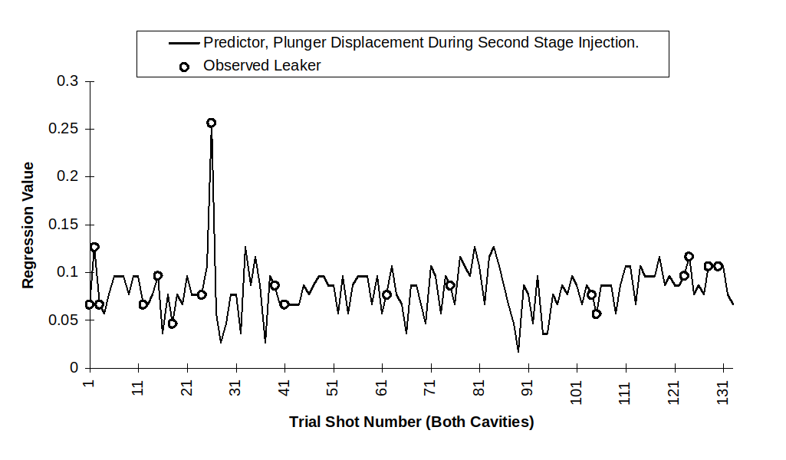
 | Measured Metal Temperature, °C.
 | Mean | Minimum | Maximum | Standard Deviation
 | 749 | 722 | 787 | 12.87
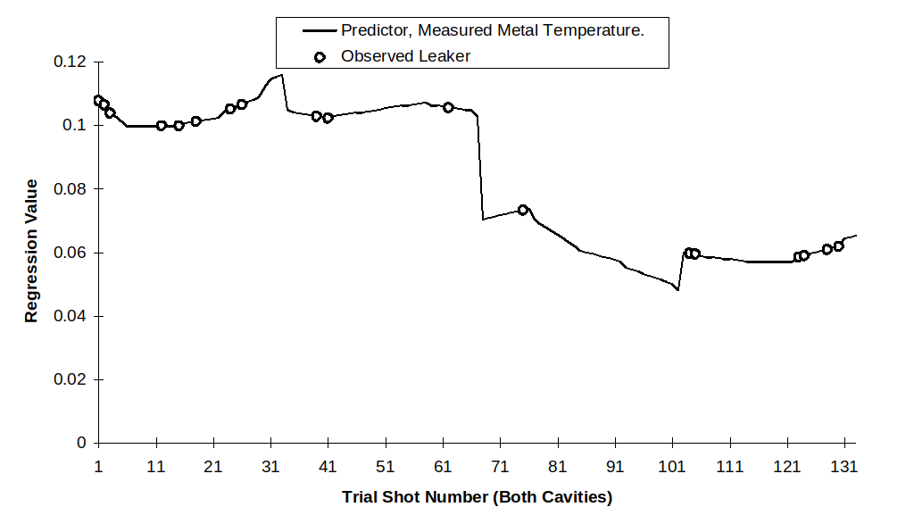

 | Maximum Plunger Speed During Second Stage Injection, m/s.
 | Mean | Minimum | Maximum | Standard Deviation
 | 3.34 | 2.60 | 4.20 | 0.37
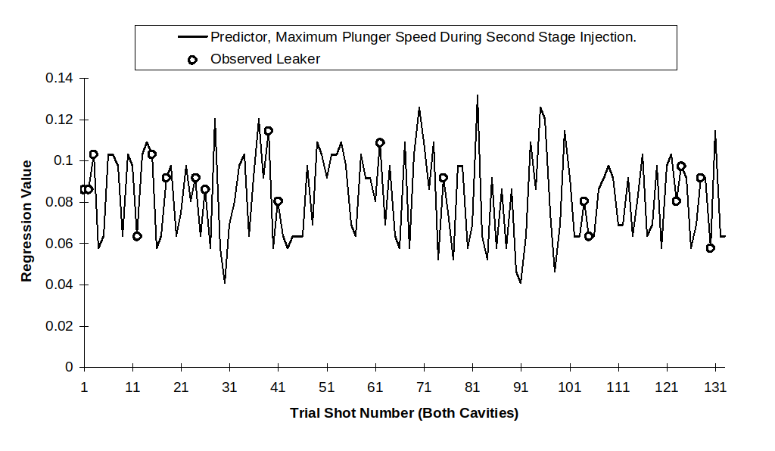
 | Delay Between End of Injection and Intensification Pressure, ms.
 | Mean | Minimum | Maximum | Standard Deviation
 | 58 | 50 | 63 | 2.61
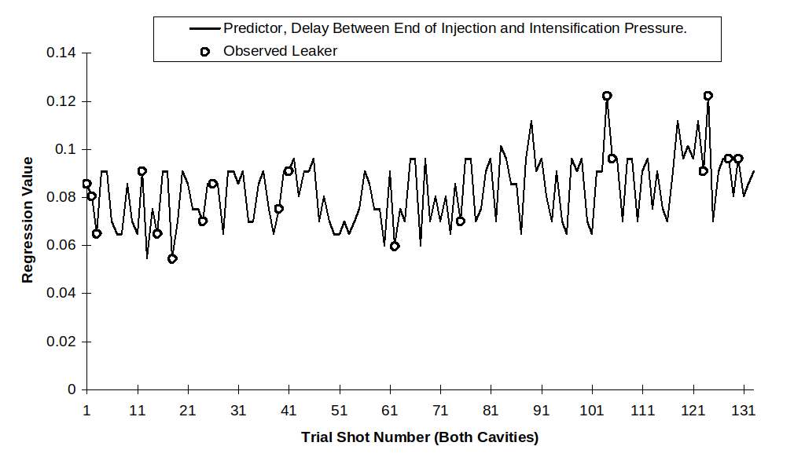
 | Plunger Displacement During First Stage Injection, mm.
 | Mean | Minimum | Maximum | Standard Deviation
 | 289 | 286 | 295 | 1.57
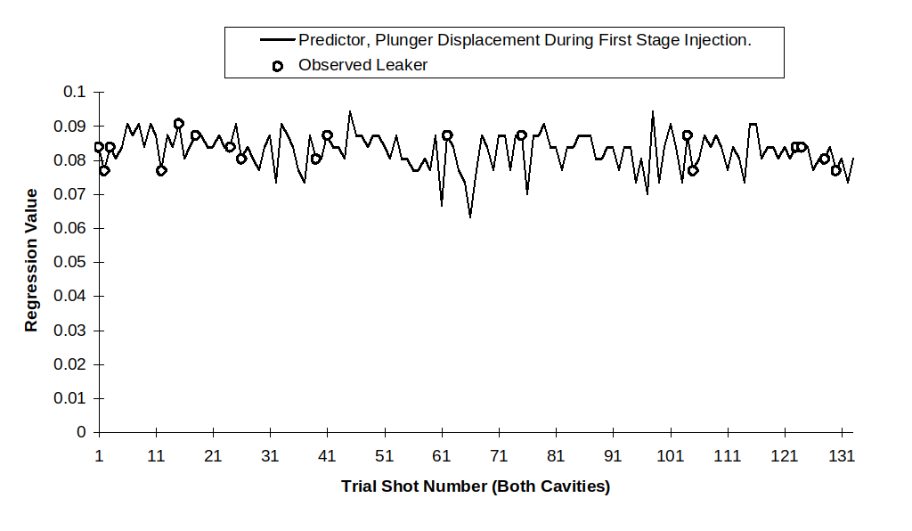

 | Average Plunger Speed During First Stage Injection, m/s.
 | Mean | Minimum | Maximum | Standard Deviation
 | 0.30 | 0.19 | 0.38 | 0.01
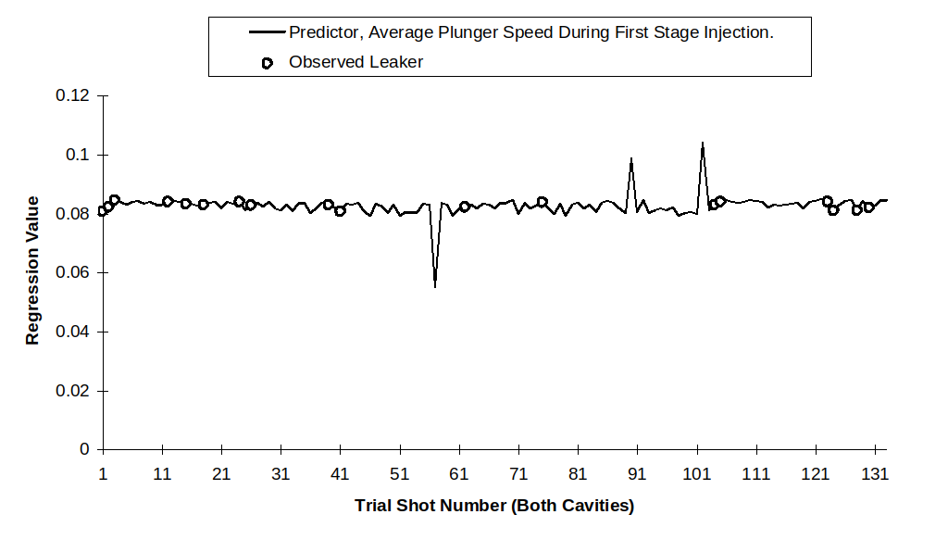
 | Casting Cycle Time, s.
 | Mean | Minimum | Maximum | Standard Deviation
 | 51 | 47 | 131 | 8.64
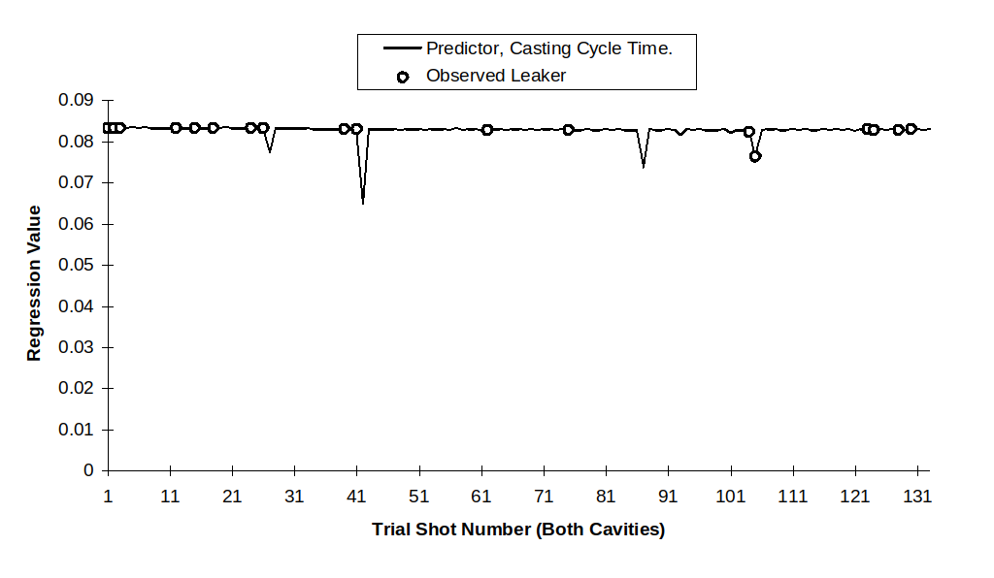

Results of Analysis of Alloy Composition of Castings Made During Trial
Table F .1 shows results of compositional analysis carried out on three water inlet castings sampled during the course of the trial discussed in Chapter 4. During the course of the trial the holding furnace was refilled with molten alloy from the melting furnace twice. The data in Table F .1 represents one casting made between each refill. The variation witnessed was deemed insufficient to warrant analysis of further castings.
 | Casting Sampled Near Start of the Trial | Casting Sampled Near Middle of the Trial | Casting Sampled Near End of the Trial
Aluminium | Balance (85.93) | Balance (85.52) | Balance (86.00)
Silicon | 8.41 | 8.7 | 8.34
Copper | 3.08 | 3.2 | 3.05
Iron | 0.89 | 0.86 | 0.88
Magnesium | 0.2 | 0.2 | 0.2
Zinc | 1.11 | 1.15 | 1.15
Lead | 0.06 | 0.06 | 0.06
Chromium | 0.03 | 0.03 | 0.03
Nickel | 0.05 | 0.05 | 0.05
Manganese | 0.21 | 0.2 | 0.21
Titanium | 0.019 | 0.019 | 0.019
Tin | 0.01 | 0.01 | 0.01
Strontium | <0.001 | <0.001 | <0.001
Zirconium | 0.005 | 0.005 | <0.005
Table F.1 Results of Analysis in Weight % for Three Sample Castings.

