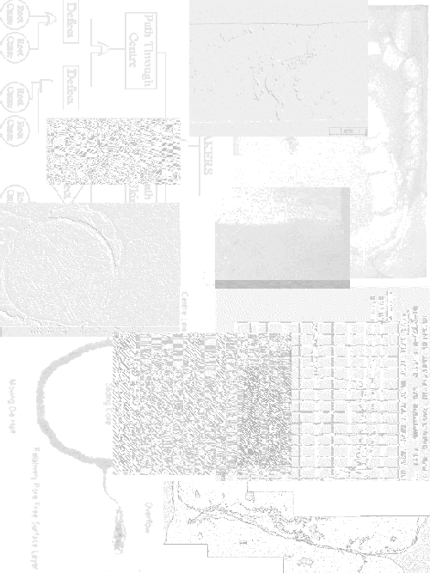

References

1 LaVelle, ‘Aluminium Die Casting and Factors Affecting Pressure Tightness’, Transactions of the American Foundrymen's Society, Volume 70, 1962.
2 Walkington, ‘Short Course on Analysis of Die Casting Defects’, Cooperative Research Centre for Alloy and Solidification Technology, 1995.
3 Holz, ‘Trouble-Shooting Aluminium Die Casting Quality Problems’, 7th International Die Casting Congress, 1972.
4 Murray, ‘Defects in Pressure Die Castings as Pertaining to Low Gas Pressure Applications’, CSIRO Consultation Report 90/M/101, Commonwealth Scientific and Industrial Research Organisation, 1990.
5 Harding, Bennet, and Robinson, ‘Production of Aluminium Die Castings Using a Fan Gate [3] Some Factors Affecting Conditions at the Orifice’, 8th SDCE International Die Casting Exposition and Congress, 1975.
6 Iwahori, Nakamura, Tozawa, and Yamamoto, ‘Metal Flowing Behavior in Die Castings and Defects in Aluminium Die Castings’, 13th SDCE International Die Casting Congress and Exposition, 1985.
7 Murray, Chadwick, and Ghomashchi, ‘Aluminium Alloy Solidification in High Pressure Die Castings’, Materials Australasia, June 1990.
8 Murray, ‘Shot Sleeves, a Quality Control’, Die Casting Bulletin, April 1996.
9 Herman, ‘Die Casting Technology - Calculations’, Die Casting Education Project RMIT University, 1995.
10 Davis and Robinson, ‘Production of Aluminium Die Castings Using a Fan Gate [2] The Effect of Casting Conditions at the Gate on Casting Quality’, 8th SDCE International Die Casting Exposition and Congress, 1975.
11 Editor of the Die Casting Engineer, ‘Eliminating Surface Defects on Zinc Die Castings’, Die Casting Engineer, January/February 1977.
12 Stuhrke and Wallace, ‘Gating of Die Castings’, Transactions of the American Foundrymen’s Society, Volume 73, 1966.
13 Neff, ‘Principles of Molten Metal Processing for Improving Die Cast Quality’, 16th NADCA Congress and Exposition, 1991.
14 Titone, ‘Important Considerations in the Trimming of Die Castings’, 5th SDCE National Die Casting Congress, 1968.
15 Johnson, Bishop, and Pellini, ‘Application of Chills to Improving Pressure Tightness of Gun Metal (88-8-4)’, Transactions of the American Foundrymen's Society, Volume 62, 1954.
16 Veinik, ‘Thermodynamic Factors in Metal Injection: Effect of Friction on Gas Content and Quality’, 4th SDCE National Die Casting Exposition and Congress, 1966.
17 Garber, ‘Theoretical Analysis and Experimental Observation of Air Entrapment during Cold Chamber Filling’, Die Casting Engineer, May/June 1982.
18 Thome and Brevick, ‘Optimal Slow Shot Velocity Profiles For Cold Chamber Die Casting’, 18th NADCA Congress, 1995.
19 Luis-Martin and Robla, ‘Evaluation of Gas Porosity in Zinc Die Castings’, 12th SDCE International Die Casting Congress and Exposition, 1983.
20 Miller, ‘Inclusion Control of Die Casting Alloys’, Die Casting Engineer, September/October 1984.
21 Shivkumar, Apelian, and Brucher, ‘Melt Cleanliness in Die Cast Aluminium Alloys’, 16th NADCA Congress and Exposition, 1991.
22 Anderson, ‘Shot Peening to Reduce Porosity in Die Castings’, Modern Metals, Volume 9 Number 1, 1953.
23 DePue and Pennington, ‘Influence of Silicon on Gun Metal Alloys’, Transactions of the American Foundrymen's Society, Volume 70, 1962.
24 Gordon, Meszaros, Naizer, and Mobley, ‘Equations for Predicting the Percent Porosity in Die Castings’, 17th NADCA Congress, 1993.
25 Garber and Draper, ‘Shrinkage in #380A Aluminium Alloy’, Die Casting Engineer, November/December 1979.
26 Otte, ‘Castability of Aluminium Alloy 380’, Report for the Cooperative Research Centre for Alloy and Solidification Technology, 1997.
27 Taylor, ‘The Role of Iron and Other Elements in the Formation of Porosity in Al-Si-Cu Alloy Castings’, Department of Mining, Minerals, and Materials Engineering, University of Queensland, 1997.
28 Kalghatgi, ‘Effect of Silicon Content on Porosity in Aluminium Die Castings with More than 1/4-in. Wall Thickness’, 14th SDCE International Die Casting Congress and Exposition, 1987.
29 Herman, ‘Die Casting Technology - Die Casting Process and Die Design Level II’, Die Casting Education Project RMIT University, 1997.
30 Kulunk, Shabestari, Gruzleski, and Zuliani, ‘Beneficial Effects of Strontium on A380 Alloy’, Transactions of the American Foundrymen's Society, 1996.
31 Sugiyama, Yonekura, and Ookouchi, ‘Transferred Pressure and Casting Qualities of Aluminium Diecasting’, Diecasting World, September 1996.
32 Arnberg, Dahle, Paradies, and Syvertsen, ‘Factors Affecting the Castability of Aluminium Foundry Alloys’, International Conference on Casting and Solidification of Light Alloys, August 1995.
33 Garber and Draper, ‘The Effects of Process Variables on the Internal Quality of Aluminium Die Castings’, 10th SDCE International Die Casting Exposition and Congress, 1979.
34 Micks and Zabek, ‘Identifying Some Common Problems With Aluminium Castings’, Transactions of the American Foundrymen’s Society, Volume 81, 1973.
35 Chu, Cheng, and Shivpuri, ‘Soldering Phenomenon in Aluminum Die Casting: Possible Causes and Cures’, 17th NADCA Congress, 1993.
36 ‘Engineering Design, (12.7 Fault Tree Analysis)’, Text, GET DETAILS FROM NICK
37 ASM International, ‘Metals Handbook - Volume 2, Properties and Selection: Nonferrous Alloys and Special-Purpose Materials’, 10th Edition, ASM International, 1990.
38 ASM International, ‘Metals Handbook - Volume 9, Metallography and Microstructure’, 9th Edition, ASM International, 1985.
39 Walpole and Myers, ‘Probability and Statistics for Engineers and Scientists’, Fifth Edition, Macmillan Publishing Company, 1993.
40 Ball and Buckwell, ‘Work out Statistics “A” Level’, Macmillan Education Ltd., 1986.
41 Moroney, ‘Facts from Figures’, Second Edition, Penguin Books Ltd., 1957.

