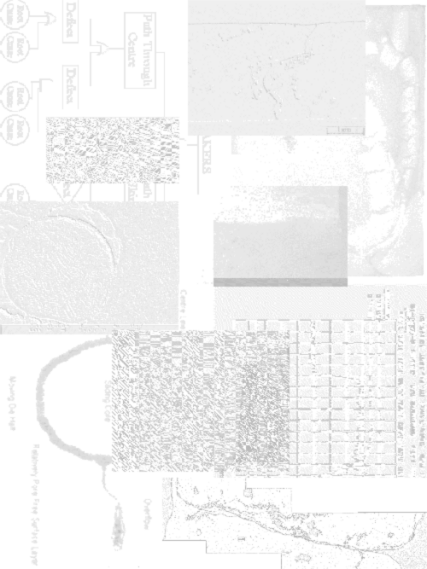

Chapter 1
An Introduction
Chapter 1Introduction

Molten Metal Forming
A vast range of complex components can be manufactured by containing solidification of molten metal within a shaped mould. However, metal cast in this way is subject to a wide range of defects due to the constraints placed upon solidification by the process and mould. The occurrence of these defects will depend upon the specifics of the casting process.
Amongst the most basic casting processes is sand casting. From this basic casting process a range of other processes have evolved over time, all with their characteristic strengths and weaknesses. Amongst these is high pressure die casting.

High Pressure Die Casting
One of the most common reasons for selecting high pressure die casting over other processes is the low cost per casting and very large production rates and volumes that the process is capable of. However, when the process is used to its full potential it is capable of casting very complicated castings with thinner wall sections and higher dimensional accuracy than most other casting processes. However, when used in this manner, the centre of the casting section will be quite porous leading to lower mechanical strengths than could be achieved otherwise.
In most cases, practical constraints prevent the process from being used to its full potential. When this occurs a large number of defects may occur. A defect is regarded as any casting feature which falls outside limits set by the customer. In the case of a casting that must contain or channel a fluid, a feature that leads to a leak forming under a given pressure will be called a “Leaker”. Castings containing such a defect must either be rejected or impregnated with a polymeric sealing agent.
Due to the great diversity of castings made by the high pressure die casting process we cannot discuss a “typical” scenario for the formation of a leaker. Within this thesis we examine the example of an automotive water inlet casting.

Leakers in a Water Inlet Casting
Figure 1.1 shows a water inlet casting manufactured primarily using high pressure die casting. The component is subject to range of possible defects. These include out of tolerance dimensions, exposed porosity on the machined areas, and a lack of pressure tightness, ie. leakers.

Figure 1.1 Automotive Water Inlet Casting.

While the bulk of the metal forming is performed by the high pressure die casting, the part is produced by a process stretching from the arrival of ingots of alloy at the foundry to the pressure testing of the final parts. Figure 1 .2 lists the various processes the part goes through during manufacture. Further details of the most critical steps in the process are contained in Appendix A.
We note that pressure testing occurs late in the process. This ensures that no leaking castings are delivered to the customer. However, it also means that all of the processes occurring before pressure testing will influence the pressure tightness of the casting. When the part is finished it is irrelevant whether it was sound in the “as-cast” condition. The only measure of part pressure tightness that matters is the condition of the part after the “secondary operations” have been performed and the casting is in it salable state. For this example the mechanisms of leaker formation are therefore complicated by the presence of factors outside of the high pressure die casting process. However, while all the stages present in the process will have an effect on the pressure tightness of the completed casting, it is likely that the defining step will be the casting stage. The reason for this is the high degree of uncertainty produced during this stage.
The potential for variation in the output of the high pressure die casting process is much greater than that for other critical steps such as machining and shot blasting. So while processes such as shot blasting and machining are likely to have a significant effect on the overall rate of leakers produced, they are unlikely to have a defining influence on whether a specific part leaks.
This assumption is proven in the results of this study. Results of observations presented in Chapter 3 indicate that machining of the tube end has a large effect on the number of leakers formed. However, in Chapter 4 an ability to predict the rate of leaker formation given only a selection of parameters from the high pressure die casting process is demonstrated. This indicates that it is the high pressure die casting process that determines the occurrence of leakers.

Figure 1.2 Flow Chart of Part Manufacture.

Understanding the Formation of Leakers in High Pressure Die Casting
A review of previously published literature revealed that leakers in high pressure die casting are not a widely studied phenomenon. The main reason for this is that although the term leaker is often used in practice to describe this class of defect, the formation of leakers is in fact due to combinations of other casting defects that form a path through the casting. Further to this, in most cases there is little information on the formation of these contributing defects in high pressure die casting.
With this in mind, this study has the following aims:
- Compile existing published research to determine common mechanisms in the formation of leakers.
- Use observations of the process and casting to determine likely mechanisms of leaker formation in the water inlet casting.
- Propose parameters, based upon the published literature, that are likely to have an important effect on the formation of leakers in the water inlet casting.
- Confirm the importance of the mechanisms determine in Step II and the important parameters proposed in Step III using a controlled experiment.
- Using published knowledge and experience gathered propose strategies that may be used to reduce the occurrence of leakers in the water inlet casting.

