## WFS – Project Setup and Build Instruction

* Install Eclipse Java EE for Web Developers (Luna Version)

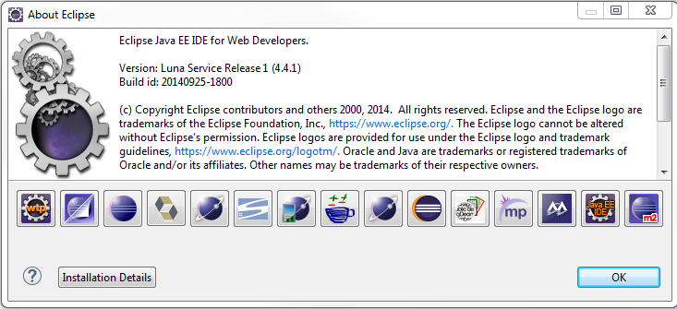

* Import Maven Project into Eclipse

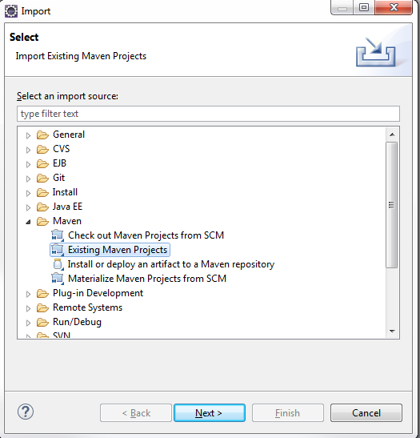

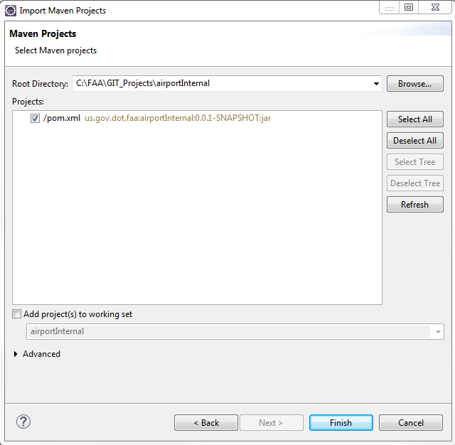

* Build War file

Right click pom.xml file

Select “Run As” -> Maven Install

