Effects Of COVID-19 On Mask and Hand Sanitizer Markets

Severe acute respiratory syndrome coronavirus 2 (SARS-CoV-2) is the strain of coronavirus that causes COVID-19. Studies about the transmission of SARS-CoV-2 show that transmission can occur through direct, indirect, or close contact with an infected individual either through infected secretions such as saliva and respiratory secretions or respiratory droplets. When an infected individual coughs, sneezes talks or sings, respiratory droplets are expelled into the surrounding area creating fomites that contaminate surfaces or objects. (World Health Organization 2020) The World Health Organization (WHO) states that the best way to prevent the transmission of the virus is to identify and quarantine infectious cases before they spread. However, transmission of the virus can still happen even when the infected person does not show symptoms. To counter this the WHO encourages fabric face masks in public places and frequent hand hygiene to limit the spread. This paper will analyze the mask and hand sanitizer markets before and after the COVID-19 epidemic including a discussion of resources, supply, demand, marginal benefits and marginal costs as a result of the increased demand for masks and hand sanitizer.

Face masks before COVID-19 were almost exclusively consumed by health workers, now they are a requirement for almost all households to participate in the community. Because of this increased demand, ReportLinker.com predicts that the global market for disposable masks will increase by 5.4% to reach US$28.8 billion by 2027 with the biggest growth spikes in 2020 and 2021 of 396.6% and 18.2% CAGR respectfully. (ReportLinker 2020) In February, the US imported $203.1 million in protective masks from China, a more than 20% drop from $261 million the same month last year as seen in Figure 1. At the same time, exports to China increased to $15.8 million as seen in Figure 2. (Zhang, Mansfield and Pulver 2020) In the 1990’s Prestige Ameritech in Texas produced 87% of the masks for the US, now China produces 50% of the US’s mask supply. As of February, the global production of face masks was around 40 million pieces per day, with China producing about half of that. With the domestic daily demand of China between 50-60 million masks per day, China can no longer keep up with production and has needed to import from multiple countries, leaving a global shortage for health workers and the general public alike. (Chan 2020)

Hand sanitizer is also an important health product to reduce the spread of the coronavirus. Hand sanitizers are believed to be faster, more efficient, and easier on skin than repeated hand washing and is used when washing hands is not convenient or possible. In 2019, the global hand sanitizer market was valued at USD 1.2 billion and is expected to reach USD 2.14 billion by 2027, growing at a CAGR of 7.5%. (Fior Markets 2020) Hand sanitizer sales have increased across every region in the world, leading to shortages across the globe. Demand for hand sanitizer has increased by 1400 percent from December 2019 to February 2020. Online retailers have increased prices by 70% due to the high demand. (PR Newswire 2020) Fortune Business Insights predicts a CAGR of 6.2% between 2019 and 2026 with North America increasing the most over the coming years. (Fortune Buisness Insights 2019) Because of the shortage of hand sanitizer, some companies that produce alcohol have started producing hand sanitizer to make up for the increase in demand.

While masks and hand sanitizers are useful tools to prevent the spread of COVID-19 but are not a real fix. If people are going to be ok with leaving their homes and not endangering their family members, we need a vaccine. Vaccines stimulate the immune system by simulating the infection of a particular pathogen, this allows the body to produce the necessary defenses to stop infection when faced with the real pathogen. A vaccine will protect those who are more susceptible to the serious side effects of COVID-19 by being able to control the amount of exposure. Vaccines also help protect against epidemics, as more of the population is vaccinated against a disease, the disease will have a harder time spreading. (Farnetti 2018)

According to the New York Times Coronavirus Vaccine Tracker, there are currently 57 vaccines in clinical trials on humans and at least 87 preclinical vaccines under active investigation in animals. (Zimmer, Corum and Wee 2020) The market for vaccine production is at risk of becoming a monopoly and is a major concern to policymakers and medical officials around the world. Dr. Manuel Martin, an adviser with Doctors Without Borders says that monopolies allow for companies to set high, unaffordable prices because their main concern is making money, not vaccines. A monopoly would increase the risk of one country hoarding all the supply of treatments. During the H1N1 pandemic of 2009, this exact thing happened, “high-income countries hogged all of the vaccine supply, crowding out low- and middle-income countries” (The World Staff 2020)

Some organizations like the Coalition for Epidemic Preparedness Innovations (CEPI) are global partnerships that are trying to develop vaccines and enable equitable access to them. CEPI currently has 8 vaccine candidates of the 57 mentioned earlier. Other companies might not have the moral standing of a global partnership like CEPI and only sell their vaccines to the highest bidder. Even CEPI is not immune to this, “the US had made a bid worth $1 billion for a vaccine candidate that was funded by CEPI for exclusive access.” (The World Staff 2020) To minimize the risk of a nationalistic takeover, any vaccine that becomes available will have to be manufactured in many locations across the globe to account for the demand and prevent one nation from hoarding the supply. (The World Staff 2020)

Companies that develop vaccines could use patents to stop other companies producing their vaccine. The issues with this are that during a national emergency, patent infringement becomes a legitimate unauthorized use. Royalties are collected by the patent holder, but these would be a fraction of the actual profits. (Crouch 2008) And patents expire after 20 years, opening the markets at a later date. If the company wanted to protect themselves from government intervention, they could consider the vaccine as a trade secret. There is no registration process for trade secrets like there is for patents, trade secrets never expire, and trade secrets are generally immune to government intervention. However, trade secrets only work as long as the product remains confidential, if the vaccine were to be reverse engineered, they would be left with no legal defense. (Medwed 2020)

It is possible that the COVID-19 vaccine industry is a natural monopoly, a monopoly producing vaccines could be good, monopolies are able to produce goods at a far lower cost than if there were many firms in the market, reducing the average costs of production. Many people fear that if one company has control over the production of a vaccine, there will not be enough supply to meet demands and vaccines will go to those who pay more and not to those who need them more.

Masks and hand sanitizer are essential everyday personal protective gear and the increase in quantity demanded for these has caused scarcity in the markets because suppliers cannot keep up with the demand. This drives pries higher and has even required rationing in some areas to ensure that as many people get the supplies they need as possible. The markets for both of these supplies will continue to increase in the coming years as the global awareness for health and hygiene increases. A vaccine for COVID-19 would lessen the need for masks and hand sanitizer but people will be more wary of something like this happening in the future and will probably plan to stock up just in case.

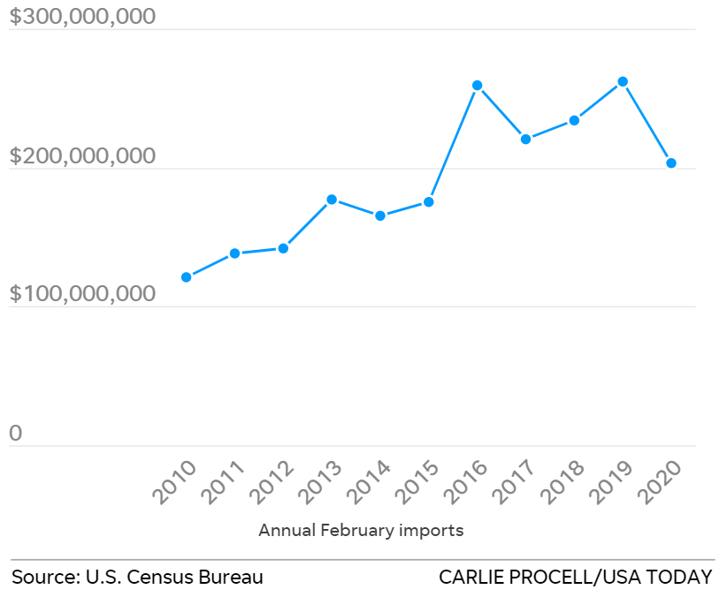

Figure 1: Annual February Imports (Zhang, Mansfield and Pulver 2020)

Figure 2: Annual February Exports (Zhang, Mansfield and Pulver 2020)

Figure 3: Global Hand Sanitizer Market Size by Region (Fortune Buisness Insights 2019)

# References

Chan, Elaine. 2020. *Coronavirus: China’s surgical mask shortage ripples through global supply chain as health crisis continues.* Feburary 16. Accessed October 27, 2020. https://www.scmp.com/economy/china-economy/article/3050717/coronavirus-chinas-surgical-mask-shortage-ripples-through.

Farnetti, Tomas. 2018. *Why do we need vaccines?* April 23. Accessed December 1, 2020. https://wellcome.org/news/why-do-we-need-vaccines.

Fior Markets. 2020. *Hand Sanitizer Market by Product (Spray, Gel, Wipes, Foam), End Use (Household Purposes, Schools, Restaurants, Hospital), Distribution Channel, and Regions, Global Industry Analysis, Market Size, Share, Growth, Trends, and Forecast 2020 to 2027.* Mar. Accessed October 27, 2020. https://www.fiormarkets.com/report/hand-sanitizer-market-by-product-spray-gel-wipes-417852.html.

Fortune Buisness Insights. 2019. "Impact of COVID-19 on The Global Hand Sanatizer Market Size, Share, Industry Analysis and Regional Forecast, 2019-2026." https://www.fortunebusinessinsights.com/impact-of-covid-19-on-hand-sanitizer-market-102719.

PR Newswire. 2020. *Huge Demand for Hand Sanitizers Rapidly Increasing Across the Globe.* May 14. Accessed October 27, 2020. https://www.prnewswire.com/news-releases/huge-demand-for-hand-sanitizers-rapidly-increasing-across-the-globe-301059060.html.

ReportLinker. 2020. *The Pandemic Changes Daily Life & Brings in New Dress Codes. The corona virus pandemic has irreversibility changed public life. Profound impact is already seen in the way governments, companies and people behave.* August 17. Accessed October 27, 2020. https://www.globenewswire.com/news-release/2020/08/17/2079430/0/en/Global-Disposable-Masks-Industry.html.

World Health Organization. 2020. *Transmission of SARS-CoV-2: implications for infection prevention precautions.* July 9. Accessed October 26, 2020. https://www.who.int/news-room/commentaries/detail/transmission-of-sars-cov-2-implications-for-infection-prevention-precautions.

Zhang, Dian, Erin Mansfield, and Dinah Voyles Pulver. 2020. *Coronavirus: How the face mask supply in the U.S. dropped.* May. https://www.usatoday.com/story/news/investigations/2020/04/08/coronavirus-how-face-mask-supply-u-s-dropped/5119824002/.

Figure 1: Annual February Imports (Zhang, Mansfield and Pulver 2020) 3

Figure 2: Annual February Exports (Zhang, Mansfield and Pulver 2020) 3

Figure 3: Global Hand Sanitizer Market Size by Region (Fortune Buisness Insights 2019) 4