Dashboard Report
SHOP NEST STORE CAPSTONE
Nexusgoods E-Commerce — Sales, Delivery & Customer Performance Dashboard
Prepared by: Thompson Liansanglun
File Reference: TJ_Power_BI_Capstone_.pbix

1. Introduction
This report documents the Power BI capstone dashboard built on the Nexusgoods e-commerce dataset, a Brazilian-style online retail dataset covering orders placed between September 2016 and October 2018. The data model links eight core tables — orders, order items, order payments, order reviews, products, product category translations, customers, and sellers — through a star-schema arrangement of relationships, with dedicated DAX measures driving each visual (e.g., Total revenue, Total Sales by Category, Delayed Orders, On-Time Orders, Average Product Rating).
The dashboard spans nine report pages covering the eight tasks set out in the Power BI Capstone Project brief: Top Categories by Total Price, Delayed Orders Analysis, Monthly Comparison of Delayed and On-Time Orders (with a drill through detail page), Payment Method Analysis, Product Rating Analysis, State-Wise Sales Analysis, Seasonal Sales Patterns, and Revenue Analysis. Across the dataset, the business processed 99,441 orders, generated approximately R$16.0 million in total payments, and achieved a 92.1% on-time delivery rate.
what the live Power BI dashboard displays. The sections below correspond to each task in the capstone brief. Each section states the underlying question, presents the relevant visualization(s) from the dashboard, and explains the key insights and findings the visual reveals. Charts in this report were regenerated directly from the same tables and DAX measures used in the .pbix file, so the figures
shown match

RELATIONSHIPS:
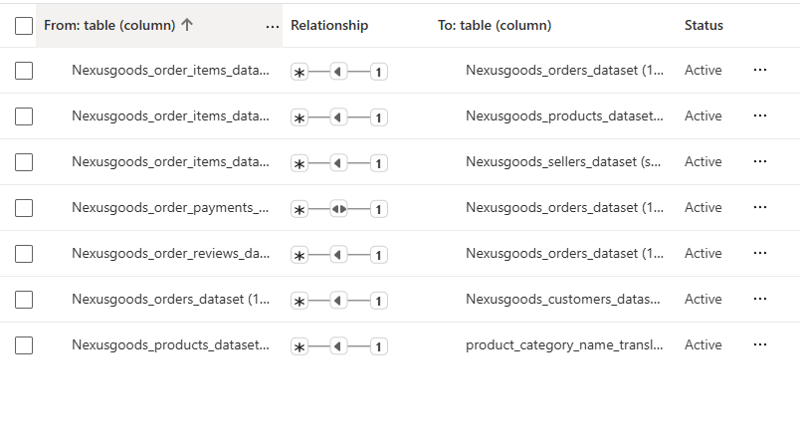
NOTE:
- enabled bidirectional filtering so customer filters propagate through Orders to Payments

2. Task 1: Top Categories by Total Price
Question Statement: Identify and visually represent the top 10 product categories by total sales.
Visualization:
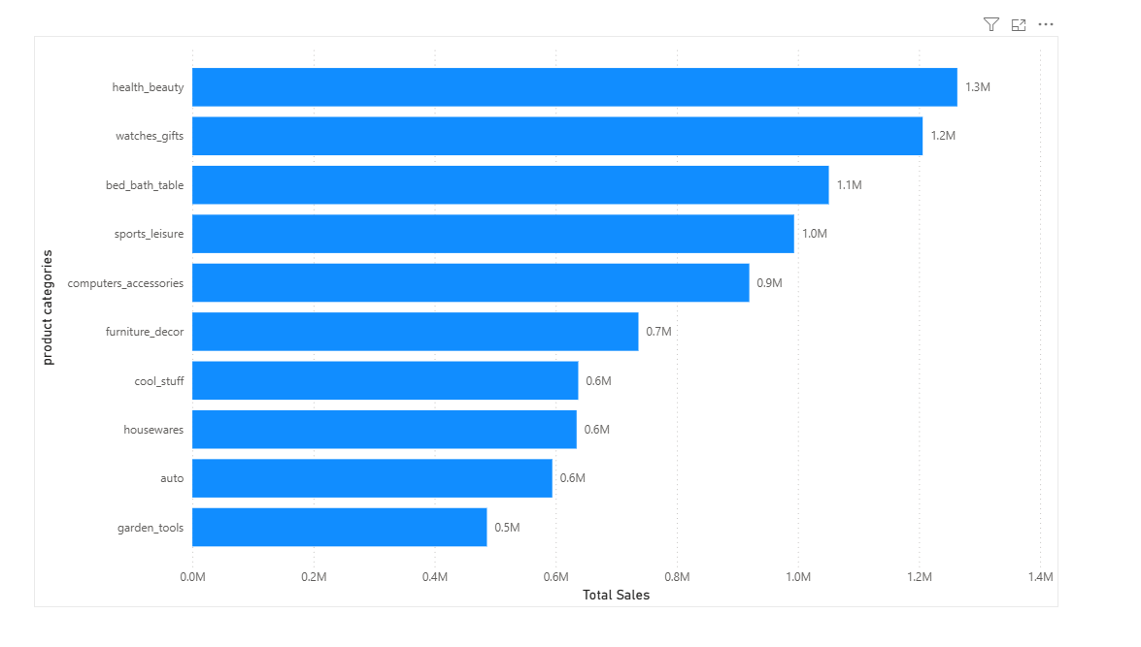
Figure 1 — Top 10 Product Categories by Total Sales (Clustered Bar Chart)
Explanation:
This chart ranks product categories by the DAX measure Total Sales by Category (SUM of order-item price). Health & Beauty is the top-selling category with R$1,263,237.54 in sales, narrowly ahead of Watches & Gifts at R$1,206,075.33 and Bed, Bath & Table at R$1,051,085.50. Together these top three categories contribute roughly 25.8% of total sales.
Sports & Leisure (R$993,684.51), Computers Accessories (R$919,721.44) and Furniture Decor (R$736,682.46) form the middle of the top 10, while Cool Stuff, Housewares, Auto and Garden Tools complete the list with sales between roughly R$486K and R$637K. In total, these 10 categories generate about R$8.52 million — approximately 62.4% of the R$13.65 million in total product sales across all 71 categories in the catalogue — showing that sales are heavily concentrated in a relatively small set of top-performing categories.

3. Task 2: Delayed Orders Analysis
Question Statement: Determine the number of delayed orders in each category. An order is considered delayed if the actual delivery date is later than the estimated delivery date.
Visualization:
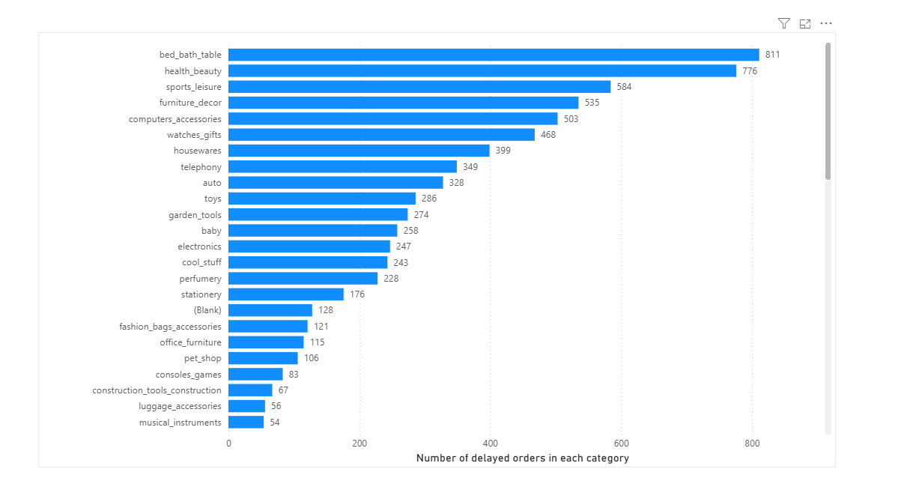
Figure 2 — Top 10 Product Categories by Delayed Orders (Clustered Bar Chart)
Explanation:
Using the Delayed Orders by Category measure (a DISTINCTCOUNT of order IDs where the delivered date exceeds the estimated delivery date), Bed, Bath & Table has the most delayed orders (811), followed by Health & Beauty (776) and Sports & Leisure (584). Furniture Decor (535), Computers Accessories (503) and Watches & Gifts (468) round out the upper half of the list.
Notably, five of these categories — Bed Bath Table, Health Beauty, Sports Leisure, Computers Accessories, and Watches Gifts — also appear in the Task 1 top-selling list, suggesting that categories with higher order volume are naturally exposed to more delivery delays in absolute terms. The 10 categories shown here account for 5,039 of the 7,827 total delayed orders in the dataset (about 64%), meaning delay risk is concentrated in a relatively small number of high-volume categories rather than spread evenly across the catalogue.

4. Task 3: Monthly Comparison of Delayed and On-Time Orders
Question Statement: Create a dynamic visual that compares the number of delayed orders to the number of orders received on time for each month. Utilize the drill through cross-report feature to provide a detailed analysis of late and on-time deliveries.
Visualization A — Monthly Comparison:
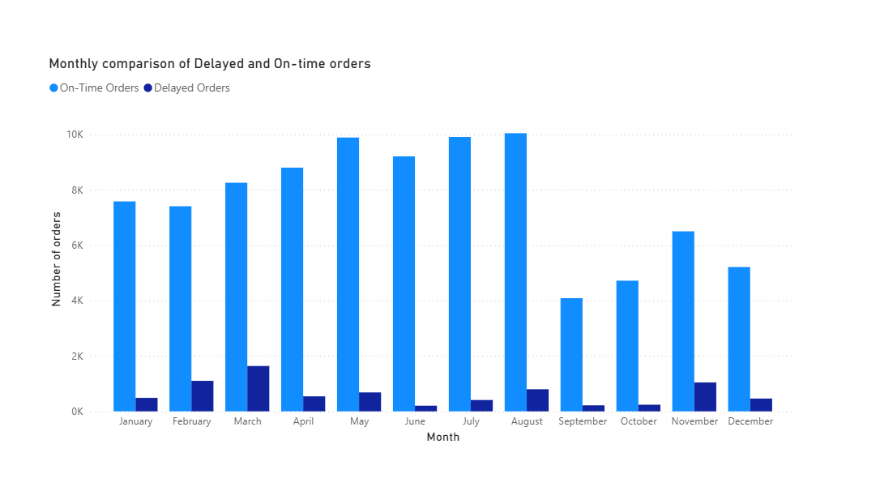
Figure 3 — Monthly Comparison of Delayed and On-time Orders (Clustered Column Chart)
On-time orders outnumber delayed orders in every calendar month, consistent with the dashboard's overall 92.1% on-time rate. Delays are most pronounced in March (1,638), February (1,102) and November (1,043), while June (204), September (217) and October (240) see the fewest delays. The February–March spike and the November spike stand out as the two periods most worth investigating operationally — for example, whether carrier capacity or order volume surges (such as seasonal or promotional peaks) are driving the increase.
Visualization B — Delivery Details (Drill-through Page):
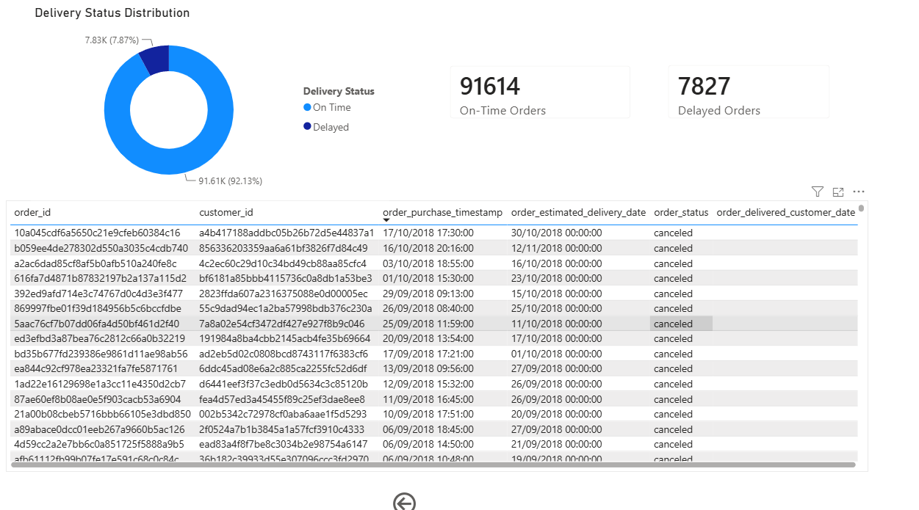
Figure 4 — Delivery Status Distribution, KPI Cards, and Order-Level Delivery Details Table
Explanation:
The supporting detail page breaks down overall delivery performance and enables drill-through analysis. Of the 99,441 orders in the dataset, 91,614 (92.1%) were delivered on or before the estimated delivery date, and 7,827 (7.9%) were delivered late — shown consistently by the donut chart and the two KPI cards. The delivery details table (accessible via the on-page button) lists individual orders with their customer ID, order status, purchase date, estimated delivery date, and actual delivered date, letting analysts drill into specific late orders to investigate root causes such as a particular carrier, seller, or time window.

Drill-through for the month of July:
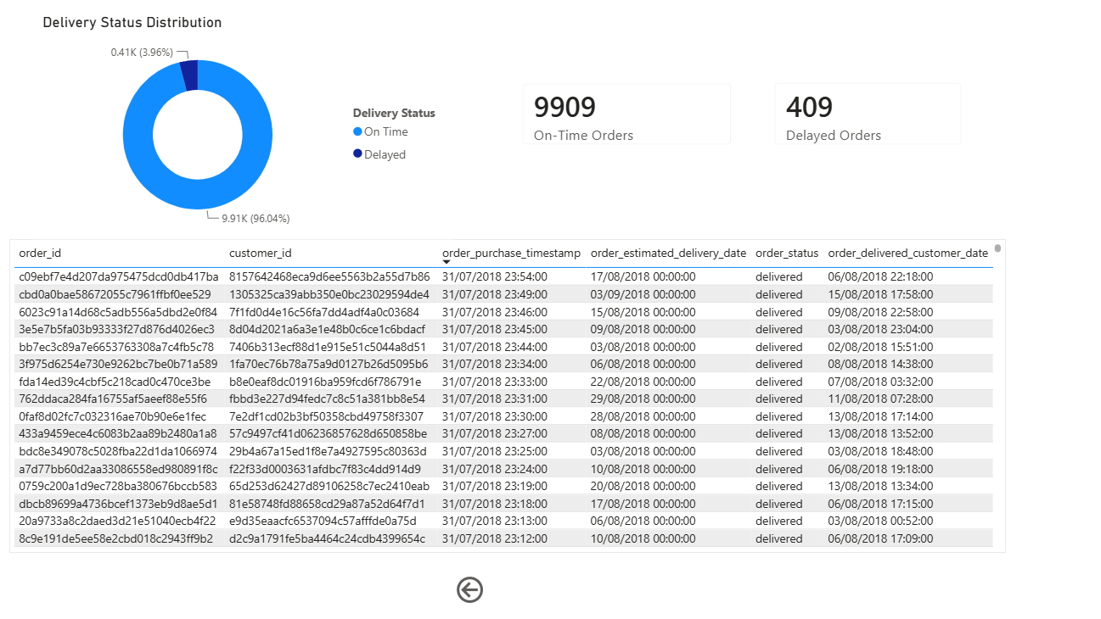

5. Task 4: Payment Method Analysis
Question Statement: Analyze the most frequently used payment methods by customers using a visually appealing representation, such as a pie chart or other suitable visuals.
Visualization:
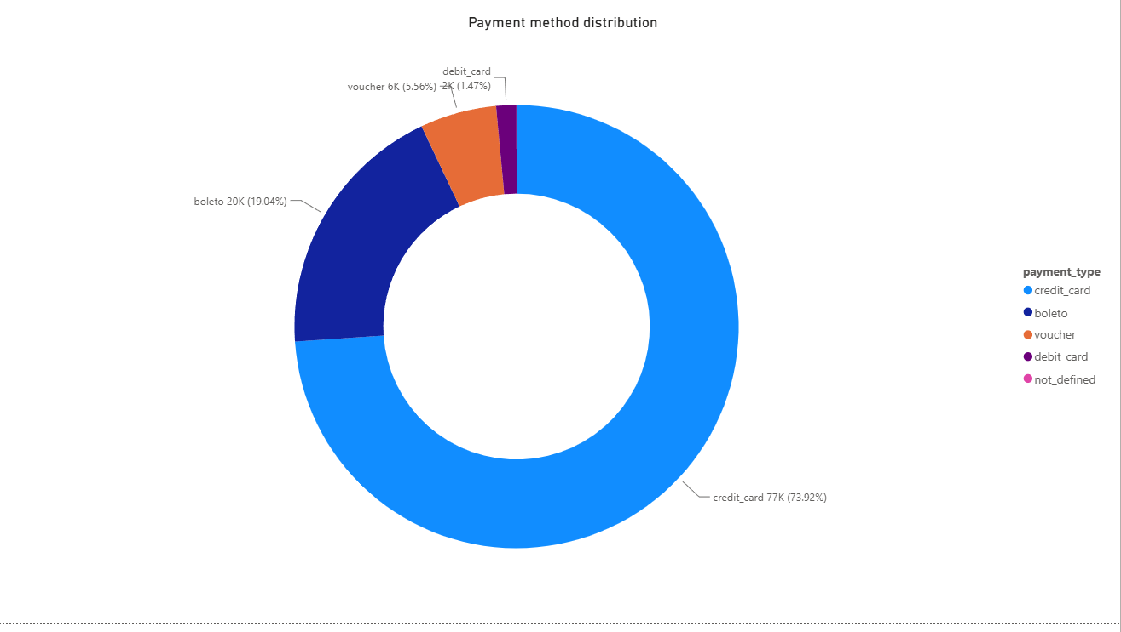
Figure 5 — Payment Method Distribution (Donut Chart)
Explanation:
Credit card is the dominant payment method, used in 76,795 transactions (73.9% of all payments), followed by boleto — a common Brazilian bank-slip payment method — with 19,784 transactions (19.0%). Voucher payments account for 5,775 transactions (5.6%), while debit card usage is comparatively low at 1,529 transactions (1.5%); a negligible 3 transactions are recorded as 'not defined'.
This distribution indicates that credit card checkout is the primary revenue channel and should remain the top priority for a smooth, reliable payment experience, while boleto is an important secondary option to preserve for customers who prefer bank-slip payments. Debit card and voucher usage are minor by comparison, so incremental improvements there would have a smaller overall business impact.

6. Task 5: Product Rating Analysis
Question Statement: Determine the top 10 highest-rated and bottom 10 lowest-rated products using a bar or column chart.
Visualization:
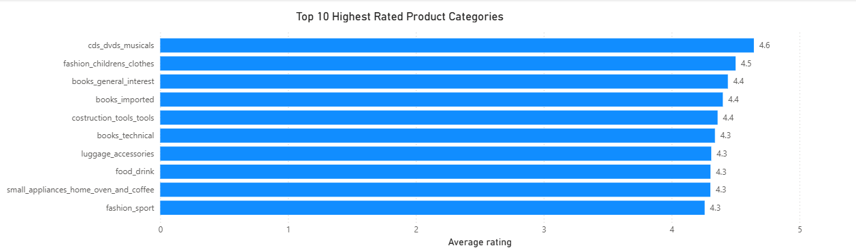
Figure 6 — Top 10 Highest Rated Product Categories (Average Rating)
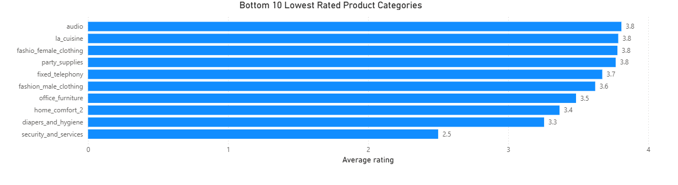
Figure 7 — Bottom 10 Lowest Rated Product Categories (Average Rating)
Explanation:
Average Product Rating is calculated across 113,322 order-item level reviews spanning 71 rated categories, against an overall catalogue average of 4.01 out of 5. CDs & DVDs Musicals has the highest average rating (4.64), followed by Fashion Children's Clothes (4.50) and Books General Interest (4.44); Books Imported, Construction Tools, Books Technical, Luggage Accessories, Food & Drink, Small Appliances (Home Oven & Coffee) and Fashion Sport complete the top 10, all averaging above 4.25.
At the other end of the spectrum, Security & Services has by far the lowest average rating (2.50) — a full point below the next-lowest category, Diapers & Hygiene (3.26). Home Comfort 2 (3.37), Office Furniture (3.48) and Fashion Male Clothing (3.62) are also notably below the 4.01 catalogue average. Since nearly all of the bottom 10 categories sit well under the overall average rating, they represent clear candidates for a closer look at product quality, descriptions, or fulfilment issues that may be driving customer dissatisfaction.
Note: the capstone brief asks for the highest- and lowest-rated products. Because individual products in this dataset carry very few reviews each (making per-product averages unstable), the dashboard implements this analysis at the product-category level using the Average Product Rating measure, which gives a more statistically reliable ranking while still directly answering which parts of the catalogue customers rate best and worst.

7. Task 6: State-Wise Sales Analysis
Question Statement: Identify and visually represent states with high and low sales, providing a clear understanding of regional sales performance.
Visualization:
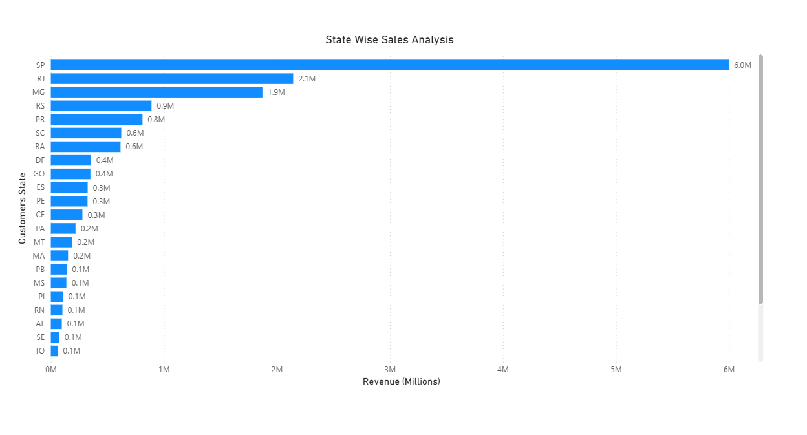
Figure 8 — State Wise Sales Analysis (Clustered Bar Chart, Total Revenue by Customer State)
Explanation:
Revenue is heavily concentrated in Sao Paulo (SP), which alone generates R$5.99 million — about 37.5% of the R$16.0 million total revenue across all 27 Brazilian states. Rio de Janeiro (RJ, R$2.14M) and Minas Gerais (MG, R$1.87M) are the next largest contributors, followed by Rio Grande do Sul (RS, R$0.89M) and Paraná (PR, R$0.81M).
Together, the top five states account for roughly 73.2% of total revenue, underscoring that sales are concentrated in Brazil's south-eastern and southern economic hubs. States such as Santa Catarina, Bahia, the Federal District, Goias and Espirito Santo each contribute more modest but still meaningful amounts (roughly R$300K–R$625K), while the remaining states each contribute smaller shares. This concentration suggests that logistics, marketing, and inventory strategy could reasonably be prioritized around the top five states, while lower-revenue regions represent potential areas for future growth investment.

8. Task 7: Seasonal Sales Patterns
Question Statement: Investigate and visualize any seasonal patterns (quarterly) or trends in sales data over the course of the year.
Visualization:
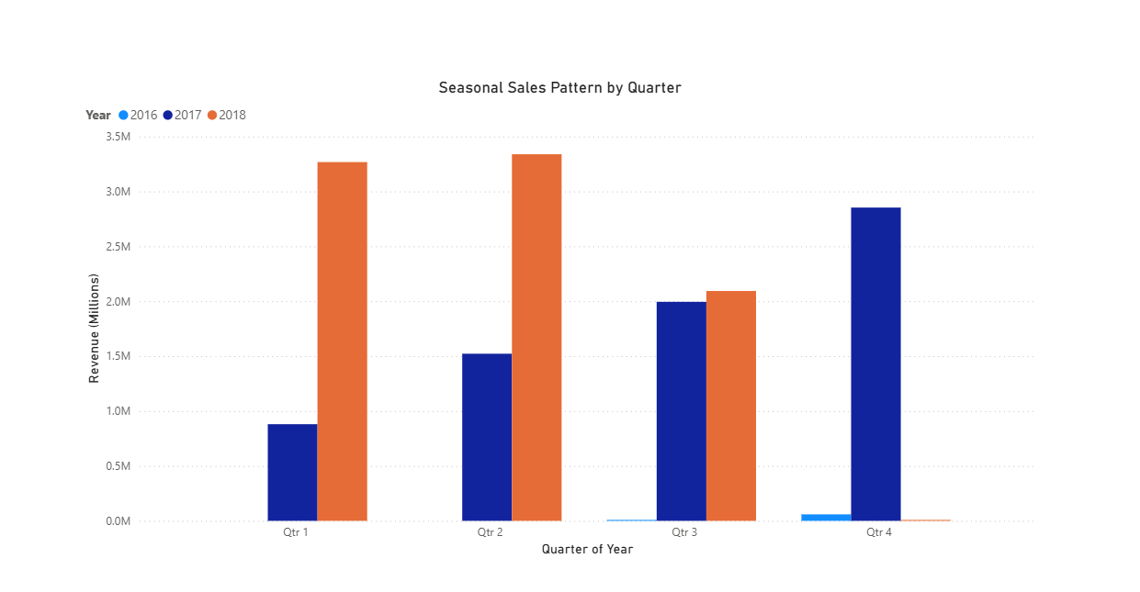
Figure 9 — Seasonal Sales Pattern by Quarter (Clustered Column Chart, Quarter × Year)
Explanation:
This chart plots total revenue by quarter, with each year as a separate series, revealing both growth trends and seasonality. In 2017, revenue rose steadily each quarter — from R$0.88M in Q1 to R$1.52M in Q2, R$1.99M in Q3, and R$2.85M in Q4 — making Q4 2017 the strongest single quarter in the dataset, likely reflecting a year-end/holiday sales peak.
2018 follows a different shape: revenue starts higher than the equivalent 2017 quarters (R$3.27M in Q1, R$3.34M in Q2), then falls to R$2.09M in Q3, with Q4 2018 showing only R$590 because the dataset ends in mid-October 2018 and that quarter is effectively incomplete. Comparing like-for-like complete quarters, Q1–Q3 2018 revenue consistently exceeds the same quarters in 2017, pointing to solid year-over-year growth, even though the strongest overall quarter on record remains Q4 2017 due to the missing 2018 year-end data.

9. Task 8: Revenue Analysis
Question Statement: Determine the total revenue generated by the store and analyze how it changes over time (yearly). Represent this information through suitable visuals to highlight trends and patterns.
Visualization:
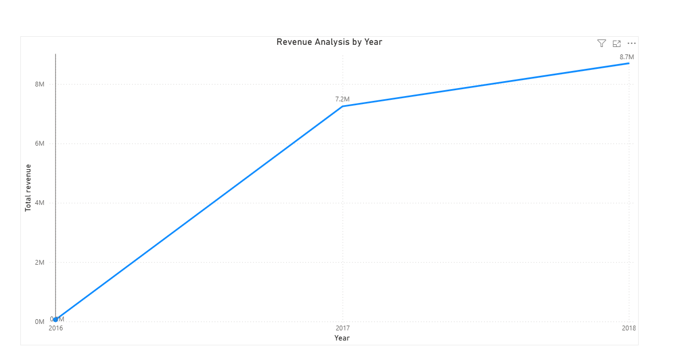
Figure 10 — Revenue Analysis by Year (Line Chart)
Explanation:
Total revenue (SUM of payment value) grew substantially across the period covered by the dataset: from R$59,362 in 2016 (a partial year, covering only September–December) to R$7.25 million in 2017, and further to R$8.70 million in 2018 (also a partial year, covering January through mid-October).
Because 2016 and 2018 are both incomplete years in the source data, 2017 is the only full calendar year and serves as the most reliable year-over-year baseline. Even so, the roughly 20% increase from 2017's full-year total to 2018's ten-month total indicates strong underlying business growth, reinforcing the upward trend already visible in the quarterly breakdown in Task 7.
Note: the capstone brief refers to the business as "ShopNest Store"; the underlying data model and table names in this .pbix file use the "Nexusgoods" naming convention instead. Both refer to the same store/dataset, so the figures above represent its total revenue.

10. Conclusion
- Sales are concentrated: the top 10 of 71 product categories generate 62.4% of total sales, led by Health & Beauty, Watches & Gifts, and Bed, Bath & Table.
- Delivery performance is strong overall (92.1% on-time), but delays spike in February, March and November — periods worth investigating for capacity or seasonal-volume causes.
- Credit card dominates payments (73.9%), with boleto as a meaningful secondary method (19.0%).
- Customer satisfaction varies widely by category — Security & Services (2.50) and Diapers & Hygiene (3.26) rate well below the 4.01 catalogue average and warrant quality review.
- Revenue is geographically concentrated, with São Paulo alone contributing 37.5% of total revenue and the top 5 states contributing 73.2%.
- The business shows clear year-over-year growth, with 2018's ten-month revenue (R$8.70M) already surpassing 2017's full-year total (R$7.25M).

Overall, the dashboard demonstrates a healthy, growing e-commerce business with strong on-time delivery performance, a small number of categories and states driving the bulk of revenue, and specific, identifiable areas — seasonal delivery delays and a handful of low-rated categories — where targeted operational improvements could have an outsized impact.

