DIT5307 Brief Development Report: THEi HR System
Student 1: Chu Lok Hang Thomson (250511652) Student 2: Yeung Chun Kit (250276567)

1. Introduction
The THEi HR System is a Java EE 8 web application for HR administration — managing employees, training enrollments, instalment-based fee payments, and automated payment-overdue warnings. Built with EJB 3.2, JPA 2.2 and JSF 2.3; packaged as a Maven WAR and deployed on GlassFish 5.1.

2. Enterprise Session Beans
CrudServiceBean — @Stateless. Centralises persistence for Employee, TrainingEnrollment, FeePaymentRecord and PaymentWarning (create / find / list / update / deactivate-warning, plus JPQL queries such as findEmployeeByHkid and getActiveWarnings). Stateless because every CRUD call is conversation-free, allowing the container to pool a small number of instances for many concurrent JSF requests with no stale per-client state.
TimerServiceBean — @Singleton @Startup. Owns the EJB Timer Service. createPaymentWarningTimer(enrollment) schedules a single-action timer for 30 calendar days before trainingStartDate; the @Timeout callback then checks fullyPaid, sets paymentOverdue=true, and persists a PaymentWarning. Singleton guarantees exactly one bean handles every timer expiry — avoiding duplicate warnings and race conditions; @Startup bootstraps it with the application.

3. Transaction Management
All EJB methods run under Container-Managed Transactions with the default REQUIRED attribute, so each public method on CrudServiceBean and the @Timeout callback execute atomically. Concrete boundaries: (a) EnrollmentDetailController.recordPayment() calls addPaymentRecord() + updateTrainingEnrollment() together so the new instalment row and the enrollment’s running total commit as one unit; (b) deactivateWarningForEnrollment() is a JPQL bulk UPDATE that atomically flips all warnings for one enrollment to active=false; (c) TimerServiceBean.timeout() sets paymentOverdue and persists the PaymentWarning in the same transaction, keeping the flag and warning row consistent.

4. JSF Pages and Backing Beans
- login.xhtml / LoginController (@SessionScoped) — authenticates the hard-coded HR account.
- index.xhtml / DashboardController — retrieves active PaymentWarnings via getActiveWarnings() and renders them sorted ascending by days remaining to the 21-day cancellation deadline; overdue entries display “Payment Overdue” only.
- employees.xhtml / EmployeeController — lists / creates Employees (title MR/MS/MRS/DR, dept, mobile, email, HKID).
- enrollment.xhtml / EnrollmentController — lists and creates enrollments; on create, invokes TimerServiceBean.createPaymentWarningTimer().
- editEnrollment.xhtml / EditEnrollmentController — edits program info, training dates and enrolled employees.
- enrollmentDetail.xhtml / EnrollmentDetailController — records instalment payments, shows payment history, and provides the “Mark Fully Paid” action that clears paymentOverdue and deactivates related warnings.

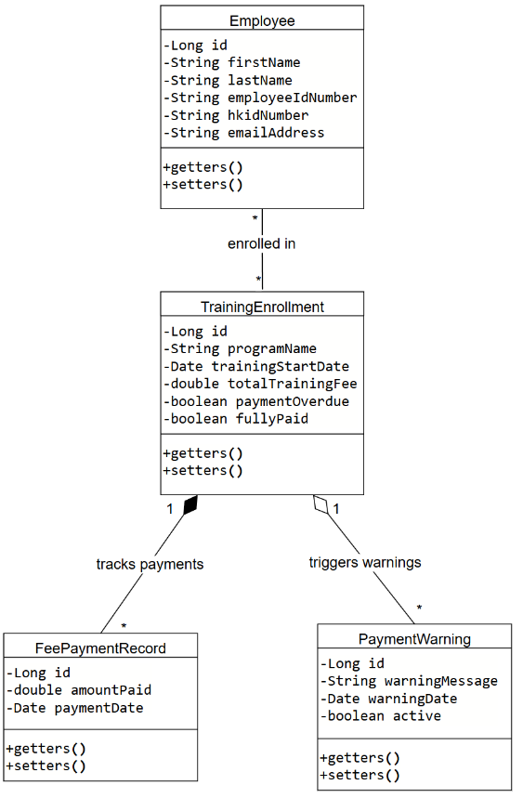
5. System Design (UML)
Relationships. Employee ⟷ TrainingEnrollment is Many-to-Many (join table ENROLLMENT_EMPLOYEE). TrainingEnrollment ⟶ FeePaymentRecord is One-to-Many (cascade=ALL, orphanRemoval=true). TrainingEnrollment ⟷ PaymentWarning is One-to-One.
Class summary (key fields only): - Employee — id, lastName @NotNull, firstName @NotNull, title (MR/MS/MRS/DR), employeeIdNumber {unique}, department, mobilePhoneNumber @Pattern(^[0-9]{8}$), emailAddress @Email, hkidNumber {unique}. - TrainingEnrollment — id, programName, programDescription, enrollmentDate, trainingStartDate, totalTrainingFee, paymentOverdue, fullyPaid. - FeePaymentRecord — id, amountPaid, paymentDate, @ManyToOne trainingEnrollment. - PaymentWarning — id, warningMessage, warningDate, active, @OneToOne associatedEnrollment.

6. JPA Highlights
Bean Validation is enforced via @NotNull, @Email, @Pattern (mobile = 8 digits), @Size, plus DB-level unique/nullable=false on employeeIdNumber and hkidNumber. Key JPQL queries in CrudServiceBean: SELECT e FROM Employee e WHERE e.emailAddress = :email; SELECT e FROM Employee e WHERE e.hkidNumber = :hkid; SELECT w FROM PaymentWarning w WHERE w.active = true (with cache REFRESH hint so newly-fired warnings appear immediately); and a bulk UPDATE PaymentWarning w SET w.active=false WHERE w.associatedEnrollment.id = :eid.

7. Assumptions
A single hard-coded HR admin account is sufficient (per the brief). For the demo, createPaymentWarningTimer() is shortened to 30 seconds instead of 30 days before start date — the production line is retained in the source and commented next to the demo override. Days-remaining used for warning sort = trainingStartDate − today − 21 (matches the 21-day cancellation cut-off). All dates use the Asia/Hong Kong timezone; currency uses standard decimal (HKD). One PaymentWarning per enrollment is sufficient; re-marking unpaid reuses the existing row, so duplicates are not created.

8. References
1. Apache Software Foundation, “Apache Maven project documentation,” 2023. Available: https://maven.apache.org/
2. Oracle, “Java EE 8 Technologies (EJB 3.2, JPA 2.2, JSF 2.3, etc.).” Available: https://www.oracle.com/java/technologies/java-ee-8.html
3. Oracle, “Java EE 8 SDK Downloads (includes GlassFish 5.0.1).” Available: https://www.oracle.com/java/technologies/javaee-8-sdk-downloads.html
4. Oracle, “Java EE Tutorial — Using the EJB Timer Service.” Available: https://docs.oracle.com/javaee/7/tutorial/ejb-basicexamples004.htm

