Bug Report

Run Date | 02/07/2026, 15:21:06
Total Tests | 8
Passed | 6
Failed | 2

Bug #1 — should logout successfully
Suite | Login
File | tests\e2e\login.spec.ts
Browser | e2e
Duration | 7.7s
Retries | 0
Error | Error: expect(page).toHaveURL(expected) failed Expected: "https://www.saucedemo.com/dashboard" Received: "https://www.saucedemo.com/"

Steps to Reproduce
1. [PASS] Navigate to "/"
2. [PASS] Fill "standard_user" getByTestId('username')
3. [PASS] Fill "secret_sauce" getByTestId('password')
4. [PASS] Click getByTestId('login-button')
5. [PASS] Click getByRole('button', { name: 'Open Menu' })
6. [PASS] Click getByText('Logout')

Screenshot
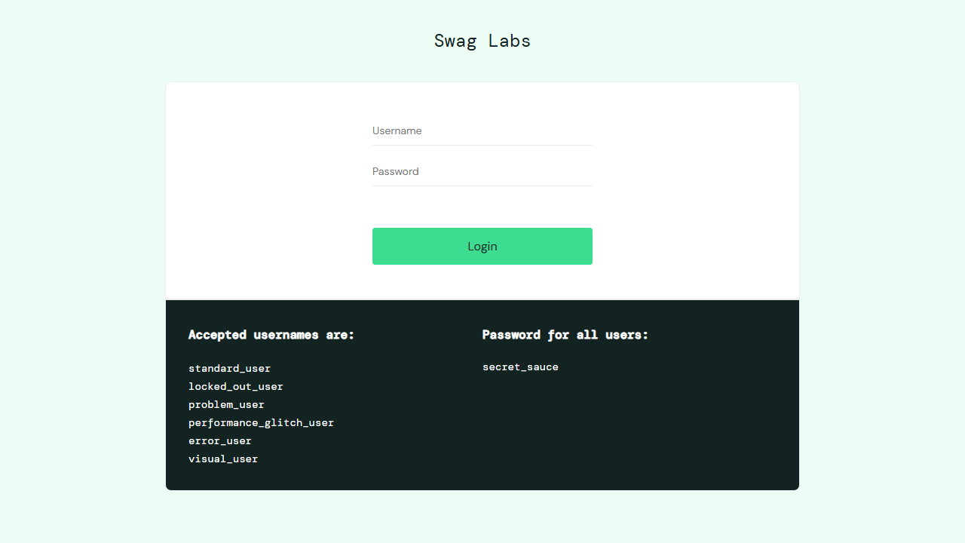

Bug #2 — should login with performance glitch user
Suite | Login
File | tests\e2e\login.spec.ts
Browser | e2e
Duration | 11.7s
Retries | 0
Error | Error: expect(page).toHaveURL(expected) failed Expected: "https://www.saucedemo.com/inventory-missing" Received: "https://www.saucedemo.com/inventory.html"

Steps to Reproduce
1. [PASS] Navigate to "/"
2. [PASS] Fill "performance_glitch_user" getByTestId('username')
3. [PASS] Fill "secret_sauce" getByTestId('password')
4. [PASS] Click getByTestId('login-button')

Screenshot
