TRAN QUANG THONG
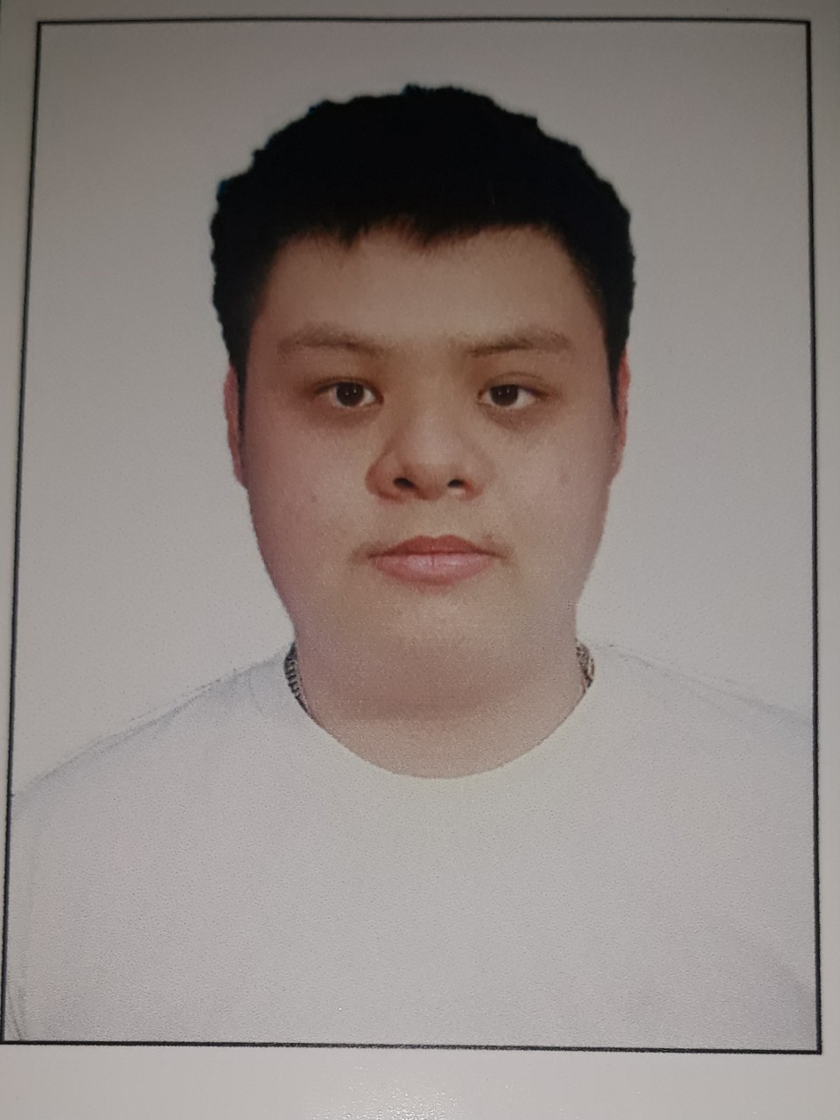)

PERSONAL DETAILS

- Name TRAN QUANG THONG
- Nationality Vietnamese
- Date of Birth November, 21st 2001
- Sex Male
- Marital status Single
- Phone No. (+84) 367 262 415
- Email quangthong211101@gmail.com

CAREER OBJECTIVES

- I hope to gain experience in a professional and dynamic working environment. Constantly learning and improving programming knowledge to develop professional skills. In the next year, will become a professional .Net programmer and learn more Android programming.

EDUCATIONAL BACKGROUND

- Software Engineering – Duy Tan University, Vietnam.

PROFESSIONAL SUMMARY

- Hard working, seft-confidence.
- Work under pressure.
- High teamwork spirit and eager to learn and share.
- Sociable, friendly communication in team work.
- Basic English communication.

SOFTWARE

- Databases etc: MS SQL Server, My SQL.
- Programming Languages: Java, JavaScript, C, C++, C#, Python.
- Frontend: HTML5/CSS3.
- Programming Tools: Visual Studio 2019,2022, Visual Studio Code, Netbeans,DevC++.
- App server / Middleware: Apache.
- OOP/UML: Object Oriented Programming (OOP), Unified Modeling Language (UML).

PROFESSIONAL EXPERIENCE

PROJECT AND PRACTICE

Project name | Website Travel and Food | Duration
Position(s) | Design and Developer | 10/2021– 12/2021
General information | - Team Size: 4 person
Description | The purpose of the website is to promote tourism and Vietnamese
Project Scope | - Requirment  - Design  - Coding  - Test
Technology used | Programming Languages  - C#  Front-end  - HTML/CSS, JavaScript, Bootstrap 5  Development environment  - Microsoft Windows 10  - Visual Studio 2019  Framework  - .Net

Project name | Software for selling and managing shoes | Duration
Position(s) | Analysis, Design and Developer | 8/2022 – 10/2022
General information | - Team Size: 4 person
Description | Create software to perform in footwear management and sales
Project Scope | - Requirment  - Design  - Coding
Technology used | Programming Languages  - C#  Framework  - Guna2 UI  Development environment  - Microsoft Windows 10  - Visual Studio 2022  Framework  - .Net
Project name | Website Pet Service | Duration
Position(s) | Design and Developer | 11/2022– 01/2023
General information | - Team Size: 4 person
Description | The purpose of the website is to care for and provide the best services for pets.
Project Scope | - Requirment  - Design  - Coding  - Test
Technology used | Programming Languages  - C#  Front-end  - HTML/CSS, JavaScript, Bootstrap 5  Framework  - .Net  Development environment  - Microsoft Windows 10  - Visual Studio 2022
HOBBIES
Read books to learn the technology, travelling, film, programming, gaming…

