**Name: Lê Chí Thông**

**ID: 17110078**

**LAB01**

1. **Iris Dataset**

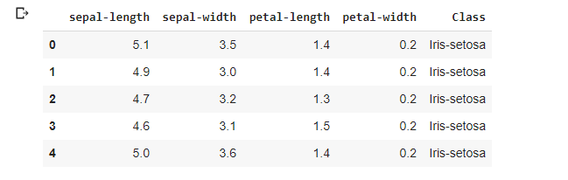

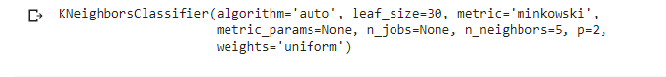

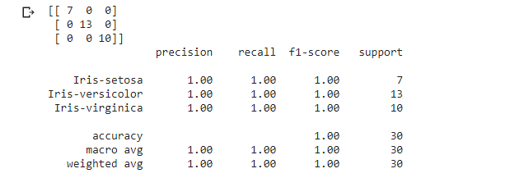

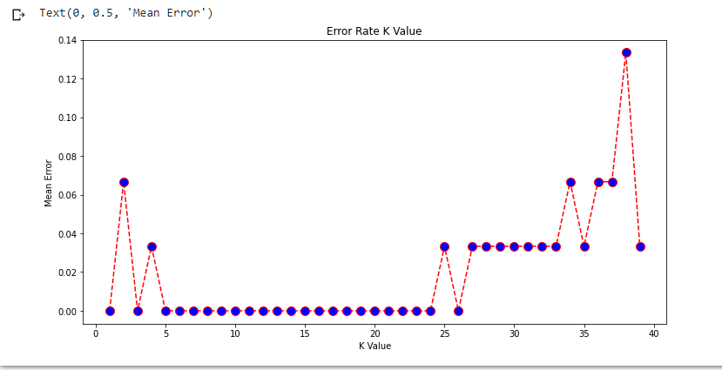

Link: <https://colab.research.google.com/drive/1oq59tZ459RbnSSnZXrkMOXgiOuua1ldi?usp=sharing>

SVM-Iris

Link:

<https://colab.research.google.com/drive/1UHz5pH922LcTY8y3TsMsUPaxmzHt4YOV?usp=sharing>