|  |  |
| --- | --- |
|  | **MOB1023** |

**Báo cáo Assignment**

**Môn: java 2**

Giảng viên hướng dẫn : Trần Thế Bảy

Mã số sinh viên : PS 36640

Họ tên sinh viên : Nguyễn Thiện Thông

Lớp : MD18401

Lab 1:

Bài 1:

/*

* To change this license header, choose License Headers in Project Properties.

* To change this template file, choose Tools | Templates

* and open the template in the editor.

*/

package lab1;

import java.util.Scanner;

/**

*

* @author macos

*/

public class Product implements Dao{

private String name;

private double price;

public Product(String name, double price) {

this.name = name;

this.price = price;

}

public Product() {

}

public double getImportTax(){

return this.price * 0.1;

}

public String getName() {

return name;

}

public void setName(String name) {

this.name = name;

}

public double getPrice() {

return price;

}

public void setPrice(double price) {

this.price = price;

}

public void nhap(){

Scanner sc = new Scanner(System.in);

System.out.print("Nhap name: ");

this.setName(sc.nextLine());

System.out.print("Nhap price: ");

this.setPrice(Double.parseDouble(sc.nextLine()));

}

public void xuat(){

System.out.printf("%-30s\t|\t%10.0f\t|\t%10.0f",this.name,this.price,this.getImportTax());

}

@Override

public void insert() {

System.out.println("Insert thanh cong");

}

@Override

public void update() {

System.out.println("update thanh cong");

}

@Override

public void delete() {

System.out.println("delete thanh cong");

}

@Override

public void create() {

System.out.println("create thanh cong");

}

}

Bài 2:

/*

* To change this license header, choose License Headers in Project Properties.

* To change this template file, choose Tools | Templates

* and open the template in the editor.

*/

package lab1;

import java.util.ArrayList;

/**

*

* @author macos

*/

public class bai2 {

public static void main(String[] args) {

ArrayList<Product> list = new ArrayList<Product>();

//nhap

for(int i=1;i<6;i++){

System.out.printf("Nhap thong tin Product thu %d:\n",i);

Product sp = new Product();

sp.nhap();

list.add(sp);

}

//xuat

System.out.println("Danh sach Product");

System.out.printf("%-30s\t|\t%10s\t|\t%10s\n","Name","Price","GetImportTax");

for(Product i: list){

i.xuat();

System.out.println("");

}

}

}

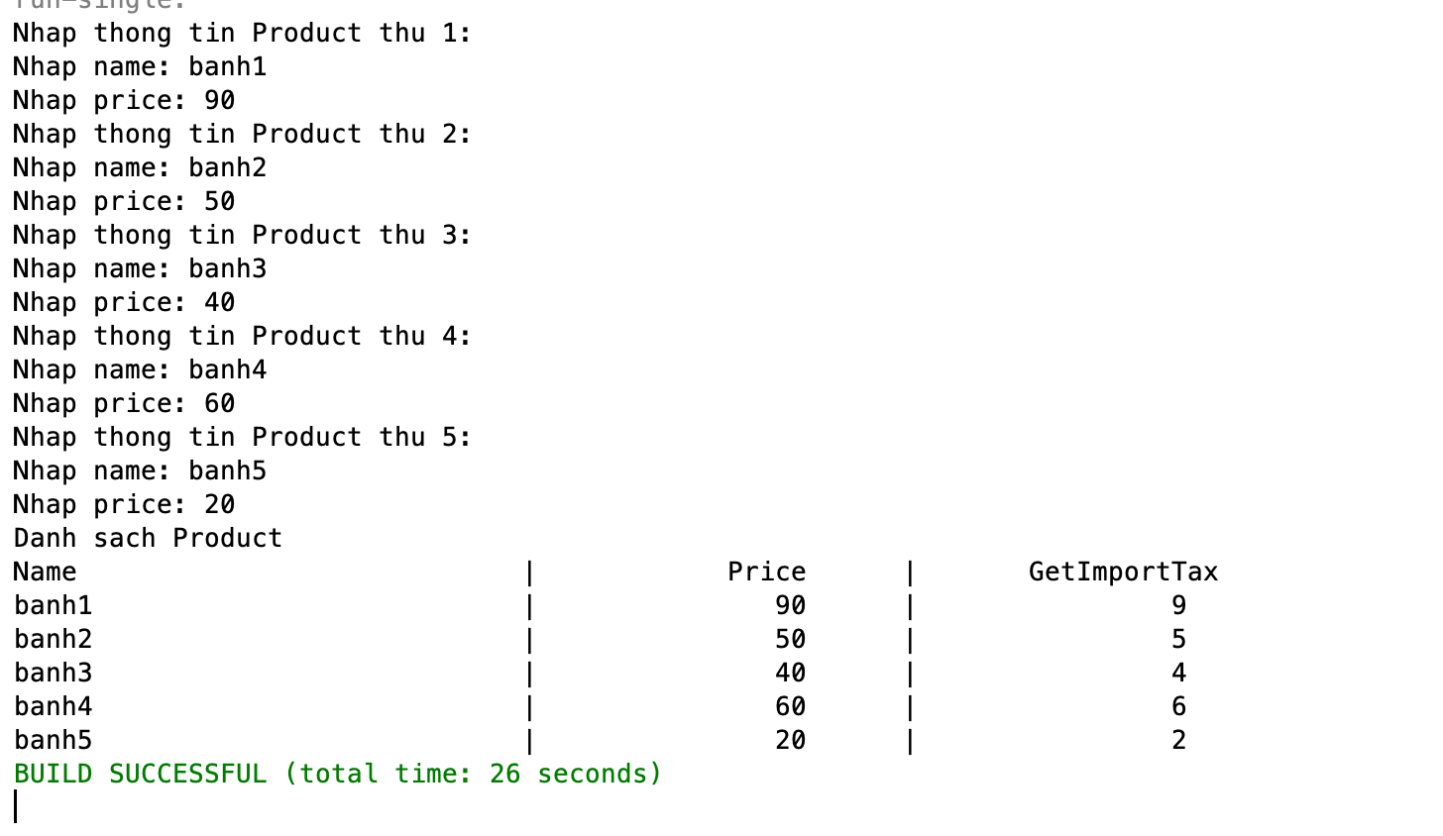

Bài 3:

/*

* To change this license header, choose License Headers in Project Properties.

* To change this template file, choose Tools | Templates

* and open the template in the editor.

*/

package lab1;

import java.util.ArrayList;

/**

*

* @author macos

*/

public class NoTaxProduct extends Product{

@Override

public double getImportTax() {

return 0;

}

}

/*

* To change this license header, choose License Headers in Project Properties.

* To change this template file, choose Tools | Templates

* and open the template in the editor.

*/

package lab1;

import java.util.ArrayList;

/**

*

* @author macos

*/

public class MainBai3 {

public static void main(String[] args) {

ArrayList<Product> list = new ArrayList<Product>();

//nhap

for(int i=1;i<3;i++){

System.out.printf("Nhap thong tin Product thu %d:\n",i);

Product sp = new Product();

sp.nhap();

list.add(sp);

}

//nhap ko thue

System.out.println("Nhap thong tin Product thu 3:");

Product sp = new NoTaxProduct();

sp.nhap();

list.add(sp);

//xuat

System.out.println("Danh sach Product");

System.out.printf("%-30s\t|\t%10s\t|\t%10s\n","Name","Price","GetImportTax");

for(Product i: list){

i.xuat();

System.out.println("");

}

}

}

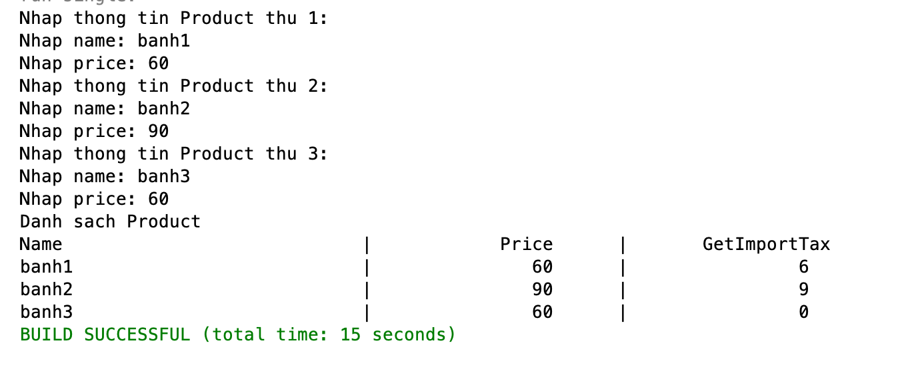

Bài 4:

/*

* To change this license header, choose License Headers in Project Properties.

* To change this template file, choose Tools | Templates

* and open the template in the editor.

*/

package lab1;

/**

*

* @author macos

*/

public interface Dao {

void insert();

void update();

void delete();

void create();

}

/*

* To change this license header, choose License Headers in Project Properties.

* To change this template file, choose Tools | Templates

* and open the template in the editor.

*/

package lab1;

import java.util.Scanner;

/**

*

* @author macos

*/

public class Product implements Dao{

private String name;

private double price;

public Product(String name, double price) {

this.name = name;

this.price = price;

}

public Product() {

}

public double getImportTax(){

return this.price * 0.1;

}

public String getName() {

return name;

}

public void setName(String name) {

this.name = name;

}

public double getPrice() {

return price;

}

public void setPrice(double price) {

this.price = price;

}

public void nhap(){

Scanner sc = new Scanner(System.in);

System.out.print("Nhap name: ");

this.setName(sc.nextLine());

System.out.print("Nhap price: ");

this.setPrice(Double.parseDouble(sc.nextLine()));

}

public void xuat(){

System.out.printf("%-30s\t|\t%10.0f\t|\t%10.0f",this.name,this.price,this.getImportTax());

}

@Override

public void insert() {

System.out.println("Insert thanh cong");

}

@Override

public void update() {

System.out.println("update thanh cong");

}

@Override

public void delete() {

System.out.println("delete thanh cong");

}

@Override

public void create() {

System.out.println("create thanh cong");

}

}