https://p4.org/p4/getting-started-with-p4.html

=====================================================================================

sudo apt update

sudo apt-get install -y cmake g++ git automake libtool libgc-dev bison flex libfl-dev libgmp-dev libboost-dev libboost-iostreams-dev libboost-graph-dev llvm pkg-config python python-scapy python-ipaddr python-ply tcpdump doxygen graphviz texlive-full

sudo apt-get install autoconf autogen automake libtool python-pip

=====================================================================================

git clone https://github.com/protocolbuffers/protobuf.git

cd protobuf

git checkout v3.2.0

git submodule update --init --recursive

./autogen.sh

./configure

make

make check

sudo make install

sudo ldconfig

=====================================================================================

git clone https://github.com/p4lang/behavioral-model.git

cd behavioral-model

./install_deps.sh

./autogen.sh

./configure

sudo make

sudo make install

sudo ldconfig

=====================================================================================

git clone --recursive https://github.com/p4lang/p4c.git

cd ~/p4c

mkdir build

cd build

cmake ..

make -j4

make -j4 check

=====================================================================================

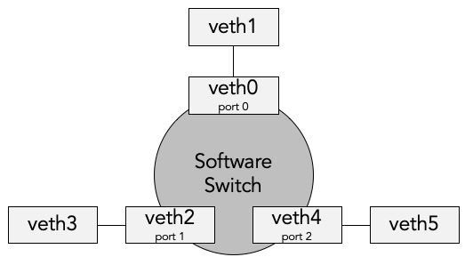

veth33 (3)

veth11 (1)

veth22 (2)

veth30 (0)

veth10 (0)

veth20 (0)

# First pair: veth10-veth11

sudo ip link add name veth10 type veth peer name veth11

sudo ip link set dev veth10 up

sudo ip link set dev veth11 up

sudo ip link set veth10 mtu 9500

sudo ip link set veth11 mtu 9500

sudo sysctl net.ipv6.conf.veth10.disable_ipv6=1

sudo sysctl net.ipv6.conf.veth11.disable_ipv6=1

# Second pair: veth20-veth22

sudo ip link add name veth20 type veth peer name veth22

sudo ip link set dev veth20 up

sudo ip link set dev veth22 up

sudo ip link set veth20 mtu 9500

sudo ip link set veth22 mtu 9500

sudo sysctl net.ipv6.conf.veth20.disable_ipv6=1

sudo sysctl net.ipv6.conf.veth22.disable_ipv6=1

# Second pair: veth30-veth33

sudo ip link add name veth30 type veth peer name veth33

sudo ip link set dev veth30 up

sudo ip link set dev veth33 up

sudo ip link set veth30 mtu 9500

sudo ip link set veth33 mtu 9500

sudo sysctl net.ipv6.conf.veth30.disable_ipv6=1

sudo sysctl net.ipv6.conf.veth33.disable_ipv6=1

=====================================================================================

p4c -b bmv2 pm_switch.p4 -o pm_switch.bmv2

sudo simple_switch --interface 1@veth11 --interface 2@veth22 --interface 3@veth33 pm_switch.bmv2/pm_switch.json

=============================================================================

show_tables

table_info <TABLE_NAME>

table_add <TABLE_NAME> <ACTION>

table_dump <TABLE_NAME>

=============================================================================

[cmd.txt]

table_add forwarding pm_forward 11.1.0.0/16 => 1

table_add forwarding pm_forward 22.2.0.0/16 => 2

table_add forwarding pm_forward 22.2.0.0/16 1 => 2

table_add forwarding pm_forward 11.1.0.0/16 2 => 1

mirroring_add 250 3 // *mirroring_add [mirror_id] [output_port]*

=============================================================================

sudo scapy

p = Ether()/IP(dst="22.2.0.1")/UDP()

sendp(p, iface="veth11")