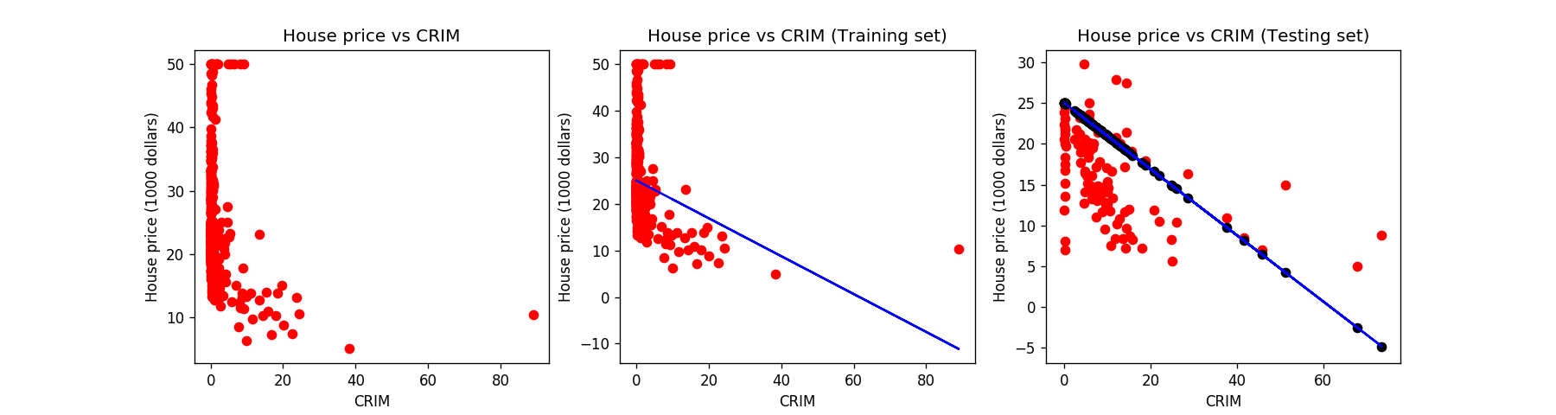
R square (CRIM) = -0.8934684755693647

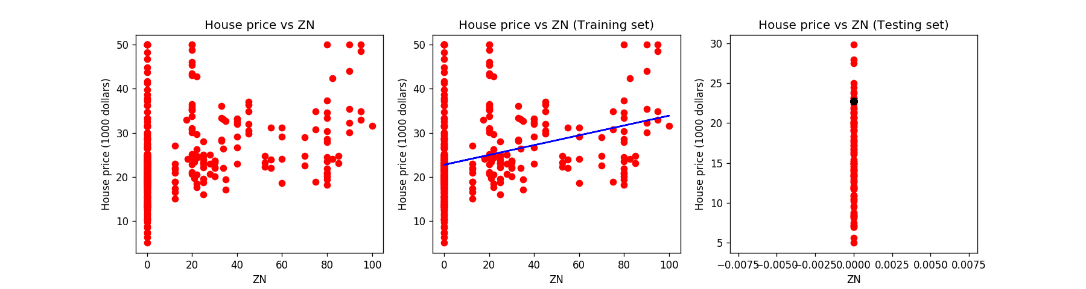
R square (ZN) = -1.7332856460357533

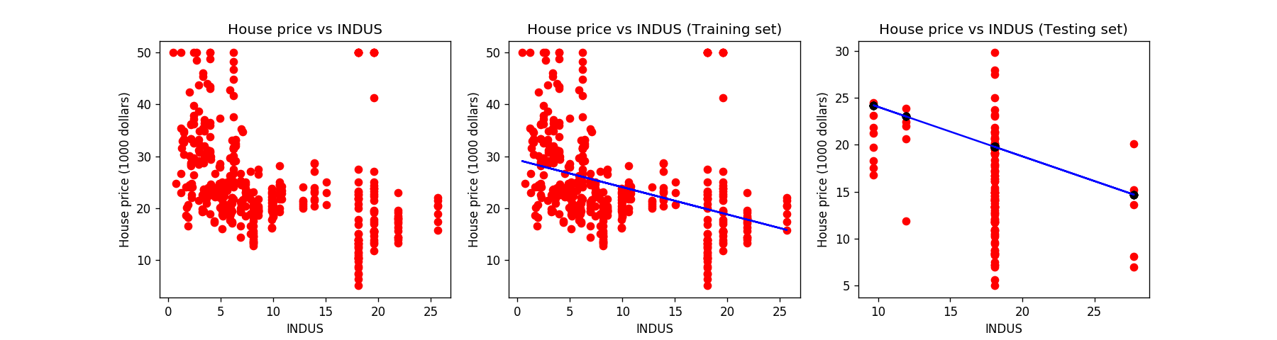
R square (INDUS) = -0.5512321521707451

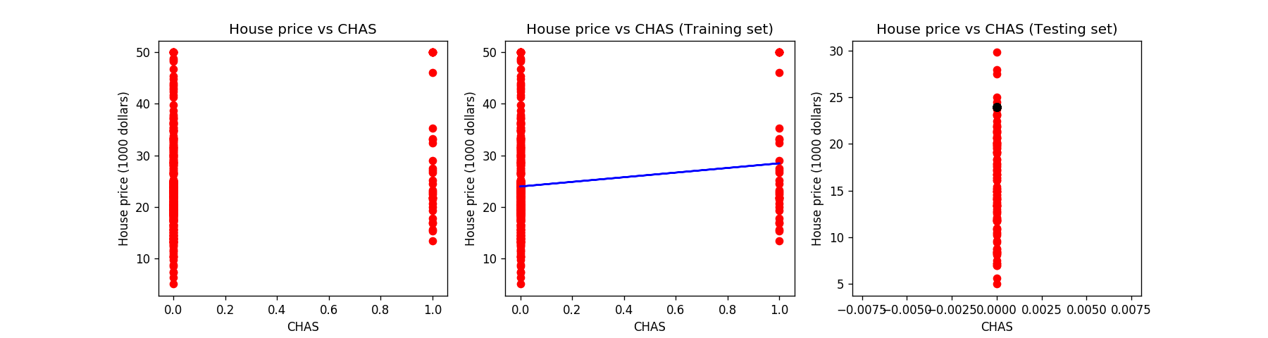
R square (CHAS) = -2.3835418413070713

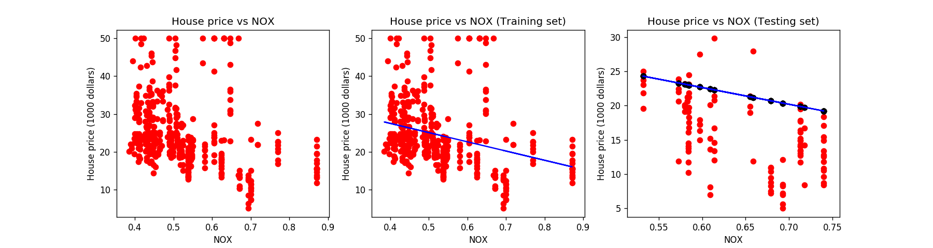
R square (NOX) = -0.943781086937773

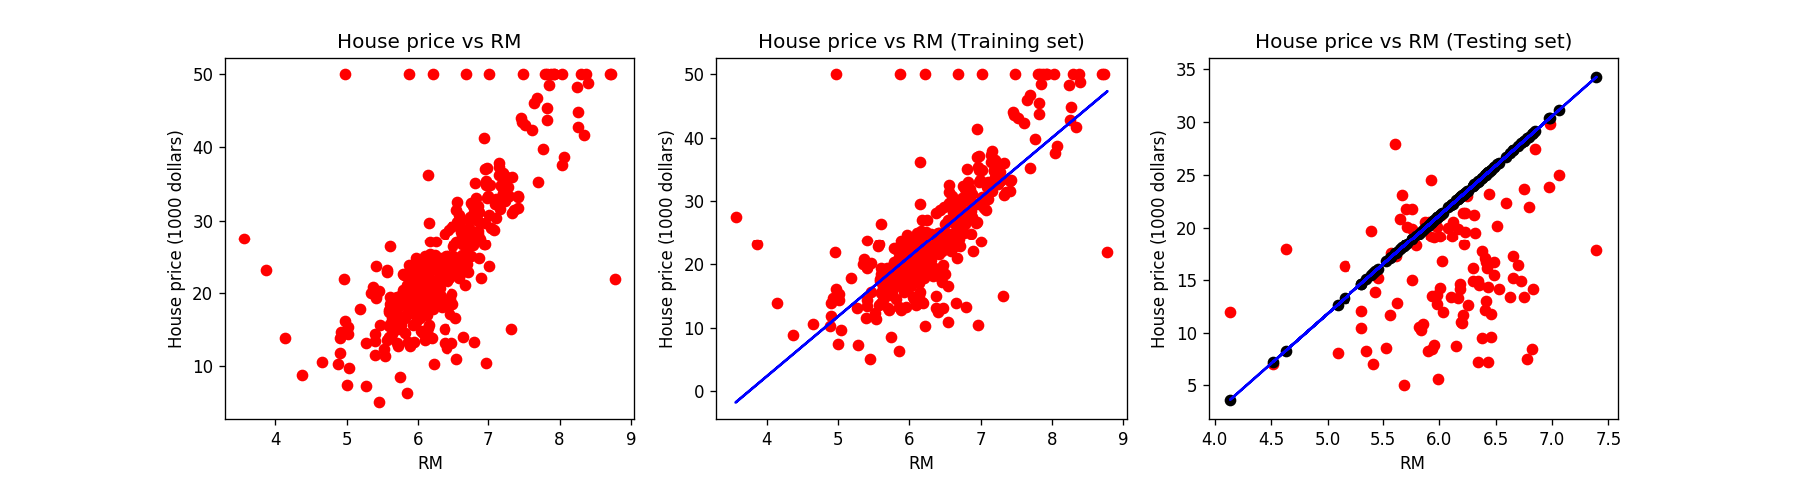
R square (RM) = -1.8178816078460653

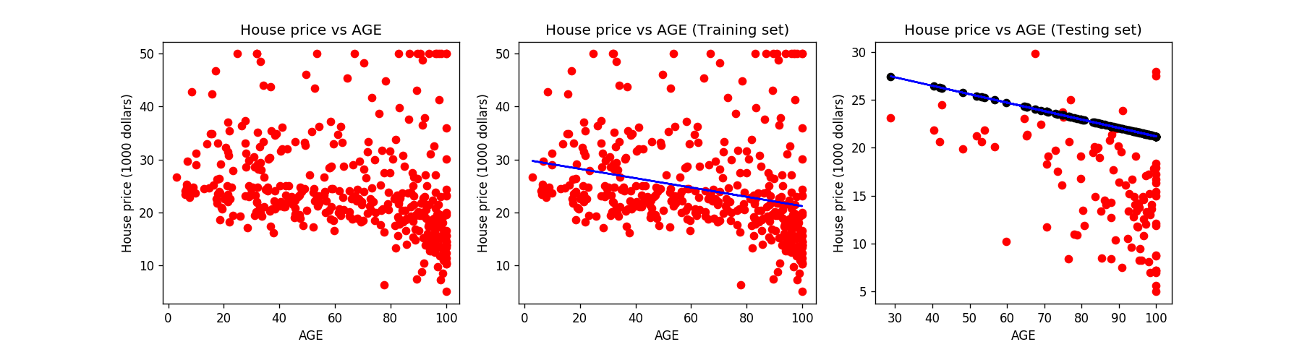
R square (AGE) = -1.408696646011831

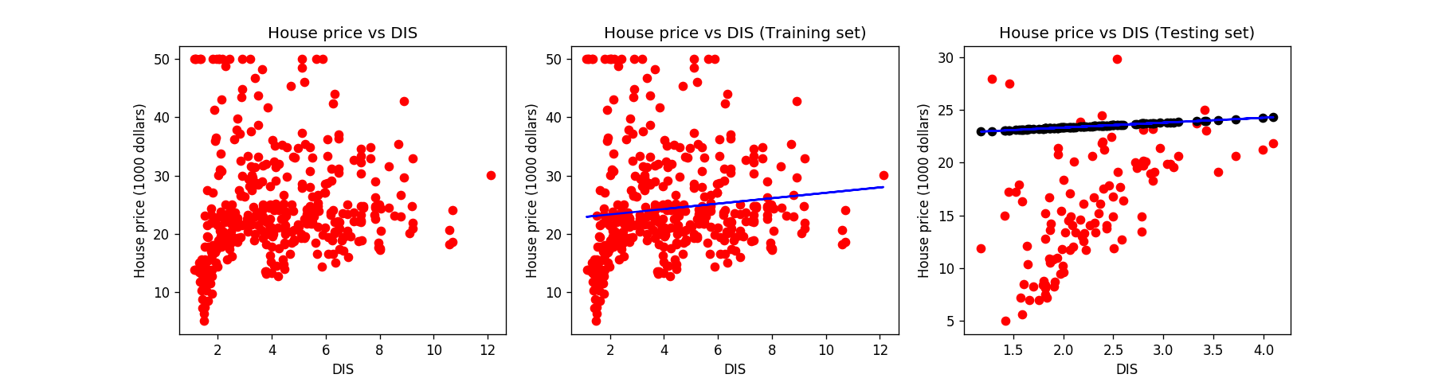
R square (DIS) = -2.0489787812031865

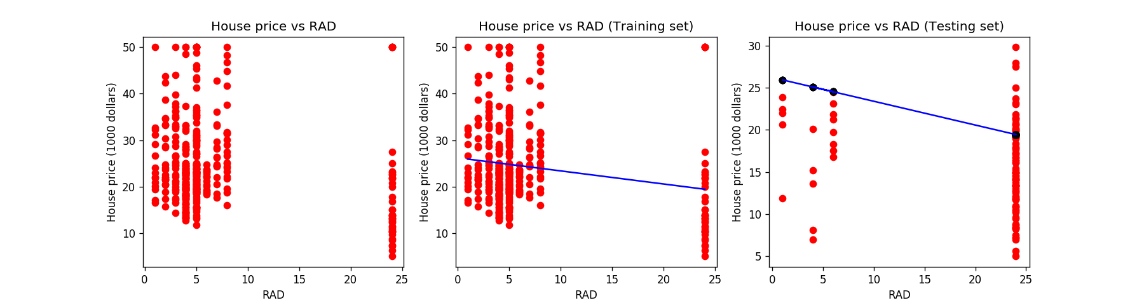
R square (RAD) = -0.7616015964104863

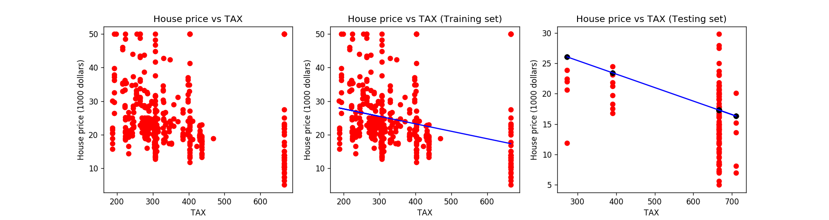
R square (TAX) = -0.1188707945956955

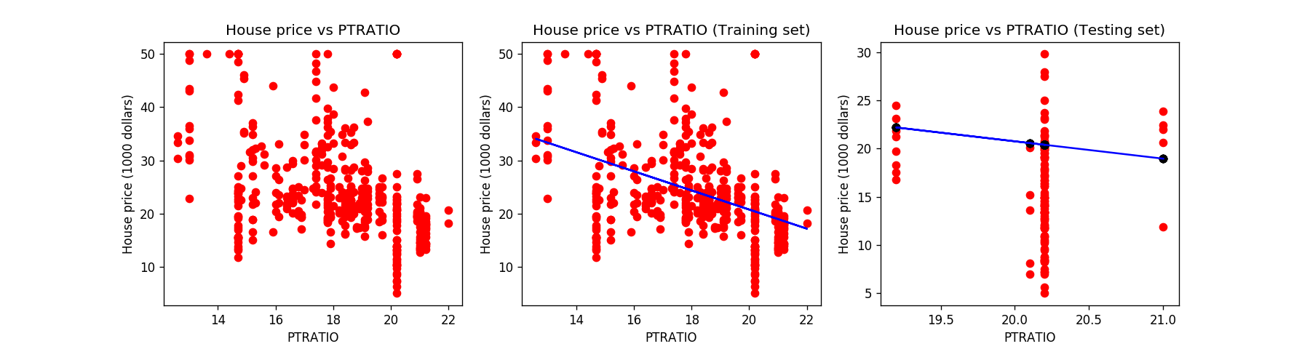
R square (PTRATIO) = -0.7824296591550945

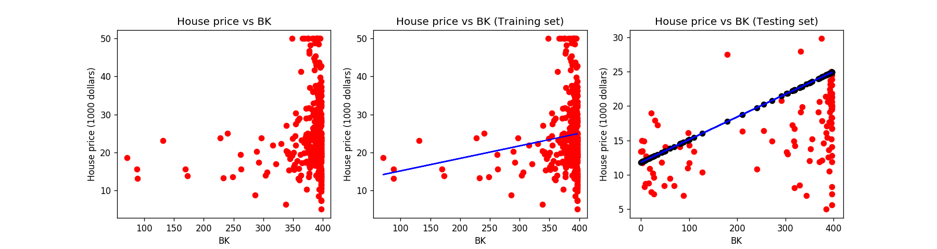
R square (B) = -0.9055737112268505

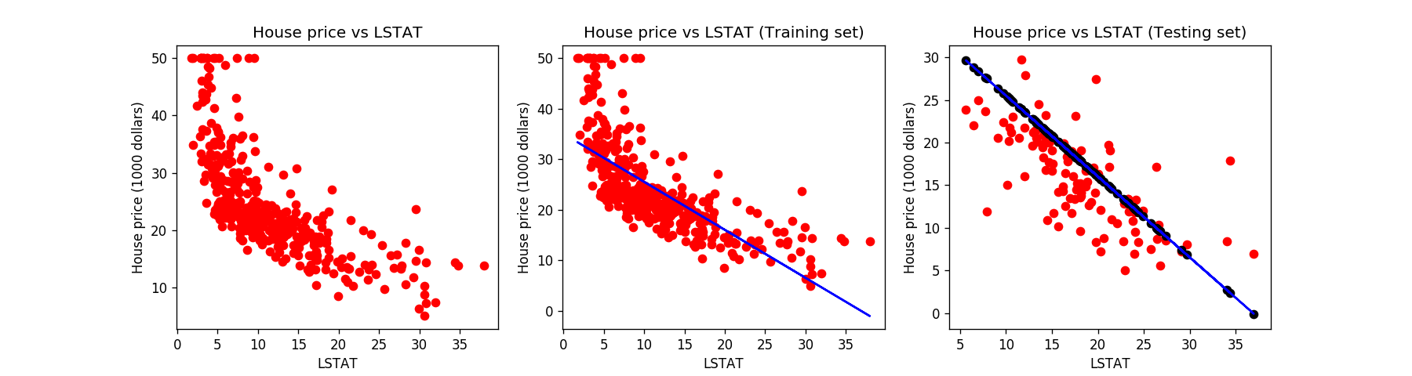
R square (LSTAT) = 0.15338361719088434
[ ]:

