**VIETNAM NATIONAL UNIVERSITY- HCM THESIS GRADUATION**

**INTERNATIONAL UNIVERSITY Advisor: Le Nhat Tan**



**REPORT**

Overview of Barrier option



STUDENT

Name: Ta Thi Phuong Dung

ID: MAMAIU13067

1. 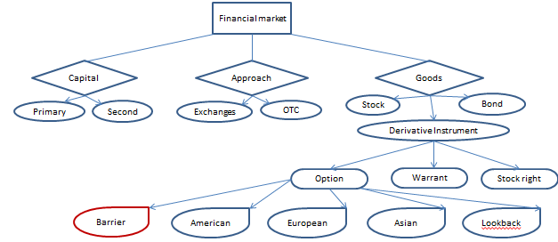**STRUCTURE OF SECURITIES MARKET**

Financial market

* Where traders buy and sell [stocks](https://www.thebalance.com/what-are-stocks-3306181), bonds, derivatives, foreign exchange and commodities.
* Classification:

+ Based on working capital:

* Primary market: New security issues sold to initial buyers. Typically involves an investment bank who underwrites the offering.
* Second market: Securities previously issued are bought   
  and sold. Involves both brokers and dealers.

+ Based on operating approach:

* Exchange market: Stock trades conducted via centralized place.

Buy/Sell is conducted through the exchange; no direct contract between seller and buyer.

* OTC market ( Over-The-Counter): No centralized place. Trading is done directly between two parties, without the supervision of an [exchange](https://en.wikipedia.org/wiki/Exchange_(organized_market)).

+ Based on goods:

* Stock market: a financial market that enables investors to buy and sell shares of publicly traded companies. There are common stock and preferred stock.
* Bond market: a [financial market](https://en.wikipedia.org/wiki/Financial_market) where participants can issue new [debt](https://en.wikipedia.org/wiki/Debt) or buy and sell debt [securities](https://en.wikipedia.org/wiki/Security_(finance)). The form may be [bonds](https://en.wikipedia.org/wiki/Bond_(finance)), notes, bills, and so on.
* Derivative instrument: a financial market that trades securities that derive its value from its underlying asset including stock right, warrant, option.

For **option contract**: granting the owner the right to buy or sell shares of a security in the future at a given price involving call and put option. (Barrier, American, European, Asian, Lookback…).

The option is valid for the holder. The holder is guaranteed a nonnegative terminal payoff, so he must pay a premium get into the option.

1. **BARRIER OPTION (OTC)**
2. **Definition**

Barrier option is a type of option whose payoff depends on whether or not the [underlying asset](http://www.investopedia.com/terms/u/underlying-asset.asp) price has reached or exceeded some barrier level during the life of the option.

1. **Classification**

* Knock-out option: the option can expire worthless if the underlying asset price touches the barrier.

+ Down and out barrier option: If the underlying asset's price falls below the barrier at any point in the option's life, the option will be worthless.

+ Up and out barrier option:  if the underlying asset’s price increases above the barrier at any point in the option’s life, the option will be worthless.

* Knock-in option:  the option has no value until the underlying asset price crosses the in-barrier.

+ Down and in barrier option: the underlying asset price moves below a barrier at any point in the option’s life, the option comes into existence.

+ Up and in barrier option: if the price of the underlying asset rises above the barrier at any point in the option’s life, the option comes into existence.

Consider a portfolio of one European in-option and one European out-option: both have the same barrier, strike price and date of expiration. Then,



1. **Mathematical models**
2. European Down and Out Call Option

We can solve the pricing models by using:

* **Partial Differential Equation Formulation**

*B*: the constant down and out barrier.

*St*: the asset price.

Then the domain

[*B,*∞*)*×[0*, T* ] in the *S*-*τ* plane

The model is given by

Subject to

Knock-out condition: *c(B, τ )* = *R(τ )*

Terminal payoff: *c(S,* 0*)* = max*(S* − *X,* 0*),*

Where

*R(τ )* the time-dependent rebate paid

*c* = *c(S, τ )* the barrier option value

*r* the constant riskless interest rate

*σ* volatility

*X* strike price

The partial differential equation formulation implies that knock-out occurs when the barrier is breached at any time during the life of the option.

1. Transition Density Function and First Passage Time Density

* **Transition Density Function**

The transition density function

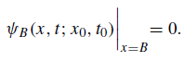

B: upstream absorbing barrier

 The forward Fokker–Planck equation



 Boundary condition:



is found to be

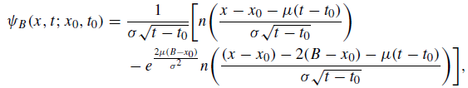



* **First Passage Time Density Functions**

The density function of the first passagetime *Q(u*; *m)*

m: the downstream barrier

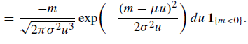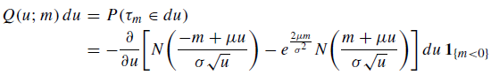

The density function of the first passagetime *Q(u*; *M)*

M: the upstream barrier



The density function of the first passagetime *Q(u*; *B)*



B: the barrier level (upstream ( ) or downstream (  )

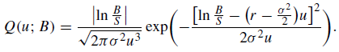

The expected present value of the rebate



*R(t)* :rebate payment

[*u, u*+*du*] : the time interval

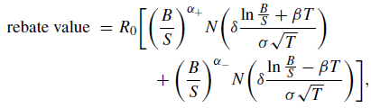 When *R(t)* = *R*0, a constant value. Then,

Where

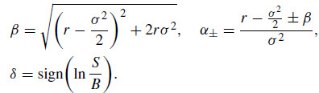

(downstream *(δ* = 1*)* or upstream *(δ* = −1*)*)

1. Options with Double Barriers

 The expanding pricing methodologies is Double Barrier. The following first passage times of the asset price process *St* can be

*U* upstream barrier

*L* downstream barrier

Three mutually exclusive events:

1. The upper barrier is first reached
2. The lower barrier is first reached

(iii) Neither of the two barriers is reached

Most double barrier options can be priced using the density functions:

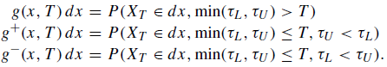

The option’s life [0, T]. *St* is a Geometric Brownian process.

so that , drift rate and variance rate

**Density Functions of Brownian processes with Two-Sided Barriers**

Let *g(x, t* ; *l, u)* the density function

*x* = *l* and *x* = *u* two-sided absorbing barriers ; l < 0 < u



the restricted Brownian process

The partial differential equation formulation for *g(x, t* ; *l, u)*

With auxiliary condition: 

Defining the transformation





satisfies the forward Fokker–Planck equation with zero drift:



The solution to *g(x, t)* is deduced to be

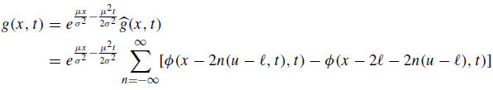

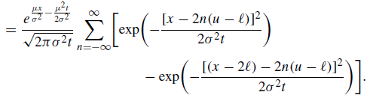

The density function of the first passage time to either barrier



Where



We deduce that

The probability flow by



The exit time densities and are seen to satisfy

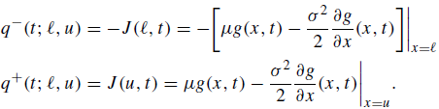

The value of the rebate portion of the double-barrier option



1. Discretely Monitored Barrier Options

We would expect that discrete monitoring would lower the cost of knock-in options but raise the cost of knockout options, when compared to their counterparts with continuous monitoring.

The price of a discretely monitored barrier option

B : constant barrier

V(B) : the price of a continuously monitored barrier option



*ξ*  : the Riemann zeta function

*σ*  : the volatility

Sign “+” : B > S

Sign “-” : B < S