Intro
This is the intro text.

Chapter 1
Welcome to chapter 1

Subsection in Chapter 1
This is a subsection in chapter 1

A | B | C | D
1 | 2 | 3 | 4

Chapter 2
Welcome to chapter 2

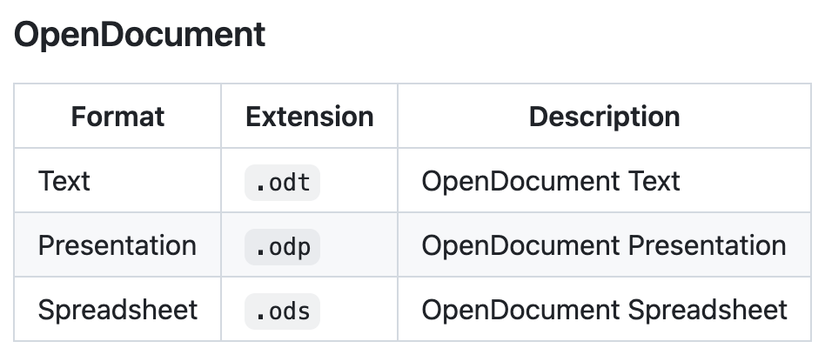
Subsection in Chapter 2
This is a subsection in chapter 2

