University of Greenwich
COMP1841 (2025/26) — Web Programming 1
Coursework Report: Student Question and Answer System
Student Name: Bùi Minh Thông
Module: COMP1841 (2025/26)
Word Count: 1,930 words
Github link: https://github.com/thonv7776/CW_WEB1_BuiMinhThong.git

Contents
1. Introduction 3
2. System Design 3
2.1 User Interface and Navigation 3
2.2 Database Design 3
3. Technologies Used 4
4. Legal, Social and Ethical Considerations 5
4.1 Personal Data and GDPR 5
4.2 GDPR After Brexit 5
4.3 Web Accessibility 5
4.4 Ethical Considerations 5
5. System Overview and Basic Functions 6
Display Questions Anyone can see the list of questions on the website. 6
Create a Question (Add) Logged-in students can ask a new question. 7
Update a Question (Edit) Students can edit their own questions later. 9
Delete a Question (Delete) Students can remove their own questions. 10
Contact Admin 12
Manage Users and Modules (Admin CRUD) Admins can manage user accounts and modules. 14
6. Additional Features 17
6.1 Password Hashing Passwords are never saved as plain text. 17
Protected Admin Area: All admin pages use a file called require-admin.php. If a normal user tries to open an admin page, the system stops them and sends them back to the login page. 18
Two-Layer Validation Forms check for errors two times to keep data safe. 19
Self-service Account with OTP New users must verify their email address. 19
Session-based Author Tracking The system automatically knows the author's name. 22
Admin Activity Log: The database saves a record every time an admin logs in, adds, edits, or deletes data. 24
7. Testing and Evaluation 25
7.1 Test Plan 25
7.2 Evaluation 26
8. Conclusion and Future Recommendations 26
References 26

1. Introduction
This project is the Student Question and Answer System. It is a simple website for university students. Students can use this website to ask for help with their coursework and modules.
On this website, users can register, log in, post questions, and add pictures to their questions. Other students can read these questions. Administrators (admins) also have a special area. In this area, they can manage users, modules, and the contact messages sent by students.
This project was built for the COMP1841 Web Programming 1 coursework. The main technologies are HTML5, CSS3, PHP, and a MySQL database. The website follows the CRUD rule: Create, Read, Update, and Delete. This rule is used for questions, users, and modules.
The system also has basic security features. For example, passwords are hidden using encryption, login pages check every user, and all user input is checked and cleaned before it is used. These features help keep the website and its data safe.

2. System Design

2.1 User Interface and Navigation
The website has two main parts: a public site and an admin dashboard.
The public site has a Home page, a Questions page, a Contact page, a Register page, and a Login page. When a student logs in, they can go to the “Ask a Question” page. On this page, students can choose a module from a drop-down list and upload a picture. The system already knows the student's name from their login session. Because of this, a student cannot post a question using another person's name.
The admin area is completely separate from the public site. Admins must log in using a different login page. After logging in, admins can see and manage Users, Modules, and Messages. They can also see an Activity Log, which shows a history of admin actions. Normal students cannot open these admin pages.
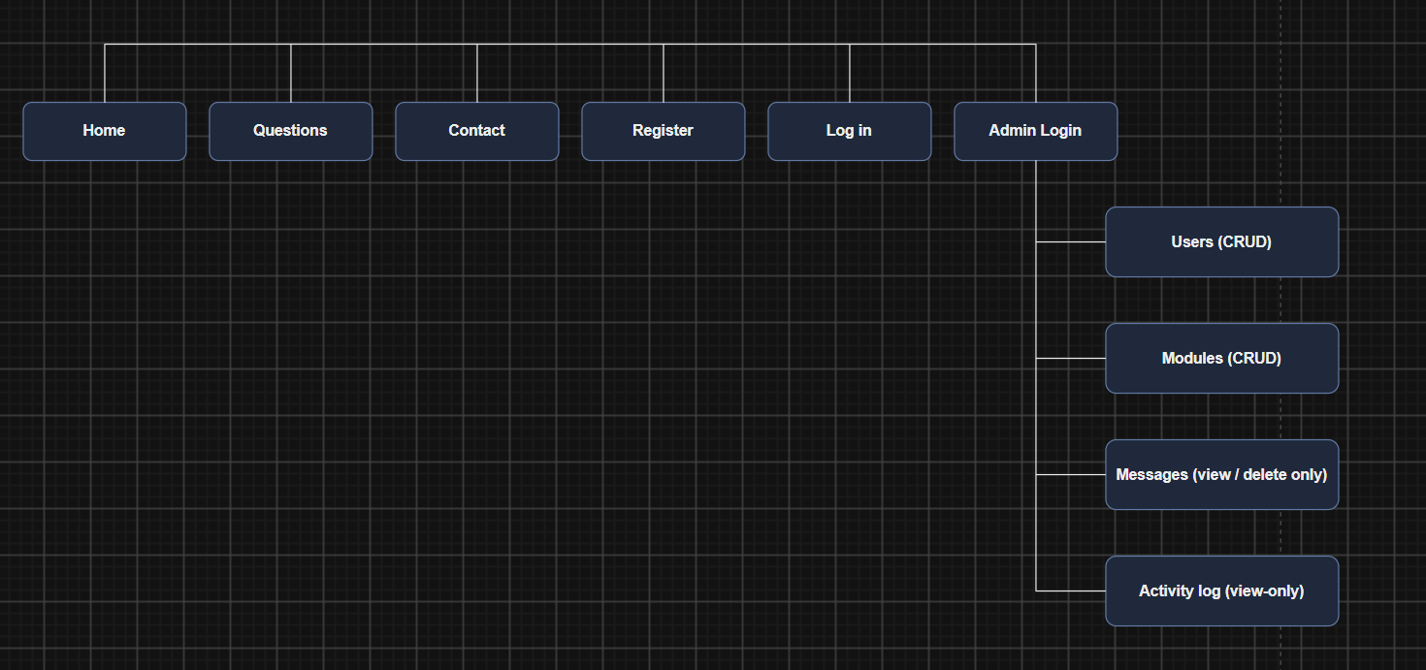
Figure 1. Navigation flow showing the public site, student area, and admin dashboard.

2.2 Database Design
The database has six tables: users, modules, questions, messages, admins, and admin_activity_log. The questions table is the most important table. It saves the question title, the content, and the image file name. It also connects to the users table and the modules table using foreign keys.
The system uses the rule “ON DELETE RESTRICT” for these foreign keys (MySQL Documentation, 2023). This rule is a safety check. It means an admin cannot delete a user or a module if that user or module still has questions connected to it. This stops broken links and missing data in the database.
The admin_activity_log table uses a different rule, called “ON DELETE SET NULL”. This means that if an admin account is deleted, the history of that admin's actions is still saved in the log. Only the admin's name is removed, not the whole record. This keeps the log complete and useful.
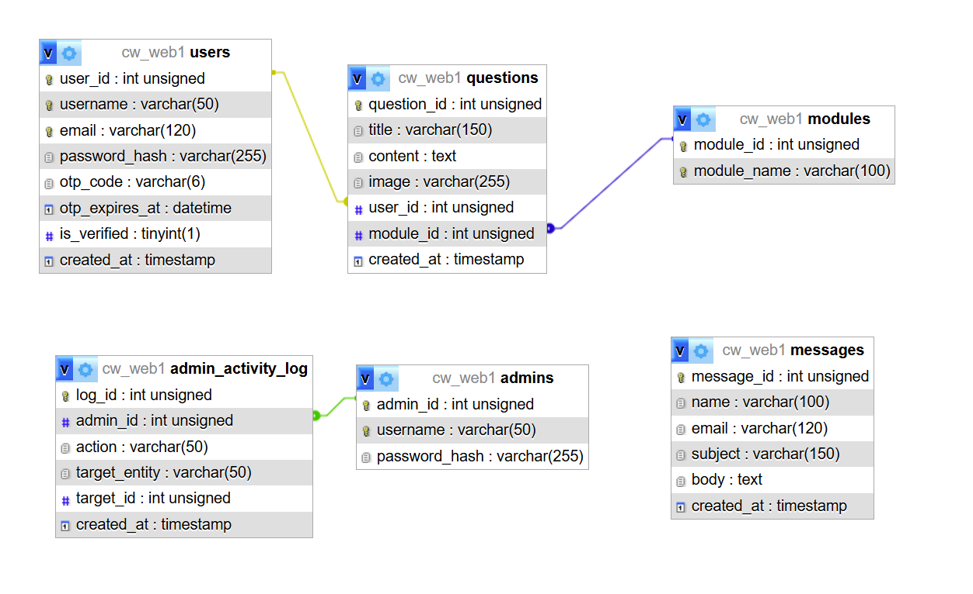
Figure 2. Database ERD showing the 6 tables and their foreign keys.

3. Technologies Used
Several web technologies were used to build this system.
HTML5 and CSS3: HTML5 was used to build the pages. Semantic tags, like <header>, <nav>, <main>, and <footer>, were used so the code is easy to read and easy for screen readers to understand. CSS3 was used to make the website look clean and simple. The CSS makes sure the website looks good on both computers and mobile phones.
PHP and PDO: PHP runs the logic on the server. To connect to the MySQL database, PHP Data Objects (PDO) was used (PHP Manual, n.d.a). MySQLi was not used anywhere in the project. PDO is a good choice because it uses Prepared Statements. Prepared Statements keep the SQL code separate from the user's input. This is the main defence against SQL Injection attacks recommended by security experts (OWASP Foundation, n.d.).
MySQL: MySQL was used to store all the data, such as users, questions, modules, and contact messages.
PHPMailer: Composer was used to add a library called PHPMailer. The normal PHP mail() function is not very reliable. PHPMailer is a better choice. It sends emails, such as OTP verification codes, safely using an SMTP server and a secure, encrypted connection.

4. Legal, Social and Ethical Considerations

4.1 Personal Data and GDPR
This website collects personal data. This data includes usernames, email addresses, and passwords. By law, this data must be kept safe and private. This rule is explained in the General Data Protection Regulation (GDPR).
The system follows the GDPR rule of “data minimisation” (ICO, n.d.). This rule says a website should only collect the data it really needs. Because of this rule, the system does not ask for phone numbers or home addresses. It only asks for a username, an email address, and a password.
Passwords are never saved as plain text. The password_hash() function in PHP is used to encrypt every password (PHP Manual, n.d.b). This function uses a strong method called bcrypt. If a hacker steals the database, the hacker still cannot read the real passwords.
GDPR also gives users the “right to erasure” (ICO, n.d.). This means a user can ask for their personal data to be deleted. In this system, an admin can delete a user account. However, the database also protects data using foreign keys. If a user still has questions on the website, the deletion is blocked. This shows a small conflict between two goals: the right to erasure, and the need to keep question data connected and correct. In a bigger, real-world system, this could be solved by deleting the user's questions first, or by keeping the questions but hiding the deleted user's name.

4.2 GDPR After Brexit
Before Brexit, the United Kingdom (UK) followed the European Union's GDPR law directly. After Brexit, the UK created its own version of this law, called “UK GDPR”. This law works together with the Data Protection Act 2018 (Great Britain, 2018).
The rules for keeping personal data safe are almost the same as before Brexit. The main difference is who manages the rules. Now, the Information Commissioner's Office (ICO) in the UK manages and enforces UK GDPR (ICO, n.d.). Organisations that send UK personal data to other countries must also follow extra rules, unless that country has an official “adequacy decision” from the UK government.
Because this project was built and would be hosted in the UK, it follows UK GDPR. This helps make sure student data, such as emails and passwords, stays safe and private.

4.3 Web Accessibility
A website must be easy to use for everyone, including people with disabilities. This system follows ideas from the Web Content Accessibility Guidelines (WCAG) (W3C, n.d.).
Several accessibility features were added to the system. Every image has alt text, so screen readers can describe pictures to blind users. All form fields use a proper <label> tag, so screen reader users know what information to type. A “skip to main content” link was also added. This lets keyboard users jump straight to the page content, without needing to move through the whole menu first.
The navigation menu also shows the current page clearly, using an aria-current attribute. This helps users understand where they are on the website. Error messages use an aria-live region, so screen readers announce the error immediately, without the user needing to search for it.

4.4 Ethical Considerations
Admins have a lot of power over student data. This power comes with responsibility. Ethically, admins should only use student emails and messages to give support, for example, replying to a message sent through the Contact form. Admins must never sell, share, or misuse this data.
The system also keeps an Activity Log. This log records every action an admin makes, such as adding, editing, or deleting data. This is good for accountability. If something goes wrong, the website owner can check the log to see which admin made the change, and when. This builds trust between the students and the people who manage the system.

5. System Overview and Basic Functions
The system has all the basic functions required by the coursework. Each function is explained below with its operation steps.

Display Questions Anyone can see the list of questions on the website.
- Step 1: The user opens the website homepage.
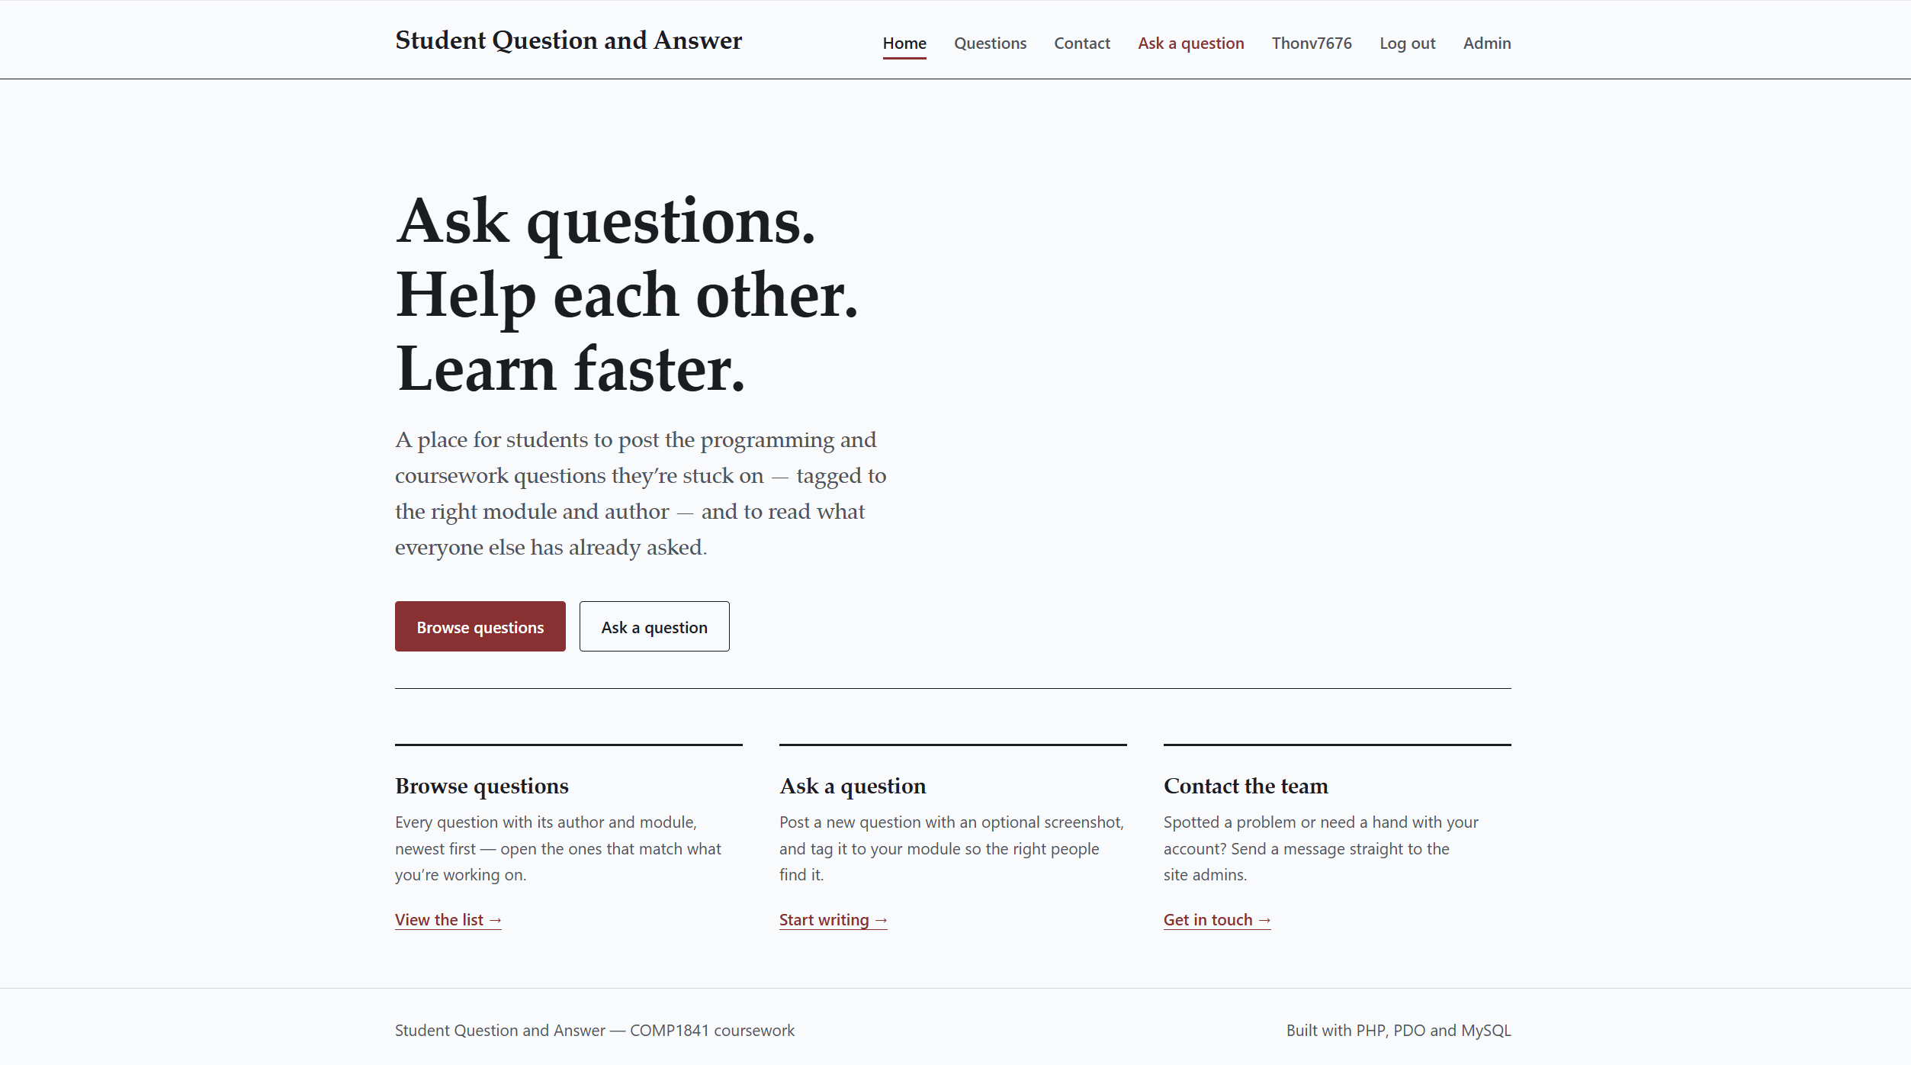
- Step 2: The user clicks the "Questions" link on the top menu.
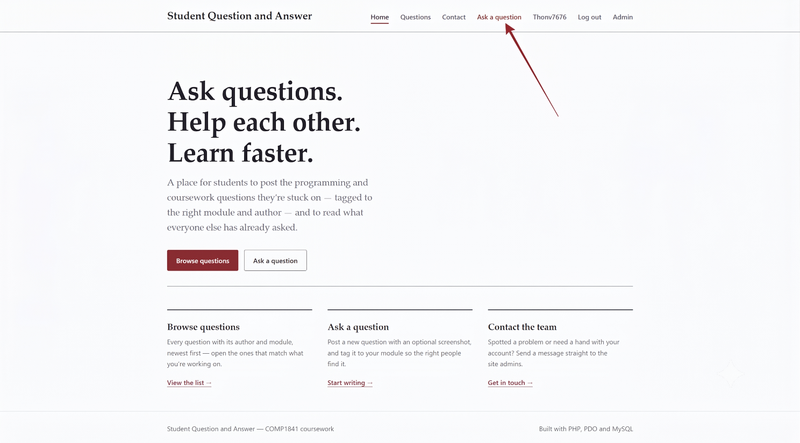

- Step 3: The system loads the data and shows all questions. Each question shows the author's name, the module, the date, and a picture.
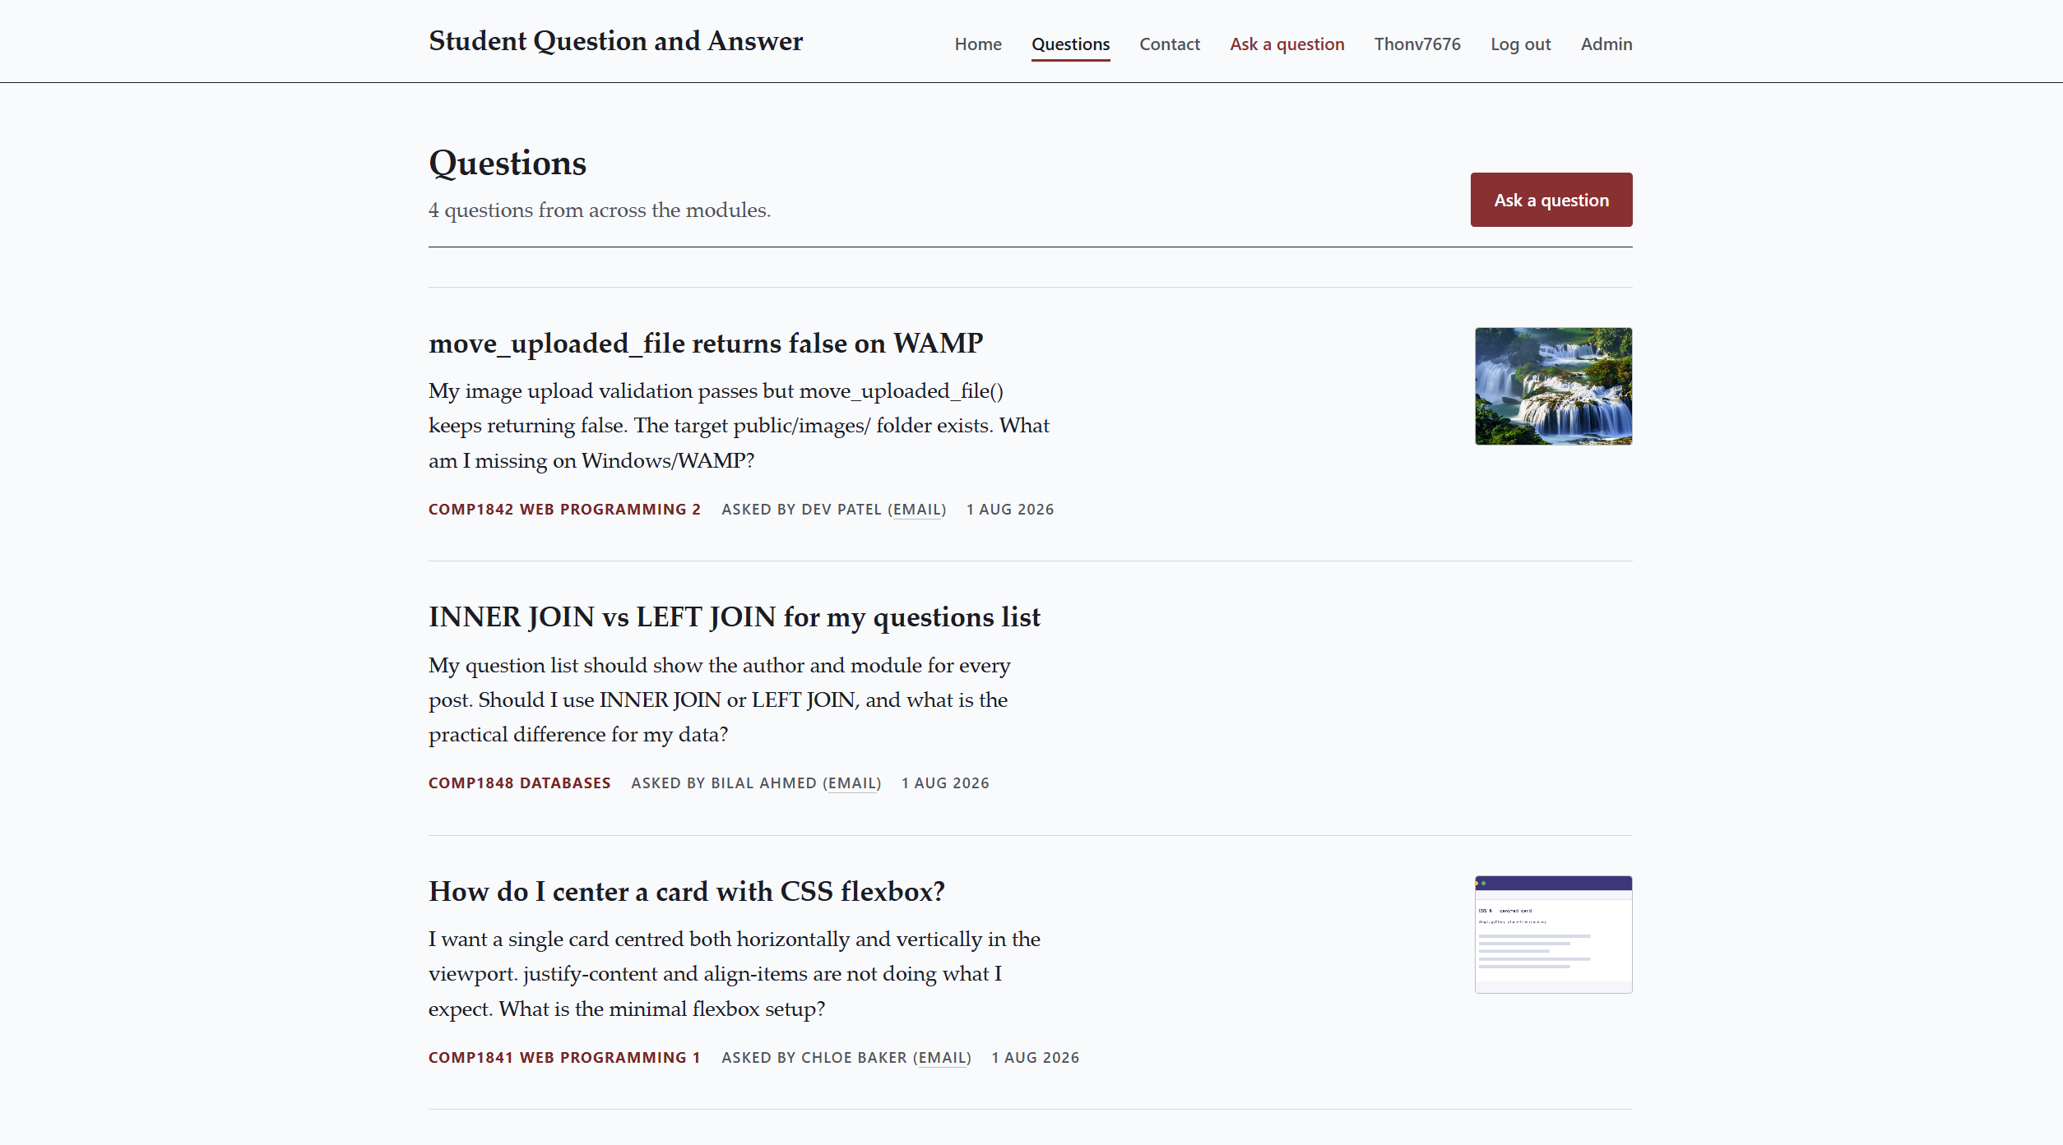

Create a Question (Add) Logged-in students can ask a new question.
- Step 1: The user opens the empty "Ask a question" form.
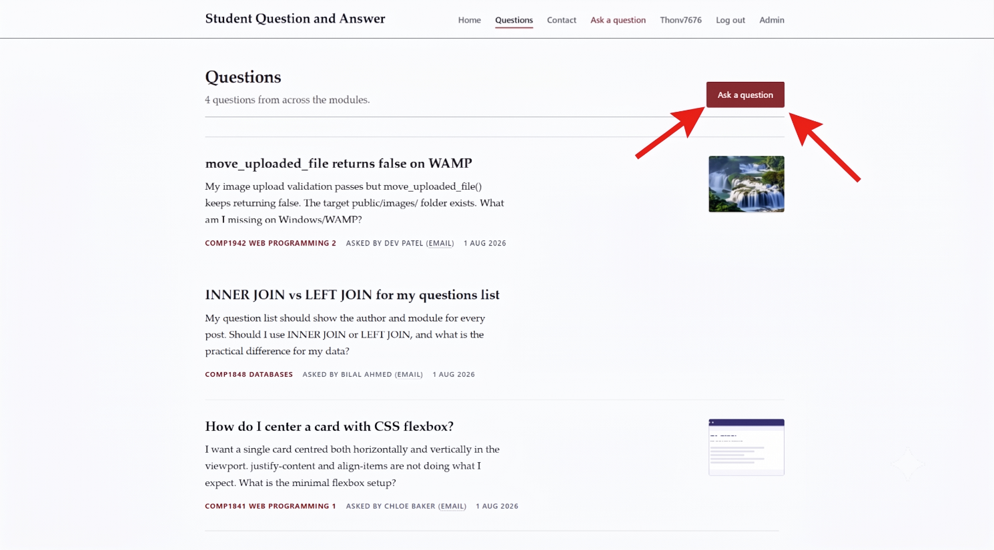

- Step 2: The user types the title, types the content, selects a module from the drop-down list, and chooses a picture file.

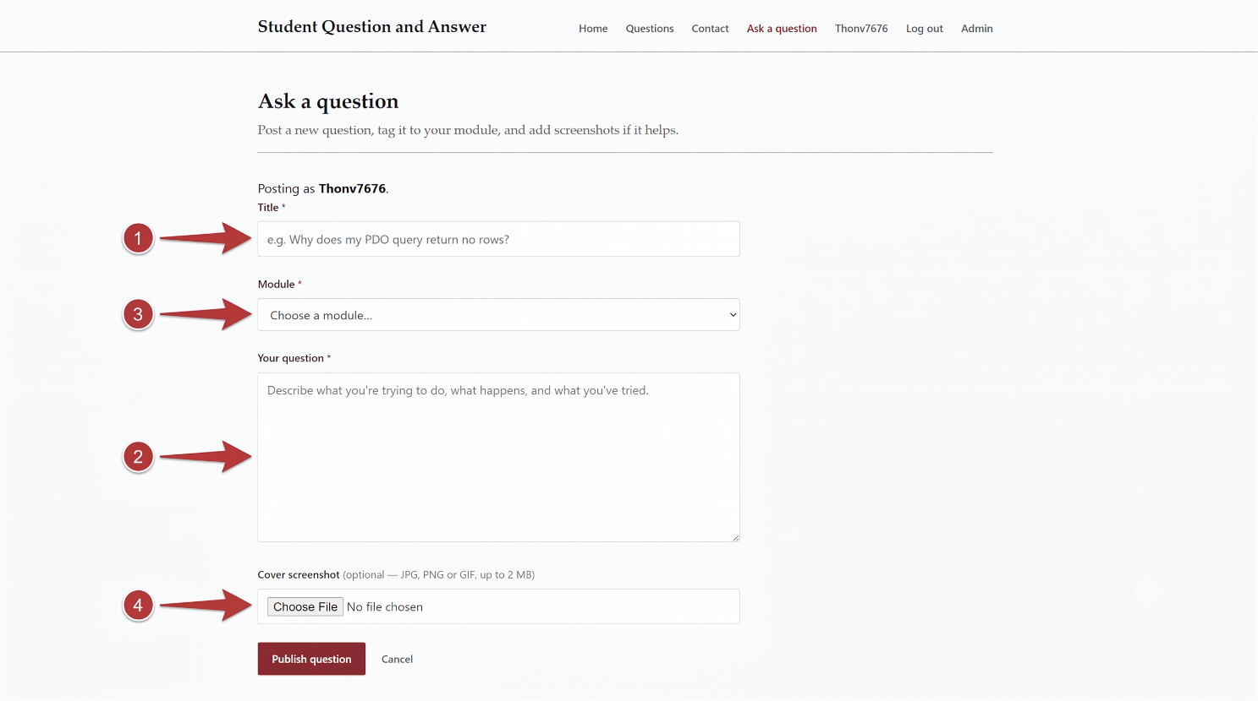

- Step 3: The user clicks the "Publish" button. The new question appears at the top of the questions list.
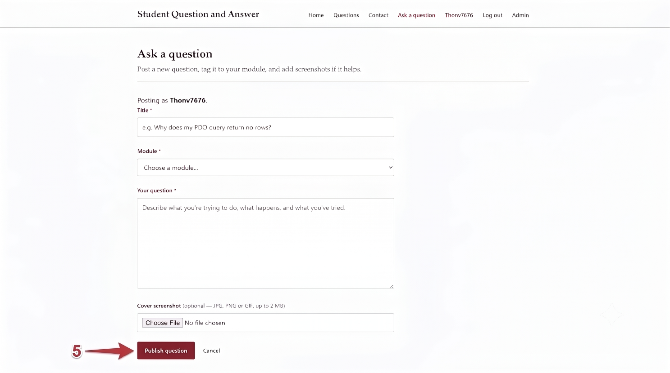

Update a Question (Edit) Students can edit their own questions later.
- Step 1: The user finds their own question in the list and clicks the "Edit" button.
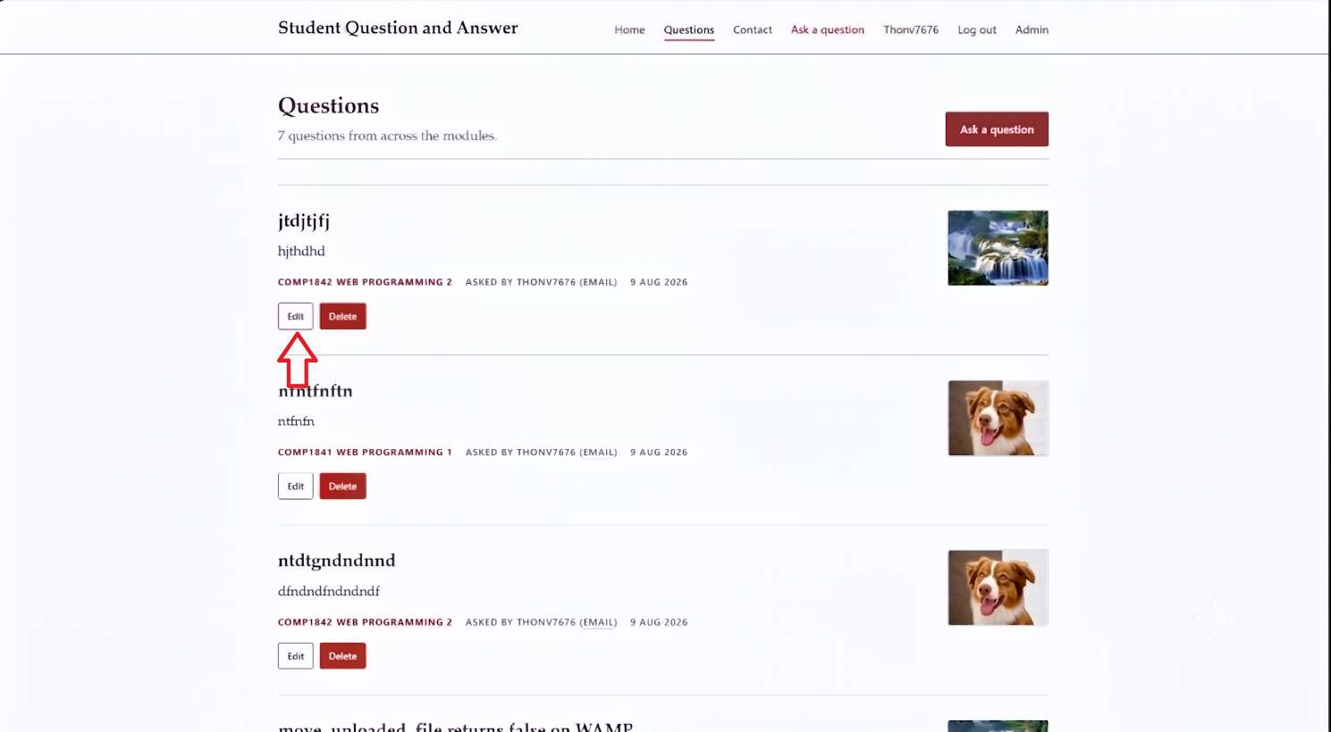
- Step 2: The edit form opens. The user changes the old text to new text.
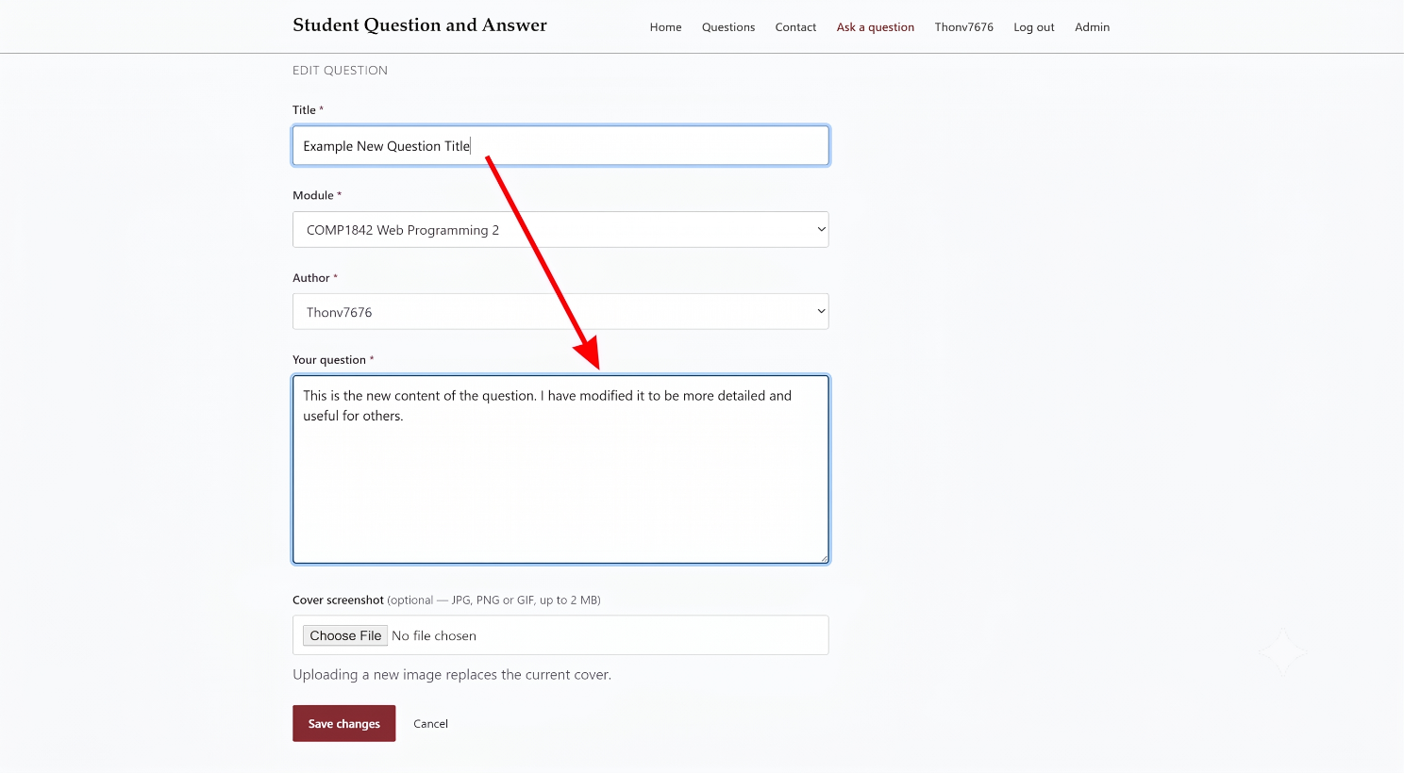

- Step 3: The user clicks save. The question list now shows the updated text.
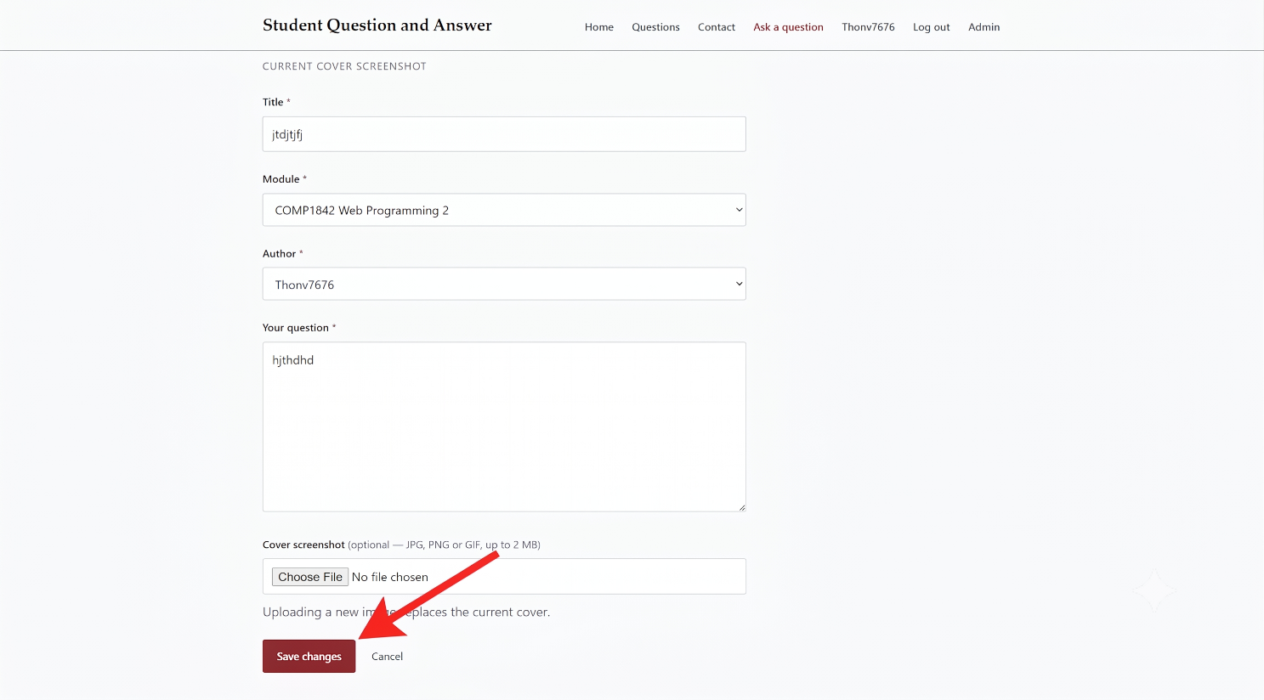

Delete a Question (Delete) Students can remove their own questions.
Step 1: The user finds their own question in the list and sees the "Delete" button.
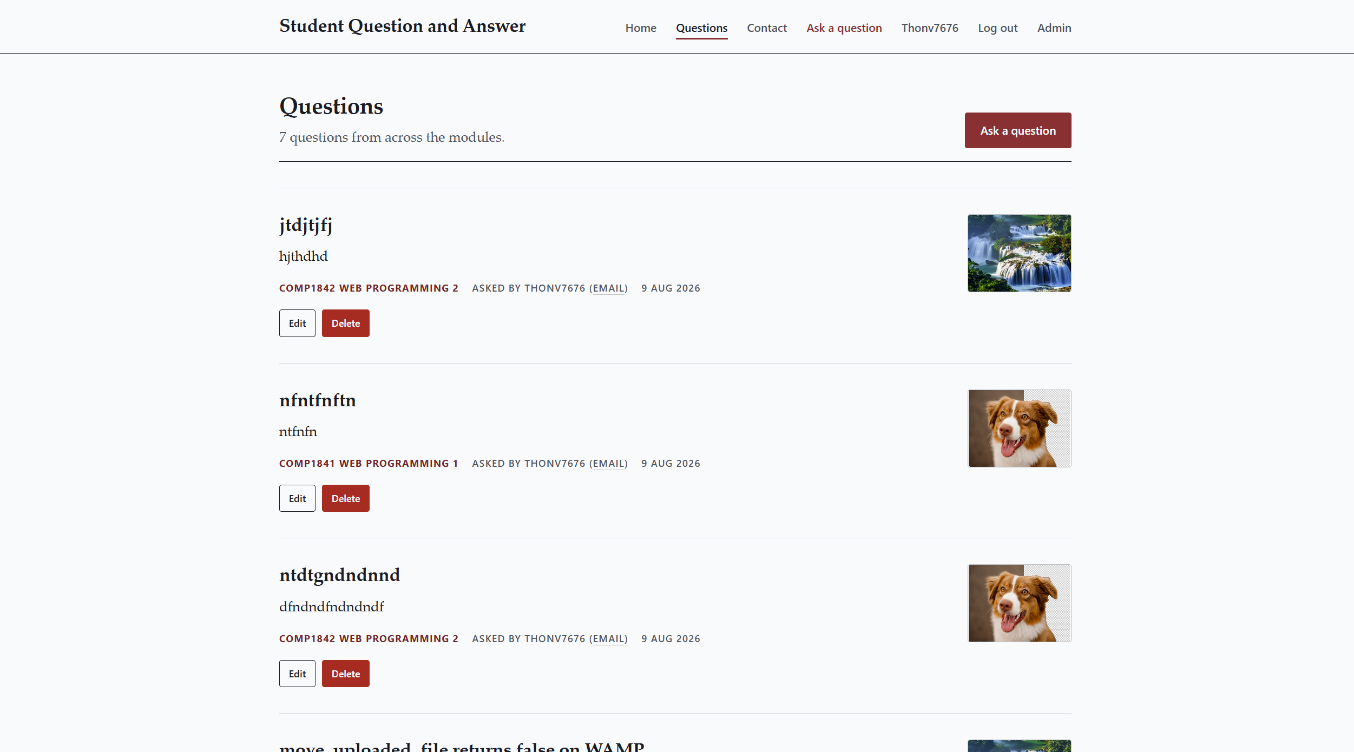

Step 2: The user clicks the "Delete" button to remove the post.
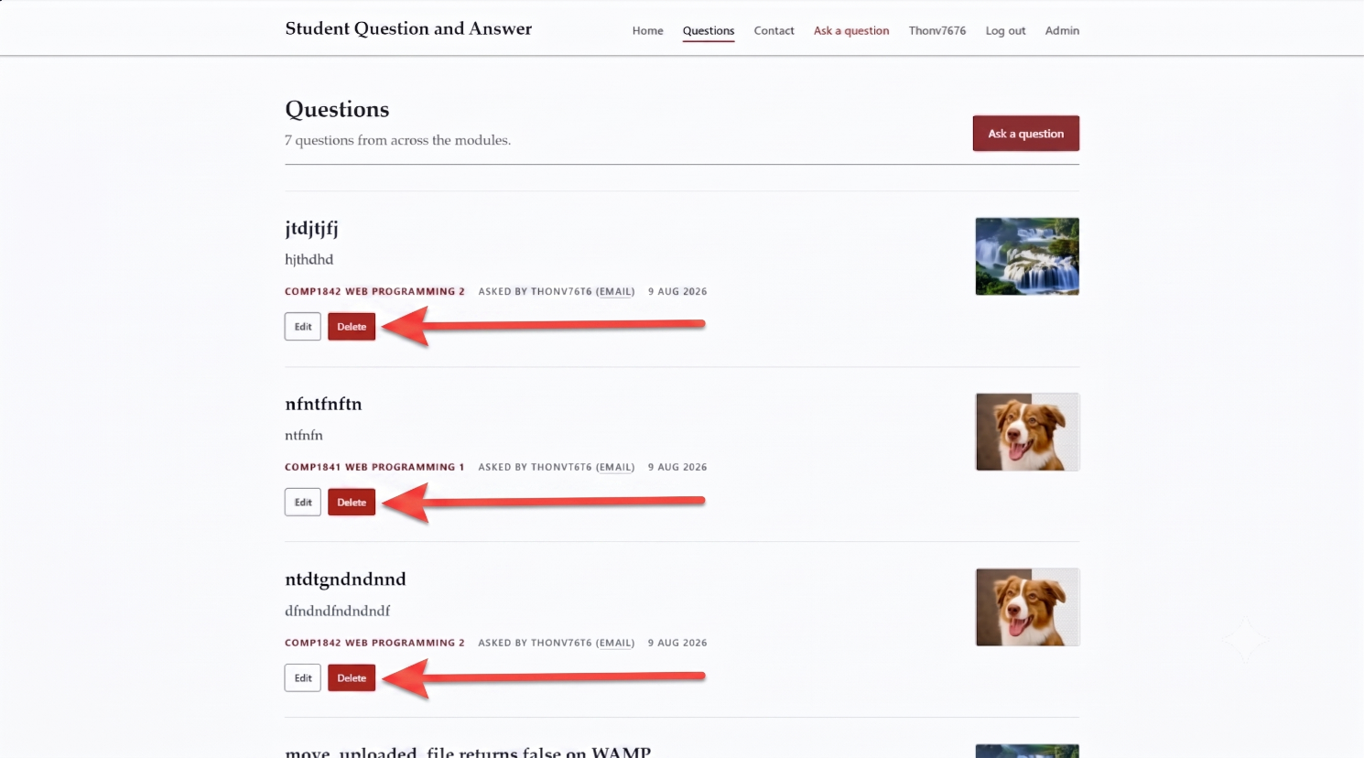
Step 3: The system deletes the data. The question is no longer shown on the website.
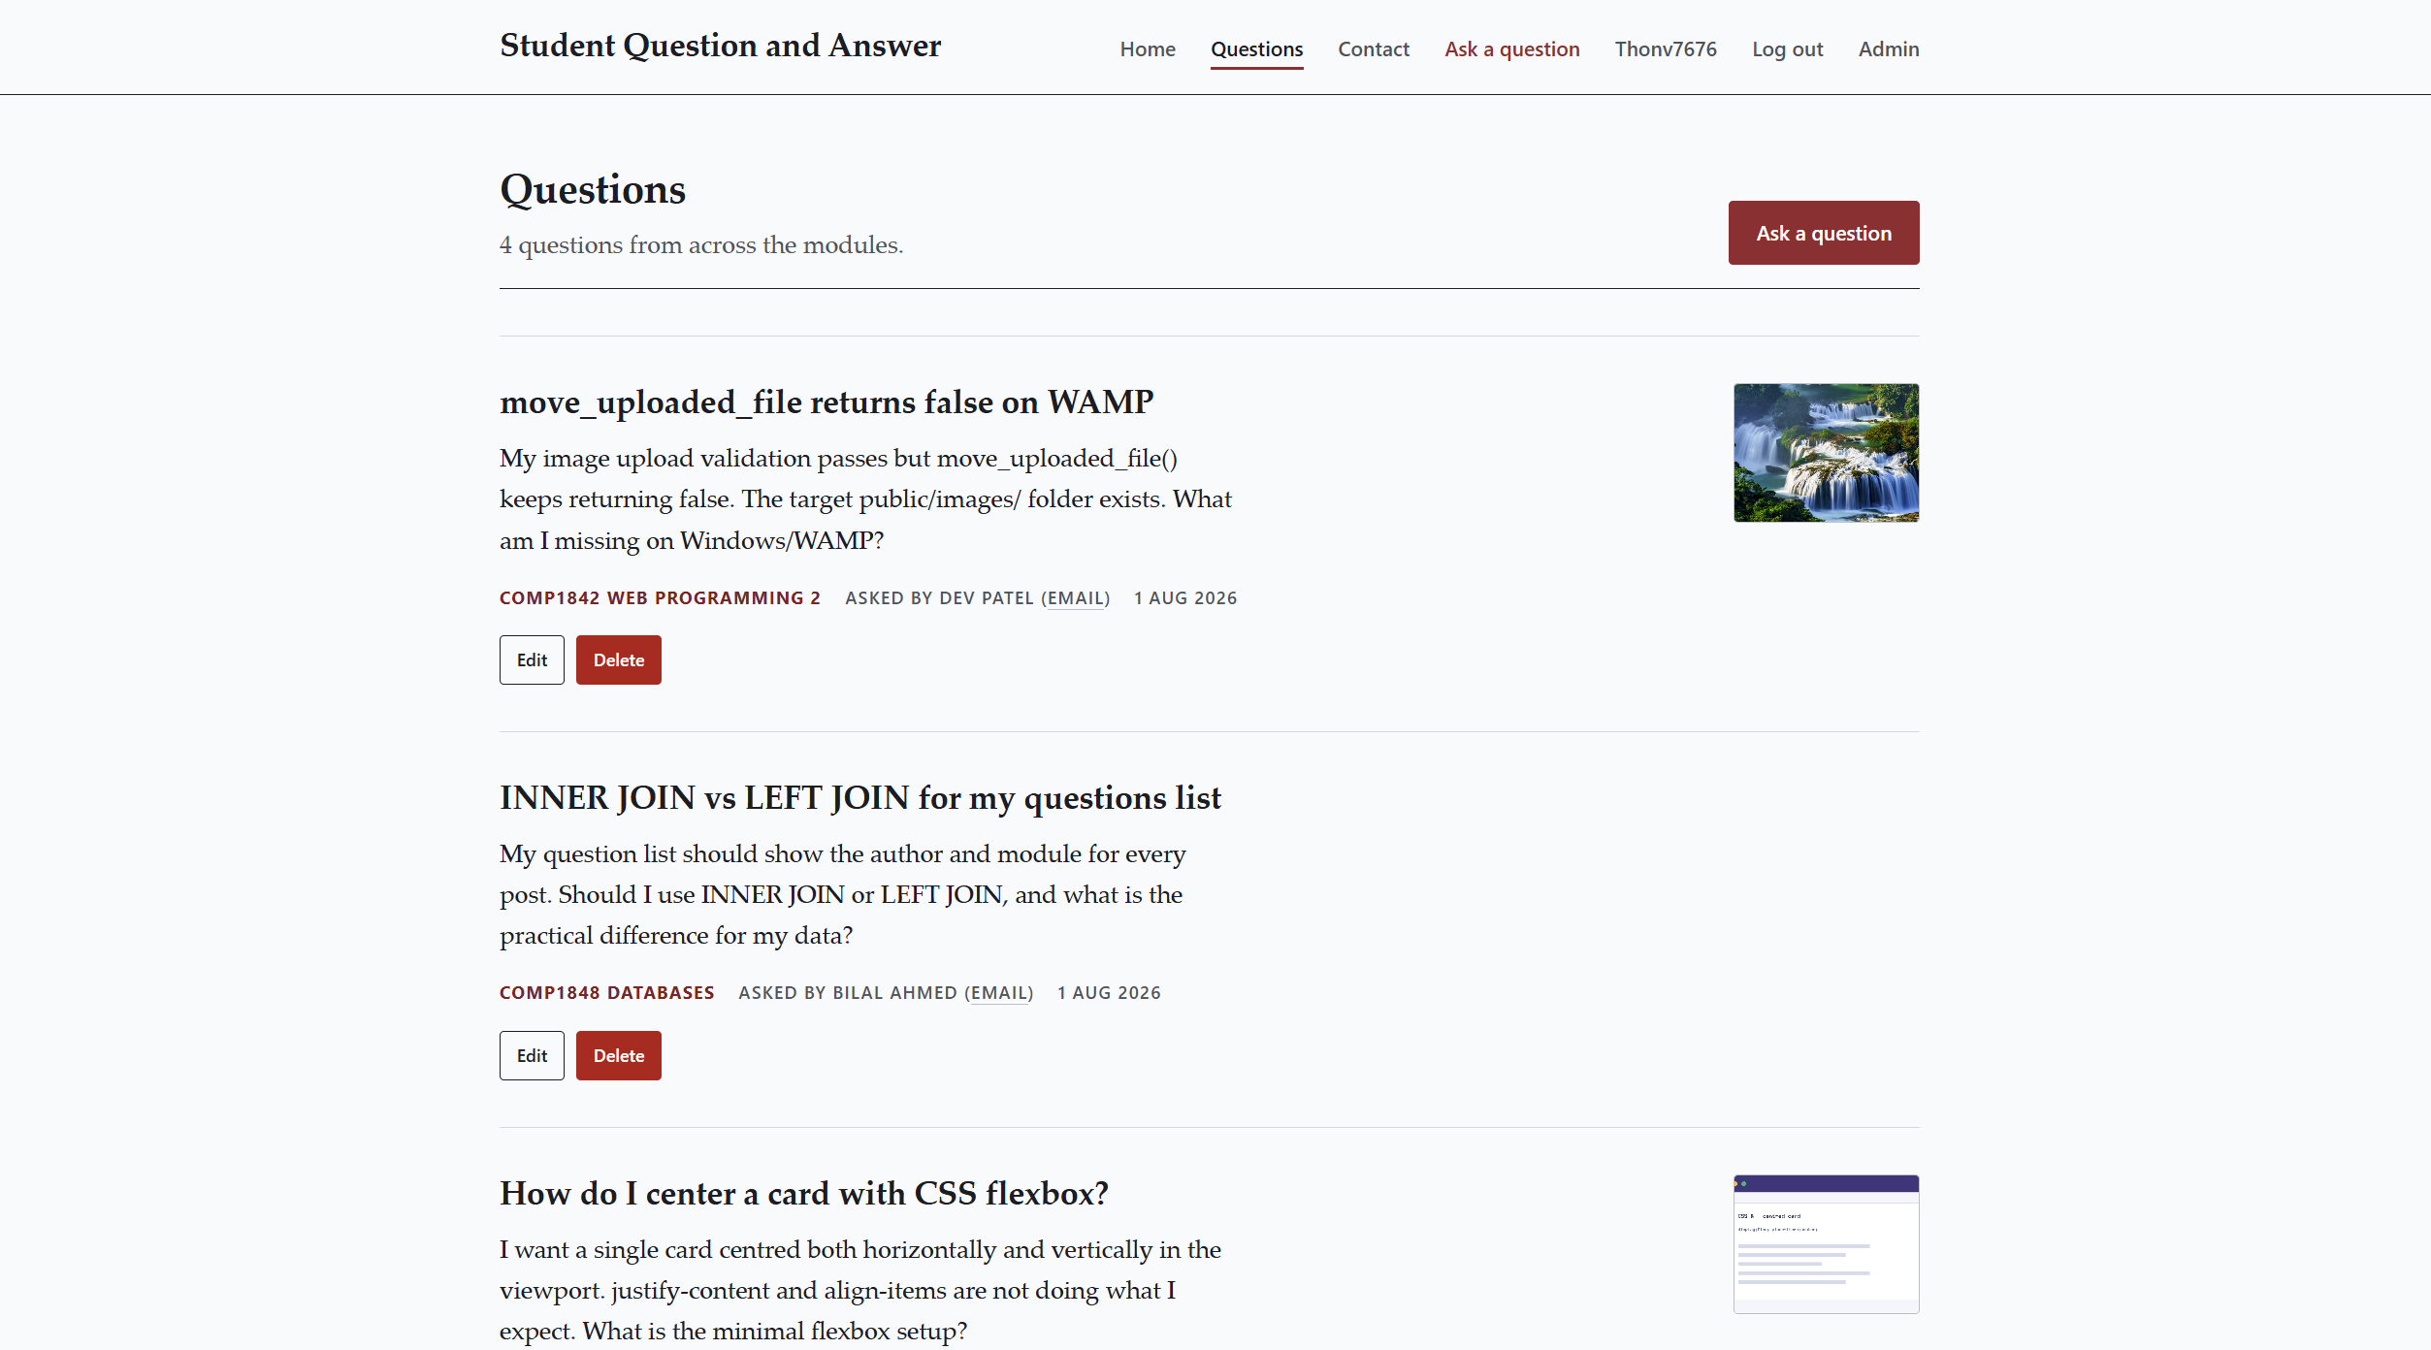

Contact Admin
Users can send messages to the system admins.
- Step 1: The user opens the Contact page and sees an empty form.
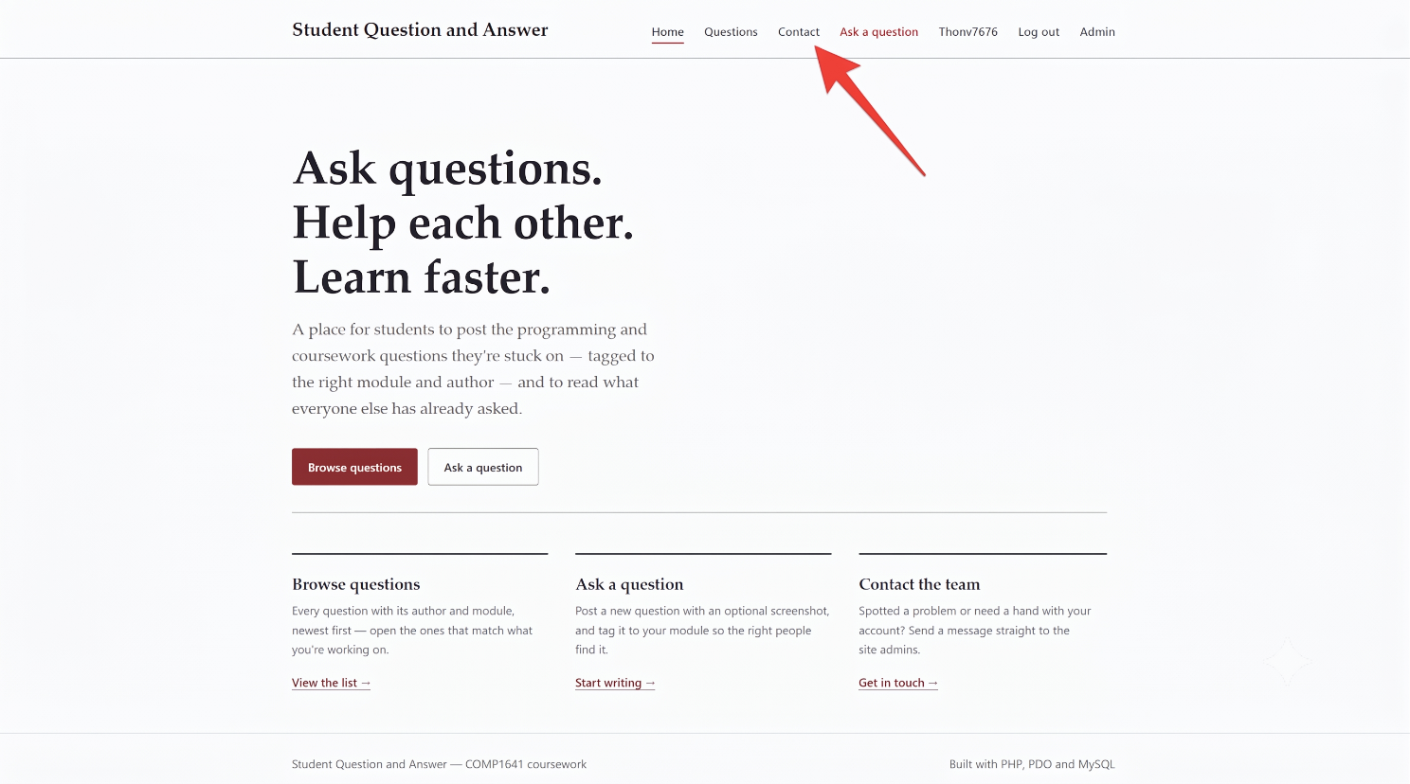

- Step 2: The user types their name, email, subject, and message.
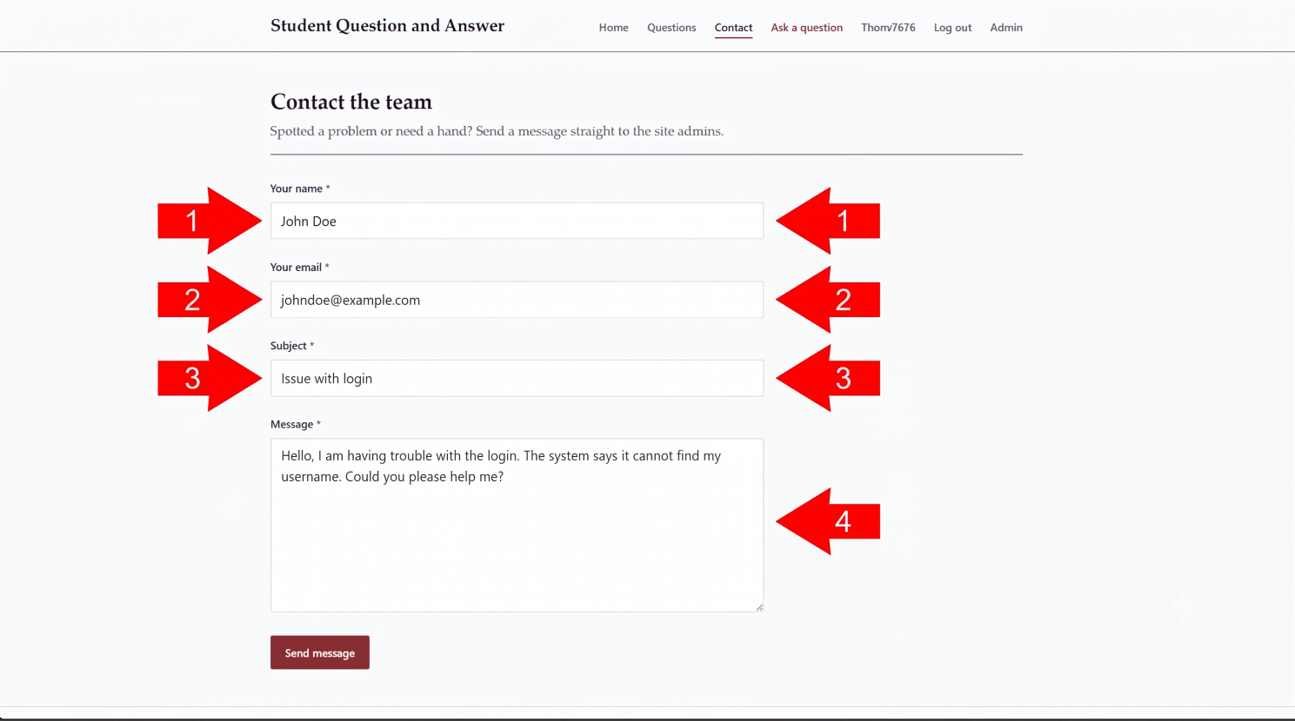

- Step 3: The user clicks send. The message is saved, and admins can read it in the admin dashboard.
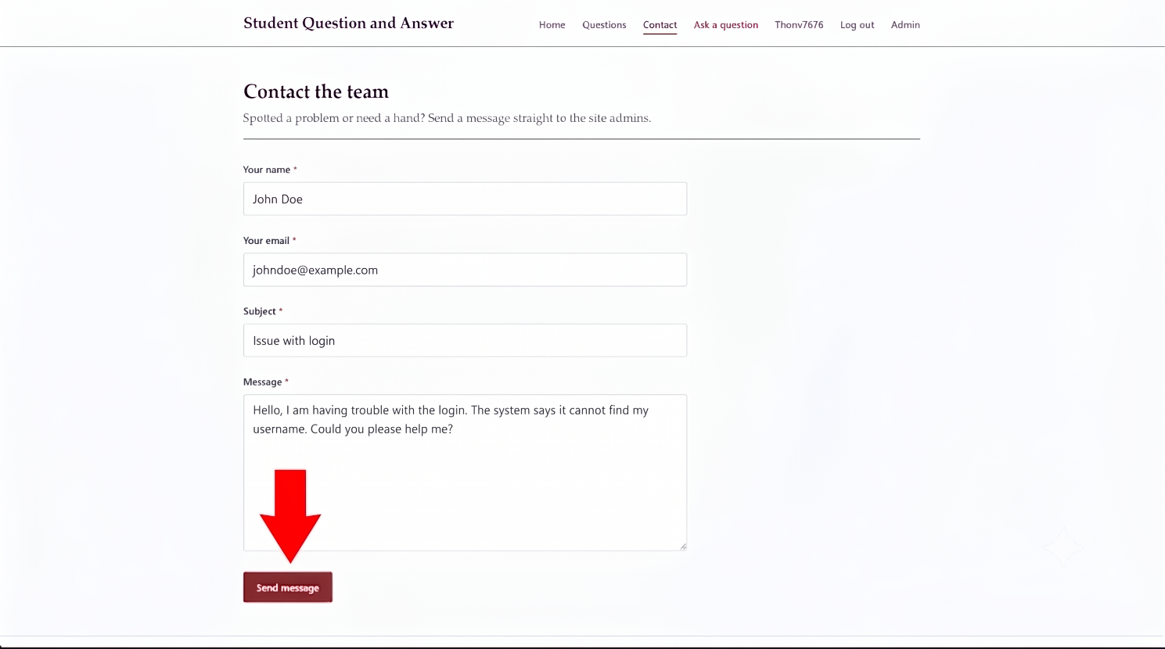

- Step 4: The result show in admins can read it in the admin dashboard.

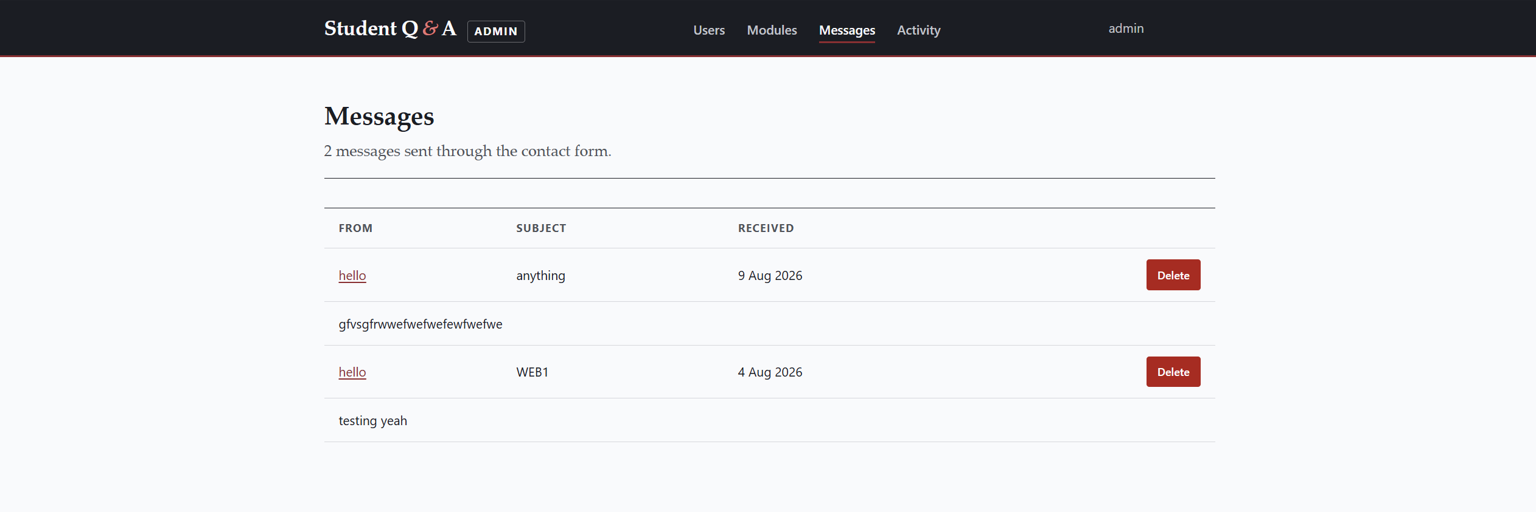

Manage Users and Modules (Admin CRUD) Admins can manage user accounts and modules.
- Step 1: The admin opens the Users or Modules management page to see the current list.
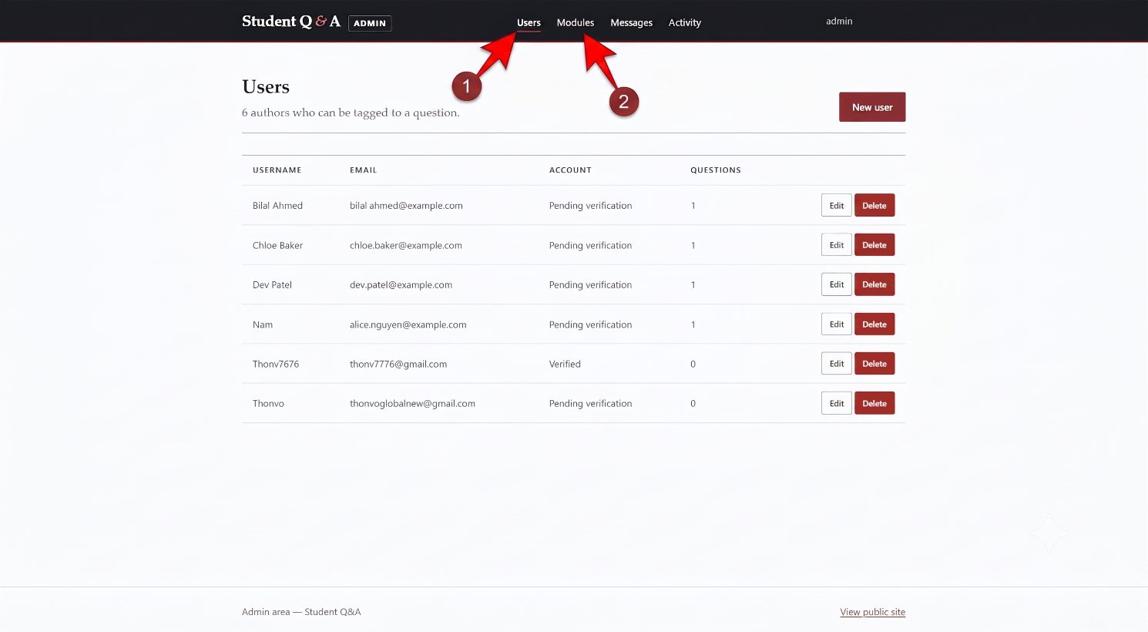

- Step 2: The admin clicks "Add new" and types the new information into the form.
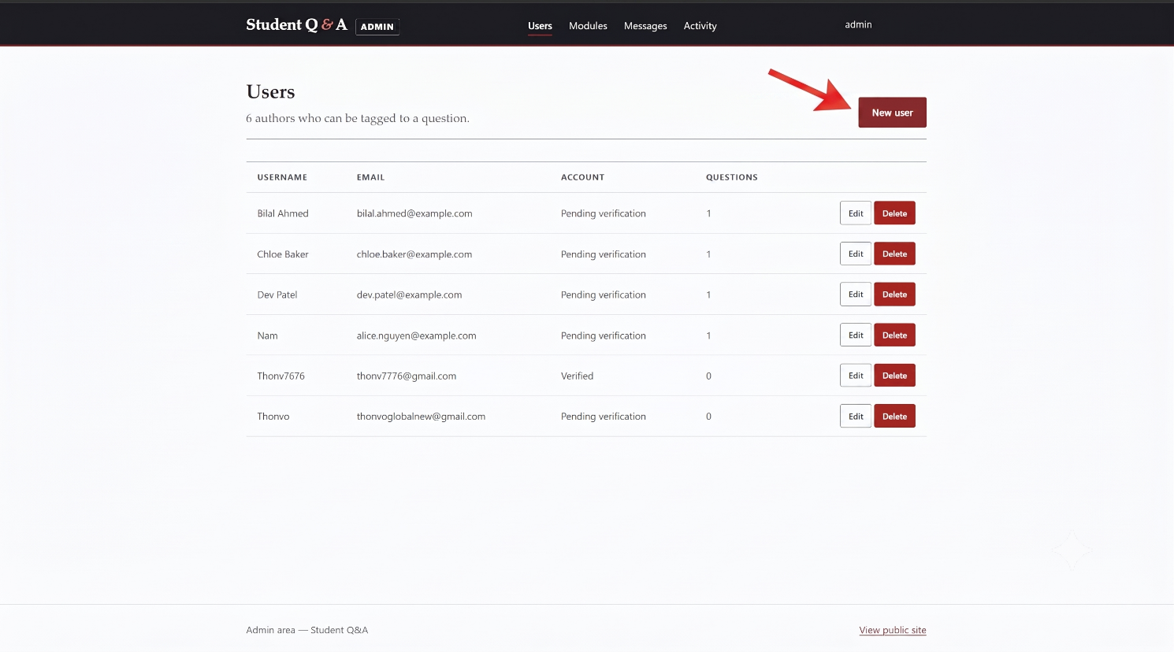
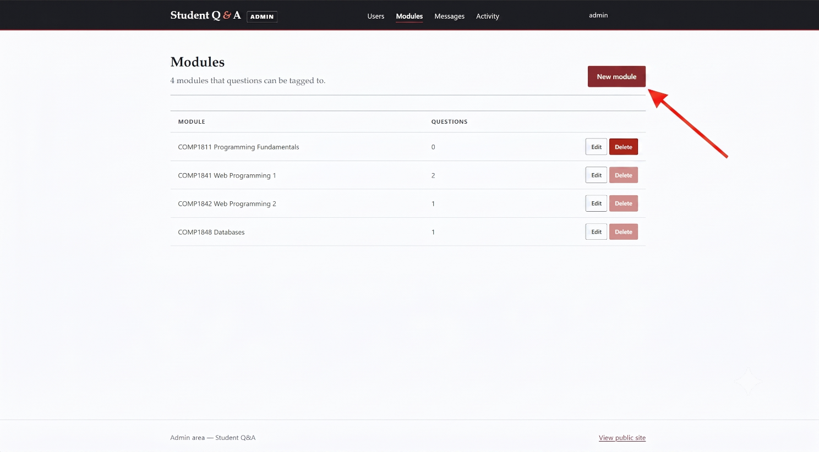

- Step 3: The admin saves the form. The system updates the list with the new data.
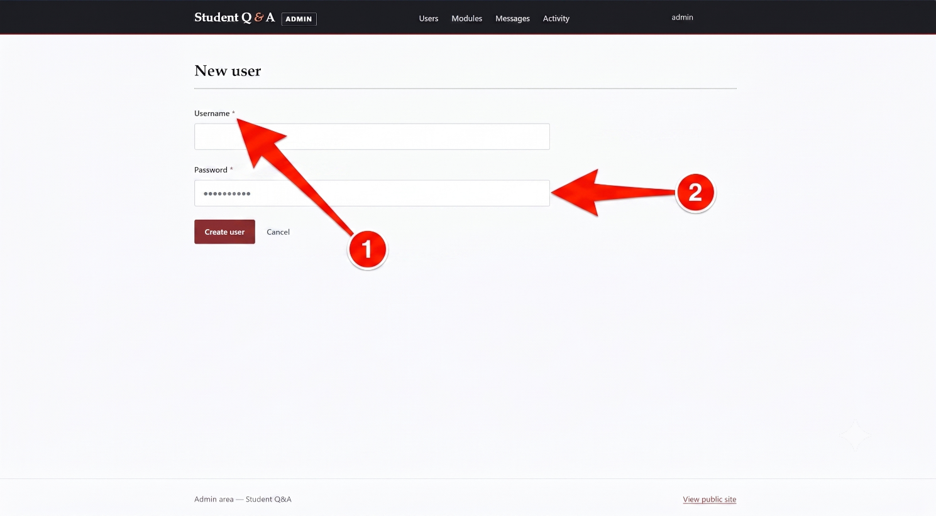
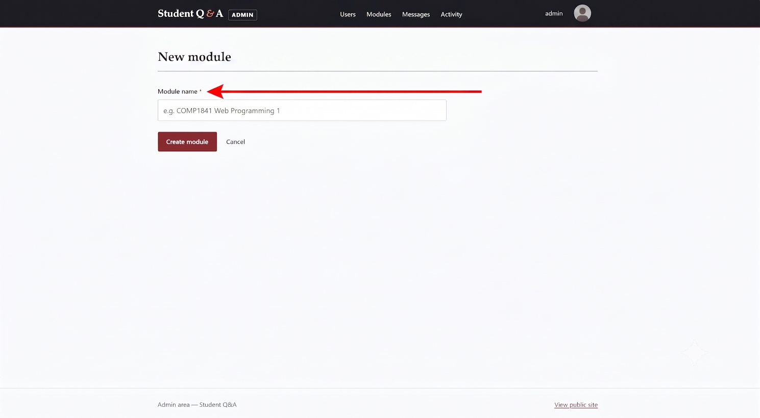
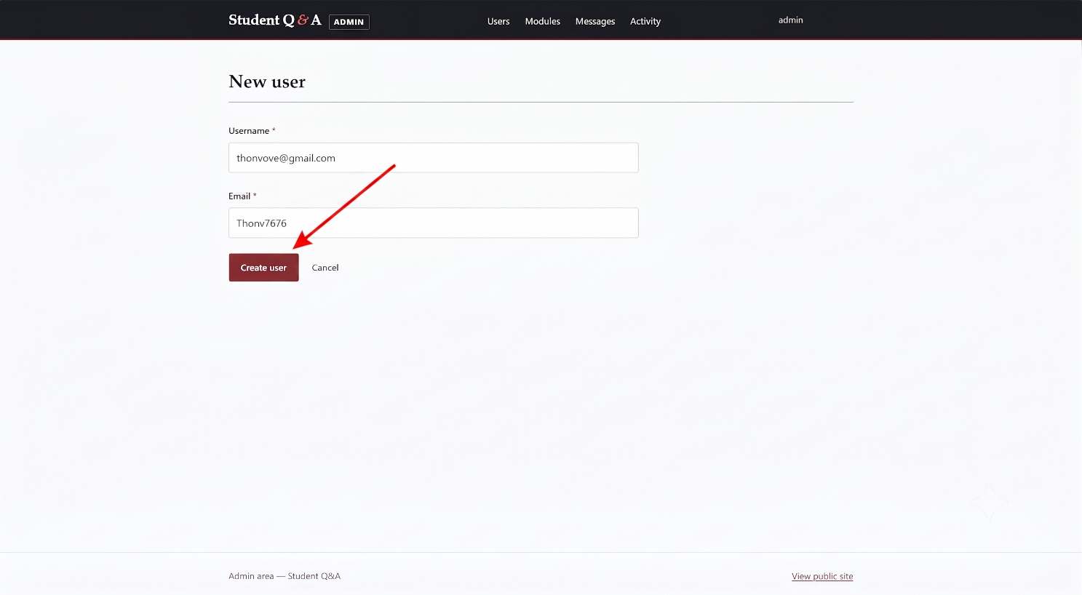
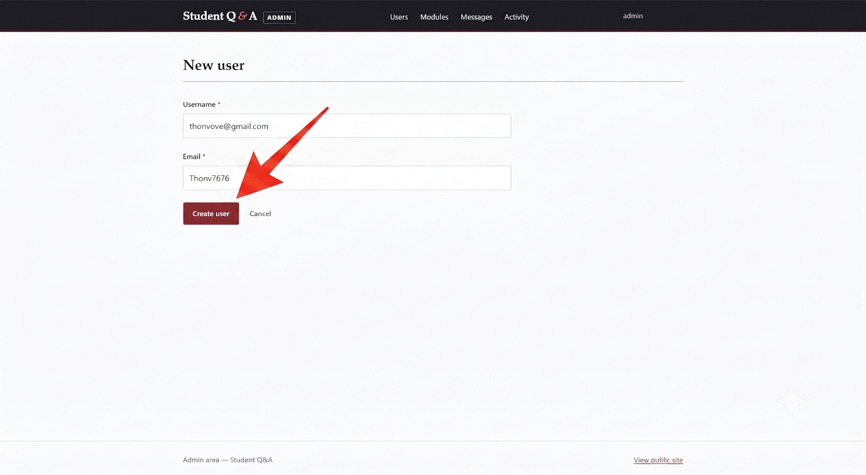

6. Additional Features
To make the system better than the basic requirements, six extra features were added. A screenshot of each feature is shown below.

6.1 Password Hashing Passwords are never saved as plain text.
- Step 1: A user types a normal password (for example, "12345678") in the register form.
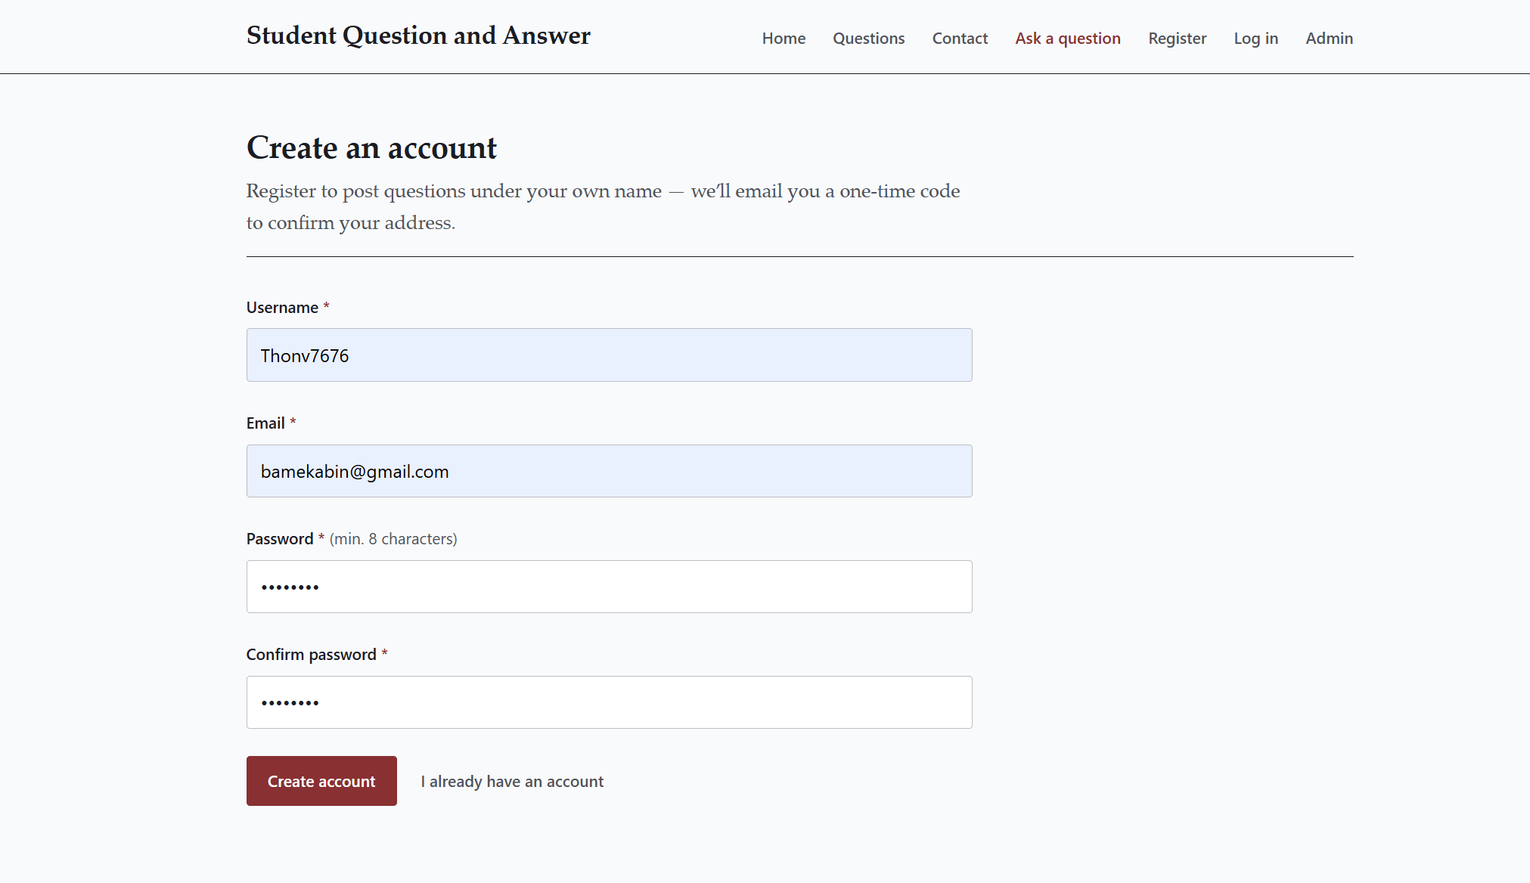
- Step 2: The system receives the password and uses the password_hash() function to encrypt it.
- Step 3: The database stores a long, mixed text string (hash) instead of the real password.

Protected Admin Area: All admin pages use a file called require-admin.php. If a normal user tries to open an admin page, the system stops them and sends them back to the login page.
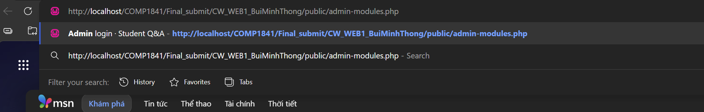
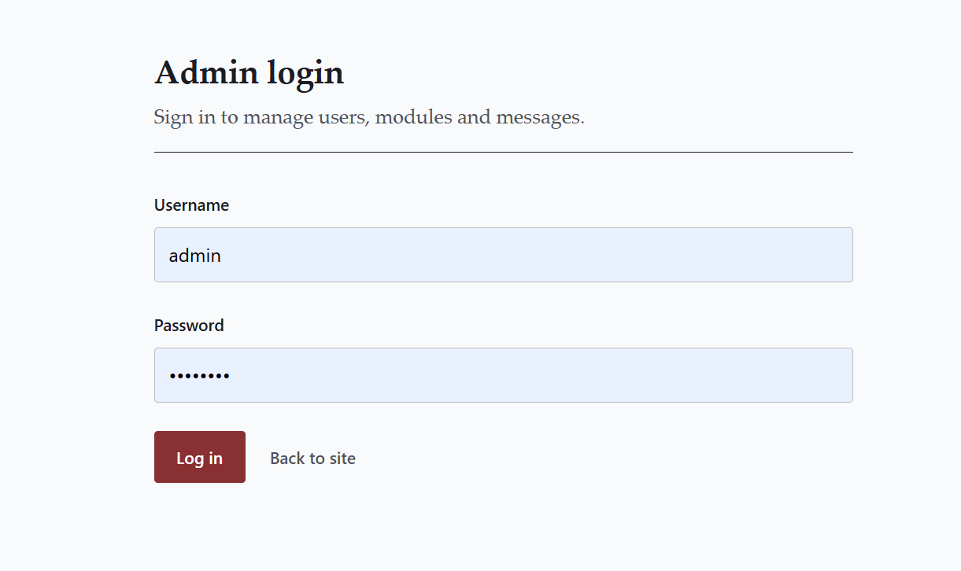

Two-Layer Validation Forms check for errors two times to keep data safe.
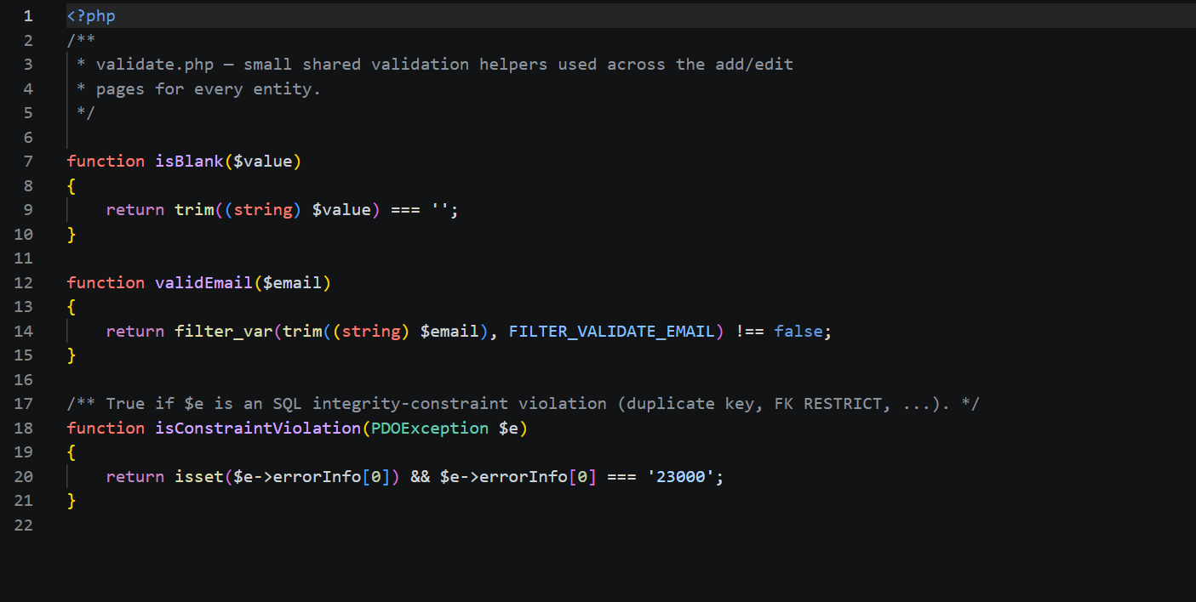

Self-service Account with OTP New users must verify their email address.
- Step 1: The user submits the registration form with their email address.
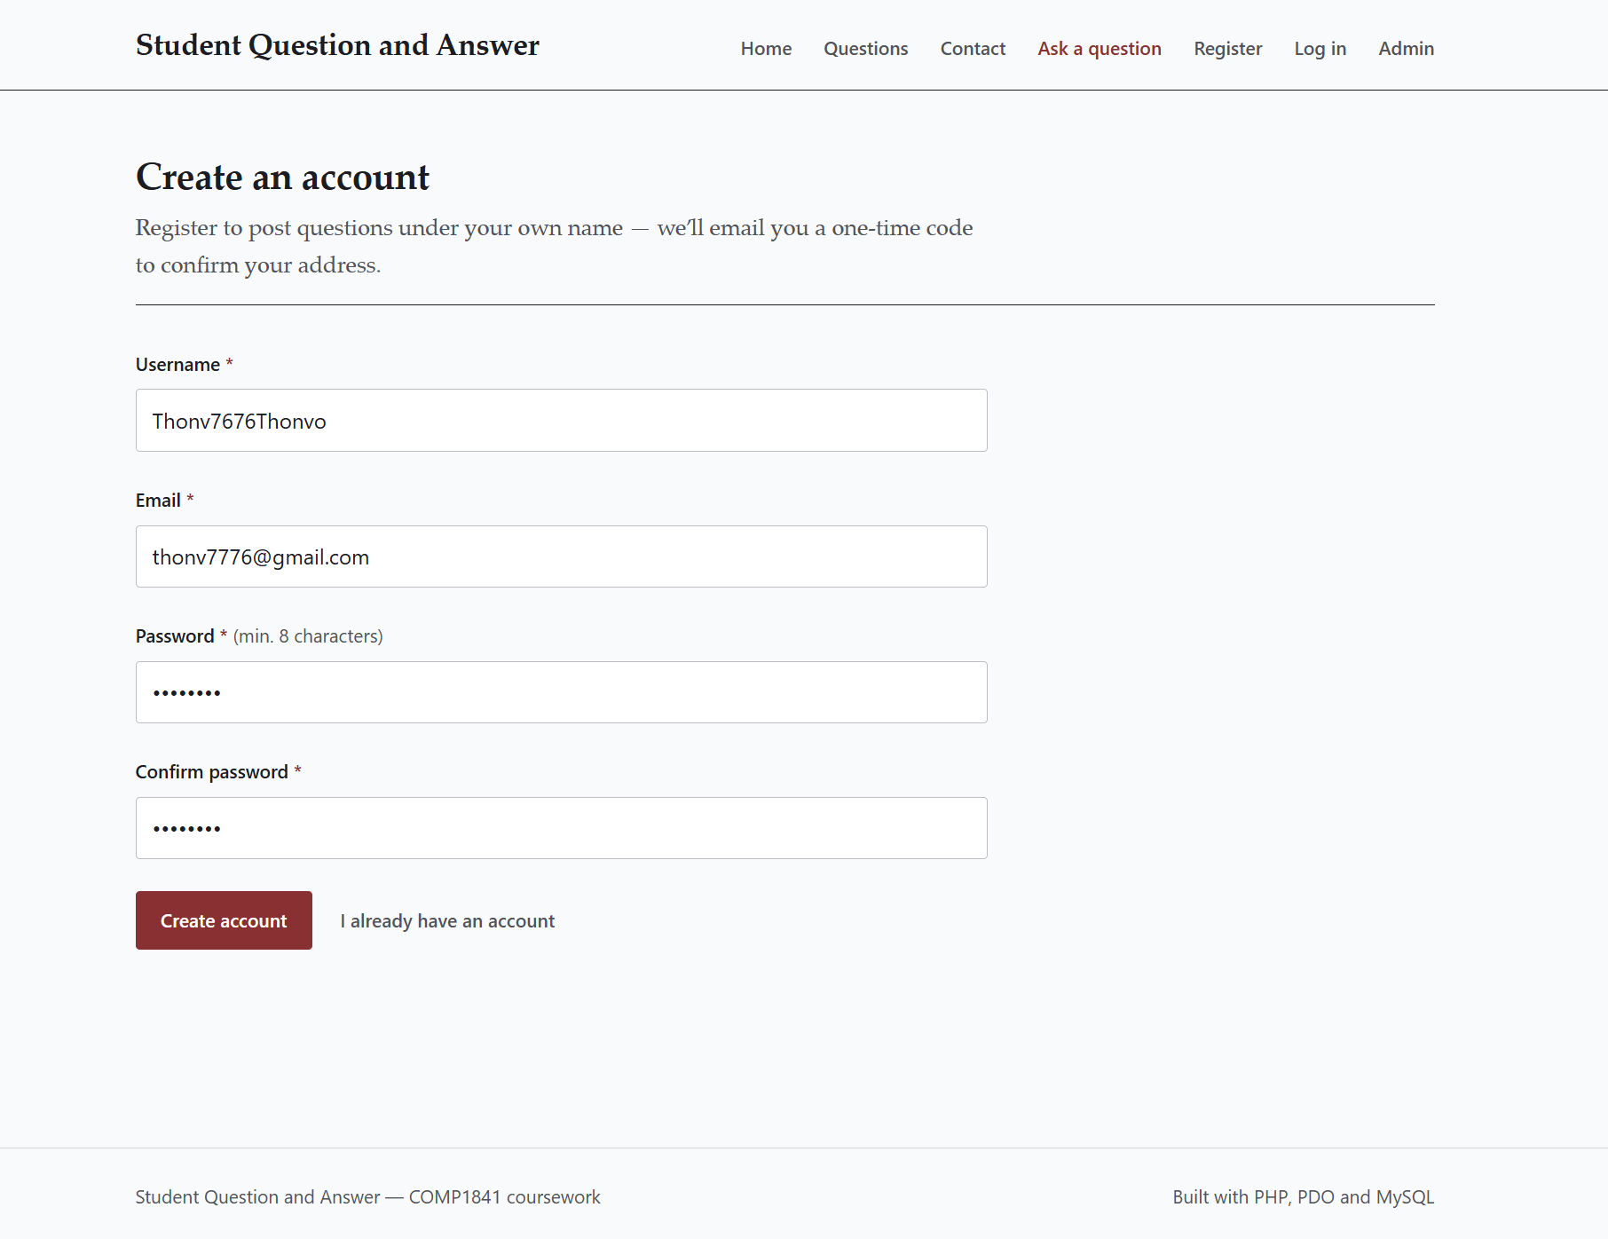
- Step 2: The system uses PHPMailer to send a 6-digit One-Time Password (OTP) to that email. The user opens their email inbox to see the code.
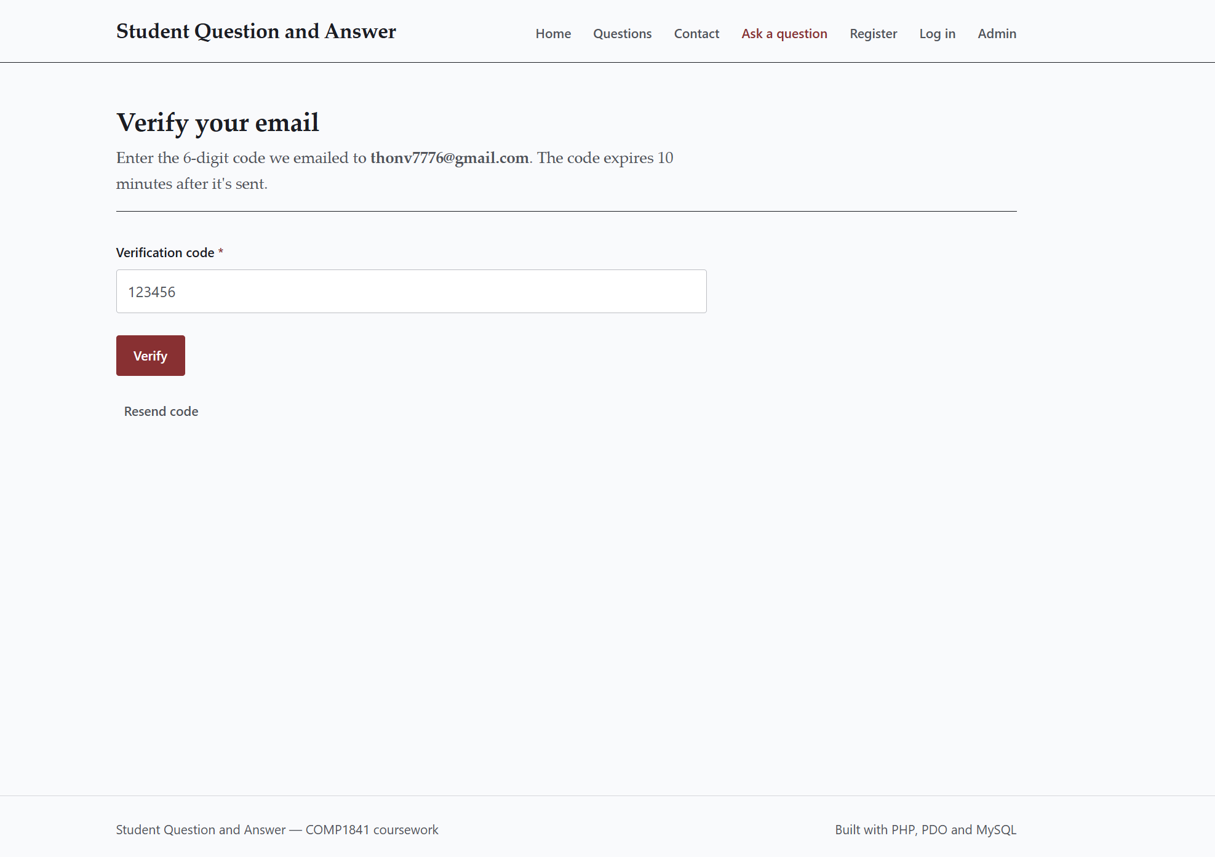
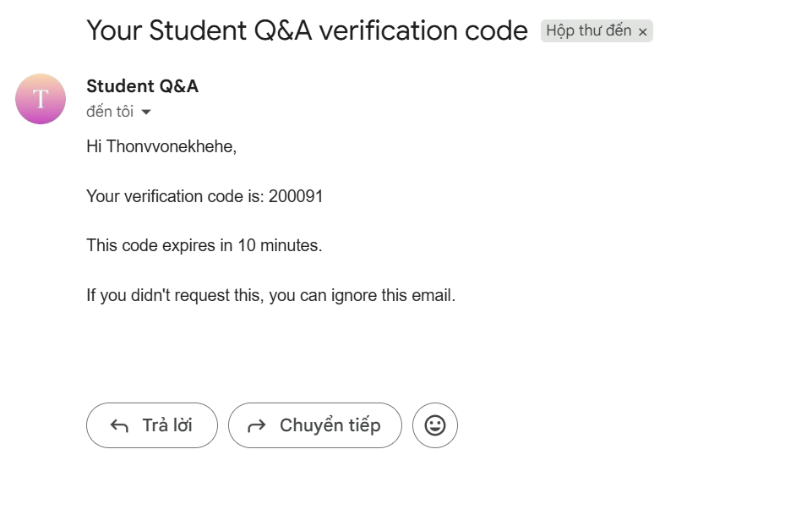
- Step 3: The user types the 6-digit code on the verify page and the account is activated.
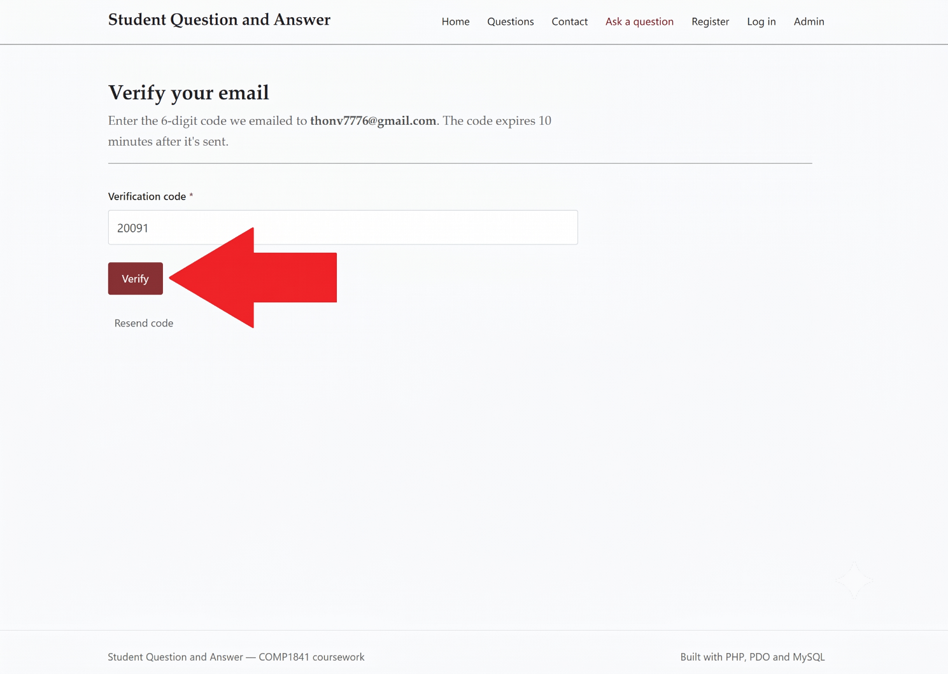

Session-based Author Tracking The system automatically knows the author's name.
- Step 1: The user logs in with their email and password.
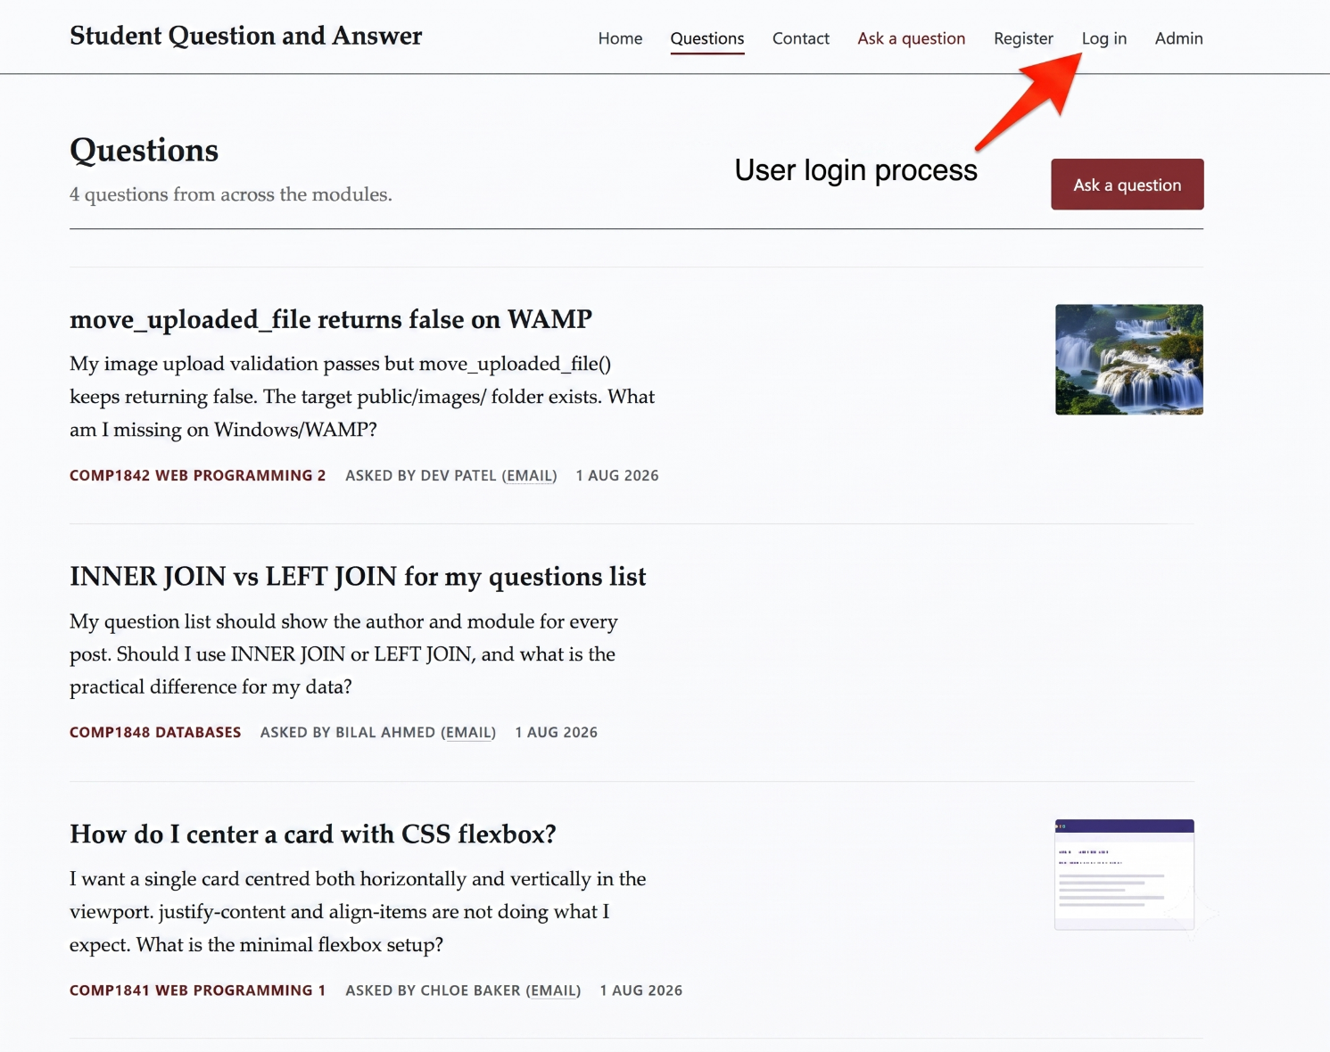
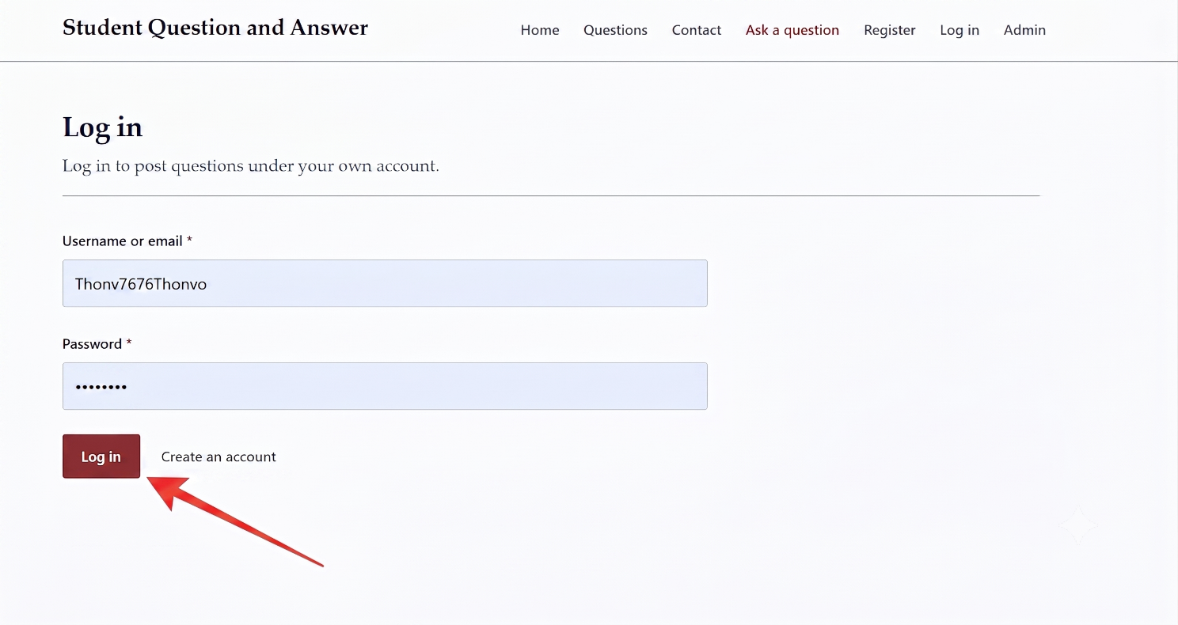

- Step 2: The user opens the "Ask a question" page.
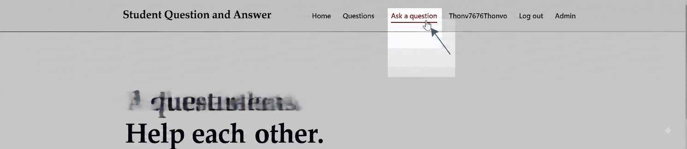

- Step 3: The form automatically shows the user's name at the top. There is no text box to type a different name
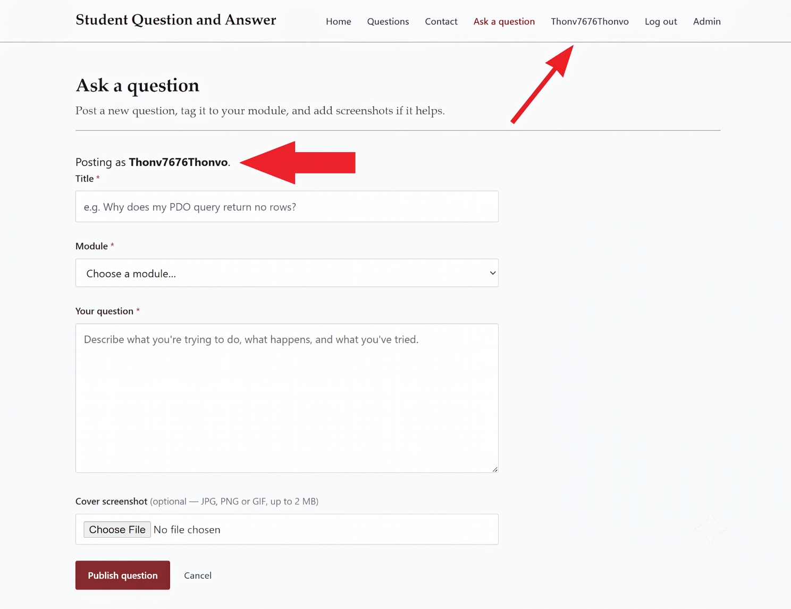

Admin Activity Log: The database saves a record every time an admin logs in, adds, edits, or deletes data.
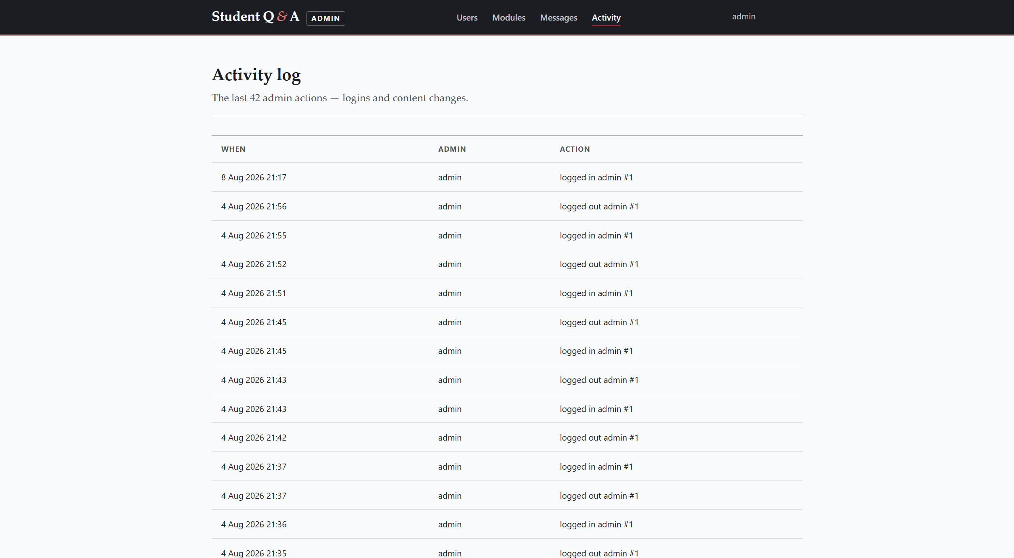

7. Testing and Evaluation

7.1 Test Plan
The system was tested many times, using both normal and incorrect inputs, to find bugs and check that the security features work correctly.
Test Case | Action / Input | Expected Result | Actual Result
1. User Registration | Fill in the register form with a valid email and password. | Account is created. System sends an OTP code to the email. | Pass
2. OTP Verification | Enter the correct 6-digit code sent by email. | Account is verified. User can now log in. | Pass
3. SQL Injection | Type ' OR 1=1 -- in the login username box. | Login fails. PDO Prepared Statements stop the attack. | Pass
4. Add Question | Add a title, text, and upload a .jpg picture. | Question is saved. The picture is renamed and stored in the images folder. | Pass
5. Bad Image Upload | Rename a .txt file to .jpg and upload it as a question image. | Upload is rejected. getimagesize() detects the file is not a real image. | Pass
6. Delete Own Question | Click delete on a question created by the logged-in user. | Question is removed from the database and no longer shown on the site. | Pass
7. Foreign Key Block | Admin tries to delete a module that still has questions. | Deletion fails. The database blocks it and a safe error message is shown. | Pass
8. Unauthorized Admin Access | Type an admin page address directly into the browser without an admin login. | Access is blocked. The system redirects back to the admin login page. | Pass
9. Edit Another Student's Question | Log in as one student and try to edit a question posted by a different student. | Action is blocked. The system shows an error and does not save the change. | Pass
10. Duplicate Email Registration | Register using an email address that is already used by another account. | Registration fails. The system shows an error and does not create a duplicate account. | Pass

7.2 Evaluation
The project successfully meets the coursework requirements. It works as a safe, functioning CRUD web application. The code is organised into small, clear functions, which makes it easy to read and reuse.
All ten test cases in the table above passed. This shows that the system correctly handles normal actions, such as adding a question, and also correctly blocks unsafe or incorrect actions, such as SQL injection attempts or editing another student's question.
One small limitation is the contact form. At the moment, it only saves messages to the database, and the admin must log in to read them. In a future version, the system could also send the message directly to the admin's email inbox, using the PHPMailer library that is already part of the project.

8. Conclusion and Future Recommendations
In conclusion, this project is a working Student Question and Answer System. It gives students an easy website to ask for help with their modules, and it gives admins full control over users and content. By using PHP PDO and following GDPR rules, the system stays safe and respects user privacy.
If more time were available, three features would be added next. First, a comment section, so students could reply and answer each other's questions. Second, a “forgotten password” page, so users could reset their own password using a link sent by email, instead of asking an admin to do it. Third, pagination (adding page numbers to long lists), which would help the website load faster once there are many questions.

References
Great Britain. (2018) Data Protection Act 2018. London: The Stationery Office. Available at: https://www.legislation.gov.uk/ukpga/2018/12/contents (Accessed: 7 August 2026).
Information Commissioner's Office (ICO). (n.d.) UK GDPR Guidance and Resources. Available at: https://ico.org.uk/for-organisations/uk-gdpr-guidance-and-resources/ (Accessed: 7 August 2026).
MySQL Documentation. (2023) FOREIGN KEY Constraints. Available at: https://dev.mysql.com/doc/refman/8.0/en/create-table-foreign-keys.html (Accessed: 7 August 2026).
OWASP Foundation. (n.d.) SQL Injection Prevention Cheat Sheet. Available at: https://cheatsheetseries.owasp.org/cheatsheets/SQL_Injection_Prevention_Cheat_Sheet.html (Accessed: 7 August 2026).
PHP Manual. (n.d.a) PDO::prepare. Available at: https://www.php.net/manual/en/pdo.prepare.php (Accessed: 7 August 2026).
PHP Manual. (n.d.b) password_hash. Available at: https://www.php.net/manual/en/function.password-hash.php (Accessed: 7 August 2026).
W3C. (n.d.) WCAG 2 Overview. Available at: https://www.w3.org/WAI/standards-guidelines/wcag/ (Accessed: 7 August 2026).

Declaration of AI Use
Please append this page to the end of your assignment when you have used AI during the process of undertaking the assignment to acknowledge the ways in which you have used it.

I have used AI while undertaking my assignment in the following ways:
- To develop research questions on the topic – NO
- To create an outline of the topic – NO
- To explain concepts – YES
- To support my use of language – YES

