**CSE203- Web Programming 1**

**TOROS UNIVERSITY**

**COMPUTER AND SOFTWARE ENGINEERING DEPATRMENT**

**Term Project**

**Design a Diet Websites using HTML, CSS and JavaScript according to the following guidelines:**







The first page (Home page) should be as the above with eight different menus.

Clicking Healthy Recipes leads to opening bellows

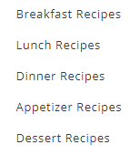

Breakfast Recipes

Eating breakfast is a healthy habit, especially if you're watching your weight. Research shows that regular breakfast eaters tend to be leaner and people are more successful at losing weight—and keeping it off—when they eat breakfast. What's more, people who eat breakfast typically get more of some important nutrients, like fiber and vitamins.

A healthy breakfast should be balanced and deliver a mix of protein, complex carbohydrates, fiber and healthy fat to keep you full and fueled up for your day. Read on to find out some of the best foods to eat for breakfast to help you lose weight and why they are so good for you.

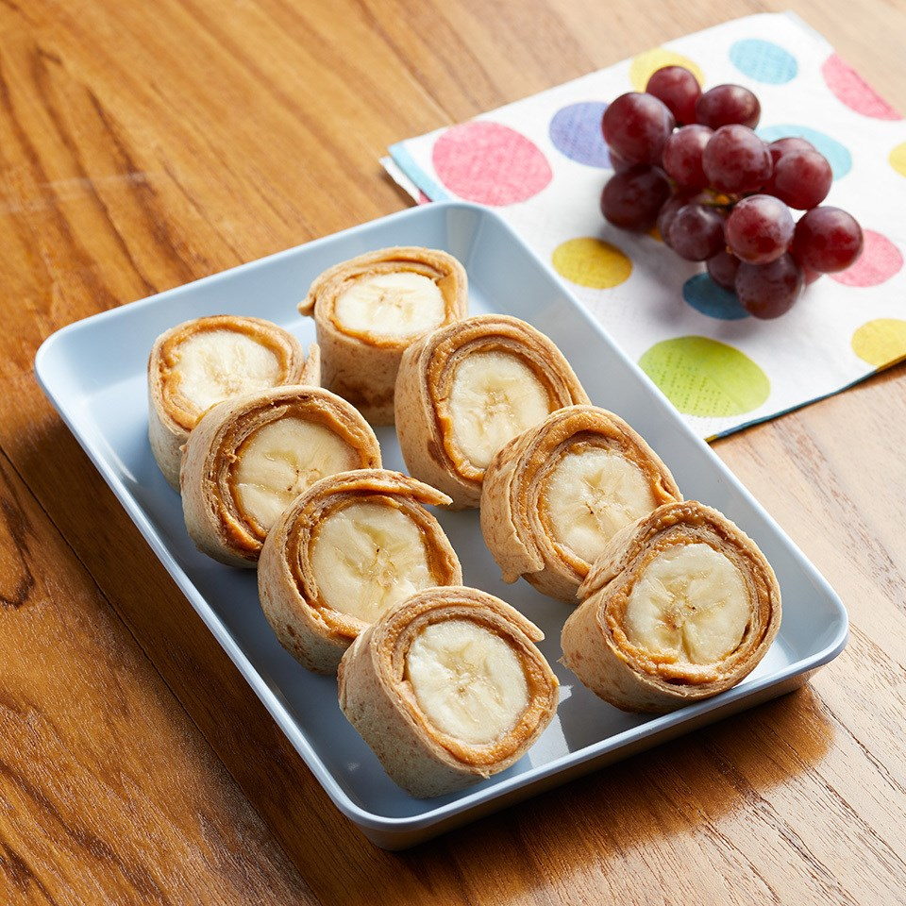

Home Page

Lunch Recipes

* Meal-Prep Curried Chicken & Chili-Lime Chicken

Combine brown rice and quinoa; divide among 4 single-serving containers with lids. Top with chicken, cilantro and scallions, dividing evenly. Seal containers and refrigerate for up to 4 days.

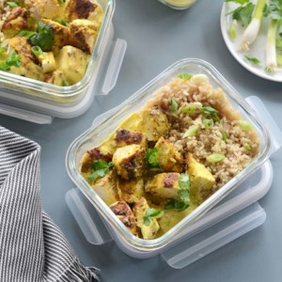

Home Page

Dinner Recipes

Instead of cooking pasta in a huge pot of water, here we use just 3½ cups for this one-pot pasta recipe. When the pasta is al dente, most of the water has evaporated and the bit that's left is thickened with the starch that cooks off the pasta. With just a few add-ins like lemon and Parmesan cheese you have a delicious silky sauce. Want to use up your veggie stash in the freezer? Swap in 8 ounces frozen spinach for fresh.

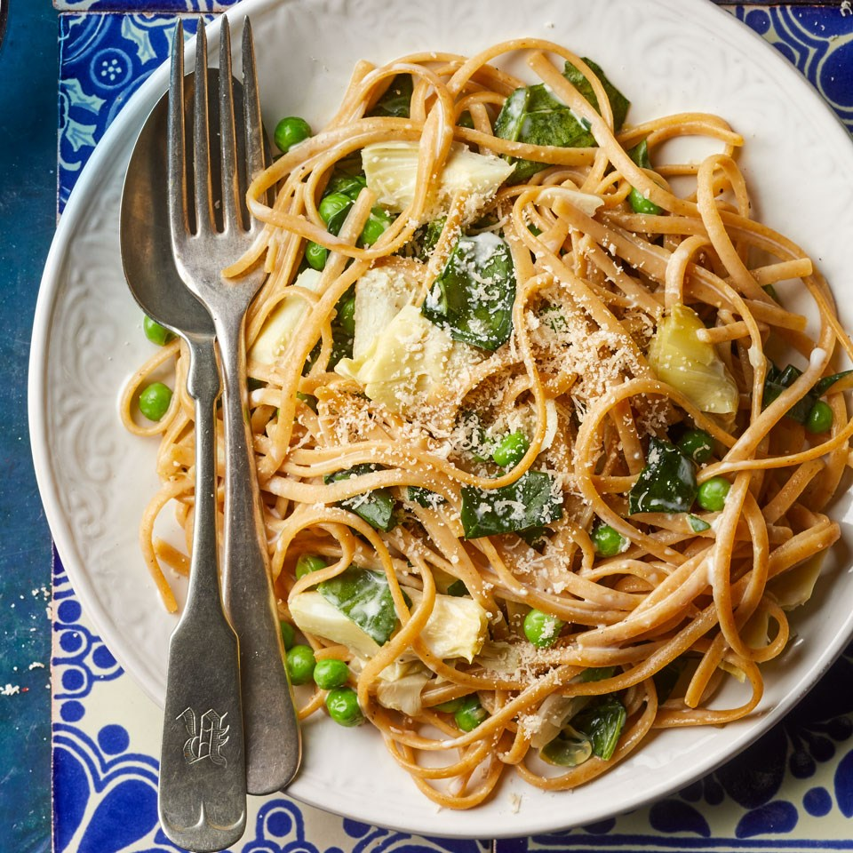

Home Page

Appetizer Recipes

* Sausage Balls
* Onion Rings

Sausage Balls

These homemade sausage balls are a healthy riff on the original—we add rice cauliflower for moisture and a veggie boost, whole-wheat flour stands in for prepared biscuit mix, and sharp Cheddar adds flavor. Serve these sausage balls for brunch, as an appetizer, or mix them with your favorite marinara for dinner.

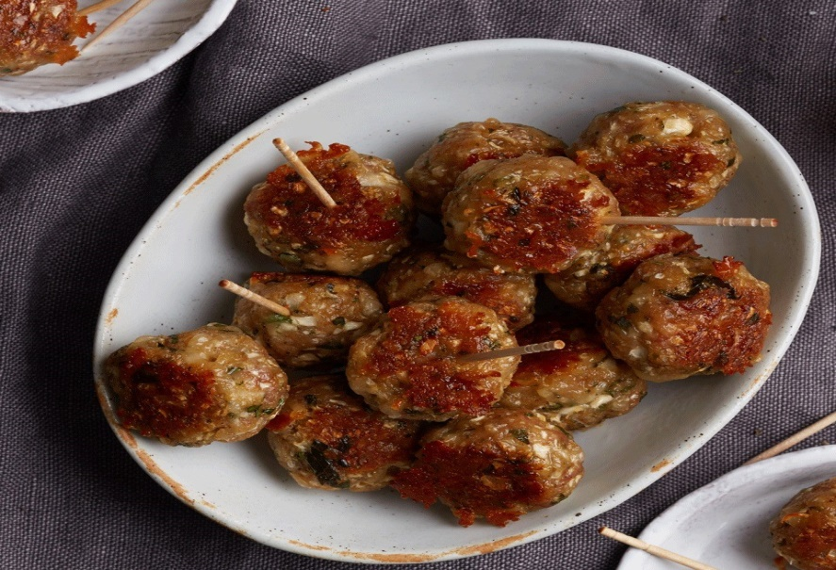

Home Page

Onion Rings

We couldn't get enough of these crunchy onion rings in the EatingWell Test Kitchen. Try any seasoning blend that you have on hand to add flavor to the breading or substitute 1 teaspoon salt instead. Seasoned whole-wheat breadcrumbs are available in some supermarkets and natural-foods stores. If you can find them, try them in place of the plain breadcrumbs and seasoning blend.

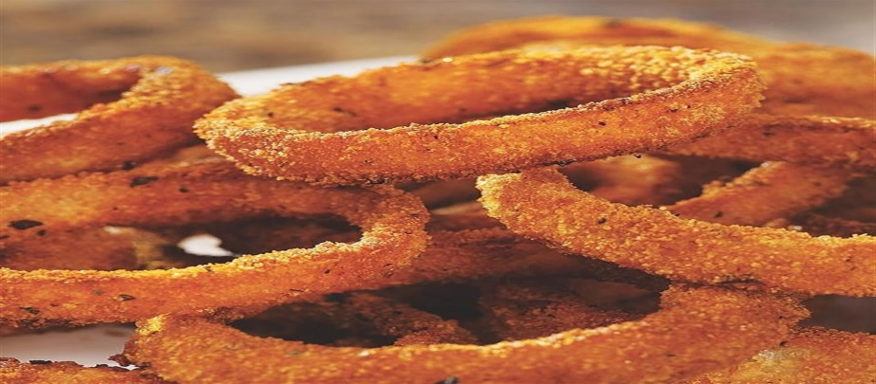

Home Page

Desert Recipes

* Oatmeal-Applesauce Cake
* Apple-Pumpkin Muffins

### Oatmeal-Applesauce Cake

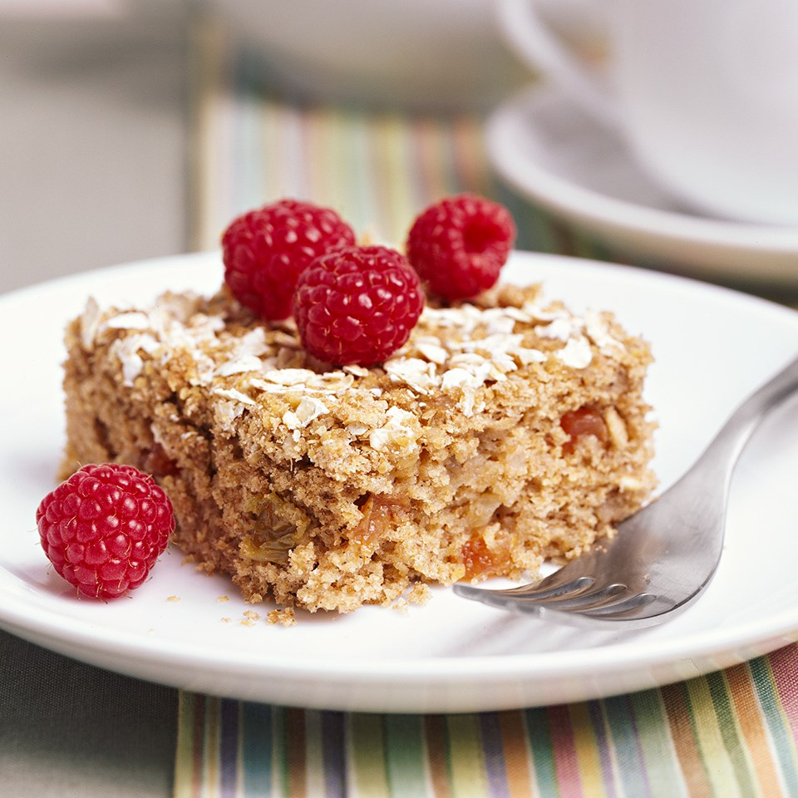

Home Page

### Apple-Pumpkin Muffins

Applesauce and pumpkin make these muffins moist, low-fat, healthful and delicious. Serve them for Thanksgiving or Christmas breakfast or brunch, or for a lunchbox treat.

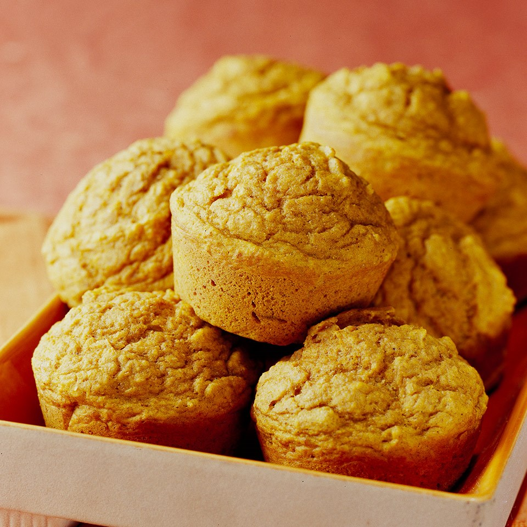

Home Page

# Weight Lose Menu

# Eating more of these foods can help you slim down. (video)

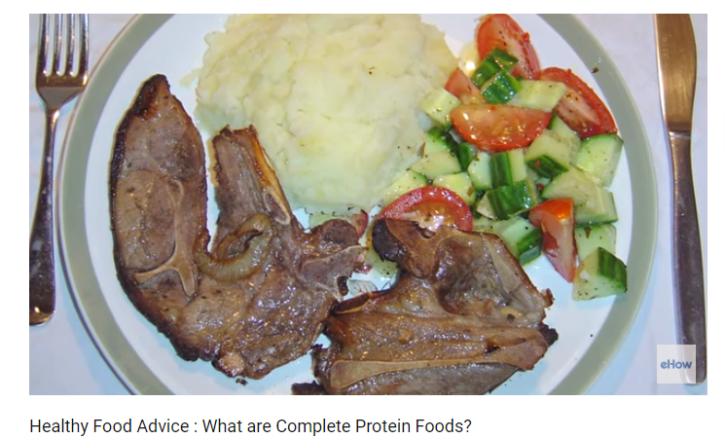

Home Page

Meal Plans Page:

# How Many Calories Should You Eat Per Day to Lose Weight?

This is a simple but highly accurate scientific calorie calculator, along with 5 evidence-based tips on how to sustainably reduce calorie intake. Enter your details in the calculator below to figure out how many calories you should be eating per day to either maintain or lose weight.

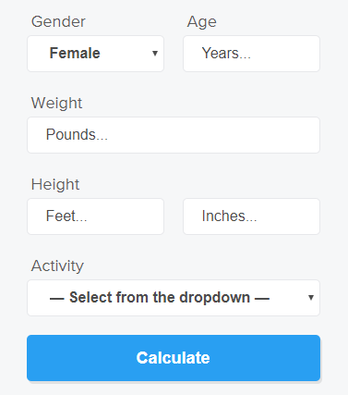

Home Page

To calculate BMR for women, use this formula: 655 + (4.35 x weight in pounds ) + (4.7 x height in inches ) - (4.7 x age).

For men, use this formula: 066 + (6.23 x weight in pounds ) + (12.7 x height in inches ) - (6.8 x age).

Next, factor in your daily activity level, using this formula:

**Sedentary:** BMR x 1.2.

**Lightly active** (light exercise one to three days a week): BMR x 1.375.

**Moderately active** (moderate exercise three to five days per week): BMR x 1.55.

**Very active** (vigorous exercise six to seven days a week): BMR x 1.725.

**Extremely active** (intense exercise or sports training six to seven days per week): BMR x 1.9.

About Us

**This website is designed by CSE203 (web programming 1) students using HTML, CSS and JavaScript according to some information achieved from internet for dieting.**

Home Page

**Due to 04.01.2019**

**You should submit your project individually and save it on a CD. Copy projects will be punished.**

Formun Altı