**Blogs Django Assignment**

**Steps To run project.**

* **Get clone from git repo mentioned in mail**
* **Install all requirements by using requirement.txt**
* **Open project in IDE**
* **By using terminal user can easily run the project**
* **For Admin access use following credentials : (username:admin,password:admin)**
* **For new user registration , user can use admin panal**
* **User registration is not included in project as its not mentioned in requirements**

**Landing Page**

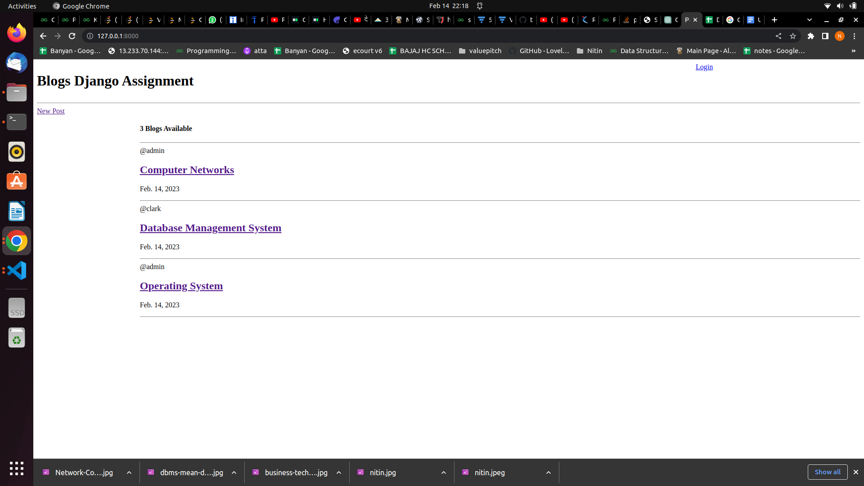

* User can view and read blogs without login
* Here delete and edit links are hidden
* Only author can see these links
* On clicking new post , user is prompted for login
* @ sign defines author name
* Publishing date is placed under the title
* User can hide blog from others by moving published blog to drafts
* Or can save blog as draft for later use

**Login Page**

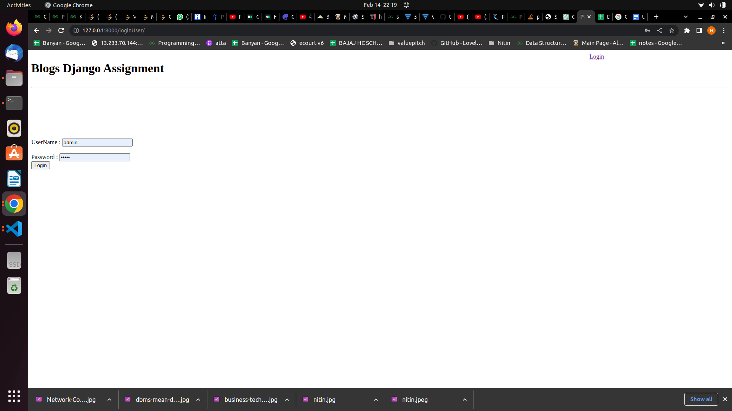

* Here user can login by using his credential
* Users are authenticated against User Table
* After authentication userf redirected to home page
* From any page user can reach to login page

**Home Page**

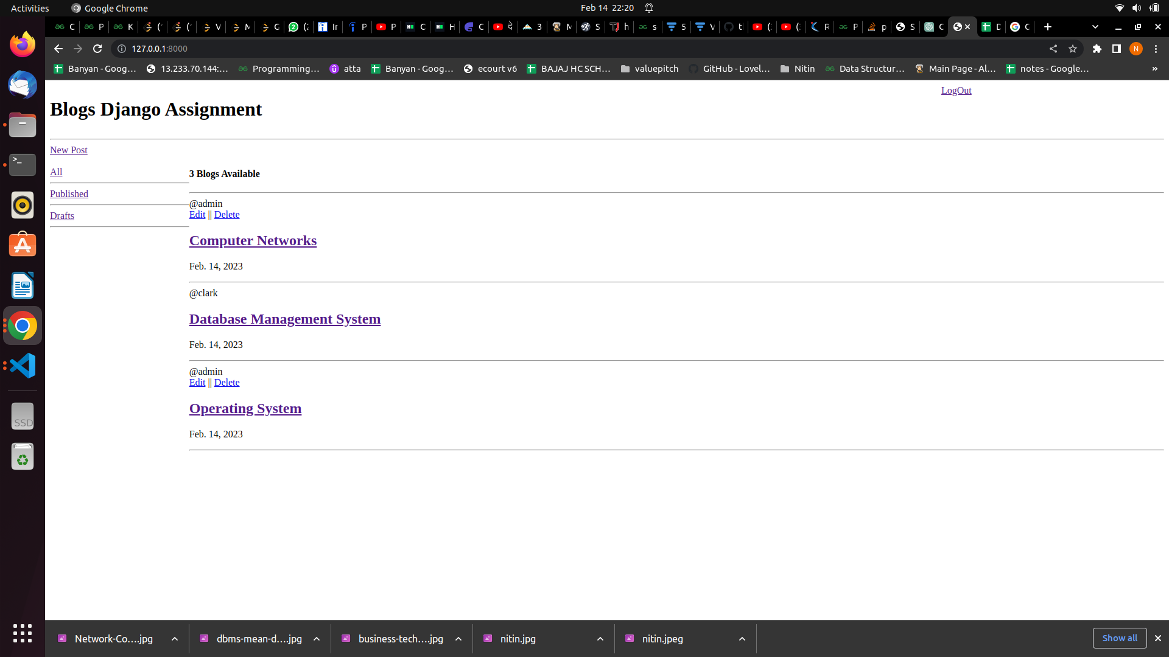

* Here user can view all posts published by other users and drafted and own published blogs
* Edit and delete links are available only for users own blogs
* User can edit or delete other users Blog

**Draft**

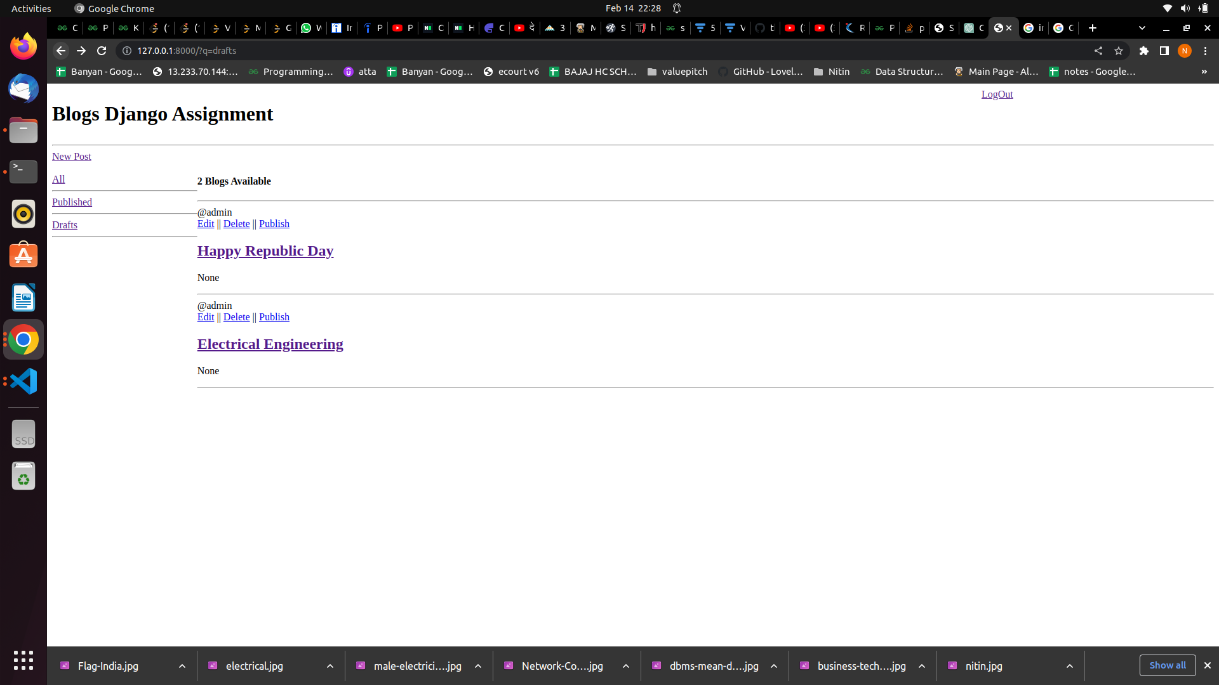

* Here user can see all listed Blogs in descending order by published date
* User can see here publish link which will publishes blog on page, so others can see
* Once blog is published, it will no longer visible in drafts section, it will now visible in published and all sections
* Published date is set to None as, these blogs are yet to publish
* User can remove blog from published to draft and vice versa

**Blog Page**

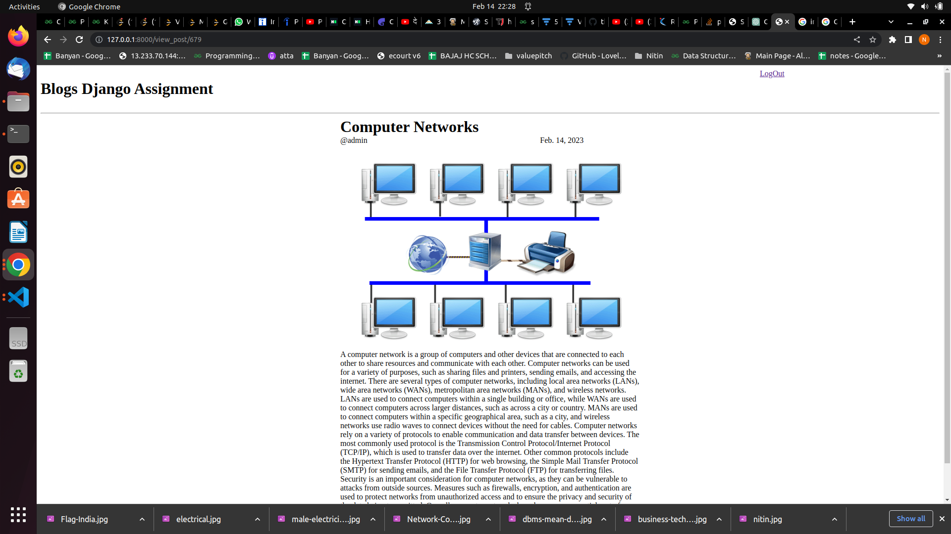

* User can read blog by simply clicking on blogs title
* Images can be added to blog

**New Post Page**

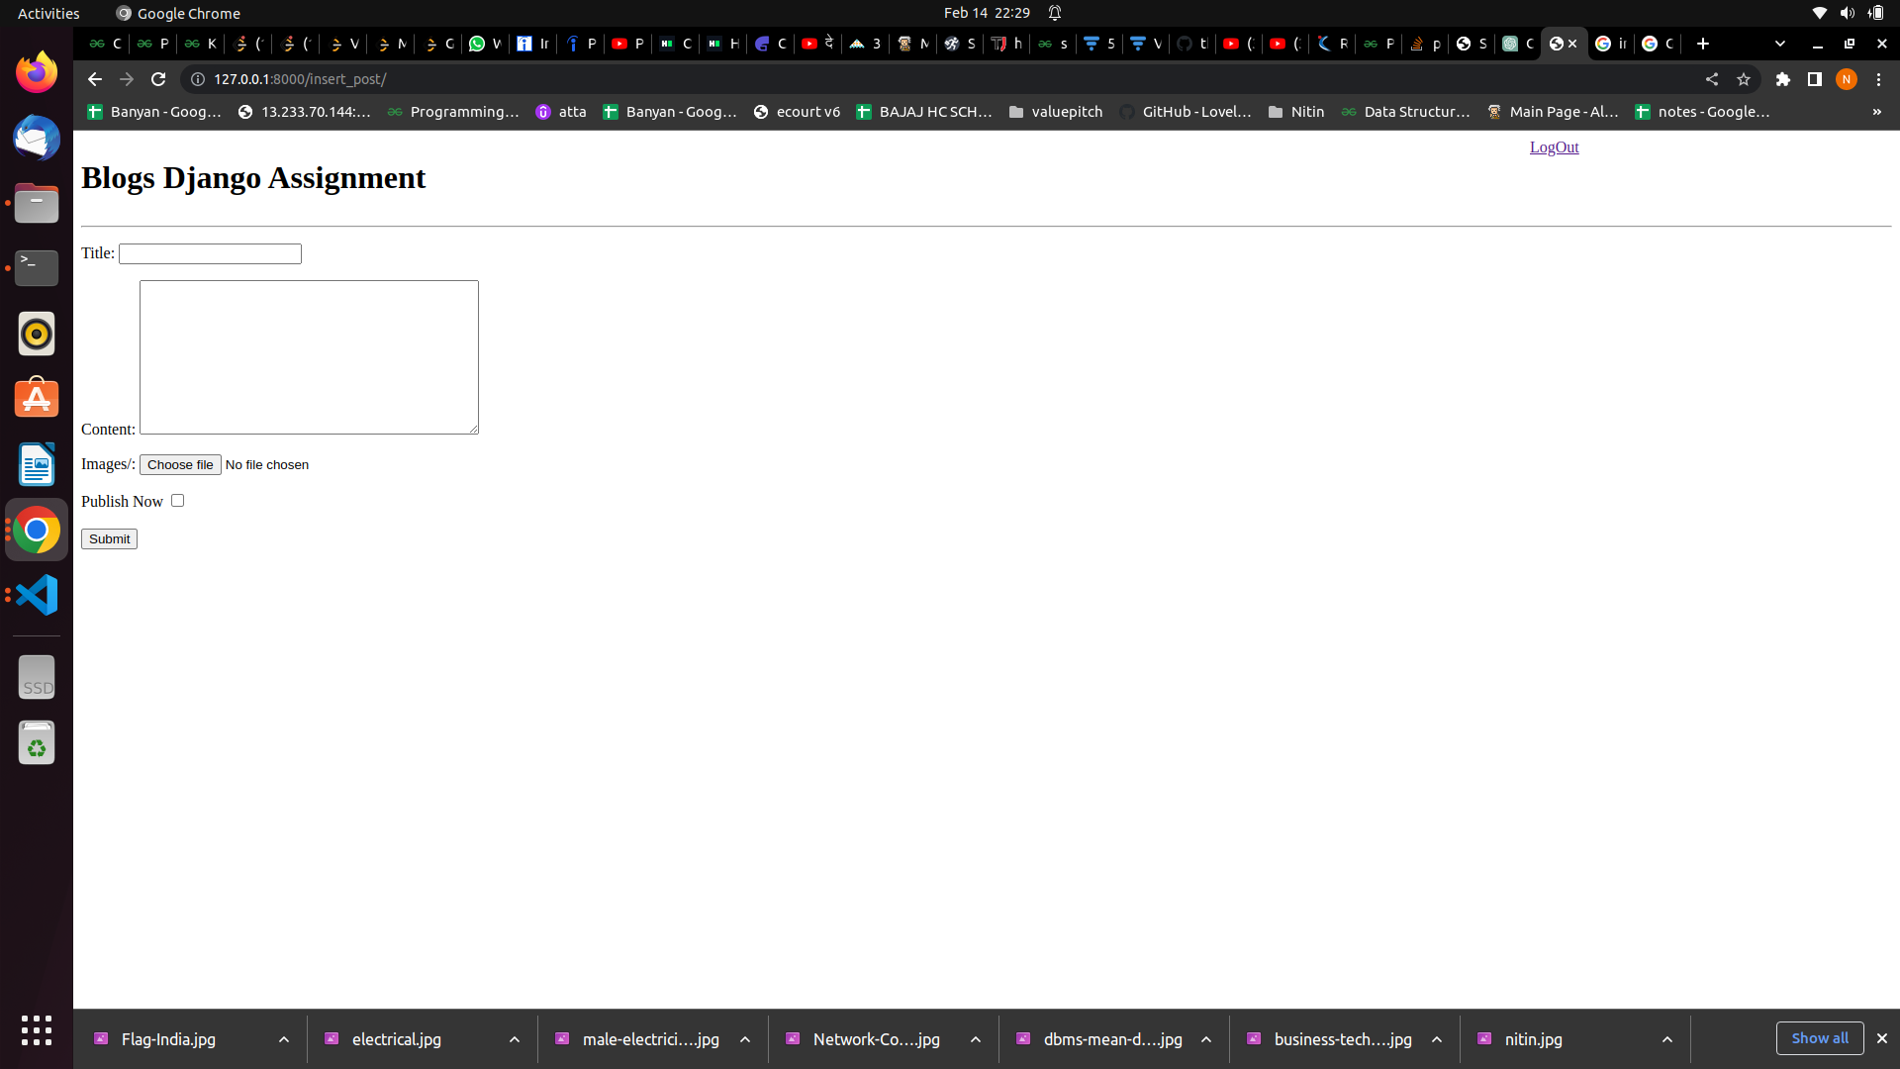

* On homepage user can find “New post” link
* By clicking on that link user can create new blog
* Here if user is not logged in then he will be redirected to login page automatically
* User decides whether post going to published instantly or he wants to save blog in draft by clicking published now checkbox

**Edit Blog page**

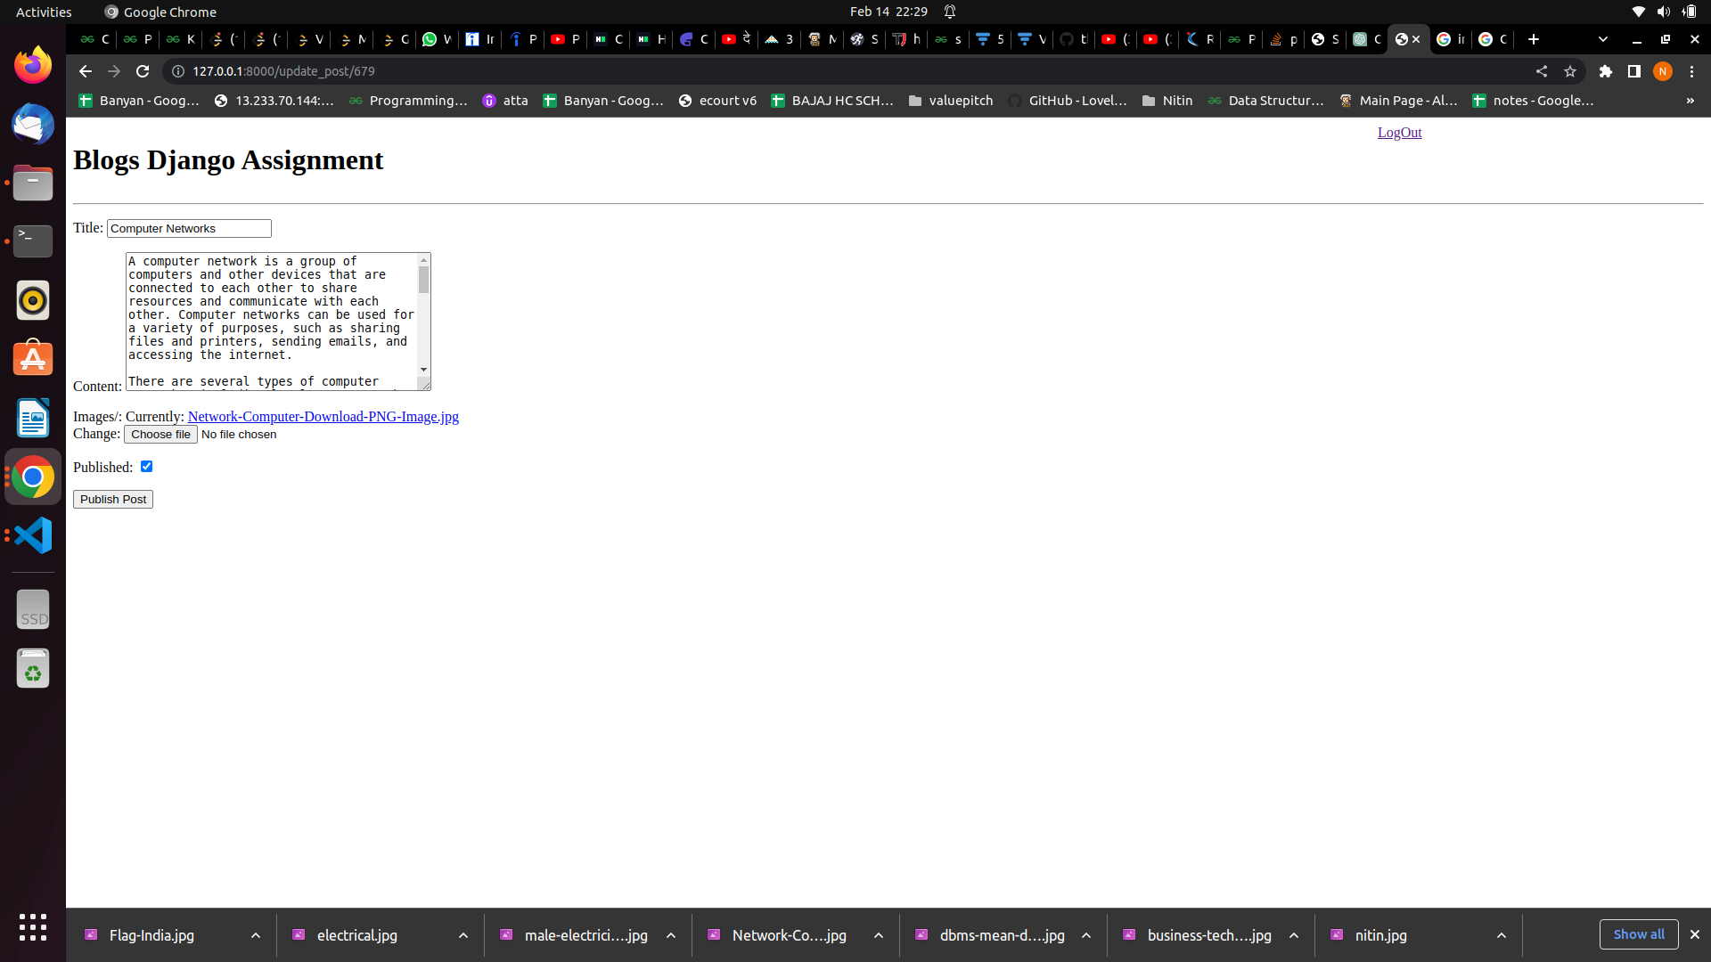

* By clicking on edit link user see this page to do updation work
* User can change image , content and title here with very ease
* By clicking on published , user can decide to publish or not

**Delete confirmation page**

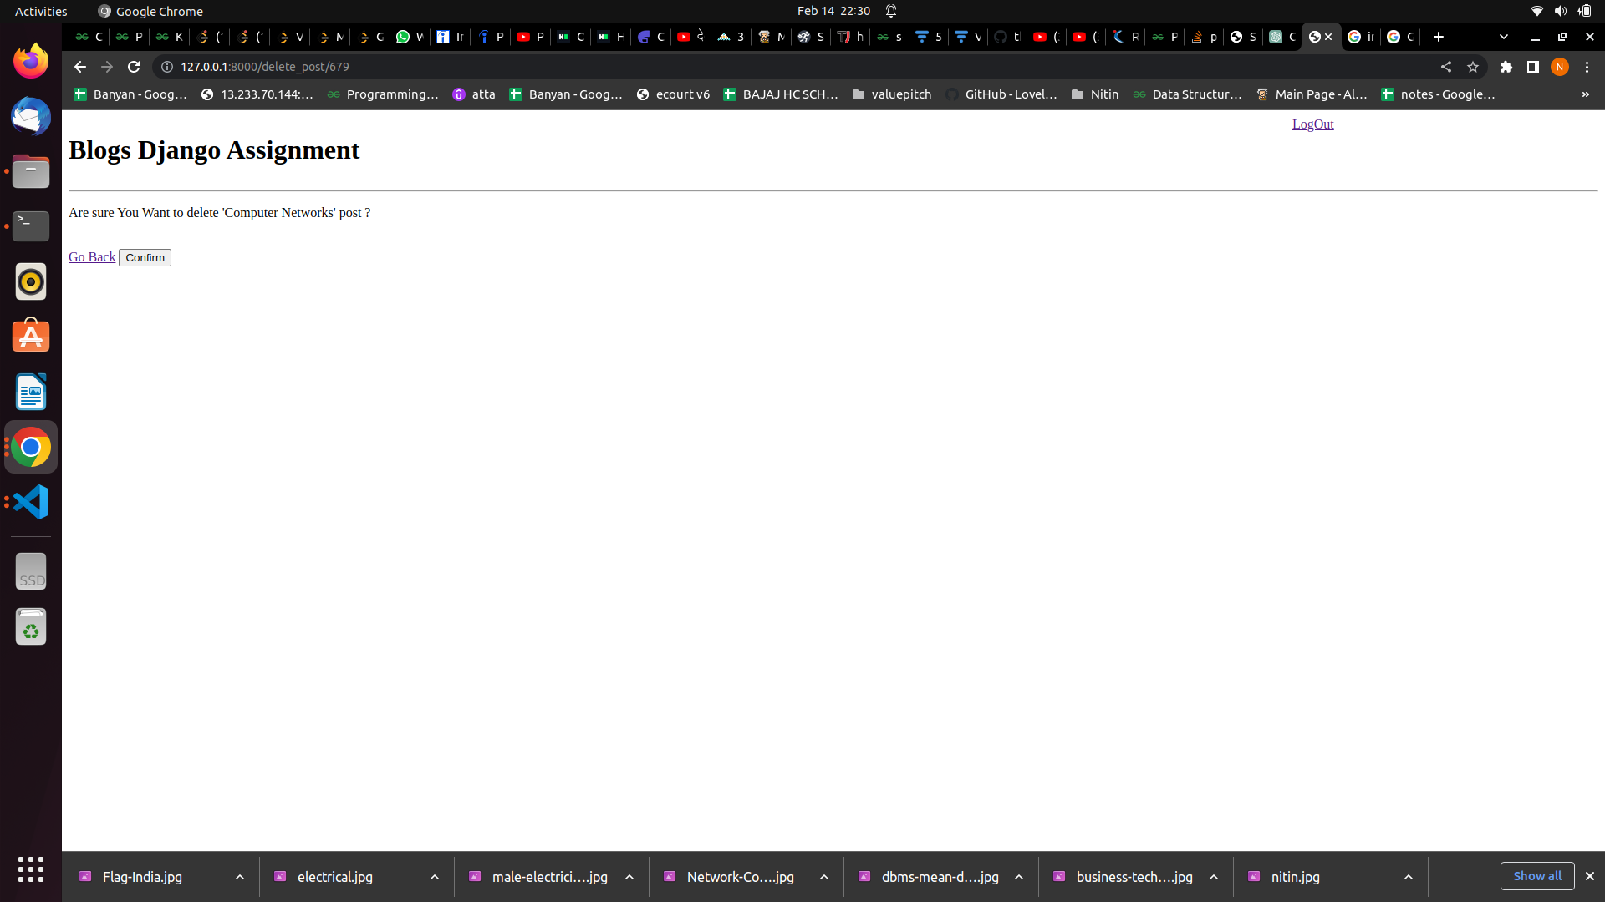

* This is delete confirmation page where user is redirected when user clicks on delete link
* By clicking go back, user can return to referrer page
* And by clicking on confirm user deletes blog
* Then user is redirected to home page

**Publish Confiramtion page**

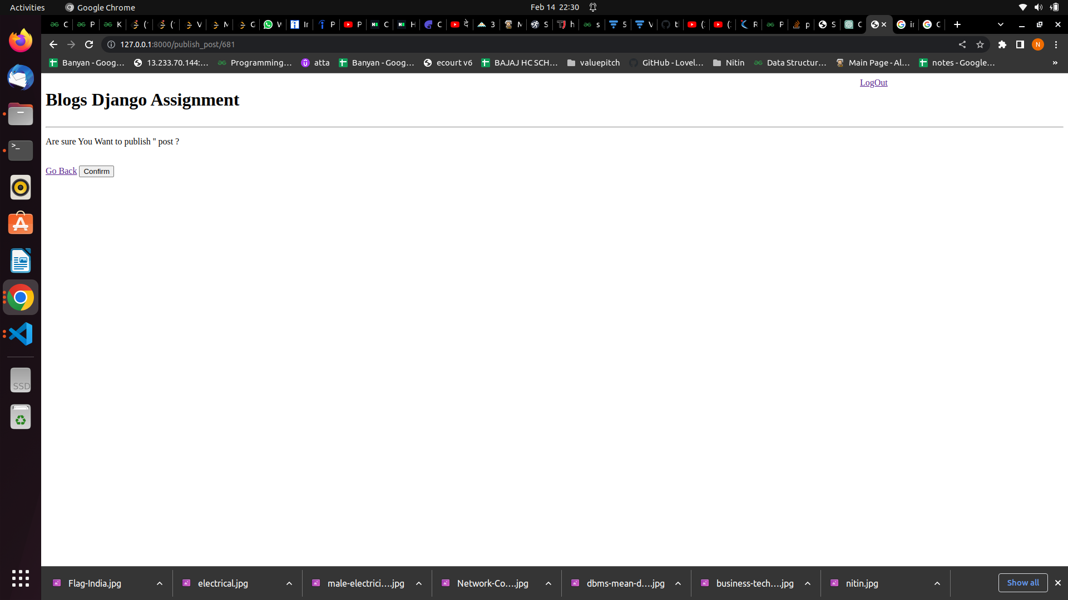

* This page only can be accessed by authenticated user
* This page confirms that user wants to publish blog
* User can do publish blog any time