**Lab 3**

**Exam results:**

- URL: http://localhost:3000

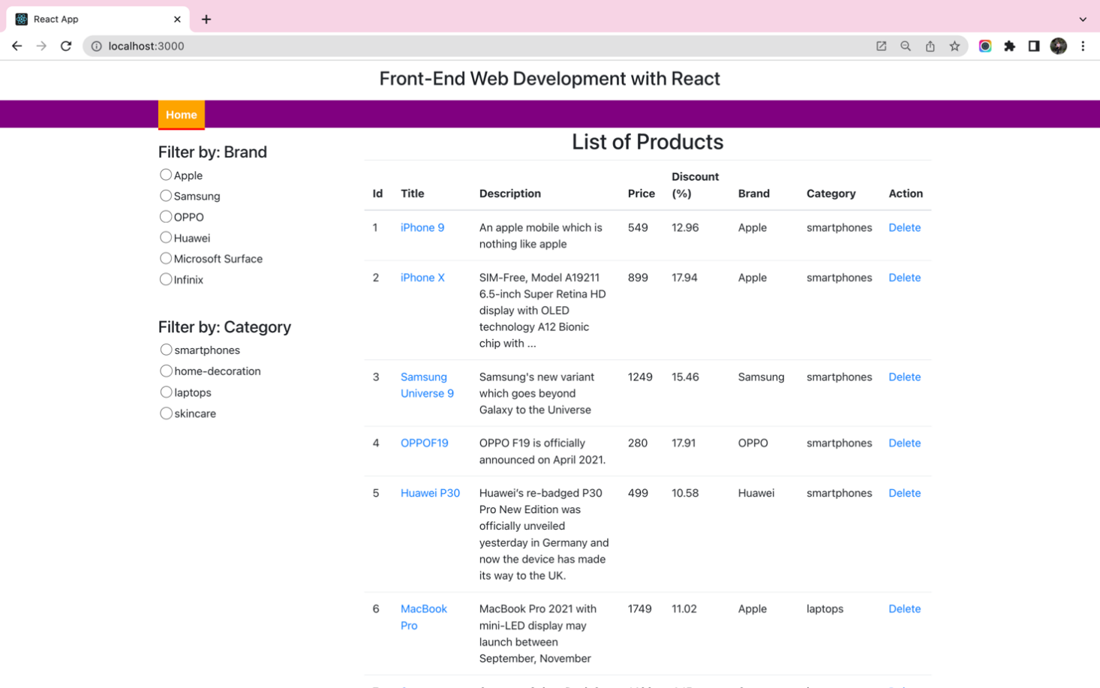

*Figure 1 - Exam result screen 1*

- URL: http://localhost:3000/product/detail/2

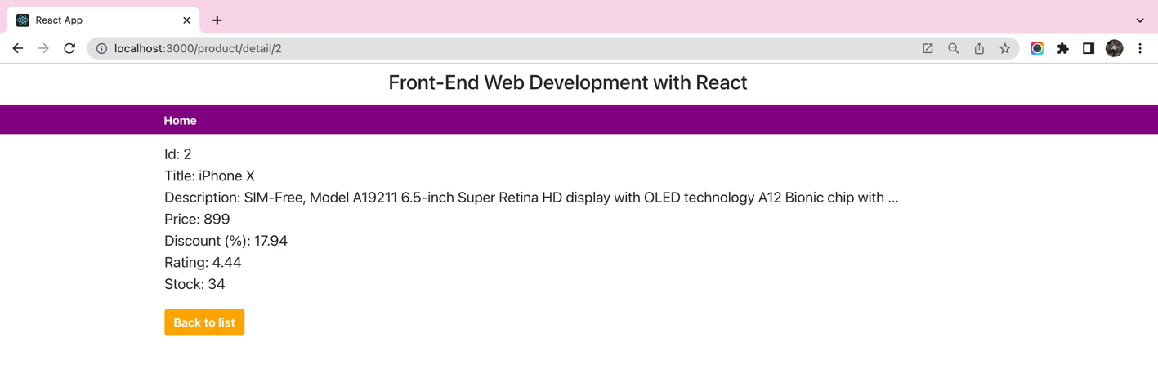

*Figure 2 - Exam result screen 2*