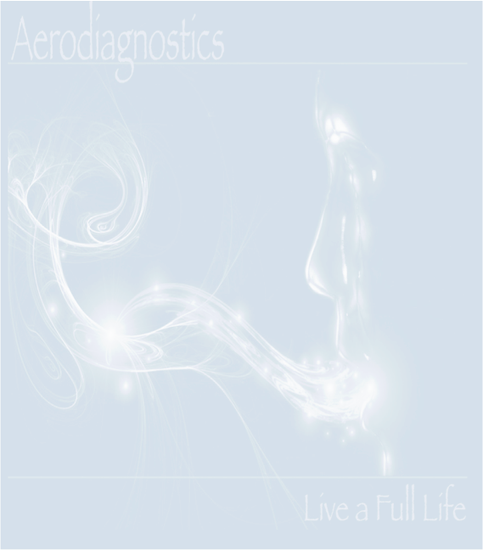

• For fourteen (14) days before your test (or as directed by your clinician), you should not take any antibiotics.

• For one (7) days before your test, do not take any laxatives or stool softeners (for example Colace, Milk of Magnesia, Ex-Lax) or stool bulking   
 agents (for example Metamucil or Citrucel). You should also not undergo any test that requires cleansing of the bowel, such as colonoscopy or  
 barium enema.

• The day before your test: You may consume only the following foods and drinks: plain white bread, plain white rice, plain white potatoes, baked or  
 broiled chicken or fish, water, non-flavored black coffee or tea. Only salt may be used to flavor your food. Butter or margarine is not permitted.   
 Soda drinks are not permitted. Do not drink or eat anything else as it could give false results for the test. Specifically, avoid beans, pasta, fiber  
 cereals, and high fiber foods. The night before the test have an early dinner of rice and meat.

• For 12 hours before your test: You must stop eating and drinking 12 hours before the test. For example, if your test is at 9:00 am, you would stop  
 eating and drinking at 9:00 pm the night before. You may continue to take your usual prescription medicines with water until 12 hours before the   
 test.

• The day of your test: You should not eat or drink anything in the morning. You may take your medications with a small amount of water. If you are  
 diabetic requiring insulin or diabetic pills, ask your physician if you should change your morning dose. Generally, half of your normal long acting  
 insulin is given. Oral hypoglycemic medications are usually not taken that morning until completion of the test and resumption of eating meals.

• Two hours before the test, brush your teeth. • Do not eat, drink, chew gum or tobacco, smoke cigarettes, eat breath mints or candy before or during  
 the test. • Do not sleep or exercise while the test is being done. • Your test may last three to four hours. Please allow yourself sufficient time to   
 complete your test.

**The Test Procedure**

• A breath sample will be collected by having you exhale through a device into bag to establish a baseline hydrogen and methane level in your breath.

• A solution of lactose, lactulose, sucrose, or fructose will be consumed. You should drink the amount directed.

• Breath samples will be collected every 20 - 30 minutes depending on the test you are taking. After each sample is collected, the sample will be   
 removed from the bag by placing a test tube over the needle attached to the bag, allowing collection of another sample into the bag.

• Do not eat, chew candy, smoke, sleep, or exercise during the test.

• The test is generally complete after three or four hours. You may return to your usual diet and activity at that time.

• Test tubes should be placed into the bubble bags (provided) and placed inside the test kit box after completing all required breath specimens. The  
 box should be mailed back to our laboratory with the pre paid postage (included) within two days of completion of the test. The samples will be   
 processed within 1 business day of receipt in our laboratory. The report may be sent securely to the person that ordered the test (clinician, patient,  
 or both).