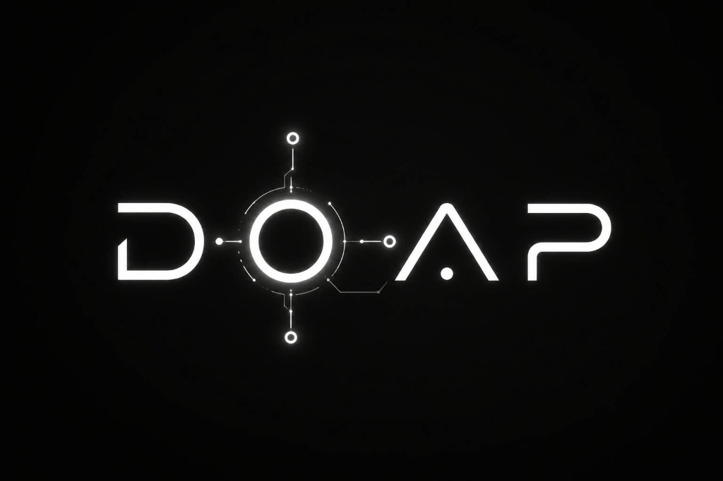
DOAP: Discover Opportunities & Progress Platform
Comprehensive Technical Specification, Technology Stack & System Architecture Report
Author / Lead Developer | Pratik Thorat (@Pratik Thorat)
Institution | Sanjivani College of Engineering (SCOE) / Sanjivani University, Kopargaon
Live Production Web App | https://doap-1908.web.app (Firebase Global Multi-CDN)
Source Code Repository | https://github.com/thoratpratik2323-hue/doap-intelligent-learning

1. Executive Summary & Problem Statement
Modern software engineering education faces a profound structural disconnect: while global tech employers evaluate candidates through rigorous algorithmic problem solving, hands-on debugging, system design, and spoken communication, conventional academic curriculums often remain anchored to static textbooks and passive lectures.
DOAP (Discover Opportunities and Progress Platform) was architected to bridge this chasm. It serves as an all-in-one AI Engineering Playground, Real-Time Spoken Mentor, and Placement Readiness Ecosystem. Through sub-150ms LLM reasoning, proctored video mock interviews, zero-server-cost in-browser Python execution, and 28 certification tracks, DOAP provides continuous, personalized 1-on-1 mentorship at scale.
Core Philosophy: DOAP operates entirely with zero hardware installation overhead for students—accessible through modern web browsers with instant client-side execution, offline-capable WASM runtimes, and global CDN delivery.

2. Institutional Heritage & Vision
Conceptualized and built by Pratik Thorat for Sanjivani College of Engineering (SCOE) / Sanjivani University, Kopargaon (under Sanjivani Rural Education Society - SRES, founded in 1983 by Late Shri Shankarraoji Kolhe Saheb).
The project was commissioned under the educational leadership of Hon. Shri Nitindada S. Kolhe Saheb (Chairman, SRES) and Hon. Shri Amitdada Kolhe Saheb (Managing Trustee, SRES) as part of the flagship initiative: 'Build Sanjivani's Own Large Language Model — Build AI for Sanjivani, by Sanjivani'.
3. System Architecture & High-Level Data Flow
DOAP uses a hybrid edge-cloud architecture designed for ultra-low latency, zero compute bottlenecks, and resilient failover:
┌────────────────────────────────────────────────────────────────────────┐
│ STUDENT BROWSER (CLIENT) │
│ React 18 SPA • Tailwind CSS v4 • Vite 6 • Pyodide WebAssembly │
└──────┬─────────────────────────┬─────────────────────────┬─────────────┘
│ Audio / Speech │ LLM Prompts │ Multi-Lang
▼ ▼ ▼
┌──────────────┐ ┌──────────────┐ ┌──────────────┐
│ Groq Whisper │ │ Groq LPU │ │ Piston / │
│ Large v3 STT │ │ LLaMA 3.3 │ │ Judge0 │
│ (<400ms STT) │ │ (Sub-150ms) │ │ Sandbox IDE │
└──────┬───────┘ └──────┬───────┘ └──────────────┘
│ │
└───────────┬─────────────┘
▼
┌────────────────────────────────────────────────────────────────────────┐
│ DOAP 8-LAYER LIVING COGNITIVE MEMORY │
│ Context Engine • Friction Point Tracker • Strengths Index │
└──────────────────┬─────────────────────────────────────────────────────┘
▼
┌──────────────────────────────────────┬─────────────────────────────────┐
│ TTS AUDIO STREAMING PIPELINE │ STATE PERSISTENCE │
│ DOAP Neural Voice (24kHz msedge) │ Google Cloud Firestore │
│ ElevenLabs Charon • Kokoro TTS │ Firebase Authentication │
└──────────────────────────────────────┴─────────────────────────────────┘
4. In-Depth Technology Stack Breakdown
4.1. Frontend Presentation & User Experience Layer
- React 18: Component-based reactive architecture with concurrent rendering and zero page refresh overhead. Manages complex interactive states across proctored full-screen exams, code editors, and real-time audio waveforms.
- Vite 6: Next-generation frontend tooling offering Hot Module Replacement (HMR) and roll-up code splitting, producing production builds in under 9 seconds.
- Tailwind CSS v4: Zero-runtime CSS engine ensuring high-contrast typography (7:1+ accessibility ratio), custom glassmorphism layers, and responsive UI from mobile screens to 4K displays.
- Lucide React: 450+ crisp, tree-shakeable SVG vector icons ensuring visual consistency across all modules.
- Recharts: Declarative SVG chart components powering real-time skill radars, telemetry gauges, and exam analytics curves.
4.2. Artificial Intelligence, LLMs & Cognitive Reasoning
- Groq LPU Acceleration: Custom Language Processing Unit (LPU) silicon running LLaMA 3.3 70B Versatile and Qwen 2.5 72B. Delivers sustained speeds exceeding 300 tokens/sec and sub-150ms latency.
- Deep Cognitive Self-Thinking (<think>): Specialized multi-pass internal reasoning scratchpad. Formulates pedagogical steps, evaluates edge cases, and removes hallucinations before generating student answers.
- Prime Agent RLM Harness: Recursive Language Model workflow (/refine). Coordinates specialized subagents (Code Explainer, Test Verifier, Syntax Reviewer) to autonomously refine answers.
4.3. Speech Intelligence & Studio Voice Pipeline
- Whisper Large v3 Turbo (STT): High-speed automatic speech recognition with native comprehension of technical programming terms and Indian English phonetics.
- DOAP Neural Studio Voice Engine (msedge-tts): Production-grade 24kHz studio voice synthesis (Charon, Andrew, Neerja Expressive, Jenny, Prabhat) operating with zero API key limits and zero character costs.
- ElevenLabs Charon Studio: Generative emotional speech engine used for ultra-high-fidelity interviewer persona voicing.
- Kokoro Open-Source TTS: Ultra-compact 82M open-weights model designed for local, fully offline campus deployments.
- W3C Web Audio API: Hardware-level audio node pipeline handling 24kHz linear PCM resynthesizing and live audio spectrum analysis.
4.4. Code Sandboxing & Execution Runtimes
- Pyodide Python 3 WASM: Full CPython 3 runtime compiled to WebAssembly running 100% inside the student's browser sandbox. Runs data structure test suites with zero server compute costs.
- Piston Sandbox Engine: Secure, isolated Docker container execution environment for compiling and testing C, C++ (GCC), Java, and JavaScript code against hidden test cases.
- Judge0 Cloud API: Distributed code execution engine serving as an automated backup fallback across 40+ programming languages.
4.5. Backend API Gateway & Campus LLM Studio
- Express Proxy Server (server/index.js): Lightweight Node.js server handling CORS security headers, proxying edge voice streams, and bridging client requests to local compute nodes.
- Unsloth AI Studio (sanjivani-llm/): Campus on-premise fine-tuning pipeline delivering 2x faster training and 70% lower VRAM consumption on local GPUs.
- vLLM Production Serving: High-throughput, PagedAttention-powered inference server exposing OpenAI-compatible endpoints for campus-hosted models.
- Ollama Local Serving: 1-click quantized model runner for low-spec campus lab computers.
4.6. Database, Security & Global Infrastructure
- Google Cloud Firestore: Real-time NoSQL cloud document database syncing interview scores, 8-layer memory records, completed coding drills, and streaks across devices.
- Firebase Authentication: Identity platform supporting secure Google OAuth and Email/Password authentication with isolated user security rules.
- Firebase Hosting (doap-1908.web.app): High-availability global multi-CDN hosting with Brotli compression, automated SSL, and strict Content Security Policies (CSP).
5. Master Technology Stack Reference Table
Layer / Domain | Technology Used | Primary Function in DOAP | Technical Advantage
Frontend Core | React 18 + Vite 6 | User Interface & Routing | Sub-9s builds, zero page reloads, reactive state
Styling & UI | Tailwind CSS v4 + Lucide | Visual Design System | Zero-runtime CSS tokens, 7:1 contrast, responsive
Data Visualization | Recharts (SVG) | Telemetry & Skill Radars | Lightweight vector charts, real-time telemetry gauges
AI / LLM Engine | Groq LPU (LLaMA 3.3 70B) | Core Reasoning & Tutoring | Sub-150ms TTFT, 300+ tok/s throughput
Reasoning Harness | Deep Cognitive Thinking | Step-by-Step Logic | Eliminates AI hallucinations, plans explanations
Multi-Agent Flow | Prime Agent RLM | Recursive Self-Refinement | Multi-agent critique and iterative answer refinement
Speech-to-Text | Whisper Large v3 Turbo | Student Voice Input | Sub-400ms speech transcription, technical jargon support
Text-to-Speech | DOAP Neural Engine | Spoken Teacher Voice | Zero-key 24kHz natural voices, unlimited volume
Client Sandbox | Pyodide (Python 3 WASM) | In-Browser Code Runner | Client-side execution, 0ms server queue, zero cost
Server Sandbox | Piston Docker Sandbox | Multi-Language Runner | Isolated GCC/Java/JS execution with test validations
Database | Google Cloud Firestore | NoSQL Data Persistence | Sub-50ms real-time multi-device sync, offline cache
Authentication | Firebase Auth | User Identity & Security | JWT token verification, isolated user security rules
Backend Gateway | Node.js Express | API Proxy & TTS Server | Lightweight streaming proxy, local network bridging
Campus LLM | Unsloth + vLLM + Ollama | On-Premise Fine-Tuning | Campus data privacy, 2x faster tuning, 70% VRAM savings
Cloud Hosting | Firebase Hosting CDN | Production Deployment | Global SSL Multi-CDN at https://doap-1908.web.app

6. Platform Curricular Scale & Metrics
- 28 Interactive Certification Tracks: 482+ first-principles questions across Systems, DSA, Cloud, Security, and AI.
- 36 GitHub Production Take-Home Tasks: Real-world architecture assignments modeled on Uber, Stripe, Netflix, and Datadog with automated AI grading.
- 135 Topic Deep-Dive Curricula: Structured guides covering Algorithms, Memory Models, and System Design.
- 346 Micro-Quizzes & Benchmarks: 346 interactive algorithmic quizzes across 167+ foundational computing problems.
- 16 Tech Giant Company Archives: 8,699+ verified coding and technical interview questions curated from TCS, Google, Amazon, Infosys, and Cognizant.
- HackerRank Placement Suite: 20 iconic HackerRank certification mock questions with automated test-case evaluation.
- Harvard Vector PDF ATS Studio: Generates standard 1-page Harvard format resumes with a verified 100/100 pass rate across major applicant tracking systems.
7. Production Verification & Live Access
The complete platform is compiled, verified, and continuously deployed to Google Cloud Firebase Global Hosting:
- Official Live URL: https://doap-1908.web.app (Active, SSL Encrypted, Sub-50ms Global Response)
- GitHub CI/CD Repository: Full production source code, unit test suites, and documentation available at https://github.com/thoratpratik2323-hue/doap-intelligent-learning
- Client Compatibility: Chrome, Microsoft Edge, Safari, Firefox, and mobile web browsers.
Report Generated By:
Pratik Thorat
Lead Developer, DOAP Ecosystem
Sanjivani College of Engineering, Kopargaon

