**Technologies: Spring Boot, Spring Data JPA, H2, Junit**

Create order using below url

<http://localhost:8080/orders>

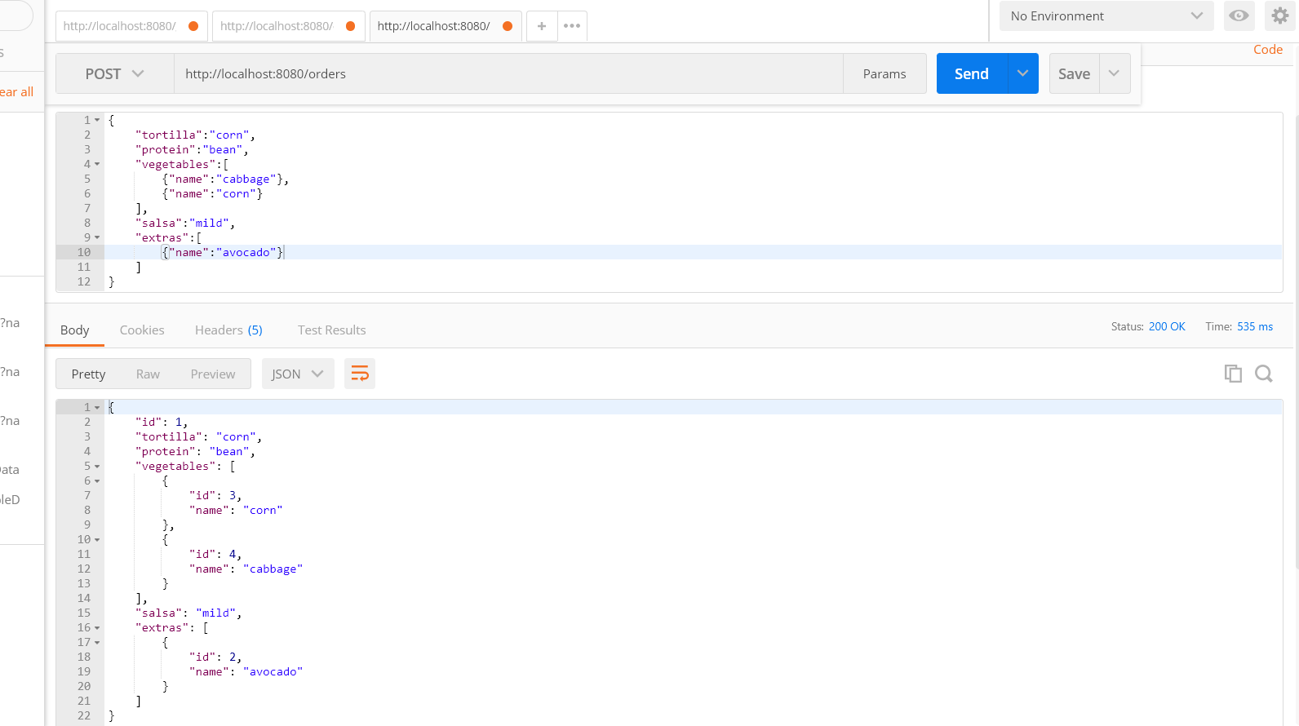

Get the order based on order id using below url

<http://localhost:8080/orders/1>

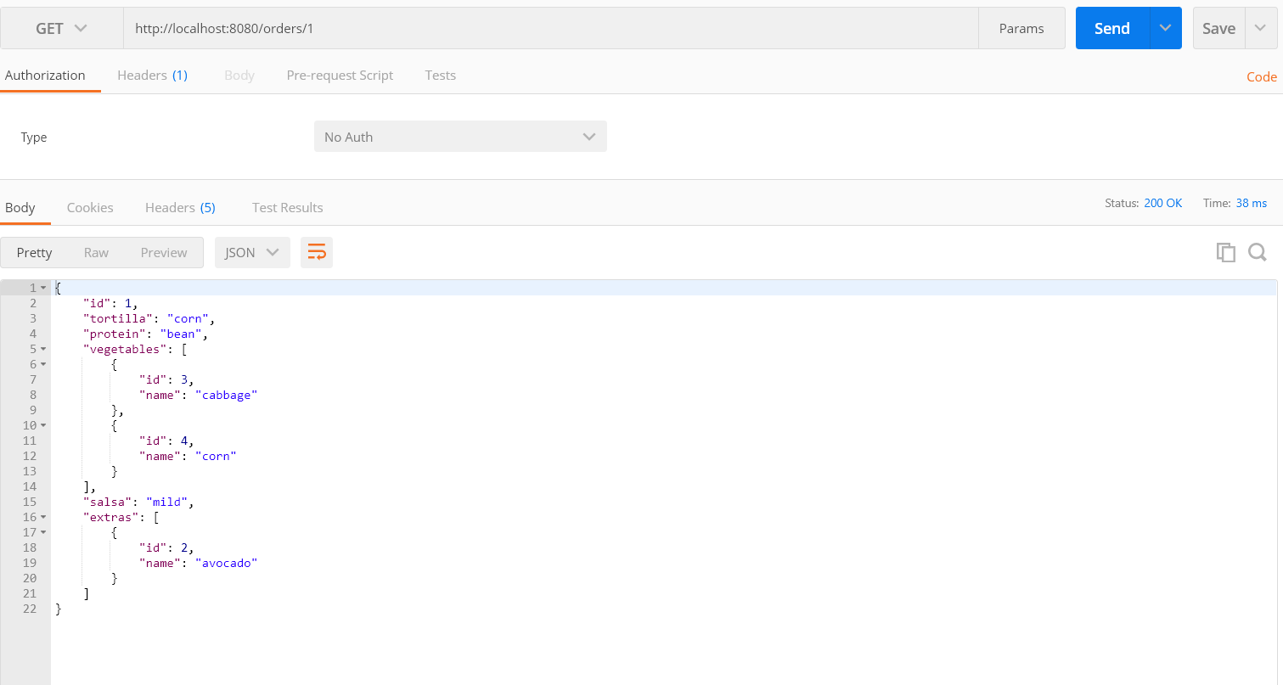

Run the below class for unit testing

BurritoOrderingServiceApplicationTests.java

