**Software Setup Instructions for KWIK Lecture + Lab**

**Ver.1.0 / Jun.01 2024**

*Please follow the instructions below to prepare your laptop for the KWIK Lecture + Lab:*

* *Install LTSpice (Optional)* *[LTspice 24 Download and Release Notes](https://ez.analog.com/design-tools-and-calculators/ltspice/w/faqs-docs/32232/ltspice-24-download-and-release-notes)*
* *Download any ADALM2000 configuration files from the specific KWIK Lecture + Lab Wiki page.*

*If you have not previously installed the ADALM2000 and Scopy:*

* *Go to the Wiki Page* [*ADALM2000 for End Users*](https://wiki.analog.com/university/tools/m2k/users)
* *Install Device Drivers by referring to Point # 3. Choose the proper version applicable to your OS*
* *Install Scopy by referring to Point # 9.1*
* *Install* [*libm2k library*](https://wiki.analog.com/university/tools/m2k/libm2k/libm2k)
* *Familiarize yourself by watching the video tutorial at the bottom of the page* ([*ADALM2000 for End Users*](https://wiki.analog.com/university/tools/m2k/users)*)*
* *Additional videos are available in the* [*ADALM2000 video series*](https://youtube.com/playlist?list=PLE6soOeVPOJ0Pj5sMui4KPDiTa7HY50y3)*. In particular:*
  + *Installation videos*
  + *Oscilloscope*
  + *Network analyzer*

*//////////////////////////////////////////////////////////////////////////////////////////////////////////*

*One more thing, the ADALM2000 kit comes with a USB-to-microUSB cable (see photo below)*

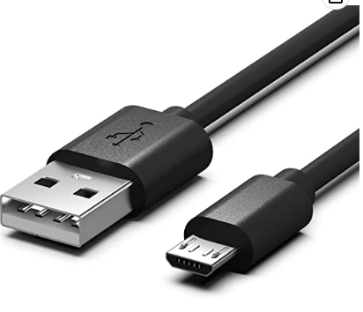

*In case your laptop is equipped with USB-C only, it’s recommended to also obtain either a USB-C to USB adapter, or a USB-C to microUSB cable like* [*this one*](https://de.farnell.com/en-DE/wurth-elektronik/632910731611/usb-cable-type-c-micro-usb-plug/dp/2506096?ICID=I-RP-STM7REC-0)*.*