Software Setup Instructions for KWIK Lecture + Lab
Ver.1.0 / Jun.01 2024
Please follow the instructions below to prepare your laptop for the KWIK Lecture + Lab:
- Install LTSpice (Optional) LTspice 24 Download and Release Notes
- Download any ADALM2000 configuration files from the specific KWIK Lecture + Lab Wiki page.

If you have not previously installed the ADALM2000 and Scopy:
- Go to the Wiki Page ADALM2000 for End Users
- Install Device Drivers by referring to Point # 3. Choose the proper version applicable to your OS
- Install Scopy by referring to Point # 9.1
- Install libm2k library

- Familiarize yourself by watching the video tutorial at the bottom of the page (ADALM2000 for End Users)
- Additional videos are available in the ADALM2000 video series. In particular:
  - Installation videos
  - Oscilloscope
  - Network analyzer

//////////////////////////////////////////////////////////////////////////////////////////////////////////
One more thing, the ADALM2000 kit comes with a USB-to-microUSB cable (see photo below)
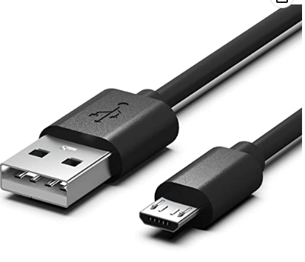
In case your laptop is equipped with USB-C only, it’s recommended to also obtain either a USB-C to USB adapter, or a USB-C to microUSB cable like this one.

